## Created EC2 Instance

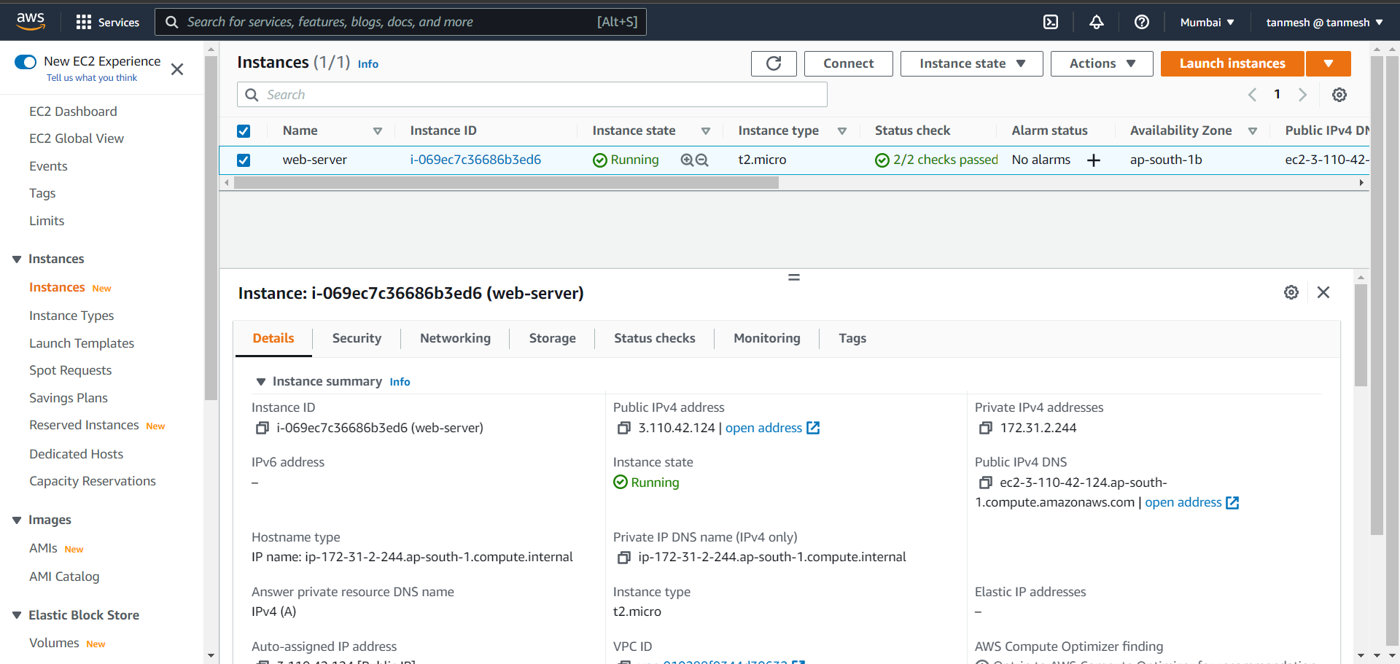

## Used my github repo which was created during the call

<https://github.com/tanmeshbhokare/nodeapp.git>

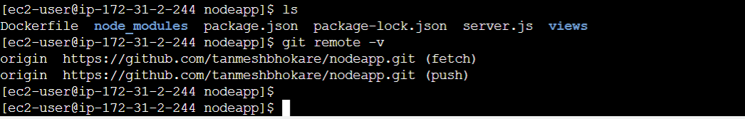

## Started the app

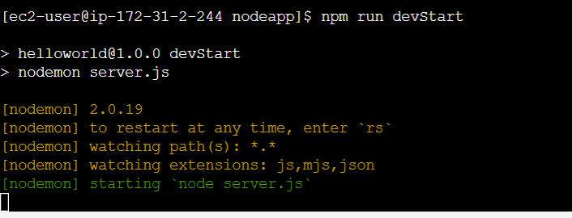

## Accessible on instance ip

<http://3.110.42.124:3000/>

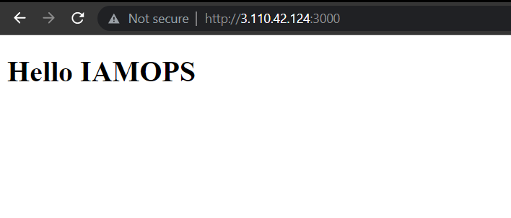

## Created target group and added the ec2 instance in it

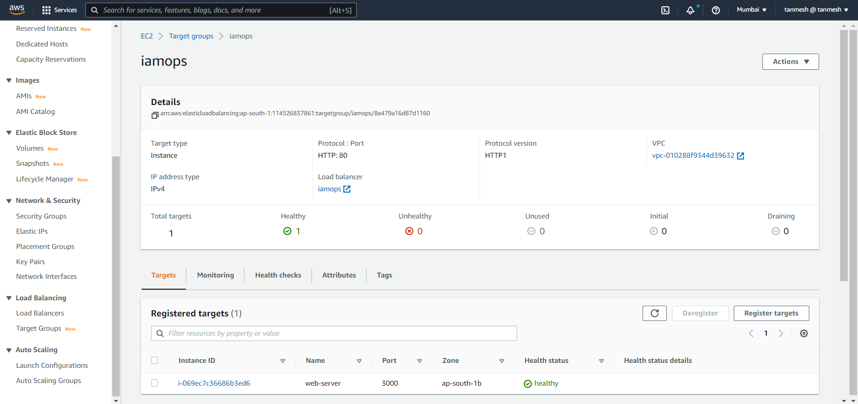

## Created an application load balancer

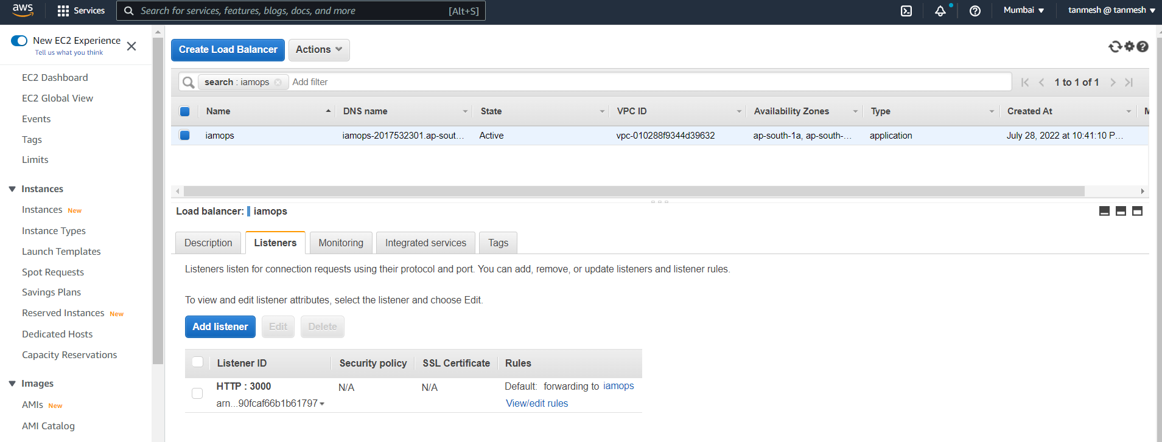

## Accessible via Load balancer

<http://iamops-2017532301.ap-south-1.elb.amazonaws.com:3000/>

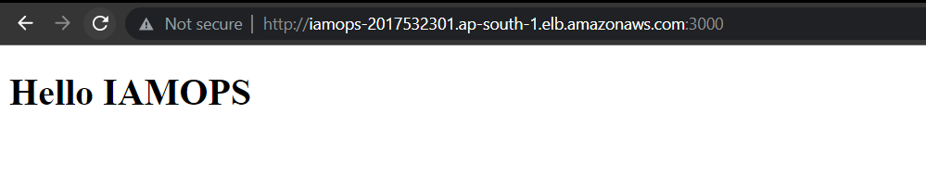

## Created a cloudfront distribution

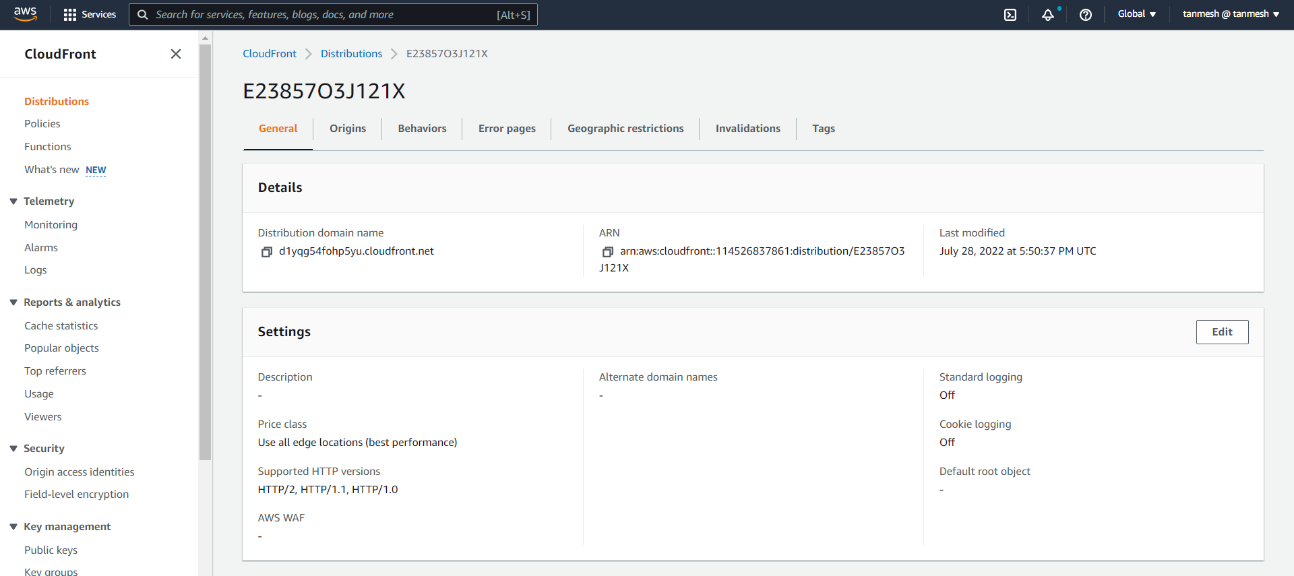

## Created origin and added load balancer in it

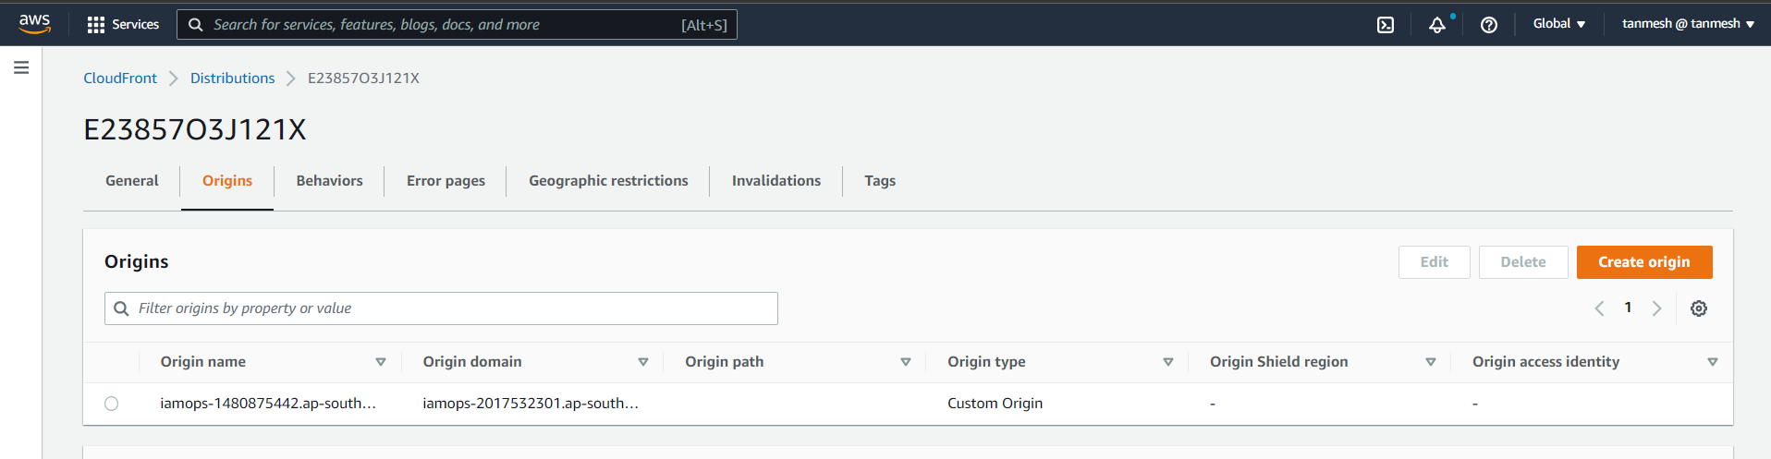

## Accessible via cloudfront

<https://d1yqg54fohp5yu.cloudfront.net/>

