Week 2: Word & Sentence Database
Objectives
- Design structured data format for emoji-to-word mapping
- Create 50+ emoji-word pairs across three difficulty levels
- Organize word list by Easy, Medium, and Hard categories
- Generate JSON/Dictionary format for game integration
Task Breakdown
- Structure word/sentence data — Create separate lists for easy (short common words), medium (longer words, short sentences), hard (full sentences, punctuation included),
- Load content at runtime — Write a ContentLoader class that reads from a .json or .txt file using BufferedReader or Gson and returns a list of strings for a given difficulty.
- Design the level system — Map Level 1 → easy words, Level 2 → medium words/short sentences, Level 3 → hard sentences
Deliverables
- Data Format Document
- 50+ Emoji-Word Pairs
- words.json File
- Difficulty Level Breakdown
Tools & Resources
- Gson — read the JSON file
- JUnit 5 — test the loader
- IntelliJ IDEA — run everything

Easy Level - Emoji-Word Pairs
Emoji & Word | Level
🎓📚✏, STUDENT | Easy
🎤🎵🎸, MUSICIAN | Easy
🏃💪🥇, ATHLETE | Easy
🌳🌱💧, NATURE | Easy
🍔🍟🥤, FASTFOOD | Easy
📚🏫📝, HOMEWORK | Easy
🚓🚨👮, POLICE | Easy
🍫🍬🍭, CANDY | Easy

Medium Level - Emoji-Word Pairs
Emoji & Word | Level
🎬🍿🎥, MOVIE | Medium
🎮🕹🏆, GAMER | Medium
🚀🌕⭐, ROCKET | Medium
📱💬📞, MOBILE | Medium
💻⌨🖱, COMPUTER | Medium
🌧☁💧, WEATHER | Medium
👑🏰⚔, KINGDOM | Medium
🌍✈🧳, TRAVELER | Medium
🚗🛣⛽, DRIVING | Medium
🏥💉👨‍⚕️, DOCTOR | Medium
⚖📜🏛, JUSTICE | Medium
🎨🖌🖼, ARTIST | Medium
🔍🕵📄, DETECTIVE | Medium
📖🧠💡, KNOWLEDGE | Medium
🏠🏗🔨, BUILDING | Medium
🎭🎬⭐, ACTOR | Medium
📺🎤📰, REPORTER | Medium
🌙⭐🌌, GALAXY | Medium

Hard Level - Emoji-Word Pairs
Emoji & Word | Level
🏏🏃🏆, CRICKET | Hard
🔥🍳👨‍🍳, COOKING | Hard
📷🌄📸, PHOTOGRAPHY | Hard
🧪🔬⚗, SCIENCE | Hard
⚡🔋🚗, ELECTRIC | Hard
🎤🎶🎧, SINGER | Hard
🧑‍💻💻☕, CODING | Hard
📡🛰🌍, NETWORK | Hard
🚲🏞🌤, CYCLING | Hard
🍎🥗💪, HEALTHY | Hard
🔐💻🛡, SECURITY | Hard
💰🏦📈, BANKING | Hard
🎓📖🏫, EDUCATION | Hard
🛒🏬💳, SHOPPING | Hard
🎹🎼🎵, PIANIST | Hard
🐘🌿🌳, WILDLIFE | Hard
✉📬📨, MESSAGE | Hard
🏆🥇🎖, CHAMPION | Hard
🕰⏳⌛, TIMING | Hard
🌋🔥🌍, VOLCANO | Hard
🎂🎉🎁, BIRTHDAY | Hard
🌊⛵🐟, OCEAN | Hard
🗺📍🌍, JOURNEY | Hard

Here
1. Designed emoji-to-word mapping format for easy retrieval
2. Created 8 emoji-word pairs for Easy level
3. Created 15 emoji-word pairs for Medium level
4. Created 23 emoji-word pairs for Hard level
5. Total: 50 emoji-word pairs across all difficulty levels
ContenLoader.py{}
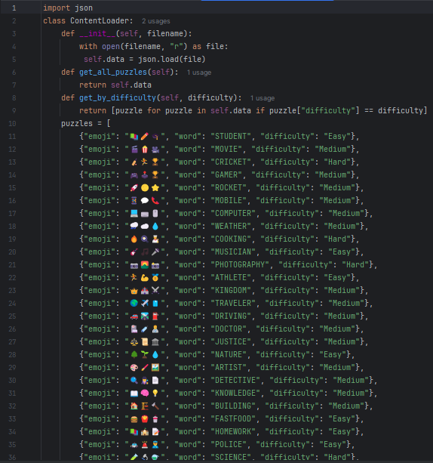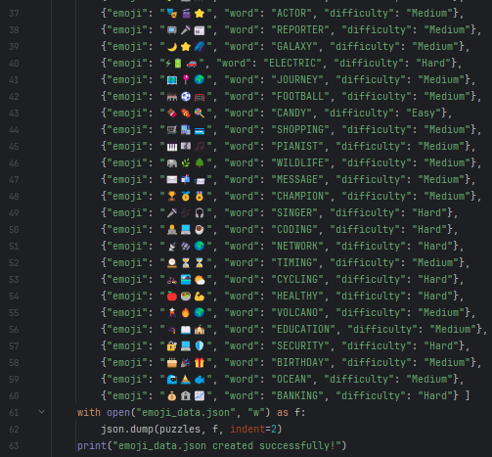
Output:
