TOPIC – A RARE CASE PRESENTING AS RAPIDLY PROGRESSIVE GLOMERULONEPHRITIS
DR SMITA PRIYADARSHINI** DR ASHIM KUMAR MAHALI*
** DM RESSIDENT (SECOND YEAR) Kalinga Institute of Medical Sciences ,Bhubaneshwar, Orissa
*ASSISTANT PROFESSOR, Dept of Nephrology ,Kalinga Institute of Medical sciences , Bhubaneshwar,Orissa

- BACKGROUND
Monoclonal gammopathy of renal significance encompasses a broad spectrum diseases associated with Monoclonal gammaglobulins. Proliferative glomerulonephritis with monoclonal immunoglobulin deposits (PGNMID) is characterized by a kidney biopsy finding that shows mesangioproliferative, membranoproliferative, and/or endocapillary proliferative glomerulonephritis on light microscopy; monoclonal immunoglobulin deposition on immunofluorescence microscopy; and nonorganized electron-dense deposits on electron microscopy. PGNMID is a kidney-limited disease The renal prognosis of patients with PGNMID after diagnosis is poor during its initial description, with around half the patients reaching kidney failure within 2 to 5 years of diagnosis

- AIM OF THE STUDY
To study PGNMID presenting as a rare case of rapidly progressive glomerulonephritis .

- METHODS
A 38yr old female presented with c/o swelling of both lower limbs and face for last 1month and decreased urine output for last 15days.she did not have any relevant past medical history. hemodialysis was initiated as patient was in fluid overload .kidney biopsy was done which showed proliferative pattern and significant IgG and kappa deposit.suggestive of proliferative glomerulonephritis with monoclonal IgG deposit.IF revealed IgG with kappa deposits as shown in fig 1,2,3,4.Bone biopsy was done which showed myeloid hyperplasia. chemotherapy was initiated with CYBORD regimen after which patient improved significantly.

- CONCLUSION
PGNMID presents as a heterogenous pattern of renal injury with a poor renal prognosis. The detection of monoclonal protein and an early hematologic study are essential, to start of specific hematologic treatment to refrain the production of the monoclonal protein and halt renal and systemic injury.

Fig 1.

Fig 2.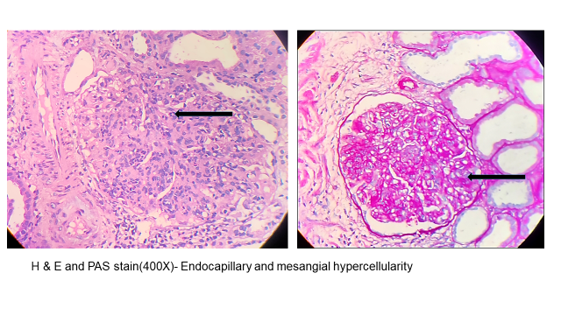
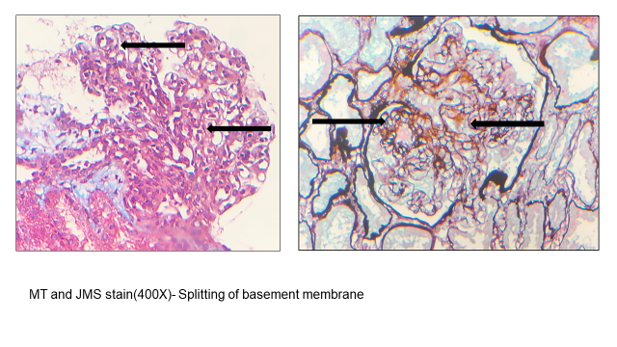

Fig 3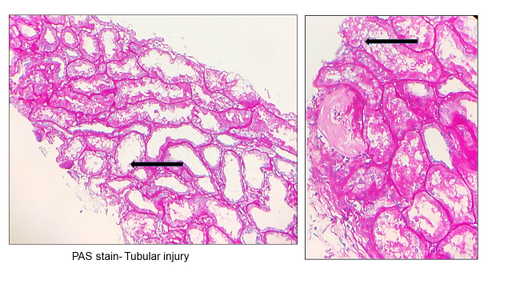

Fig 4