TOPIC: LENTIFORM FORK SIGN- A PREDICTOR OF UREMIC ENCEPHALOPATHY
DR.VARSHA YADAV**, DR. KUMAR AVIJEET DASH *, DR.SCIENTHIA SANJEEVNI*
** DM RESIDENT (first year), Department of Nephrology, Kalinga Institute of Medical Sciences, Bhubaneshwar, Odisha
* ASSISTANT PROFESSOR, Department of Nephrology, Kalinga Institute of Medical Sciences, Bhubaneshwar, Odisha

BACKGROUND
Uremic encephalopathy is a neurologic complication associated with acute or chronic renal failure. It is likely caused by the effects of neurotoxic compounds. The neurotoxic effects of excitatory N-methyl-D-aspartate receptors may be stimulated by the accumulation of uremic toxins, such as guanidine compounds (such as creatinine and guanidine), and the concurrent inhibition of inhibitory -aminobutyric acid receptors may be a significant factor in the pathogenesis of UE. ⁽¹⁾
UE manifests as a variety of neurologic symptoms, including altered mental status, cognitive abnormalities, and movement disorders (tremor, asterixis, myoclonus). ^{(2,3)}
We describe here a case of this neuro-radiological abnormality which was encountered in our patient with uraemia and metabolic acidosis -who presented with altered sensorium.
Clinical presentation
A 47 year old male patient who is farmer by occupation is a k/c/o chronic kidney disease with diabetes mellitus with hypertension who is on maintenance hemodialysis (thrice weekly) with left brachio-cephalic fistula presented in emergency with altered sensorium for 2 days . Family gives history of missed hemodialyis since last 1 week.On examination, patient was drowsy, arousable to pain stimulus.
His blood pressure was 190/91 mmHg, and his heart rate was 104 beats per min. Arterial blood gas analysis showed a pH of 7.29, bicarbonate ion of 13.1 mEq/L, and lactic acid of 1.6 mmol/L (normal, 0.5–1.6 mmol/L). Serum urea was 163 mg/dl, serum creatinine 13.79 mg/dl, serum sodium
133 meq/l, serum potassium 5.1 meq /l and serum calcium was 7.1 mg/dl.
Patients Liver function tests was normal with serum bilirubin (total/direct/indirect)- 0.49/0.09/0.40, SGOT/SGPT- 12.3/7.4, serum ALP-85, serum GGT- 14.3, serum total protein/globulin – 6.85/3.22 , fasting blood sugar – 107, PPBS- 167 with negative viral markers report.

Neuroimaging was done by NCCT and MRI-Brain as shown in fig 1, 2 and 3.
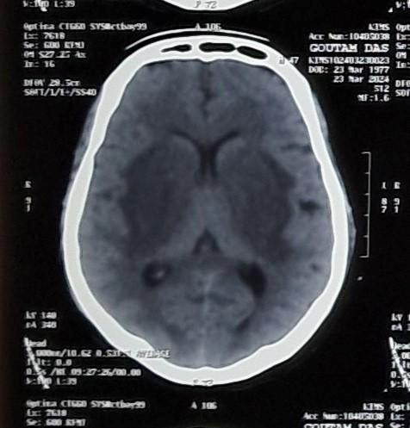
FIG 1:NCCT BRAIN
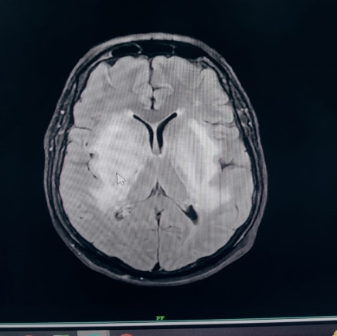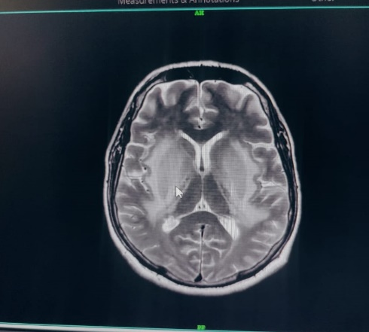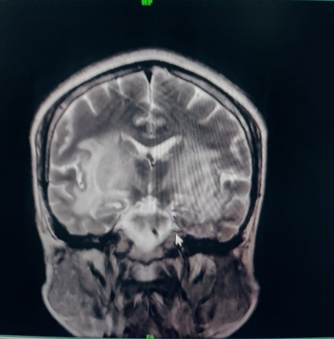

FIG3 :MRI BRAIN ( T1, T2, FLAIR)
Patients NCCT brain showed symmetrical hypodensity noted in bilateral lentiform nuclei & lateral aspect of bilateral thalami. Marked hypodensity of internal & external capsule delineating the lentiform nucleus.
MRI brain T2/FLAIR showed Diffuse hyperintensity without evidence of diffusion restriction noted involving bilateral lentiform nucleus, external capsule, and bilateral temporal lobes with edematous bilateral lentiform nucleus.
Hospital course
Patient was admitted and given hemodialysisfor consecutive 3 days with other supportive and renoprotective measurements following which patients GCS was improved and condition was stable, later patient was shifted to ward and then discharged with hemodynamically stable condition.

DISCUSSION
Basal ganglia lesions showing an expansile high signal intensity on
T2-weighted MRI are termed the lentiform fork sign. This specific finding is mainly observed in diabetic patients with uremic encephalopathy with metabolic acidosis, although there are also reports in patients with ketoacidosis, dialysis disequilibrium syndrome, intoxication, and following drug treatment (e.g., metformin).(4)
DM may make the basal ganglia more vulnerable to uremic toxins because of endothelial dysfunction in cerebral vessel and vascular autoregulatory dysfunction(5). Uremic toxins inhibits mitochondrial function with destruction of the pallidum and putamen.(6)
The lentiform fork sign is comprised of the following elements: 1) the lateral arm, formed by the edematous external capsule and extending from the anterior end of the putamen to the stem; 2) the stem, created by merging of the edematous external and internal capsules at the inferoposterior end of the putamen; and 3) the medial arm, which extends from the stem anteriorly up to one third of the medial edge, where it splits into two slightly less T2/FLAIR-hyperintense branches engulfing the globus pallidus (7)
The Lentiform fork sign is a rare occurrence which can be related to a long list of toxic and metabolic causes. In our case, the neurological deficit was reversed after identifying uremia and metabolic acidosis as the cause and giving adequate management.
References
- Vanholder R, De Smet R. Glorieux G; European Uremic Toxin Work Group. Review on uremic toxins: classification, concentration, and interindividual variability. Kidney Int 2003;63:1934 –43 CrossRef Medline.
- Seifter JL, Samuels MA. Uremic encephalopathy and other brain disorders associated with renal failure. Semin Neurol 2011;31: 139 –43 CrossRef Medline
- Etgen T. Kidney disease as a determinant of cognitive decline and dementia. Alzheimers Res Ther 2015;7:29 CrossRef Medline
- Narra RK. Lentiform fork sign in uraemic encephalopathy. BMJ Case Rep 2021;14(9):e245623.
- Kwok RP, Juorio AV. Concentration of striatal tyramine and dopamine metabolism in diabetic rats and effect of insulin administration. Neuroendocrinology 1986;43:590
–96 Medline
- Albin RL. Basal ganglia neurotoxins. Neurol Clin 2000;18:665–80 CrossRef Medline.
- Grasso D, Borreggine C, Perfetto F, et al.: Lentiform fork sign: a magnetic resonance finding in a case of acute metabolic acidosis. Neuroradiol J.
2014;27(3):288–292. 10.15274/NRJ-2014-10041

