Abstract Theme: Clinical Nephrology

Title: An Open-Label Randomized Controlled Trial Comparing Between Solo Prednisolone Therapy vs. steroid Sparing Agent Along with Daily Doses of Prednisolone in Achievement of Remission Among FRNS And SDNS Patients

Aishwarya Chandra¹, Jatadhari Mahar², Subal Kumar Pradhan³, Pravakar Mishra⁴

Presenting Author:
Dr. Aishwarya Chandra, Postgraduate student,
Division of Pediatric Nephrology,
Department of Pediatrics, SCB Medical College and Hospital and SVP PGIP, Cuttack.
Email: draishwaryachandra@gmail.com
Phone: +91 86538 41216

Background: Childhood-onset nephrotic syndrome generally is steroid sensitive and resolves spontaneously on reaching puberty. However, 50% of patients have frequent relapses or become steroid dependent which requires prolonged exposure to steroids, and in turn, may require steroid-sparing agents. There is insufficient evidence regarding the choice and timing of use of steroid-sparing agents. Cyclophosphamide and Levamisole are recommended to be started after the patient has achieved remission with steroids. No such recommendation exists for Mycophenolate Mofetil and Calcineurin Inhibitors. Literature to date is lacking on the use of steroid-sparing agents before a child has achieved remission and whether it is a more effective approach to induce early remission and limit the number of relapses occurring in FRNS and SDNS cases.

Objective: To assess the efficacy of early initiation of steroid-sparing agents along with a daily dose of prednisolone compared to only prednisolone therapy in achieving remission among patients aged 1-14 years diagnosed with FRNS/SDNS.

Method: An investigator-initiated, prospective, open-label, randomized, two-arm parallel-group superiority trial comparing two approaches to treating FRNS/SDNS patients presenting in relapse. In arm “A” steroid-sparing agents were simultaneously administered with steroids. In arm “B,” a steroid-sparing agent was added after the child had achieved remission.
Result: The median age of the first attack of nephrotic syndrome in our cohort of FRNS/SDNS patients was 36 months. There was a male preponderance in patients with nephrotic syndrome. On kidney biopsy, minimal change disease (MCD) was the most common histological subtype of nephrotic syndrome. The null hypothesis was found to be true. There was no statistical difference between the two arms in achieving remission. Group A (prednisolone + steroid-sparing agent) reported fewer relapses which approached statistical significance (p = 0.081). There was no difference in the number of serious infections between the groups.
Conclusion: Prednisolone plus steroid-sparing agent is non-inferior to solo Prednisolone therapy in achieving remission in FRNS/SDNS patients with relapse, however, it may be beneficial in decreasing the overall number of relapses.
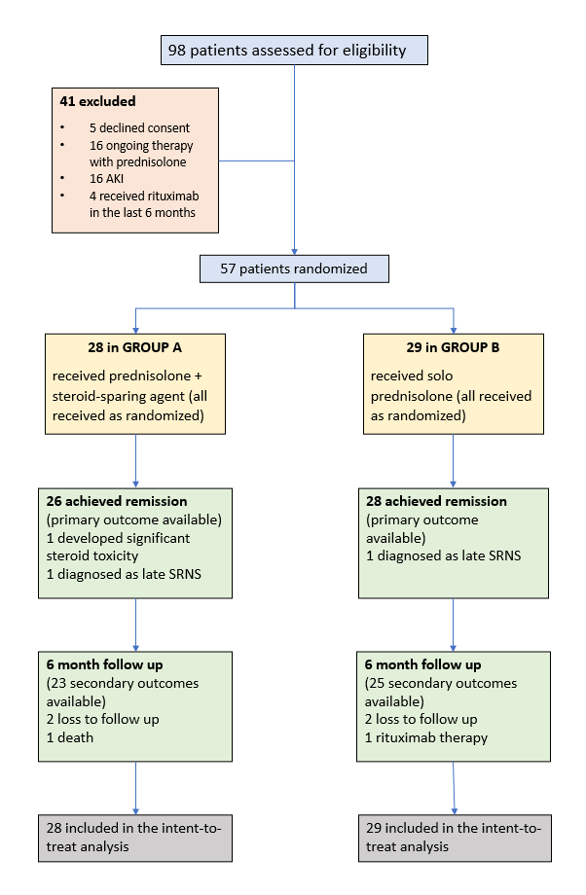
Figure 1: CONSORT flow diagram of study
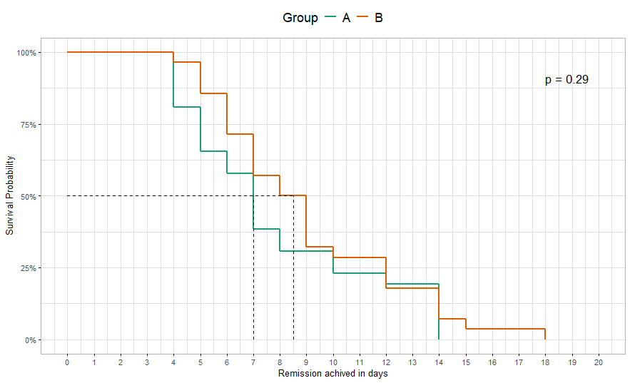
Figure 2: Kaplan-Meier Log Rank Analysis of both arms

