SPECIFICATIONS

Foodbot is designed to receive food orders and deliver in a user friendly manner. It accomodates user choices such as choosing between restaurants, cuisines and food types using informative templates, AI for text understanding, easy location tracking and more. Here are a list of specifications that the chatbot uses to facilitate user interaction.

1. User Interactions

a) Get started: The first impression of the bot on messenger. This displays a short message and registers users to the bot. This is displayed on first encounter with user.

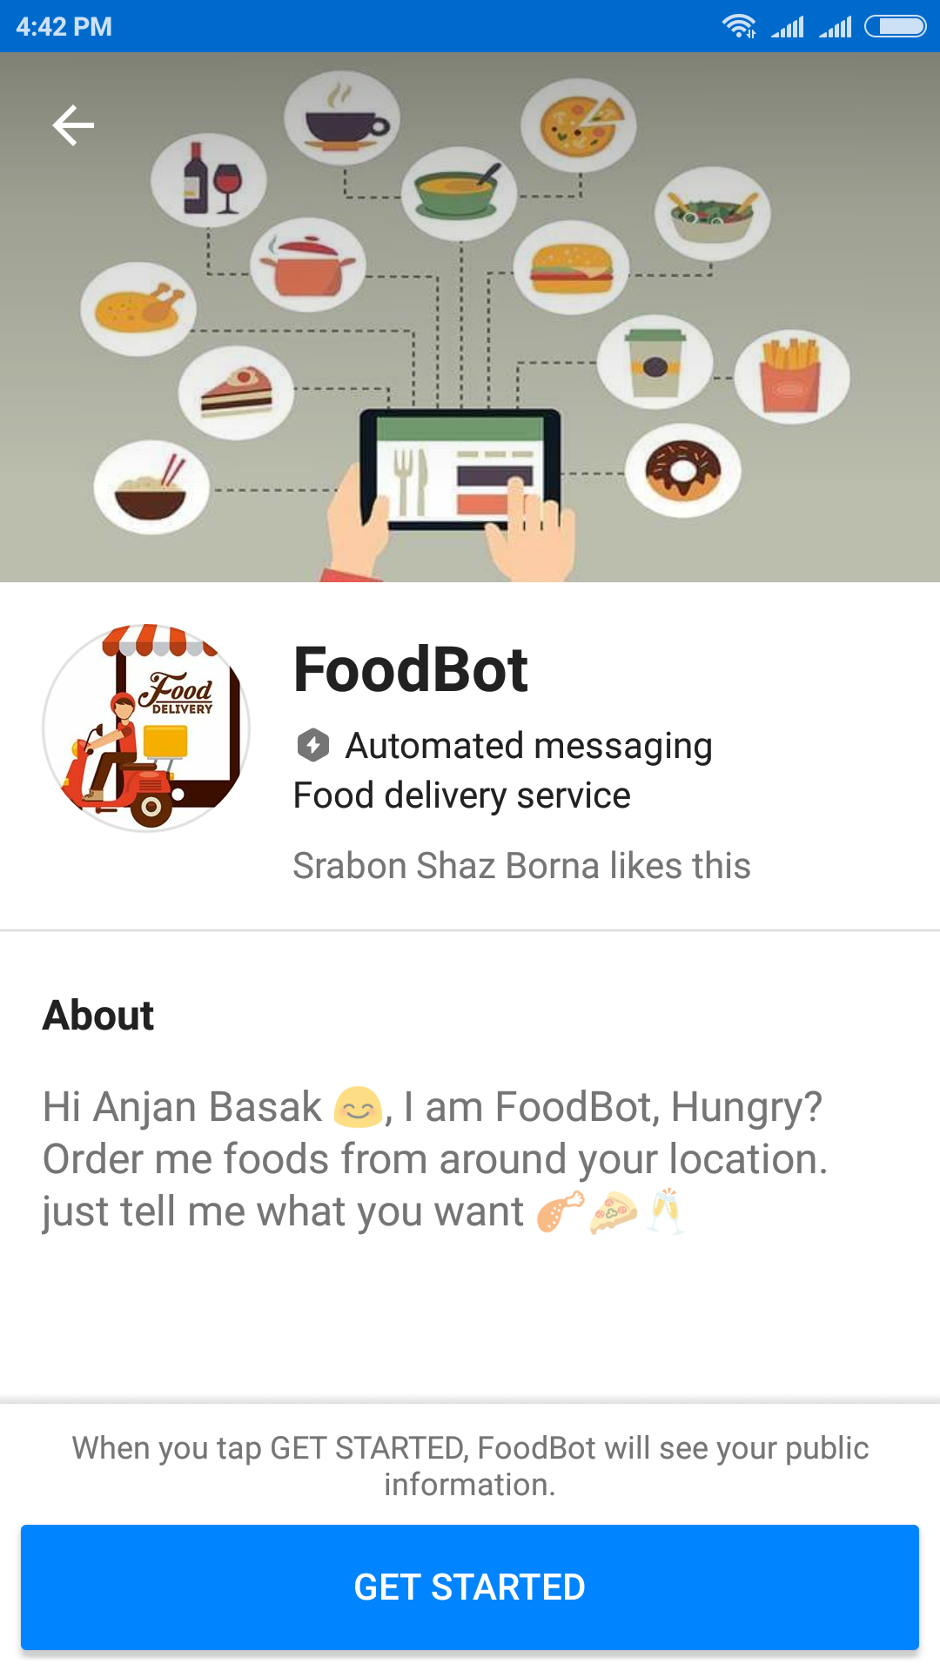

2. Persistent Menu

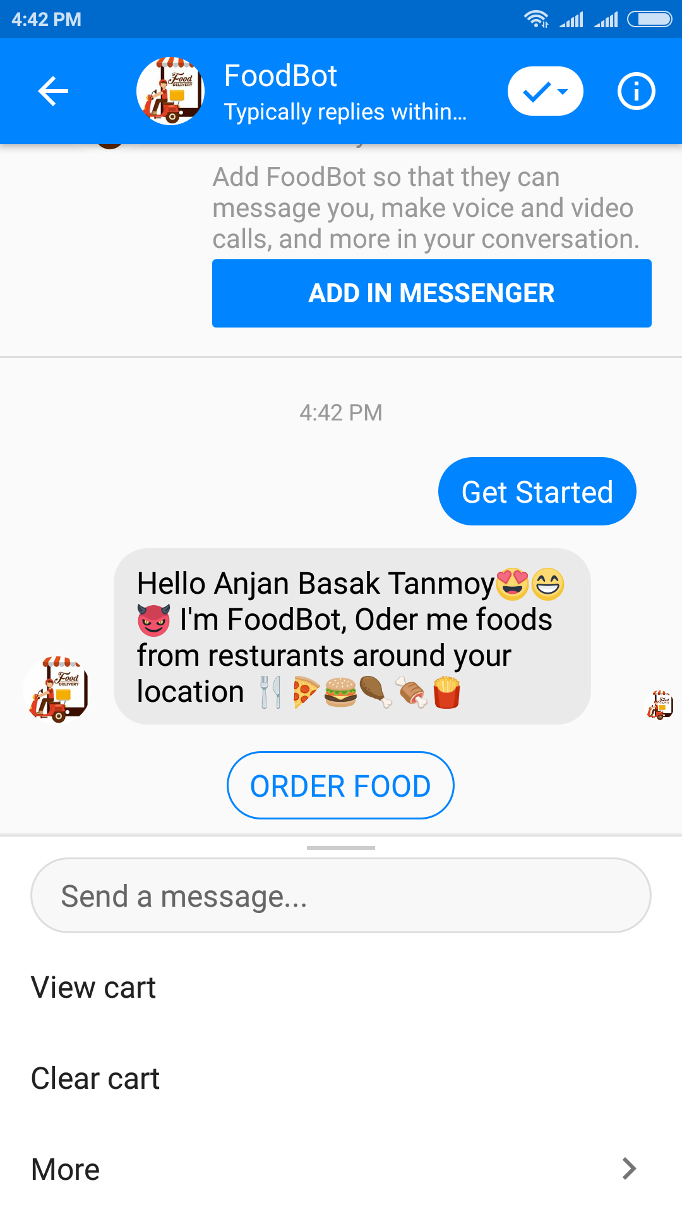A menu at the bottom helps navigate

3. Getting Information

Foodbot shows options of restaurants, food menu, where to look for restaurants and what type of food the user is looking for.

a) getting location and showing restaurants available. On specific location or region.

