LAB Assignment 08
NAME : TANMOY BANIK ROLL:CSE 206

Table
flight_id | airline | source | destination | price | duration
1 | Indigo | Delhi | Mumbai | 5000 | 2
2 | AirIndia | Kolkata | Chennai | 6500 | 3
3 | SpiceJet | Mumbai | Bangalore | 4000 | 1.5
4 | Vistara | Delhi | Chennai | 7000 | 3
5 | GoFirst | Mumbai | Delhi | 4800 | 2
6 | Indigo | Bangalore | Kolkata | 5500 | 2.5
Table
booking_id | passenger_name | flight_id | city | seats | total_fare
101 | Aarav | 1 | Delhi | 1 | 5000
102 | Meera | 2 | Kolkata | 2 | 13000
103 | Rohan | 3 | Mumbai | 1 | 4000
104 | Sneha | 4 | Delhi | 3 | 21000
105 | Kunal | 5 | Mumbai | 2 | 9600
106 | Priya | 6 | Bangalore | 1 | 5500

QUESTIONS
Q1. Display all flights.
Query:db.flights.find()
Output:
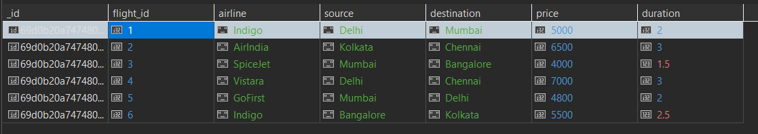
Q2. Display passenger_name and city from bookings.
Query: db.bookings.find({}, { passenger_name: 1, city: 1, _id: 0 })
Output:
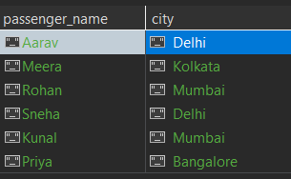
Q3. Find flights where source is Delhi.
Query: db.flights.find({ source: "Delhi" })
Output:
Q4. Find bookings where seats = 1.
Query: db.bookings.find({ seats: 1 })
Output:
Q5. Sort flights by price in ascending order.
Query: db.flights.find().sort({ price: 1 })
Output:
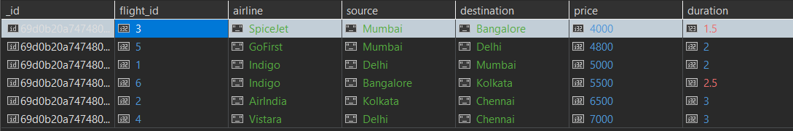
Q6. Display top 2 bookings with highest total_fare.
Query: db.bookings.find().sort({ total_fare: -1 }).limit(2)
Output:
Q7. Find flights where price is greater than 5000.
Query: db.flights.find({ price: { $gt: 5000 } })
Output:
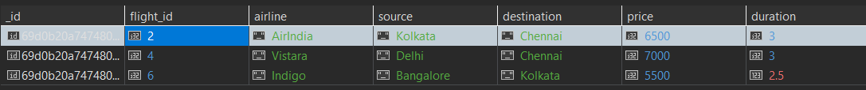
Q8. Display flights where destination is not Chennai.
Query:db.flights.find({ destination: { $ne: "Chennai" } })
Output:
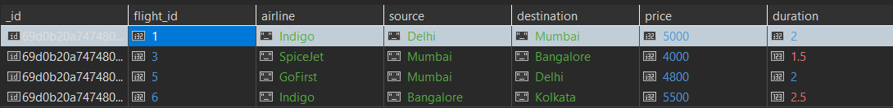
Q9. Find bookings where seats are between 1 and 2.
Query: db.bookings.find({ seats: { $gte: 1, $lte: 2 } })
Output:
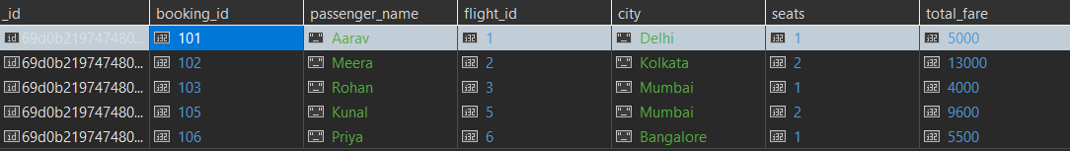
Q10. Update price by +500 for flights of airline "Indigo".
Query: db.flights.updateMany({ airline: "Indigo" },{ $inc: { price: 500 } })
Output: {acknowledged: true,
insertedId: null,
matchedCount: 2,
modifiedCount: 2,
upsertedCount: 0}
Q11. Delete bookings where seats are greater than 2.
Query: db.bookings.deleteMany({ seats: { $gt: 2 } })
Output:

Q12. Find total fare collected city-wise. (Aggregation)
Query: db.bookings.aggregate([{ $group: { _id: "$city", totalFare: { $sum: "$total_fare" } } }])
Output:
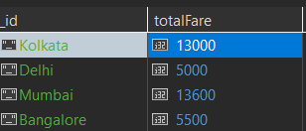
Q13. Find average flight price per airline. (Aggregation)
Query: db.flights.aggregate([{ $group: { _id: "$airline", avgPrice: { $avg: "$price" } } }])
Output:
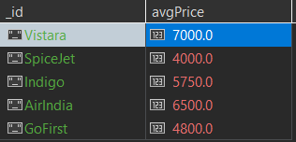
Q14. Display airlines where average price is greater than 5500. (Aggregation + filter)
Query: db.flights.aggregate([{ $group: { _id: "$airline", avgPrice: { $avg: "$price" } } }, { $match: { avgPrice: { $gt: 5500 } } }])
Output:
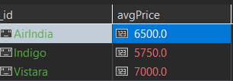

Q15. Find maximum total_fare among bookings for each city. (Aggregation)
Query: db.bookings.aggregate([{ $group: { _id: "$city", maxFare: { $max: "$total_fare" } } }])
Output:
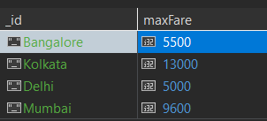
Final output:
Flights table:
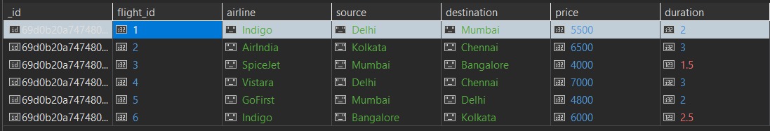
Bookings table:
