MongoDB Lab – Day 6 (Advanced Queries)
TANMOY BANIK
Roll-UG/SOET/30/23/206
Schema { emp_id, name, department, designation, city, salary, experience}
Initial Data
Emp ID | Name | Department | Designation | City | Salary | Experience
101 | Amit | IT | Developer | Kolkata | 60000 | 3
102 | Neha | HR | HR Executive | Delhi | 45000 | 2
103 | Ravi | IT | Tester | Mumbai | 50000 | 4
104 | Pooja | Finance | Accountant | Chennai | 55000 | 5
105 | Karan | IT | Developer | Kolkata | 65000 | 6
106 | Sneha | HR | Manager | Delhi | 70000 | 7
107 | Arjun | Finance | Analyst | Mumbai | 48000 | 2
108 | Meera | IT | Developer | Bangalore | 75000 | 8
109 | Rohit | IT | Team Lead | Pune | 90000 | 10
110 | Anjali | HR | Recruiter | Kolkata | 42000 | 1

Lab Questions
Q1. Display employee name and salary only.
Query: db.employee_CSE_206.find({}, {name:1, salary:1, _id:0})
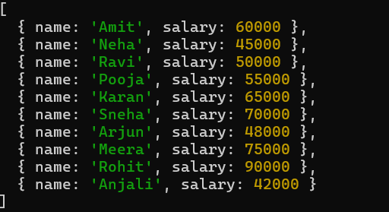

Q2. Find employees working in HR department.
Query: db.employee_CSE_206.find({department:"HR"})
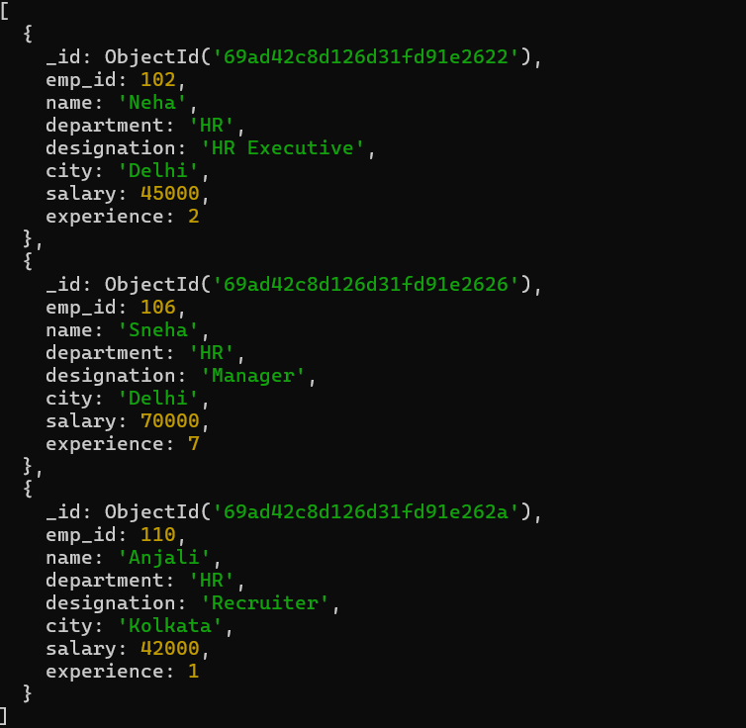
Q3. Find employees whose salary is between 50,000 and 80,000.
Query: db.employee_CSE_206.find({salary:{$gte:50000,$lte:80000}})
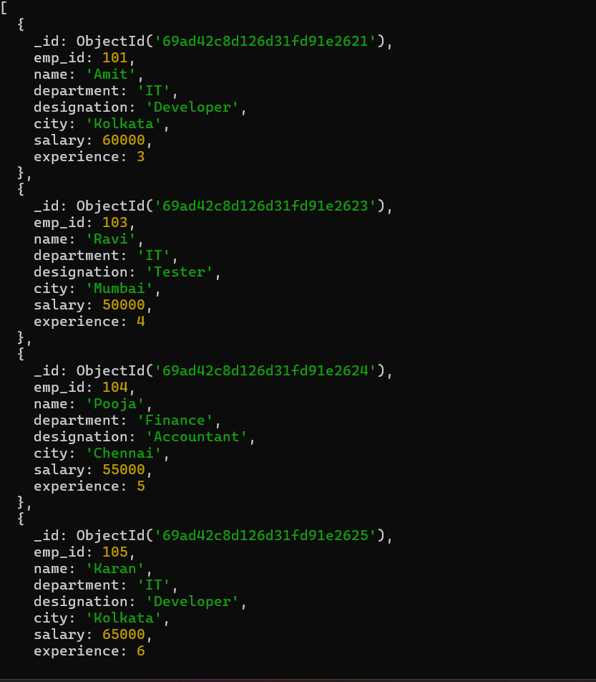
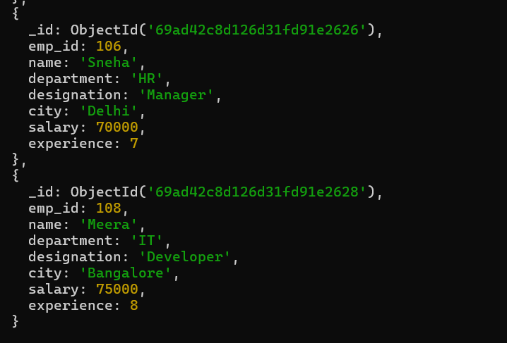
Q4. Display employees from Kolkata city.
Query: db.employee_CSE_206.find({city:"Kolkata"})
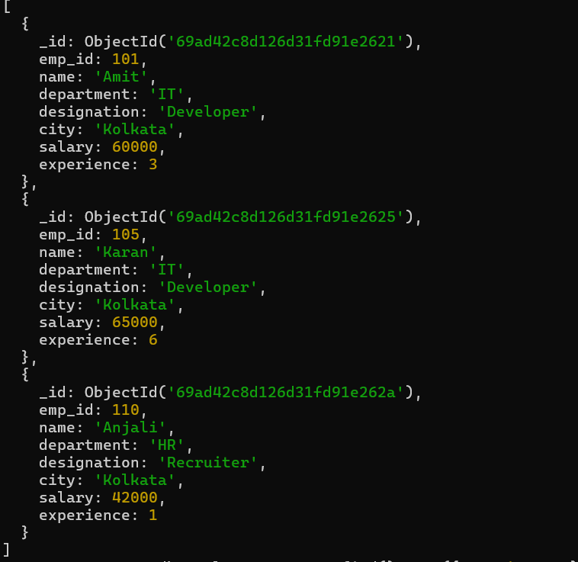
Q5. Sort employees by experience in ascending order.
Query: db.employee_CSE_206.find().sort({experience:1})
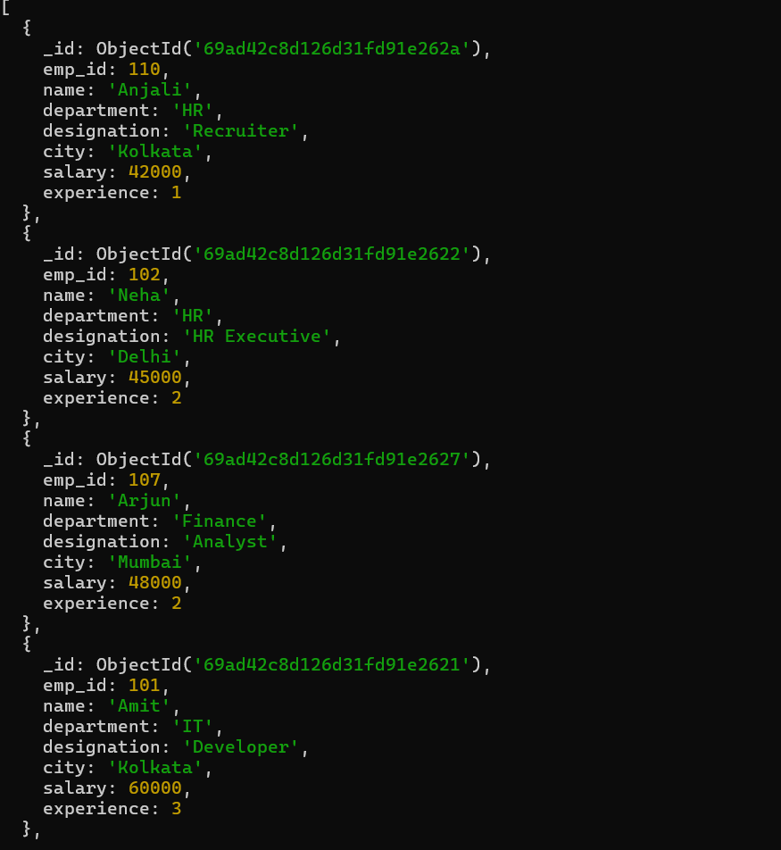
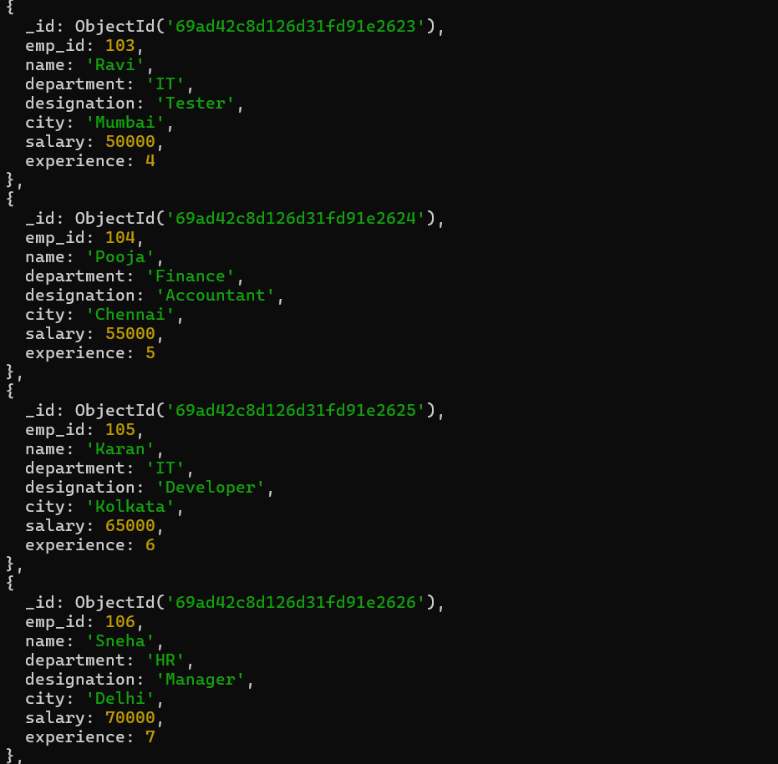
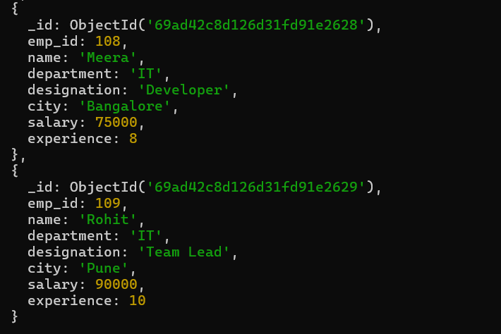

Q6. Display top 5 most experienced employees.
Query: db.employee_CSE_206.find().sort({experience:-1}).limit(5)
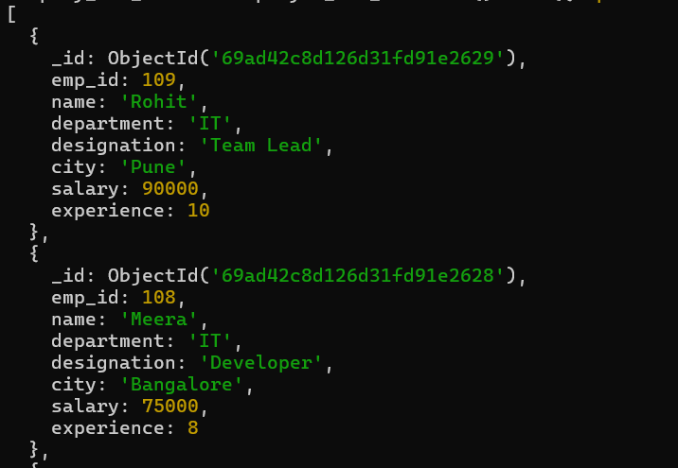
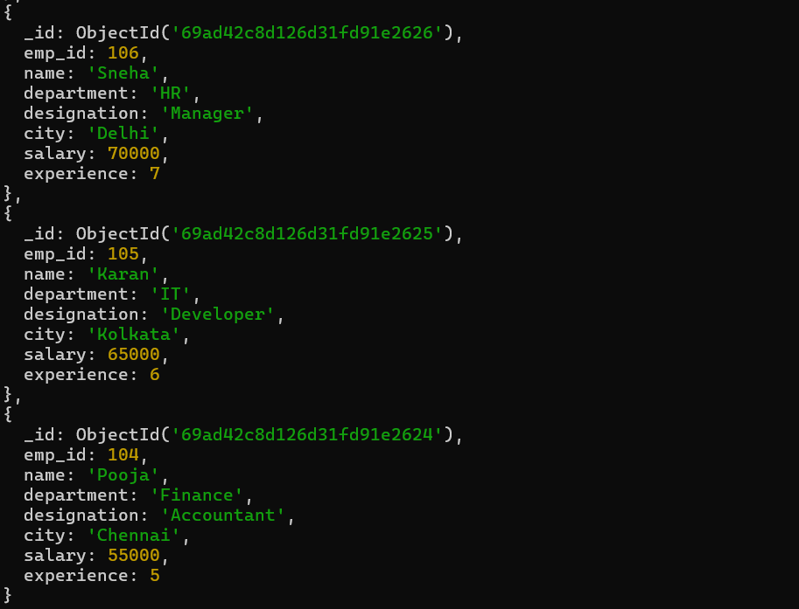
Q7. Update salary of employee with emp_id 102 to 48,000.
Query:db.employee_CSE_206.updateOne({emp_id:102},{$set:{salary:48000}})
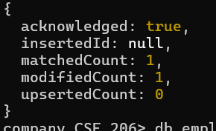
Q8. Increase salary of all IT employees by 10,000.
Query: db.employee_CSE_206.updateMany({department:"IT"},{$inc:{salary:10000}})
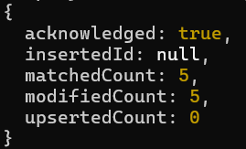
Q9. Update designation to “Senior Developer” for IT employees having experience more than 5 years.
Query: db.employee_CSE_206.updateMany({department:"IT",experience:{$gt:5}},{$set:{designation:"Senior Developer"}})
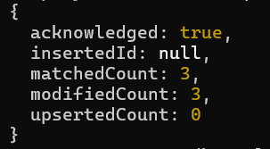
Q10. Delete employees whose experience is less than 2 years.
Query: db.employee_CSE_206.deleteMany({experience:{$lt:2}})
Output: { acknowledged: true, deletedCount: 1 }
Q11. Display employees who are not from Delhi.
Query: db.employee_CSE_206.find({city:{$ne:"Delhi"}})
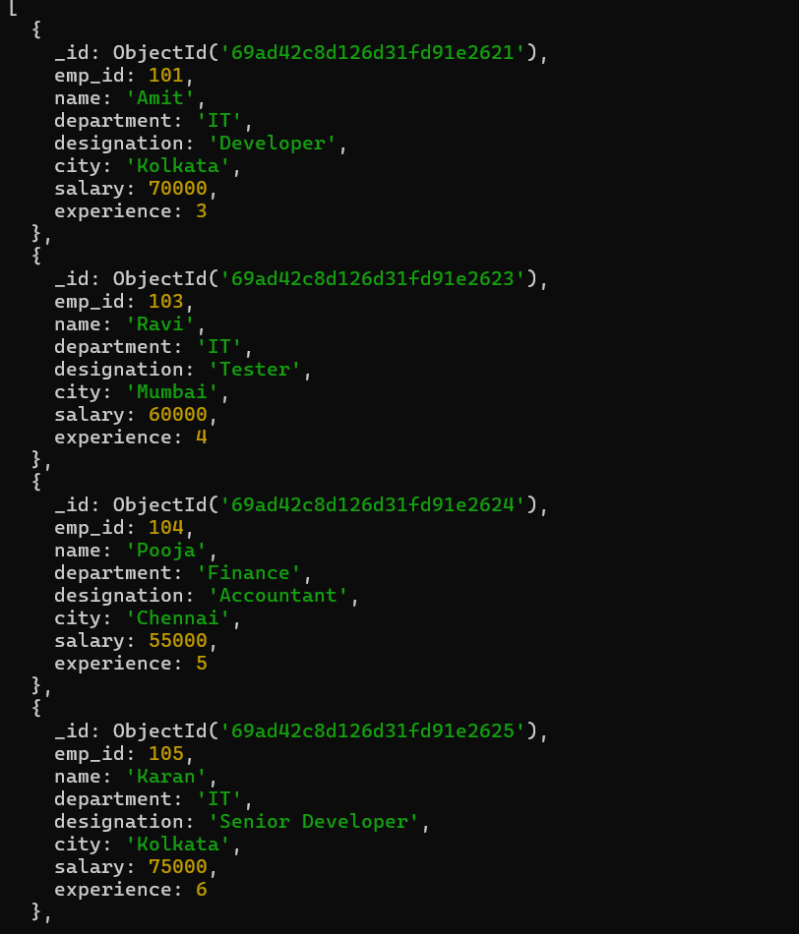
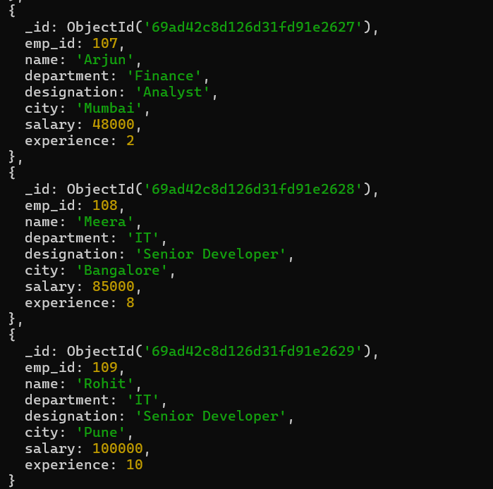
Q12. Find employees whose designation is Developer and salary greater than 60,000.
Query: db.employee_CSE_206.find({designation:"Developer",salary:{$gt:60000}})
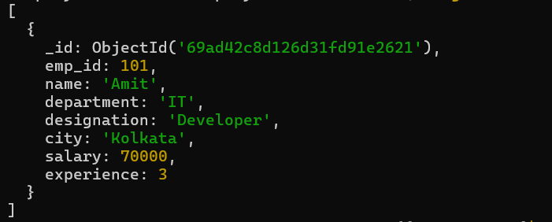
Q13. Display employees working in IT or Finance department.
Query: db.employee_CSE_206.find({department:{$in:["IT","Finance"]}})
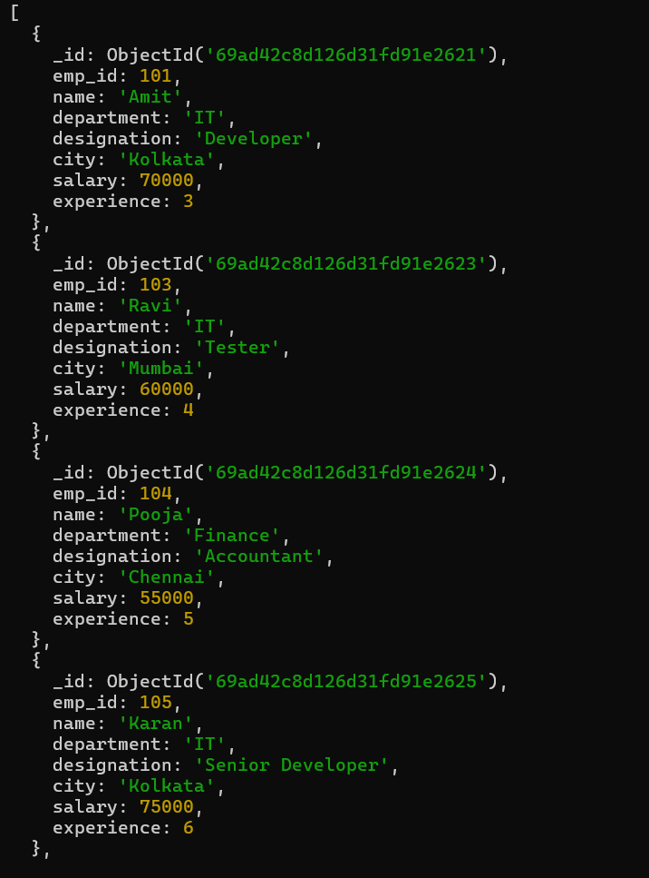
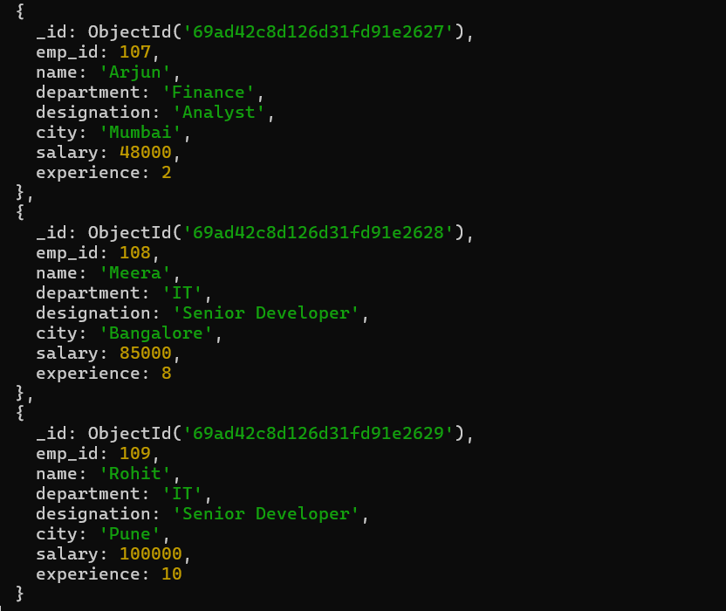
Q14. Display employees sorted by department and then by salary.
Query: db.employee_CSE_206.find().sort({department:1,salary:1})
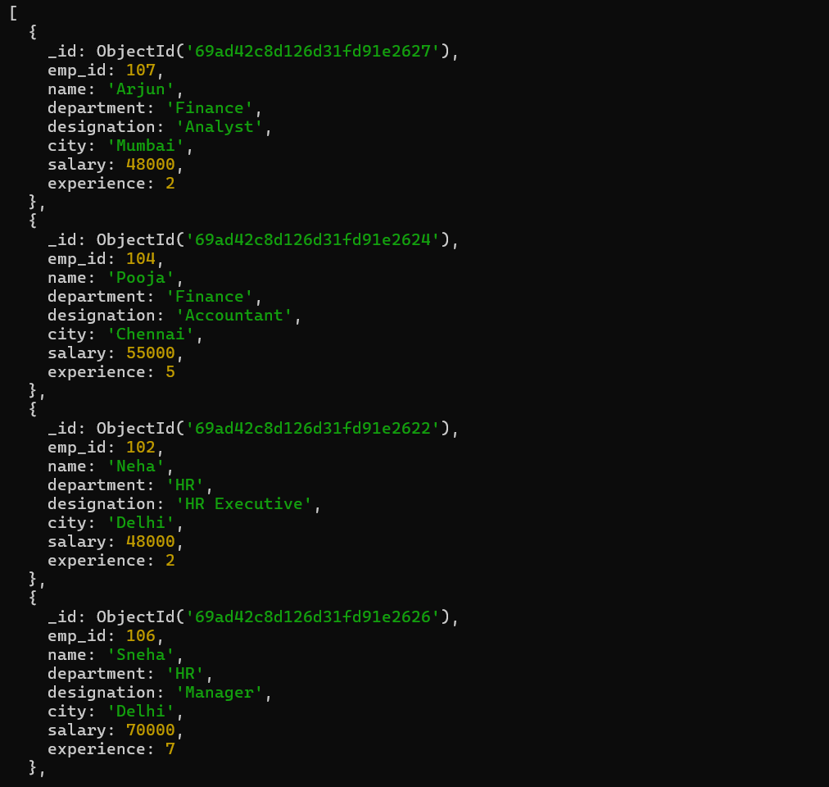

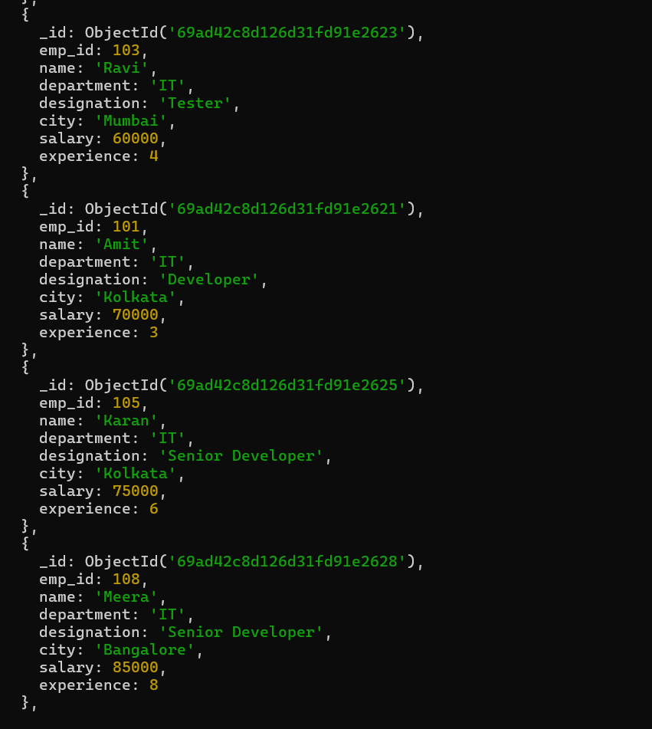
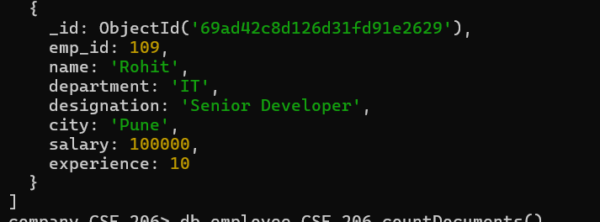
Q15. Count total number of employees in the company.
Query: db.employee_CSE_206.countDocuments()
Output:9
Q16. Display employees whose salary is not equal to 50,000
Query: db.employee_CSE_206.find({salary:{$ne:50000}})

