AI-Powered FAQ Chatbot for IIM Africa
Technical Design — Proposed Solution, Architecture and Scope
Subject | ICT728 Capstone Project 1 (T226)
Assessment | Assessment 2 — Project Proposal (Group Report, 30%)
Project | AI-Powered FAQ Chatbot for the Institute of Information Management (IIM) Africa
Contribution | Member 3 — Technical Design
Prepared by | Tanmoy Bhowmick · Student ID 20034806

1. Proposed Solution
The proposed solution is an AI-powered FAQ chatbot for the Institute of Information Management (IIM) Africa, capable of providing accurate, up-to-date, and contextualized answers to any inquiries about memberships, certifications (including CDPO and CIM), payment methods, benefits, and other general questions. Instead of picking either a retrieval-based approach or a generative one, the proposal involves combining the two. There will be a single chatbot interface, where the user’s query will be first processed by a retrieval-augmented generation pipeline to gain access to the most relevant documents from the IIM Africa knowledge base. Then the results from the retrieval step will be used to generate the response using a large language model (LLM), thus avoiding hallucinations and ensuring that all information is consistent with the content on the IIM Africa website (Lewis et al., 2020).
The model used for the generation can be replaced since the code will use a standard API (OpenAI) for communication. For testing purposes, the prototype will use the Llama 3.2 (3B) model (through Ollama), but the production-grade solution can use either OpenAI’s API or another LLM deployment, depending on performance and budget requirements. The entire solution will be hosted and operated as a single lightweight application, where the chatbot interface will be embedded as a widget. The web application can be deployed on the existing IIM Africa website. The model can be updated periodically to get the latest features and security updates.

2. System Overview
The system uses a client-server architecture. The interface is a responsive chat widget implemented in HTML, CSS and JavaScript talking over REST to the server. The server is written in Node.js/Express framework. It accepts and sanitize the user input from the chatbot frontend, then passes it to the RAG engine (rag.js). There, it is scored against the permitted IIM knowledge base (knowledge.js). If the score is high enough, the best-matching items are pulled from the knowledge base and combined with the initial request in a prompt sent to the LLM service; if not, the request is forwarded to the fallback engine, which prepares a response based on a set of predefined answers or redirects the user to the IIM website instead of trying to ‘guess’ the answer. The resulting response is sent back to the frontend as JSON and displayed in the chat.

3. High-Level Architecture
Figure 1 is an overview of the system. The design decouples the presentation, application, intelligence, model serving, and knowledge storage layers to allow independent evolution while maximizing opportunities for reuse. This modularity implies that the model-serving implementation can be switched (between a local Llama deployment and/or the OpenAI API) with no impact on either the presentation or the retrieval logic.
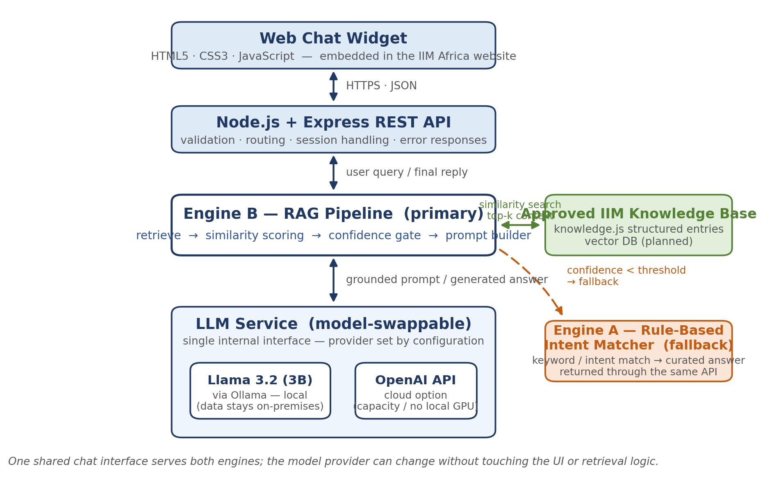
Figure 1: High-level system architecture of the IIM Africa FAQ chatbot.

The primary components are as follows:
- Frontend : The responsive chat widget implemented in HTML5/CSS3/JS for embedding in the IIM Africa website
- Backend : The Node.js/Express.js REST API with input validation and routing
- Engine B (primary): The RAG pipeline in rag.js that implements retrieval, similarity thresholding, confidence estimation, and prompt construction for the LLM
- Engine A (fallback): Rule-based intent classifier that provides pre-defined answers for common/frustrating queries
- LLM service: Switchable between Ollama (Llama3.2 3B) and OpenAI API for primary operations; fallback to basic rule-based responses when needed
- Knowledge base: Curated IIM content in knowledge.js, with future plans to transition to a vector database

4. LLM Workflow
Figure 2 summarize the request lifecycle for a single chat turn:
1. The user asks a question in natural language in the chat widget
2. The Express backend performs validation, sanitization, and formatting of the request
3. The RAG layer identifies the most relevant approved knowledge entries and applies its confidence gate
4. A grounded prompt is constructed from the system instructions, the retrieved context, and the user's question. The system instructions are necessary to ensure that the model does not use its own knowledge and sticks to the provided context
5. The LLM service performs inference, with Llama 3.2 via Ollama being used in the prototype and the OpenAI API being used in the cloud version. Responses are generated with a low temperature to ensure coherence and factual accuracy
6. The response is post-processed, formatted, and returned to the chat widget, with appropriate timeouts and error handling.

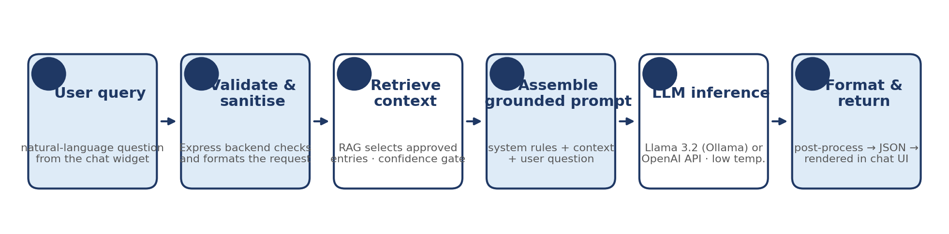
Figure 2: LLM request workflow for a single chat turn.

5. RAG Workflow
Retrieval-Augmented Generation employs a two-step process (see Figure 3). First, the approved external information, which was provided by the IIM, is cleansed and organized into knowledge entries. Each entry contains a category, canonical question-answer, and associated keywords. Second, similar knowledge entries are retrieved by comparing the input question with the canonical questions using a scoring function. The retrieved entries are ranked based on their scores, and the top-k entries are selected. When using the ground-truth entries for response generation, relevance is controlled at the retrieval level. This is done by applying a threshold to the similarity scores. Only the entries that scored above this threshold are used for response generation (Gao et al., 2023).
As a result, the model can provide answers that are organization-specific while minimizing hallucinations (Lewis et al., 2020). At the same time, the ease of editing the answers is enabled because the changes only need to be made in the knowledge base, not in the model itself.
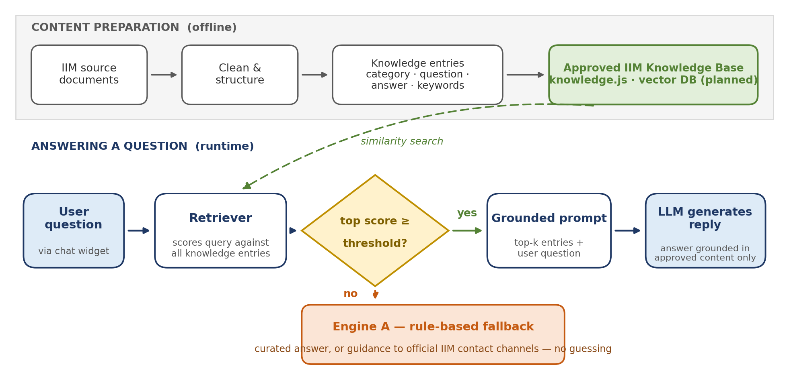
Figure 3: RAG pipeline — offline content preparation and runtime retrieval with a confidence-gated fallback.

6. Technology Stack
Table 1 summarises the technologies selected and the rationale for each choice.
Layer | Technology | Purpose and justification
Frontend | HTML5, CSS3, JavaScript | Lightweight, framework-free chat widget that is simple to embed in the existing IIM website.
Backend | Node.js + Express.js | Non-blocking runtime well suited to I/O-bound API calls; one language across the stack.
Primary engine | RAG pipeline (rag.js) | Grounds every answer in approved IIM content before generation.
Fallback engine | Rule-based intent matcher | Deterministic, zero-cost responses when retrieval confidence is low.
LLM (local) | Llama 3.2 (3B) via Ollama | Open-weight model served on-premises, so candidate queries never leave IIM systems (Touvron et al., 2023; Grattafiori et al., 2024).
LLM (cloud option) | OpenAI API | Model-swappable alternative offering higher capacity without local GPU hardware.
Knowledge store | knowledge.js structured module | Version-controlled, human-readable and simple for the client to update; ChromaDB/FAISS vector store planned.
Collaboration | Git / GitHub | Version control, code review and team coordination.
Table 1: Technology stack and selection rationale.

7. APIs
The backend exposes a small internal REST surface and wraps all external model calls behind a single service module, so switching model providers is a configuration change rather than a code change. Table 2 lists the interfaces.
Endpoint | Type | Role
POST /api/chat | Internal REST | Primary chat endpoint used by the widget: accepts the user message and returns the reply with its source and confidence.
GET /api/health | Internal REST | Service status check used during testing and demonstrations.
POST /api/chat (Ollama, localhost:11434) | External – local model | Sends the grounded prompt to Llama 3.2 for on-premises inference.
POST /v1/chat/completions | External – OpenAI cloud | Sends the same grounded prompt to the OpenAI API when cloud mode is configured.
Table 2: Internal and external API surface.
All requests are made in JSON, and the LLM service uses request timeouts, retries and consistent error responses so that the chat interface gracefully handles failures of individual model backends. API keys are provided on the server via environment variables and are never sent to the client.

8. Database
The prototype uses no relational database, storing the verified organizational content in a simple structure as entries in knowledge.js - each with an identifier, category, canonical question and answer, and keywords for discovery, for direct access by the retrieval module. This light-weight approach keeps the prototype’s content fully version-controlled and any updates to it simply edits that can be reviewed. Two possible enhancements to this approach as the knowledge base grows are a vector database (e.g., ChromaDB or FAISS) containing embeddings of each entry for similarity search, and a privacy-focused conversation logging system (with anonymization and retention limits) to allow for analyzing FAQs and improving the knowledge base, subject to IIM Africa’s data-protection policies.

9. In Scope Items
- An AI chatbot for answering IIM Africa’s membership, certification (CDPO, CIM), fee, benefits, and general organizational questions.
- A dual-engine system, with the RAG approach as the default and a rules-based system as a fallback, presented through a single chat interface.
- Using the open-source Llama 3.2 (3B) model via Ollama as the default language model, with an option to swap in other models via the OpenAI API.
- Retrieving relevant information from the organizational knowledge base for use in chat responses.
- A responsive, web-embeddable chat interface.
- Testing the chatbot’s responses to ensure they are accurate according to the knowledge base.

10. Out of Scope
- Student enrolment, registration, or payment processing systems.
- User account management or authentication systems.
- Integration with external or third-party databases in real time.
- Speech recognition or multilingual conversation support.
- Editing or generating documents or other administrative automation.
- Hosting and operations support for the prototype - deployment and operations are out of scope and will be handled by IIM Africa after delivery.

11. Deliverables
- An AI chatbot prototype, with a web interface and a Node.js backend.
- The prototype includes the RAG (rag.js) system, which uses the organisational knowledge base (knowledge.js).
- The prototype includes a rules-based fallback system, with a shared chat interface.
- The prototype uses the Llama 3.2 (3B) model via Ollama by default but can be switched to other models via the OpenAI API.
- Documentation of the prototype architecture, including the documents provided with this report.
- Testing and evaluation results.

References
Gao, Y., Xiong, Y., Gao, X., Jia, K., Pan, J., Bi, Y., Dai, Y., Sun, J., Wang, M. and Wang, H. (2023) ‘Retrieval-augmented generation for large language models: a survey’, arXiv preprint arXiv:2312.10997. DOI: 10.48550/arXiv.2312.10997.
Grattafiori, A. et al. (2024) ‘The Llama 3 herd of models’, arXiv preprint arXiv:2407.21783. DOI: 10.48550/arXiv.2407.21783.
Institute of Information Management (IIM) Africa (2026) Internal organisational documentation provided for the capstone project (unpublished).
Lewis, P., Perez, E., Piktus, A., Petroni, F., Karpukhin, V., Goyal, N., Küttler, H., Lewis, M., Yih, W., Rocktäschel, T., Riedel, S. and Kiela, D. (2020) ‘Retrieval-augmented generation for knowledge-intensive NLP tasks’, Advances in Neural Information Processing Systems, 33, pp. 9459–9474.
Ollama (no date) Ollama documentation. Available at: https://ollama.com (Accessed: 29 July 2026).
OpenAI (no date) OpenAI API reference. Available at: https://platform.openai.com/docs (Accessed: 29 July 2026).
Touvron, H., Lavril, T., Izacard, G., Martinet, X., Lachaux, M.-A., Lacroix, T., Rozière, B., Goyal, N., Hambro, E., Azhar, F., Rodriguez, A., Joulin, A., Grave, E. and Lample, G. (2023) ‘LLaMA: open and efficient foundation language models’, arXiv preprint arXiv:2302.13971. DOI: 10.48550/arXiv.2302.13971.

