# **YouTube Downloader - Technical Documentation**

**Author**: Tanmoy Bandyopadhyay  
**Version**: 1.0  
**Last Updated**: 9/5/2025

## **1. Overview**

A Python-based tool to download YouTube videos/audio concurrently with:

* Threaded downloads for performance
* Automatic filename shortening
* Robust error handling

## **2. Package Dependencies**

| **Package** | **Purpose** | **Installation** |
| --- | --- | --- |
| yt-dlp | YouTube content download | pip install yt-dlp |
| youtubesearchpython | URL resolution | pip install youtubesearchpython |
| aria2 | Accelerated downloads | scoop install aria2 (Windows) / brew install aria2 (Mac) |
| FFmpeg | Audio conversion | Download from [ffmpeg.org](https://ffmpeg.org/) |

## **3. Core Function Flow**

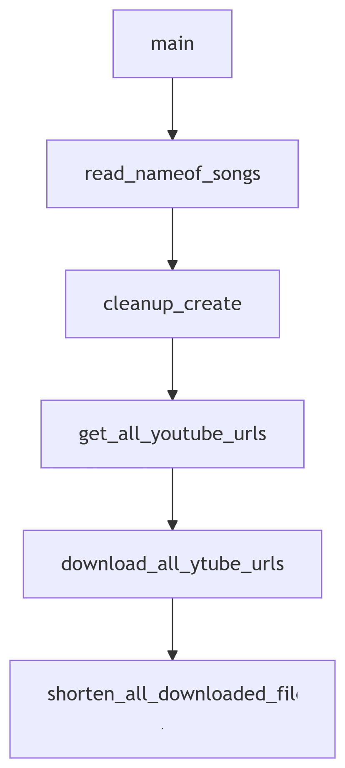

## **4. Key Functions**

### **4.1 File Processing**

| **Function** | **Description** |
| --- | --- |
| read_nameof_songs() | Parses input file with v/a prefixes |
| cleanup_create() | Ensures fresh download directory |

### **4.2 URL Resolution**

| **Function** | **Concurrency** | **Description** |
| --- | --- | --- |
| search_youtube() | Threaded | Gets YouTube URL for a query |
| get_all_youtube_urls() | ThreadPoolExecutor | Batch-resolves URLs |

### **4.3 Download Handlers**

| **Function** | **Type** | **Features** |
| --- | --- | --- |
| download_youtube_audio_as_mp3() | Audio | MP3 conversion via FFmpeg |
| download_youtube_video() | Video | Adaptive format fallback |

### **4.4 Post-Processing**

| **Function** | **Threaded** | **Description** |
| --- | --- | --- |
| shorten_downloaded_file_name() | Yes | Safe filename shortening |
| return_short_string() | No | Truncates strings to N words |

## **5. Concurrency Architecture**

with ThreadPoolExecutor() as executor:

futures = {

executor.submit(downloader, url): query

for url in url_list

}

*# Process completed futures*

**Threading Used In**:

1. URL resolution (get_all_youtube_urls)
2. Batch downloads (download_all_ytube_urls)
3. Filename shortening (shorten_all_downloaded_file_names)

## **6. Error Handling**

| **Error Type** | **Mitigation Strategy** |
| --- | --- |
| Format Unavailable | Multi-stage fallback in download_youtube_video() |
| Network Timeouts | aria2c with 10 retries and exponential backoff |
| File Collisions | Sequential numbering in shorten_downloaded_file_name() |