The Uplift project Assignment

CNN and RNN

Ans 1: Recurrent Neural Network (RNN) are a kind of Neural Network that predicts the output from preceding steps where the outputs from the preceding steps is fed as input for the current step. In instances like when it is required to predict the subsequent phrase of a sentence, the preceding phrases are required and consequently there is a need to take into account the preceding words. Thus, RNN solves this difficulty with the assist of a Hidden Layer. The principal and most necessary function of RNN is Hidden state, which remembers some data about a sequence. RNN has a “memory” which remembers all information about what has been calculated. It makes use of the identical parameters for every input as it performs the identical assignment on all the inputs or hidden layers to produce the output.

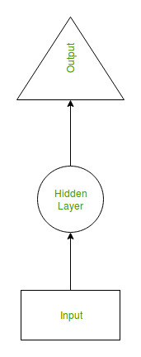

**Fig. Recurrent Neural Network**

Recurrent neural networks were created due to the fact there had been a few troubles in the feed-forward neural network:

* Cannot manage sequential data
* Considers solely the contemporary input
* Cannot memorize preceding inputs

The answer to these troubles is the Recurrent Neural Network (RNN). An RNN can manage sequential data, accepting the modern-day input data, and until previously received inputs. RNNs can memorize preceding inputs due to their internal memory.

E.g., RNNs in one form or the other can be used in Google Translator for translating text from one language to other. Here, the input can be the source language and the output will be in the target language which the user wants. This is currently one of the most popular and prominent machine translation application for translation.

**Ans 2: A convolutional neural network, or CNN, is a deep learning neural network sketched for processing structured arrays of data. It is very satisfactory at picking up on design in the input image, such as lines, gradients, circles, or even eyes and faces. This characteristic makes a convolutional neural network so robust for computer vision. CNN can run directly on an underdone image and does not need any pre-processing.**

**A convolutional neural network is a feed-forward neural network. The strength of a convolutional neural network comes from a particular kind of layer called the convolutional layer. It contains many convolutional layers assembled on top of each other, each one competent in recognizing more sophisticated shapes. With three or four convolutional layers it is viable to recognize handwritten digits and with 25 layers it is possible to differentiate human faces. The main aim of CNN is to activate machines to view the world as humans do and even use the knowledge for duties such as image and video recognition, image inspection and classification, media recreation, recommendation systems, natural language processing, etc.**

**E.g., Facial recognition. A** facial recognition is broken down by a convolutional neural network into the following major components -

* Identifying every face in the picture
* Focusing on each face despite external factors, such as light, angle, pose, etc.
* Identifying unique features
* Comparing all the collected data with already existing data in the database to match a face with a name.