*Cellarium*

Proposal

Developed By:

Tanner Turba

February 2024

**Table of Contents**

1. Introduction ……...……………………………………………………………….……...… 3
   1. System Requirements …….……………………………………………………………. 3
   2. Installation ………………………………………………………………….………….. 3
   3. Resources ………………………………………………………………….…..……….. 3
2. Getting Started ……...……………………………………………………………………...... 3
3. My Ingredients ……...………………………………………………………………...…….. 5
   1. Viewing Ingredients ………………………………………………………………...….. 5
   2. Adding Ingredients …………………………………………………….…………...….. 6
   3. Removing Ingredients ………………………………………………………………….. 6
   4. Modifying Ingredients ………………………………………………………………….. 6
   5. Filtering Ingredients ……...……………………………………..……………………… 7
4. The Pantry ...…...……………………………………………………………………………. 7
   1. Viewing Ingredients ……………………..….……………………………………...….. 8
   2. Adding Household Members ……………….….………………………………………. 8
   3. Adding Ingredients ……...………………………….………………………………….. 9
   4. Removing Ingredients ……...………………………………………………………….. 9
   5. Modifying Ingredients ……...………………………………………………………….. 9
   6. Filtering Ingredients ……...………………………..………………………………….. 10
5. Messages ……...…………………………………………………..…………………………11
6. My Account ……...……………………………………………..……………………………11
   1. Modify Account……...…………………………….……………………………………12
   2. Sign Out ……...…………………………………………………………………………12
7. User Stories……...…………………………………………...………………………………12
8. **Introduction**

This proposal outlines the uses, specifications, and requirements for this project. Cellarium, which is Latin for pantry or storeroom, is a proposed web application that is used to detail and manage the ingredients in a user’s pantry. A general user can add, remove, and modify the contents of their pantry when adding or using ingredients.

A user can create a household group to emulate the experience of a shared pantry. This way, multiple users that share a pantry can manage their own ingredients, while viewing what is and is not theirs for clarity and collaboration. When a user creates the household group, they become the administrator of that household. A user can only be a part of one household group at a time.

* 1. **System Requirements**

This product takes the form of a web application, so it can be run on any system that supports modern browsers like Chrome, Edge, or Safari.

* 1. **Installation**

This product does not need any installation since it is a web application. Simply navigate to its URL to access Cellarium.

* 1. **Resources**

This product will be made using a Mongoose, Express, Angular, and Node.js stack, along with the Bootstrap CSS framework. The EDAMAM Food Database API will be used to gather ingredient information including names, images, nutritional facts, ingredients, and macronutrient information. The names and images will be used on the ingredient tile for the ingredient grid views and in the ingredient detailed view, along with the other facts.

1. **Getting Started**

To begin using Cellarium, and account must be created. This must be done through the user creation page, which can be accessed through the link at the bottom of the login page. Simply enter your first name, last name, a username, and a password to begin using the application! If you already have credentials, you can enter them in the form on the login page and click submit.

Figure 1: Login Page

Figure 2: Signup Page

1. **My Ingredients**

Upon successful registration or login, you be redirected to the “My Ingredients” page. This page features a collection of tiles that describes a single ingredient in your pantry using an image, the ingredient name, and the quantity.

Figure 3: My Ingredients Page

* 1. **Viewing Ingredients**

An ingredient can be viewed by selecting its tile card in the “My Ingredients” grid. Extensive information about the ingredient, such as nutrition facts and ingredients, will be displayed in a modal.

Figure 4: Ingredient Details

* 1. **Adding Ingredients**

An ingredient can be added to your pantry by selecting the “Add Ingredient” button near the top of the page. A modal will appear and ask for the name of ingredient to be added. Once a name is entered in the form and the search button is clicked, a list of results will populate within the modal. The user can add a result to their pantry by adding an amount to add and then selecting the “Add” button. The modal will close automatically to signify the addition of the ingredient and to streamline the ingredient addition process. The ingredient will be added to the “My Ingredients” page and will reflect the chosen quantity.

Figure 5: Add Ingredient Modal

* 1. **Removing Ingredients**

An ingredient can be removed by selecting the trash can icon, which will promptly remove the item from the list of ingredients.

* 1. **Modifying Ingredients**

An ingredient can’t be changed into another ingredient, but the quantity can be incremented or decremented by using the “+“ and “-“ buttons, respectively. If the quantity is decremented to zero, the ingredient will be completely removed from the list. This case has identical behavior to the selecting the trash can icon to remove and ingredient.

Figure 6: Modify and Delete Ingredient Buttons

* 1. **Filtering Ingredients**

This list of ingredients can be filtered by allergen type or macronutrient type. A search bar will be available to filter ingredients by name.

Figure 7: Filters Options

1. **The Pantry**

The Pantry is a place for collaboration between household members. A household member is an individual member who is invited to join a shared list of ingredients. This collection of ingredients will automatically be populated with the ingredients that are owned by each member of the household.

Figure 8: The Pantry Page with active Members

* 1. **Viewing Ingredients**

An ingredient can be viewed by selecting its tile card in the “Pantry” grid. Extensive information about the ingredient, such as nutrition facts and ingredients, will be displayed in a modal. This is identical to the viewing functionality from the “My Ingredients” page.

* 1. **Adding Household Members**

Before a user has joined a household, “Pantry” will contain a link to the member management page, which instructs the user to begin a household group. Invitations can be sent to others user by entering their username and selecting the “invite” button. An invitation can be viewed on the “Messages” page by any user that is not a current member of another household. Once and invitation is accepted, the user can view the collection of ingredients of the group. The user who began the household group will become the admin of the group and will have access to the member management page, even after initializing the group, through the “Pantry” dropdown in the navbar. A member can leave the group anytime by selecting the “Leave Household” button.

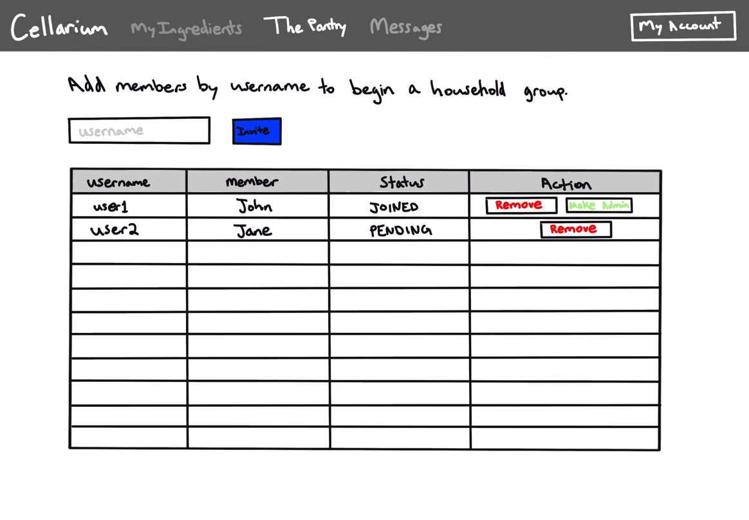

Figure 9: The Member Management Page

* 1. **Adding Ingredients**

An ingredient can be added from the “Pantry” page in the same fashion as on the “My Ingredients” page, however this will be considered a shared ingredient. Ownership of an ingredient is signified by a small label on the ingredient card that contains the owner’s name and the quantity of the ingredient that they own. If multiple individuals own the same ingredient, there will be multiple labels to indicate each owner. A shared ingredient will be signified by a label containing the word “Shared.” Usernames cannot contain the word “shared” for this reason.

* 1. **Removing Ingredients**

Any shared ingredient can be removed from the shared ingredient list in the same manner that an ingredient is removed from the “My Ingredients” list. By selecting the trash can icon, the quantity of shared units will be removed.

* 1. **Modifying Ingredients**

A shared ingredient can be modified from the “Pantry” page in the same fashion as on the “My Ingredients” page. Only a shared ingredient’s quantity can be decremented or incremented by selecting the “-“ or “+” button, respectively. To modify the quantity of another user’s ingredient, a request must be sent to receive permission from the owner. A request is sent by selecting the owner’s label and filling out the modal form. Requests can be approved or denied and will appear on the “Messages” page.

Figure 10: Send Request Modal

* 1. **Filtering Ingredients**

The filtering and sorting options will be the same as on the “My Ingredients” page, with the addition of an owner filter and sort option. In this case, the “shared” label will be considered the owner of the shared items.

Figure 11: The Pantry Filter Options

1. **Messages**

A page will appear upon clicking the “Messages” tab in the navigation bar. This page will contain the names of anyone in your household who has sent you a request. These requests can be seen once selecting the name of an individual to view. A request can be approved or denied by selecting the corresponding buttons. An approved request will have a green background and a denied request will have a red background. A badge will be positioned on the “Messages” button in the navigation bar when a request is available, and when a request is answered.

Figure 12: The Messages Page

1. **My Account**

A dropdown menu at the top right of the window can be used to manage a user’s account. Three options are available to choose from including “Modify,” “Messages,” and “Sign Out.”

Figure 13: My Account Options

* 1. **Modify Account**

A modal will appear upon clicking the “Modify” button, which will contain details like a first name, last name, username, and password. Any of these account details can be modified by selecting the “Edit” button, entering changes, and selecting “Save.”

Figure 14: Modify Account Modal

* 1. **Sign Out**

The current user will be signed out of their account once “Sign Out” is selected. They will be redirected to the initial login page where they can choose to login or create a new account.

1. **User Stories**

As a potential user, I want to be able to register for an account.

As a user, I want to be able to

* Log in with my username and password.
* Log out.
* Edit my profile details, include username, password, first name, and last name.
* View each of my ingredients in a tile format with a large image.
* Add an ingredient to my collection of ingredients.
* Remove my entire store of a single ingredient.
* Increment the quantity of a single ingredient.
* Decrement the quantity of a single ingredient.
* Filter my ingredients by a keyword.
* Filter my ingredients by allergens.
* Filter my ingredients by macronutrients.
* Receive an invitation to join a household group through the “Messages” page.

As a current member of a household group, I want to be able to

* View every ingredient that is in my household’s collective pantry.
* Leave the group if desired.
* Add a shared item to the pantry.
* Send an ingredient request to another member.
* Receive an ingredient request from another member.
* Filter all ingredients by a keyword.
* Filter all ingredients by allergens.
* Filter all ingredients by macronutrients.
* Filter all ingredients by owner.
* See a badge appear on the “Messages” tab to alert me of any unanswered requests.

As an administrator of a household group, I want to be able to

* Invite users to join my household by entering their username.
* Assign the administrator role to another group member.