**SCREENSHOTS.DOCX – Tanner Benavides**

Screen shots showing when the constructors/deconstructors initiate also show the line number that the class function starts on.

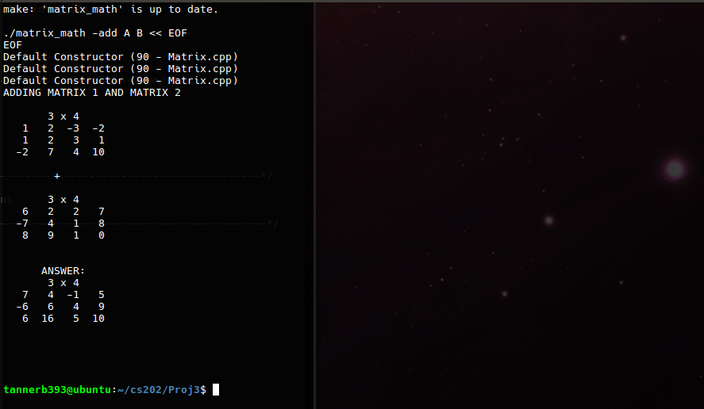  
• show when the **Default Constructor** is used in the program

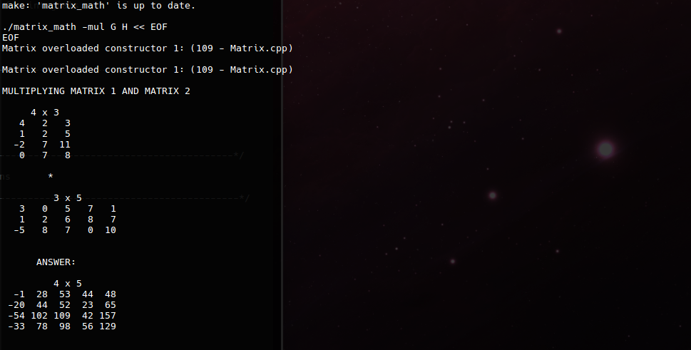  
• showing when the 1st **Overloaded Constructor** is used in the program.

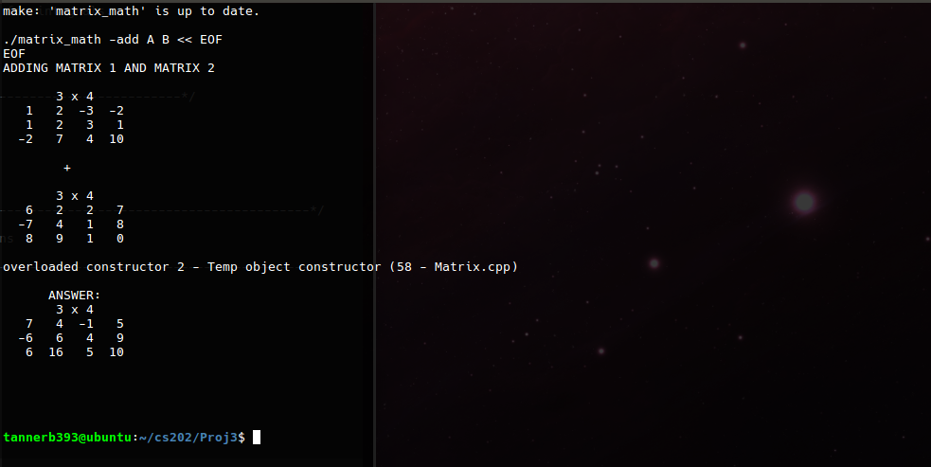  
• showing when the 2nd overloaded contructor, **Temp Constructor** is used.

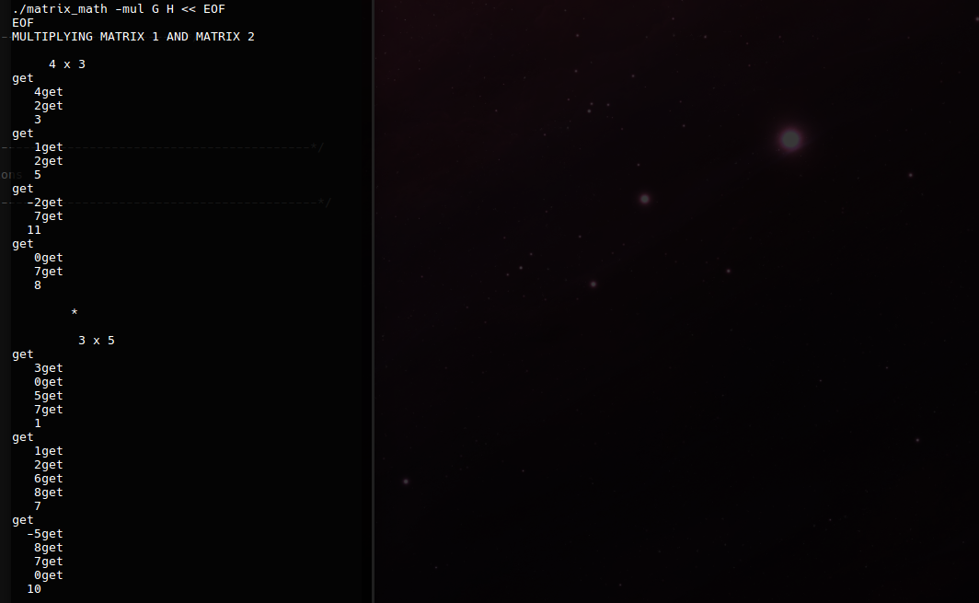  
• example of when the get () class function is called.

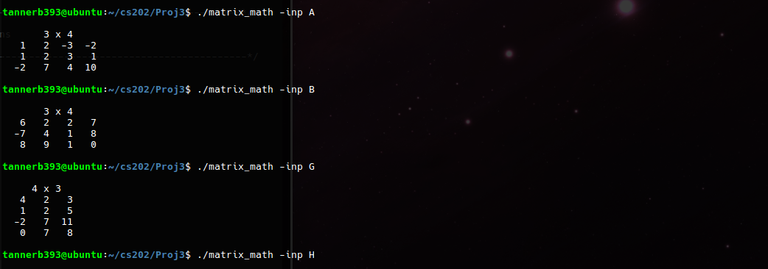

• using the **–inp command** which uses the **overloaded << operator** to display a matrix

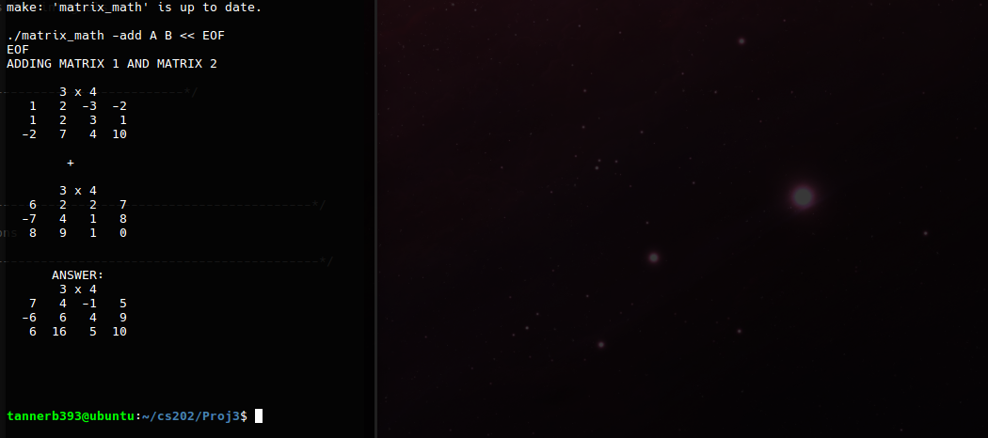• using the **–add command** with two .mtx files shows displayed matrices and resulting answer

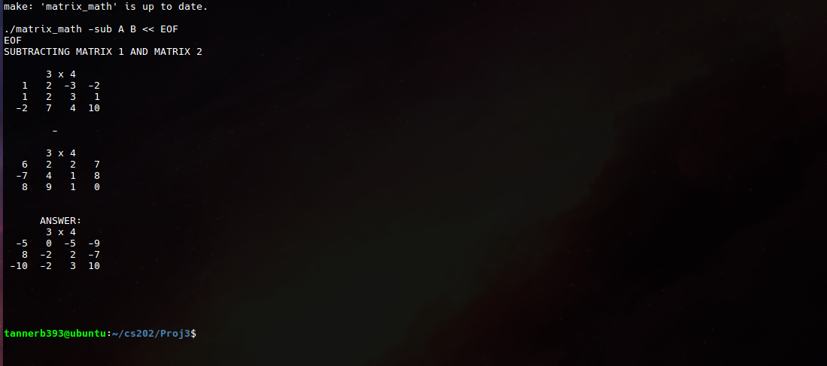  
•using the **–sub command**  with two .mtx files. Shows displayed matrices and resulting answer

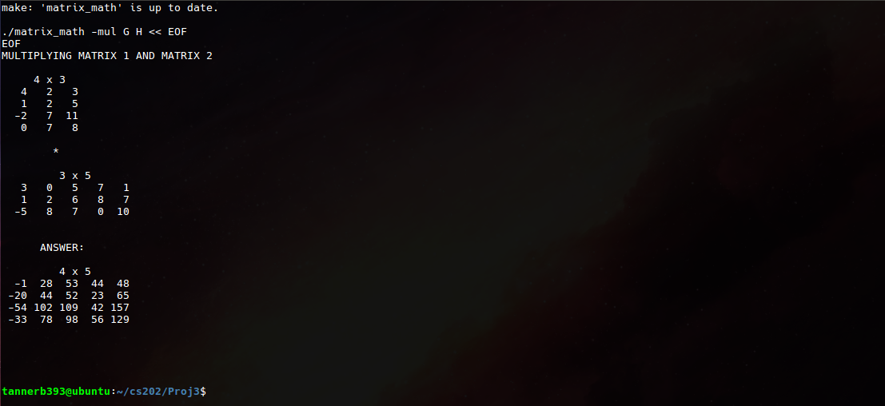  
• using the **–mul command** and two .mtx files. Displaying matrices and the resulting answer after.

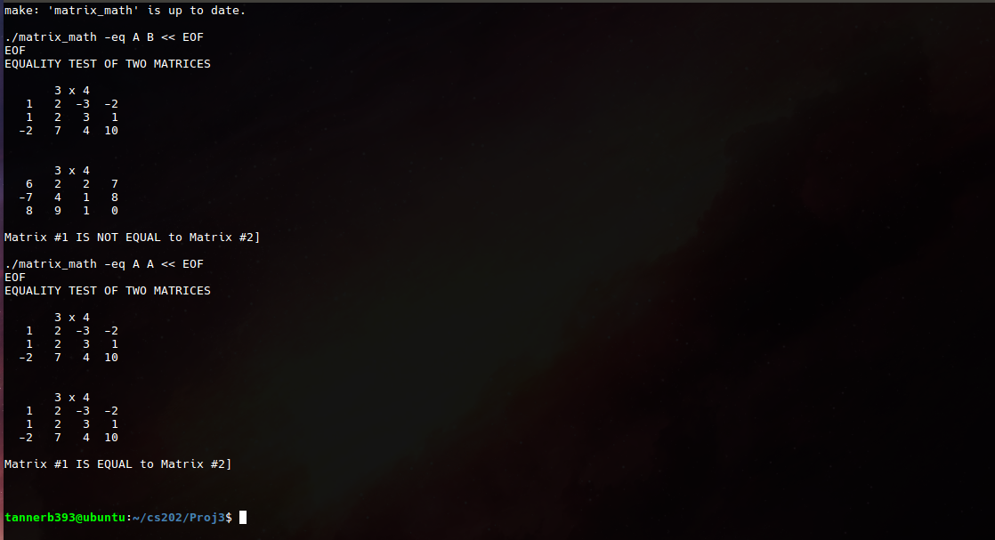  
•using the **–eq command** to check for equality. Two test are ran here showing the results of comparing two non-alike matrices as well as two identical matrices and the resulting message that is given.

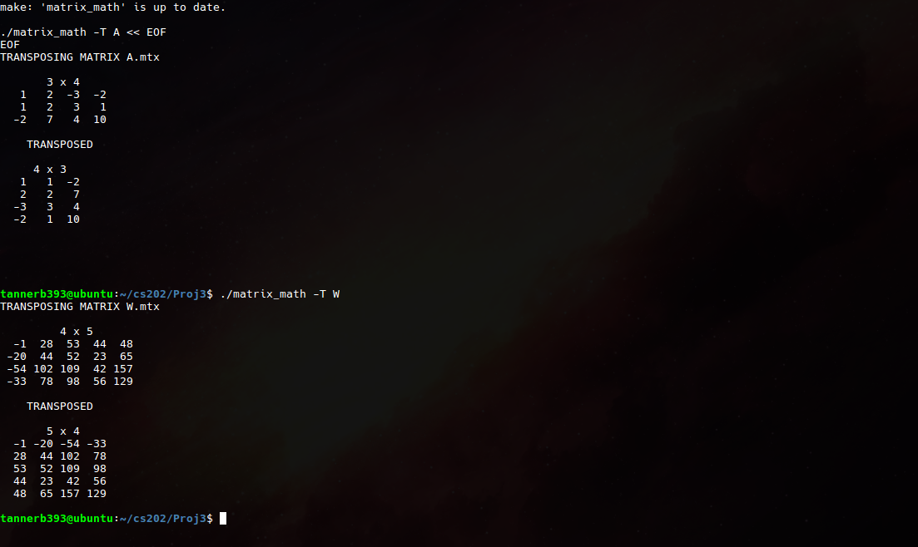  
• The transposition of two different matrices using the **–T command** showing the before matrix and the matrix after it has been transposed.

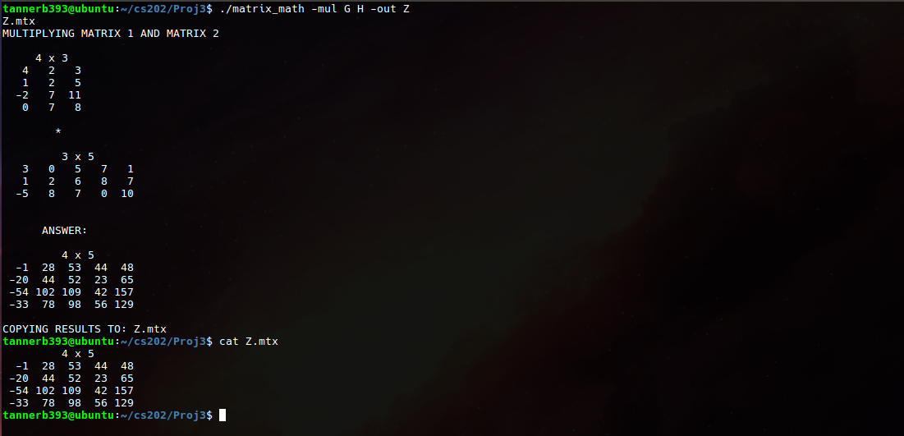  
• showing the use of the **–out command** which writes out the answer from matrix to a .mtx file from a math function that uses two other .mtx files (-add, -sub, -mul). Also showing a ‘cat’ display out of the saved .mtx file

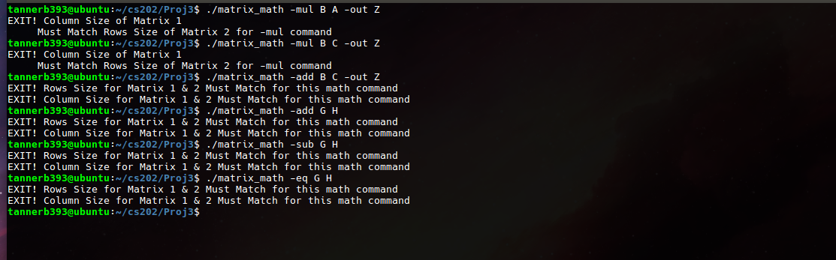  
•separate error messages given if user attempts to perform operations on matrices that are not of the correct size for the given command.  
• error for –add, -sub, -eq matrices not being of the same row and column size  
•error for –mul column (in matrix 1), not being same size as rows (in matrix 2)

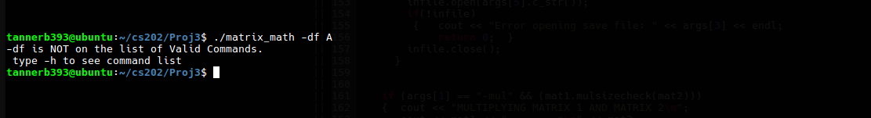  
• error message if invalid –command is typed on the command line

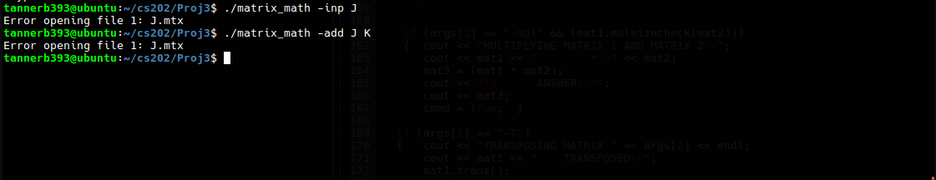  
• error message if invalid filename (A,B,C etc. is used for one of the .mtx file commands)

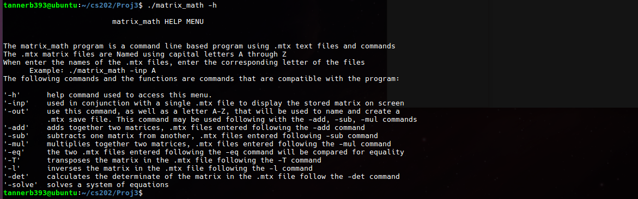  
Help –h command list