BOWSHOT

BOWSHOT

BOWSHOT

Software Requirement Specifications

Version: 1.0.1  
Last Modified: October 3, 2019

Team 9

Tanner Huynh, David Sadowsky, Alice Tilles, Dian Wang

Table of Contents

**1. Introduction** **3**

1.1 Purpose 3

1.2 Scope 3

1.3 Definitions, Acronyms, and Abbreviations 3

1.4 References 4

1.5 Overview 4

**2. Overall Description** **5**

2.1 Product Perspective 5

2.1.1 System Interfaces 5

2.1.2 Interfaces 5

2.1.3 Hardware Interfaces 5

2.1.4 Software Interfaces 6

2.1.5 Communication Interfaces 6

2.1.6 Memory Constraints 6

2.1.7 Operations 6

2.1.7.1 User Organization Modes of Operations 6

2.1.7.2 Periods of Interactive/Unattended Operations 6

2.1.7.3 Data Processing Support Functions 7

2.1.7.4 Backup and Recovery Operations 7

2.1.8 Site Adaptation Requirements 7

2.2 Product Functions 7

2.3 User Characteristics 7

2.4 Constraints (incomplete) 7

2.5 Assumptions and Dependencies 8

2.6 Apportioning of Requirements 9

**3. Specific Requirements** **10**

3.1 External Interfaces 10

3.1.1. User Interfaces 10

3.1.1.2 Main Page 10

3.1.1.3 Settings Page 11

3.1.1.4 Channel Management Page 12

3.1.2. Hardware Interfaces 12

3.1.3. Software Interfaces 12

3.1.4. Communication Interfaces 12

3.2 Functions 13

3.2.1. User Class 1 - Users 13

Security 13

Creating / Using Channels 14

Creating Direct Messages 15

Communicating - Forwarding 16

Communicating - Channel - Specific 16

Communicating - Direct Messages - Specific 16

3.2.8 User Class 2 - Moderators 17

Security 17

Channels 17

Promoting/Demoting Moderators 17

3.3 Logical Database Requirements 18

3.3.1 User Database 18

3.3.2 Message Database 18

3.3.3 Channel Database 18

3.4 Design Constraints 19

3.4.1 Standards Compliance 19

3.5 Software System Attributes 19

3.5.1 Reliability 19

3.5.2 Availability 19

3.5.3 Security 20

3.5.4 Maintainability 20

3.5.5 Portability 20

# 1. Introduction

The following subsections of the Software Requirements Specifications (SRS) document provides an overview of the entire SRS.

## 1.1 Purpose

This working document is for the product team to outline and review, and for stakeholders to understand, the project’s scope and requirements.

## 1.2 Scope

**BOWSHOT** will allow people to communicate with other people through direct, private messages or in channels. Users will be able to create and join channels that are moderated by other users.

**BOWSHOT** is a simple app for sharing mixed media (rich text messages, emojis, videos, and images) within a community.

## 1.3 Definitions, Acronyms, and Abbreviations

|  |  |
| --- | --- |
| Workspace | A workspace is a dedicated environment private to the individuals within a company or institution. |
| Moderators | Moderators have elevated privileges and permissions in their channels. Each channel has at least one moderator. |
| Channel | Channels are for specific subsets of users in a workspace. Channels must have a moderator. Public channels can be joined by any user. Private channels are “invite-only” by moderator. |
| Direct Messages | Direct messages are between two users. Direct messages do not have a moderator. Direct messages are private by default. |
| Users | Users are individual people in the workspace. Users can direct message each other, create channels, or join channels. Users can also be moderators of channels they create or are assigned to moderate. |

## 1.4 References

ISO/IEC

<https://www.iso.org/isoiec-27001-information-security.html>

GDPR

<https://eugdpr.org/>

FEDRAMP

<https://www.fedramp.gov/>

HIPAA

<https://www.hhs.gov/hipaa/index.html>

CALEA:

<http://des.wa.gov/sites/default/files/public/documents/About/1063/RFP/Add7_Item4CALEA.pdf>

## 1.5 Overview

Product users and stakeholders can reference section 2 - overall description for interface design, characteristics, and constraints.

Developers can reference section 3 - specific technical requirements for functional requirements, attributes, and design constraints.

# 2. Overall Description

## 2.1 Product Perspective

### 2.1.1 System Interfaces

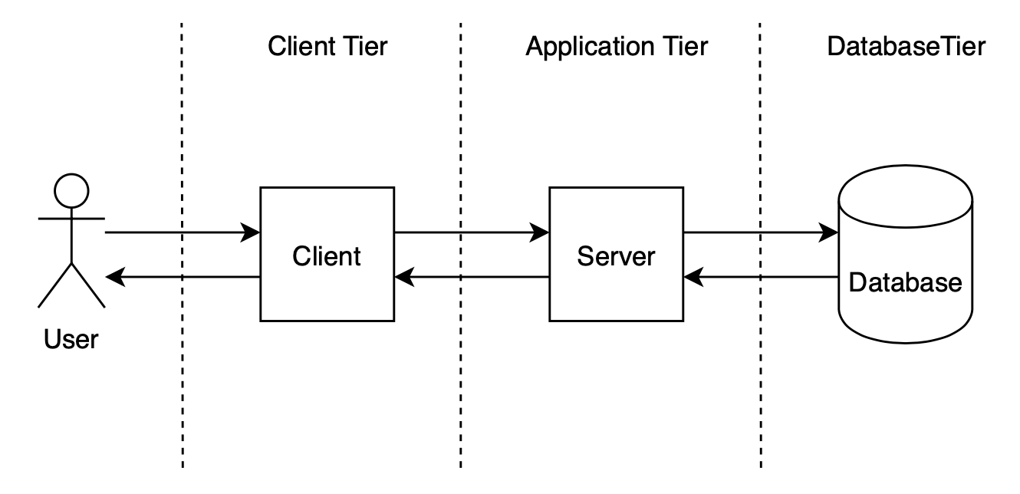

**BOWSHOT** will have three tiers:

* Client
* Application
* Database

The user will interact with **BOWSHOT** through the client application, the client application will interact with the server, and the server will interact with the database.

### 2.1.2 Interfaces

The principle interface the system will center on is a graphical user interface (GUI). It will feature:

* An open textbox for typing messages
* Buttons for various user choices (sending a message, editing a message, attaching media to a message, messaging a user, and other small tasks)
* A sidebar with a clickable list of channels the user is part of, and all open conversations
* The biggest panel is the display for messages. It will show the most recent messages and automatically calibrate / reveal the newest messages as they come through.

### 2.1.3 Hardware Interfaces

**BOWSHOT**’s specific required Hardware Interfaces are yet to be determined.

It is likely that most hardware will be rented(think AWS comparables), with local in-house access points gleaning live vitals and pushing updates to centralized servers.

### 2.1.4 Software Interfaces

**BOWSHOT** can use third-party database or software to store or encrypt messages. Software is yet to be determined.

### 2.1.5 Communication Interfaces

**BOWSHOT** will use Apache Tomcat for server-client communication. The detailed communication interfaces are yet to be determined.

### 2.1.6 Memory Constraints

Some undetermined amount of local memory will be required to run **BOWSHOT**.

**BOWSHOT** will be able to hold as many messages as is standard with a messaging application and all data will be stored in some cloud hosting service. The memory requirements to store messages and data locally is undetermined, but will be nearly insignificant for a standard computer.

### 2.1.7 Operations

Normal and special operations required by the user

#### 2.1.7.1 User Organization Modes of Operations

* Start new channel or DM
* Message Composition and Editing(inside channel)
* Deleting Messages
* Workspace/Channel Navigation
* Moderation
  + Sending requests to other individuals or groups
  + Adding or deleting members from a channel
* Profile Customization(Avatar Selection, Bio, etc.)
* Passively logged in(afk, device sleeping)
* Potentially viewing other users’ profiles/connections(“connections” from backlog ambiguous)

#### 2.1.7.2 Periods of Interactive/Unattended Operations

Outside of the immediately above modes, users’ instances are considered to be unattended at all other times (logged out or app closed). App will timeout after a period of inactivity (to be specified).

#### 2.1.7.3 Data Processing Support Functions

Not expected to be applicable for users, not their responsibility

#### 2.1.7.4 Backup and Recovery Operations

* Backups will either be at regularly scheduled intervals, or upon request
* Recovery will be available to a certain date in history(determined by the tier of service a user/enterprise pays for)

### 2.1.8 Site Adaptation Requirements

Users must have a working desktop, laptop, or mobile device capable of running browser or app instances to install the software.

## 2.2 Product Functions

**BOWSHOT** provides services for the users to communicate effectively and securely.

**BOWSHOT** allows the user to:

* Log in to a user account.
* Manage Channels and Users inside a Workspace as a moderator.
* Create and remove channels inside a Workspace.
* Communicate in a channel inside a Workspace.
* Join and leave channels inside a Workspace.
* Communicate through direct message to another user inside a Workspace.

## 2.3 User Characteristics

**BOWSHOT** is intended for a wide, general audience, who has at least a minimal level of computer literacy. The system will be accessible to users thirteen years of age or older with normal or corrected vision, and normal motor abilities.

The system may have adaptations or settings to extend functionality to users with increased accessibility requirements.

## 2.4 Constraints (incomplete)

(1) Regulatory policies

Must be [FCC](https://en.wikipedia.org/wiki/Federal_Communications_Commission), [Homeland Security](https://en.wikipedia.org/wiki/United_States_Department_of_Homeland_Security), and [CALEA](https://en.wikipedia.org/wiki/Commission_on_Accreditation_for_Law_Enforcement_Agencies) compliant.

(2) Hardware limitations

Should only support devices built after a certain year(2010?)(Windows, MacOS, Ubuntu, Android, iOS)

(3) Interface to other applications

Potential Email integration

Potential language translation(Google Translate API)

(4) Parallel operation

Should support “few hundred” users

(5) Audit functions

(6) Control functions

(7) Higher-order language requirements

(8) Signal handshake protocols (for example, XON-XOFF, ACK-NACK)

(9) Reliability requirements

(10) Criticality of the application

(11) Safety and security considerations

## 2.5 Assumptions and Dependencies

The device operating the software must be capable of supporting peripherals, connectivity, and software instances when instantiating the latest operating system. Operating systems that are deprecated or no longer supported by their parent companies may not be able to support **BOWSHOT** instances. Desktop and laptop devices must be capable of connecting and running user input devices (i.e. keyboard and mouse) in order to type and send messages on **BOWSHOT**. **BOWSHOT** requires smart mobile devices that are able to run apps and have a full QWERTY keyboard. Devices must be able to connect to a stable internet connection in order to send and receive basic messages. Higher quality multimedia messages, like videos or high resolution images, need a high bandwidth connection. Mobile devices might experience slower download or connectivity issues when out of network or on a slower connection. Sending multimedia videos or images require a device that supports a camera lens. Receiving video or audio requires a device equipped with an audio board/driver and audio output for a better experience.

## 

## 2.6 Apportioning of Requirements

Features to be implemented in future versions by priority level:

(high priority indicates a high likelihood of being implemented sooner, none of these items are guaranteed)

HIGH

* Additional channel specific password
* Friends’ online status
* Users searchable by other, so-far unconnected, users(opt-out)
* English, Spanish, French character set support
* Capability to delete messages
* Time Stamps

MEDIUM

* Avatars look different to relative-hierarchy level users(boss versus contemporaries)
* Threads from seed message (with subject)
  + Reply to subset of group (mediating unnecessary reply-alls)
  + Special expiring messages
* History tiers (users can view their message history up until a certain amount of years ago based on tier price)
* Time shifting?, Queueing
  + Queued messages must be delivered in the order they were sent
* Governmental compliance
* Private messages (not copy pastable)
* Hashtags
* Schedule meetings/events, RSVPs

LOW

* Additional non-US Governmental Compliance
* Forwarding messages(maybe message originator can view forward path(think tumblr)
* Asian language support
* Auto-translate messages between languages
* Premium message encryption
* Parental-control(auto-filter,
* Following(People, Channels)

# 

# 3. Specific Requirements

## 3.1 External Interfaces

### 3.1.1. User Interfaces

The system shall provide users a graphic user interface(GUI).

The system shall enable users to use keyboard and mouse to operate the system.

#### 3.1.1.2 Main Page

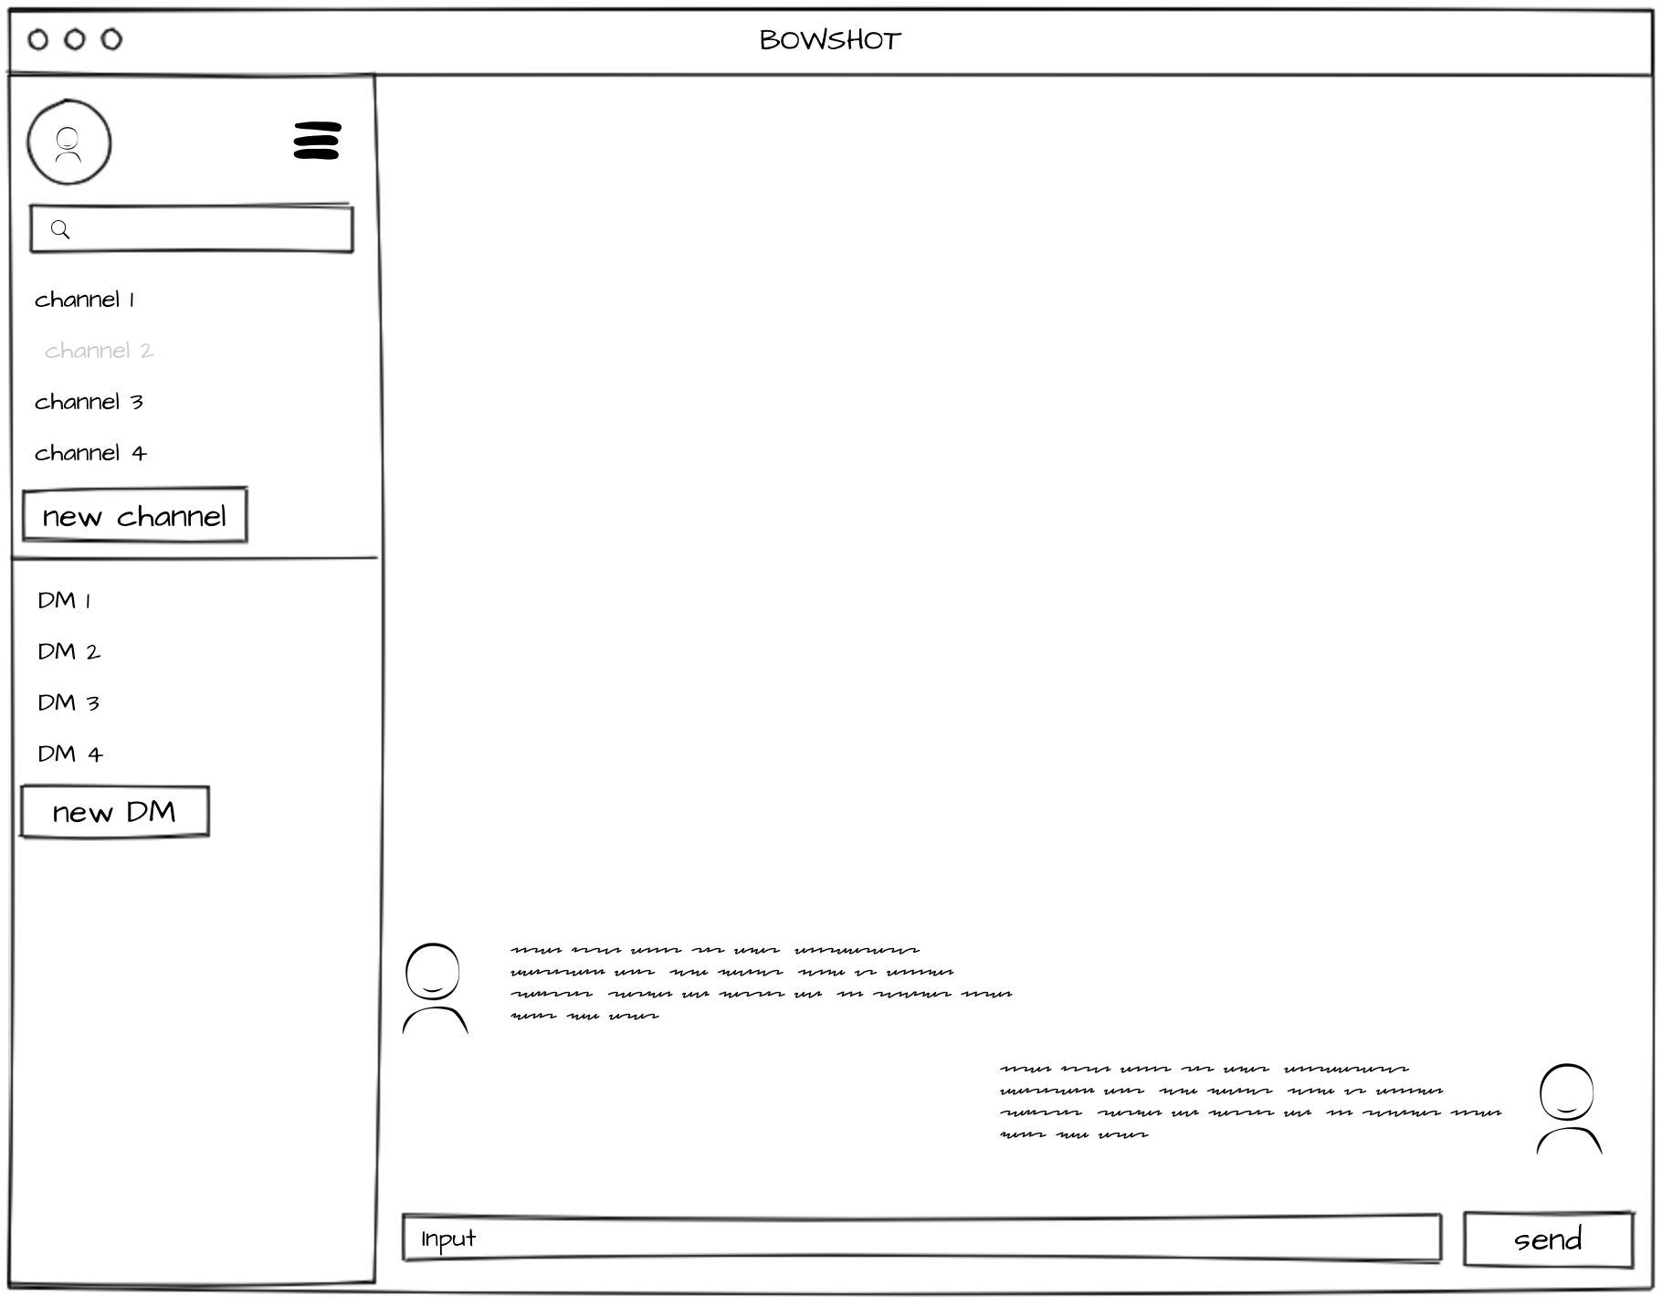

1. The main page shall provide a messaging window.
2. The messaging window shall provide an input box and a send button.
3. The messaging window shall show the message history
4. The messaging window shall show the profile picture of the user for each message.
5. The main page shall provide a side section for the user to select recipient.
6. The main page shall provide functionalities for user to add new channel or start new direct message.
7. The main page shall allow the user to enter setting page.

#### 3.1.1.3 Settings Page

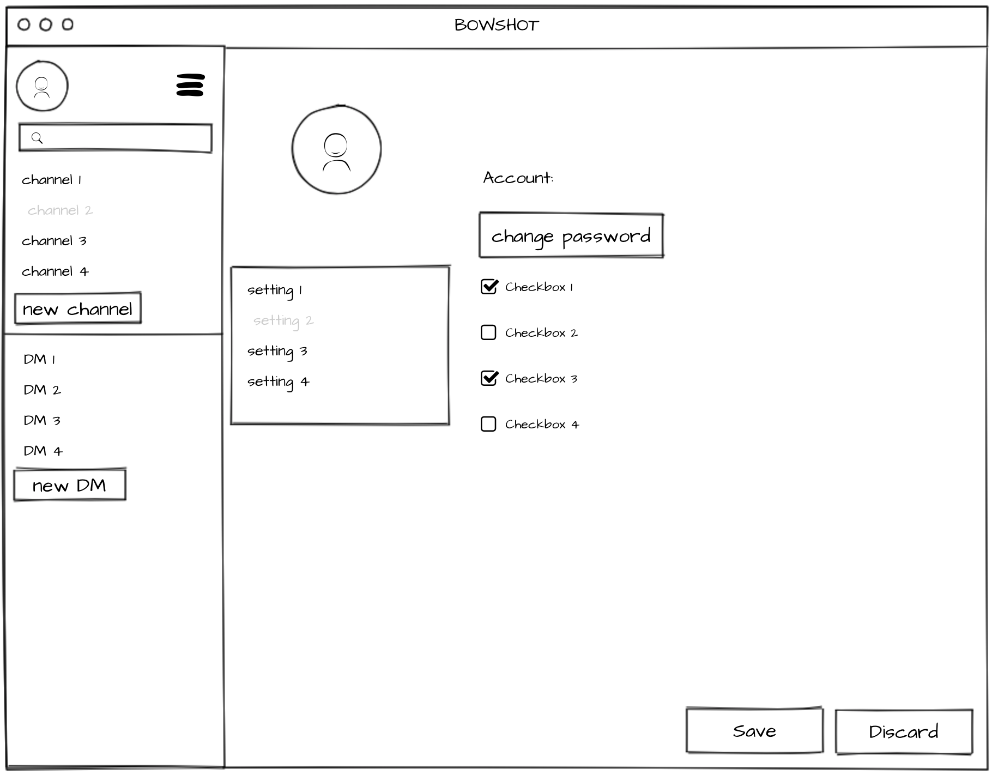

1. The settings page shall allow user to change general settings.
2. The settings page shall allow user to save or discard changes.

#### 3.1.1.4 Channel Management Page

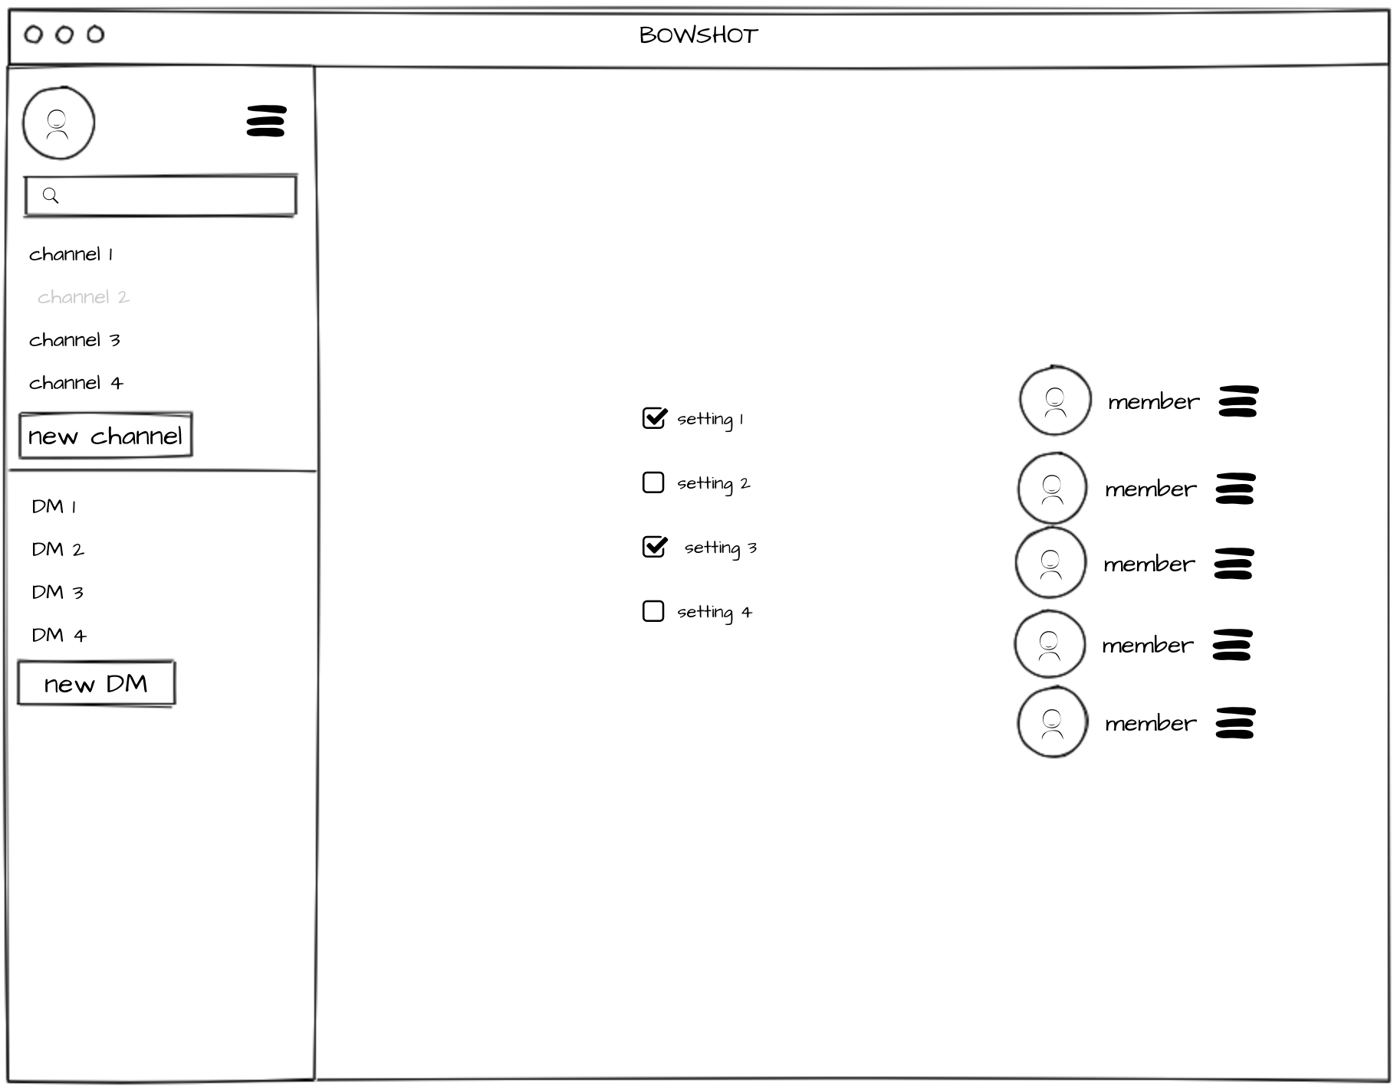

1. The channel management page shall allow channel moderator to change channel settings.

### 3.1.2. Hardware Interfaces

No hardware interfaces are applied in this system.

### 3.1.3. Software Interfaces

The system shall interact with the database through a programmatic interface.

The system shall use Apache Tomcat for interactions between server and client.

### 3.1.4. Communication Interfaces

The system shall send a notification to users when there is a new message.

The system shall send a notification to users when there is new activity in the workspace.

## 3.2 Functions

### 3.2.1. User Class 1 - Users

3.2.1.1

The system shall enable users to see the display names and profile images of the users in channels.

* Profile images are images of specific sizes
* All users have a default placeholder profile image
* Profile images can be uploaded and changed by users
* Users cannot edit or download the profile image of another user

3.2.1.2

The system shall enable users to search for other users who have an account via display names and emails.

3.2.1.3

The system shall require users to have a display name and display icon. It will provide the ability to edit this at any time.

3.2.1.4

If the user has a normal account (i.e., not a government account) then they can be found in search within a workspace.

3.2.1.5

The system shall provide the users with notification settings. It will enable users to turn all notifications off (“do not disturb”) and finetune different notifications (mute a channel or mute a user).

#### Security

3.2.1.6

The system shall require an email and password from each user.

3.2.7.2

The system shall require an email only be associated with one account.

3.2.7.3

The system shall enable users to login with email and passwords.

3.2.7.4

The system may enable users to login through other websites.

3.2.7.6

The system should enable users to encrypt their message.

3.2.7.7

The system may block, flag, or mark out inappropriate content based on users’ setting.

3.2.7.8

The system should enable the users to create private messages.

3.2.7.9

The system shall send a government agency a copy of the communications traffic as the system get it(upon subpoena).

3.2.7.10

The system shall be able to provide government agency a copy of the exact messages.

3.2.7.11

The system shall be able to provide IP of each message for government agency.

3.2.7.12

The system shall record login activities for each user.

#### Creating / Using Channels

3.2.2.1

The system shall allow any user to create a channel at any time.

3.2.2.2

The system shall require the user who creates a channel to give a unique name to the channel upon creation (less than 60 characters).

3.2.2.3

The system may enable three privacy settings, which the creator of the channel will be required to choose: public, visible, or private.

* The public setting in the system will allow channels to be searched for by users uninvited to the channel via related keywords and name, and will be visible on the homepage. The public setting in the system will allow any user to join the channel.
* The visible setting in the system will allow channels to be searched for by users uninvited to the channel via related keywords and name, and will be visible on the homepage. The visible setting in the system will require the moderator to invite a user to join, or the moderator to accept a request to join.
* The private setting for a channel will prevent the channel from showing up to any user not invited to the channel.

3.2.2.4

By default, the system will assign every channel the ‘visible’ setting, as defined in 3.2.2.3.

3.2.2.5

The system shall require a moderator for every channel, and automatically designate the channel creator as the moderator upon creation.

3.2.2.6

The system shall allow the user, upon creation of a channel, to optionally add up to five related keywords to the channel.

3.2.2.7

The system shall enable users to search for public channels via related keywords and channel names.

3.2.2.8

The system will show channel members the display name and icon of other members of the channel.

3.2.2.9

The system shall require at least one user as a prerequisite to create a channel.

#### Creating Direct Messages

3.2.3.1

The system shall allow any user to create a direct message instance, directed at another user, given that another user exists.

3.2.3.2

The system will not enforce a minimum or maximum number of users in a direct message.

3.2.3.3

The system shall allow users within a direct message to send a direct message at any time.

3.2.3.4

The system shall require a user to be invited to a direct message by another user in the direct message in order to join.

3.2.3.5

The system will show direct message members the display name and icon of other members of the direct message.

#### Communicating - Forwarding

3.2.4.1

The system may enable the users to forward any message received to any other user.

3.2.4.2

The system may enable the users to track the forwarding of the message they sent.

#### Communicating - Channel - Specific

3.2.5.1

The system shall enable the users to see the information of other people in their channel.

3.2.5.2

The system shall enable the user to mute notifications.

3.2.5.3

The system may enable users to follow other users and channels. The system may implement some sort of notification system.

3.2.5.4

The system shall enable the user to send messages to a channel.

#### Communicating - Direct Messages - Specific

3.2.6.1

The system shall enable the users to see the information of other people in a direct message they’re in.

3.2.6.2

The system shall enable the user to mute notifications of a direct message.

3.2.6.3

The system shall allow users to send text and multimedia messages.

3.2.6.4

The system shall make direct messages private and does not allow them to be searchable.

3.2.6.5

The system shall allow users to forward content in direct messages to other users only and not channels.

### 3.2.8 User Class 2 - Moderators

#### Security

The system should allow moderators to create passwords for channels.

#### Channels

3.2.8.1

The system shall allow a moderator to be the only type of user to have the ability to delete a channel.

3.2.8.2

The system shall allow a moderator to be able to modify the related keywords and the name of the channel at any time.

3.2.8.6

The system shall allow moderators to create and delete channels.

3.2.8.7

The system shall allow moderators to restrict users from joining without permission.

3.2.8.8

The system shall allow moderators to accept incoming invitations to merge channels of users.

3.2.8.10

The system shall allow moderators to remove users from channels.

#### Promoting/Demoting Moderators

3.2.8.3

The system shall require a moderator to choose a replacement moderator in order to leave the channel.

3.2.8.4

The system shall allow a moderator to promote any user of the channel to become a moderator.

3.2.8.5

The system shall allow a moderator to demote another moderator at any time.

## 3.3 Logical Database Requirements

### 3.3.1 User Database

When a user creates an account, the database will immediately store the following fields:

* User ID
* Email address
* Display name
* Icon
* First name
* Last name
* Date account created
* IP address

The following information will accumulate within a user’s profile as they use their account:

* Inbound message count
* Outbound message count
* Record of warnings/reports

### 3.3.2 Message Database

The system will store all text-based messages sent in the system indefinitely.

The system may store video and image messages sent in the system indefinitely.

The system will store each message in the database with the following information:

* Content
* Content formatting
* Time/date sent (UTC)
* Sender
* Recipient(s)

### 3.3.3 Channel Database

The system will store a record of all channels created. Each record of a channel will include:

* The channel name
* A list of users, who are the moderators
* The date the channel was created
* A list of related keywords related to the channel
* The privacy setting of the channel
* A list of every member of the channel
* A list of every member’s relationship to the channel
  + A date/timestamp of each time the user left the channel
  + A date/timestamp of each time the user joined the channel
  + The list of channels of which that person is currently a member
  + The member’s role within the channel (moderator or non-moderator)

## 3.4 Design Constraints

Specify design constraints that can be imposed by other standards, hardware limitations,

etc.

### 3.4.1 Standards Compliance

At minimum, **BOWSHOT** must keep a record of all messages and their timestamps should the company be subpoenaed into handing them over to the federal government.

In order for **BOWSHOT** to be ready for healthcare enterprise usage, we need to be HIPAA compliant.

In order for **BOWSHOT** to be ready for federal usage, we must comply by and obtain a fedRAMP authorization and NIST 800-171.

In order for **BOWSHOT** to service EU clients, we must comply by GDPR regulation which took effect on May 25, 2018. There are various other security and data management practices should we open up our product to other countries.

If we wanted to be compliant in terms of ISMS, SCPUC, and PII, ISO/IEC offers audit certificates and inspections to help achieve these higher security compliances.

## 3.5 Software System Attributes

### 3.5.1 Reliability

The system shall experience at most two failures per month.

### 3.5.2 Availability

Should run 24/7, except for:

* Unscheduled failures referenced in 3.5.1 Reliability
* Scheduled maintenance periods. (if non-regular, warning should be given at least during business hours the day of, and must take place on off-hours(least busy period of day)

Checkpoint - Option to manually save contents of draft

Recovery - No passive recovery aid

Restart - Drafts should be accessible upon restart

### 3.5.3 Security

All user login names and passwords must be encrypted through HMAC hashing or oAuth service and stored separately in AWS. Login could potentially be safeguarded against brute force attacks using Google ReCaptcha.

All user communication is recorded and stored in a database. This database must be able to store encrypted messages and time stamps of all communication.

Under CALEA, user communication can be tapped under subpoena; however, watchers should not be able to directly access user credentials. Login must be an isolated module.

User profile and metadata does not need to be encrypted and can be stored in the same

database.

### 3.5.4 Maintainability

The average time for the repair of each failure should be no more than 24 hours.

### 3.5.5 Portability

The program will be runnable on Linux, Mac OS, Windows OS, Chrome, Edge, and Safari. Further improvements should expand the product to be supported on iOS and Android phones.