**Memorandum**

**To:** Bruce Oakley, Carolina Beach Town Manager

**From:** JANT Engineering

**Date:** October 30, 2022

**Subject:** Carolina Beach Storm Reduction Conceptual Design

**___________________________________________________­­_**

**INTRODUCTION**

The purpose of this technical memorandum is to provide a conceptual design for the storm reduction project comprised of shoreline in Carolina Beach, North Carolina. This memorandum will cover three conceptual designs broken into sections that address structural layout and profile, justification of design from past projects and/or pragmatic equations, cost throughout project life cycle, and environmental impacts. A comparison of each concept will lead to the selection of one design that is best suited for the project.

**CONCEPTUAL DESIGN**

1. **NO ACTION PLAN**

A no action plan provides an option during the planning phase where JANT Engineering would not contribute in any action to address problem. This would allow clients, officials, and the public to compare all alternatives with that if no engineering or construction were to take place for the proposed project.

1. **SUBMERGED LIVING BREAKWATER**

A living breakwater is a shore-parallel, rubble-mound structure that is ecologically enhanced to incorporate natural elements and/or promote habitat creation and biological activity. A typical rubble-mound breakwater is comprised of a core, filter layer, and armor layer. In the case of a living breakwater design, the armor layer would include live shellfish, such as oysters, using techniques employed in previously constructed living breakwater projects (e.g., oyster shell gabions, spat-on-shell, oyster mesh bags) (GOSR, 2017). The structure would be fully submerged with a maximum water depth (still water level to base) of 35 feet due to oyster habitat requirements (NOAA Fisheries, 2022). A series of breakwaters would be constructed offshore for the purpose of wave energy dissipation to reduce potential storm impacts.

1. **BEACH RENOURISHMENT**

Renourishment of the project area would consist of rebuilding the cross-shore profile template by adding beach fill material to areas including swash zone, berm, and dune from dredging a borrow site. This would require bringing material from an offshore borrow site, dredged waterway, or sand mine that has similar sediment characteristics of that from the project site. The dune system has not been over washed, however, due to erosion and aeolian transport some of the elevation of the dune has been decreased. Figure 11 in Appendix A.I.B shows the difference in elevation from the wet/dry line during low tide to the top of the dune at all transects that survey data was collected by JANT. In addition to beach renourishment, some dune locations will need to be reconstructed.

1. **DESIGN SELECTION**

In determining a final conceptual design, the impacts of each alternative should be assessed and compared with others. This is advantageous in determining the best course of action when selecting a final design. Table 1 provides a comparison chart between the three alternatives as a breakdown between pros and cons of each design.

Table 1. Comparison of alternatives based mainly on long-term impacts.

|  |  |  |  |
| --- | --- | --- | --- |
| **Alternative Pros & Cons Comparison Chart**  **✓** Positive Impact **X**  Negative Impact **—** No Impact | | | |
|  | *Submerged Living Breakwater* | *Beach Renourishment* | *No Action* |
| Storm Impact Reduction | **✓** | **✓** | **X** |
| $20mil Budget | **✓** | **X** | **✓** |
| Littoral Transport/  Sedimentation | **✓** | **✓** | **X** |
| Short-Term  Environmental Disruption | **X** | **X** | — |
| Biodiversity Promotion | **✓** | **X** | — |
| Navigation | **—** | **✓** | — |
| Habitat Creation | **✓** | **✓** | — |
| Recreation | **✓** | **✓** | **X** |
| **Total ✓** | **6** | **5** | **1** |

In conclusion, the submerged living breakwater will be the most viable alternative. Short term, the submerged living breakwater will cost more than no action but is closely comparable with that of beach renourishment. However, long term the breakwater will cost less, promote more biodiversity, and allow for more recreation like surf breaks, diving, and fishing. Beach renourishment after 10 years will exceed the project lifespan budget in contrast to that of the breakwaters. Figure 1 shows the cross-section view of the submerged living breakwater conceptual design with layers labeled appropriately and dimensions shown.

Figure 1. Cross-shore location and depth of submerged living breakwater shown on USACE survey data at Transect 2.

**Appendix A. Conceptual Design**

**Table of Contents**

1. No Action Plan
   1. Design Justification
   2. Estimated Potential Damages
   3. Potential Impacts
2. Submerged Living Breakwater
   1. Structural Layout and Profile
   2. Design Justification
   3. Estimated Project Costs
   4. Potential Impacts
3. Beach Renourishment
   1. Structural Layout and Profile
   2. Design Justification
   3. Estimated Project Costs
   4. Potential Impacts
4. Design Selection
5. References

**Appendix A. Conceptual Design**

1. **No Action Plan**
   1. **Design Justification**

The purpose of the no action plan is to leave the beach in its current state, with no additional nourishment or maintenance. This lets the beach stay in a nature-driven state. One benefit of this option is that it is the cheapest alternative, as in no additional cost for maintaining the beach. If Carolina Beach cannot afford/get funding for any other alternative, this portion of the Appendix will talk about potential outcomes and damages.

* 1. **Estimated Potential Damages**

Selecting the no action plan would result in the most damages to Carolina Beach. Due to sea level rise and parameters based on a 100-year storm event, Carolina Beach would be tragically affected if the no action plan was taken. There is a high rate of beach erosion on the north side of the study site. The current dune elevation at the southern edge of the study site is very close to the elevation of the 100-year water level event (10.5 ft, NAVD88). The last USACE survey data in 2021 and the survey data collected from JANT Engineering will be used to estimate damages, because this is the most recent state of the beach. The transect from the southern edge can be seen in Figure 2.

Figure 2. T06 Elevations from USACE and JANT Engineering.

This would result in extreme flooding, over wash, and damage to infrastructure with no action. Flooding in Carolina Beach from Hurricane Ian from September of 2022 can be seen in Figure 3.

Figure 3. Flooding from Hurricane Ian in Carolina Beach. Source: WECT Staff

This flood level would drastically increase from a direct impact 100-year storm. On the north side of Carolina Beach, near the beach, water levels would get up to the rock revetment and potentially overtop the structure. Water levels just south of the pier following Hurricane Isaias in August of 2020 can be seen in Figure 4.

Figure 4. Water levels following Hurricane Isaias. Source: Port City Daily

An estimated 50 million dollars in damage would be done because of no action with a 100-year storm event. The damage would include houses, infrastructure, businesses, and boats. This number is based on damages done by Hurricane Fran in 1996 (Island Ecology, 2011).

* 1. **Potential Impacts**

Although the no action plan may not reduce damage or flooding from a 100-year storm event, it allows for natural movement of the barrier island and its nearby inlet. With this natural occurrence of barrier island retreat, it would allow the beach to change naturally as if no resources were threatened. This could be beneficial in the long-term for naturally letting the island move, but not for residents and other infrastructure in Carolina Beach. It is hard to say how the no action plan would affect the biodiversity, habitat creation, and navigation of the selected site.

1. **Submerged Living Breakwater**
   1. **Structural Layout and Profile**

A preliminary design of the submerged living breakwater (like a conventional rubble-mound breakwater) would include three layers: the core, filter layer, and armor layer (Figure 5). The core would be comprised of fine materials such as quarry run or concrete. The filter layer would consist of rock to prevent the fine material from being washed out. The armor layer would be made up of live shellfish and empty shells to serve as substrate (New York State Governor’s Office, 2013).

Figure 5. Example schematic of a shellfish breakwater. Not drawn to scale.

The preliminary dimensions of the submerged breakwater structure are as follows:

* Breakwater length (): 1000 ft (300 m)
* Gap length (): 200 ft (60 m)
* Crest width (): 40 ft (12 m)
* Structure height (): 5 ft (1.5 m)
* Cross-shore distance (): 500 ft (150 m)
* Water depth (): 10 ft (3 m)
  1. **Design Justification**

The principal function of a submerged (low-crested) breakwater is to dissipate wave energy and/or reflect wave energy back into the sea. This typically results in the reduction of wave heights in the lee of the structure and the reduction of longshore sediment transport. The low-crested aspect of the breakwater allows for more wave transmission compared to a standard breakwater which helps prevent tombolo formation. Additionally, low-crested breakwaters often warrant lower construction costs. The structure submersion also works to maintain the aesthetic value of the beach (USACE, 2008).

A living breakwater is structurally similarly to a rubble-mound breakwater. Considering that the wave height and period associated with a 100-year storm in Carolina beach are 19.1 ft and 11.2 s, the breakwater type that is suitable for those conditions is a rubble-mound or filled structure (Figure 6).

Figure 6. Breakwater types for typical ranges of wave height & period. Source: PND Engineers

Sabdono et al. (2004) describes a submerged breakwater design for 100-year storm with a 50-year lifespan off the coast of Alexandria, Egypt. The author makes note that the design considers tourism activities, such as swimming. Following the method used in Sabdono et al. (2004), based on the concept of Uda et al. (1988), the breakwater length () and gap length () was determined to be 1000 ft (~300 m) and 200 ft (60 m) respectively using a shore-to-breakwater distance () of 500 ft (~150 m) to the USACE baseline. The cross-shore distance is based on existing submerged breakwaters which have horizontal locations ranging from 330-650 ft (100-200 m) (Liang, 2014). The water depth of these submerged breakwater case studies tends to range from 10-15 ft (3-4.5 m). The selected cross-shore distance of 500 ft corresponds to approximately 10 ft water depth () relative to MSL at Carolina Beach (Figure 7).

Eq.1.

Eq.2.

The project domain is approximately 21,000 ft in length (alongshore) and 6,070 ft in width (cross-shore). Based on the dimensions determined by Equations 1 & 2, there would be approximately 17 breakwaters if the structures were to span the entire longshore length of the project domain (Figure 9). Constructing a series of submerged breakwaters along the entire domain is likely unwarranted for the project to be effective, therefore the exact number and placement of the breakwaters will be determined definitively upon further investigation.

The preliminary estimates for crest width () and structure height () are 40 ft (~12 m) and 5 ft (1.5 m), respectively (Figure 8). The crest width is based on the hypothetical dimensions used in Sabdono et al. (2004) and scaled to the determined breakwater length. If scaled using the hypothetical submerged breakwater dimensions in Foley (2015), the crest width would be 100 ft (~30 m). A detailed analysis would include testing various crest widths ranging from 40-100 ft. The estimate of structure height is an initial guess based on the ratio of breaking wave height () to water depth () being ~0.8, in conjunction with an estimated water depth of 10 ft (to the base of the structure) and the understanding that a 100-year storm wave height for Carolina Beach is approximately 19.1 ft with a water level of 10.5 ft (NAVD88). Similarly, the height of the submerged breakwater structure would be varied during functional testing and analysis.

Figure 7. Cross-section of the submerged living breakwater based on preliminary design.

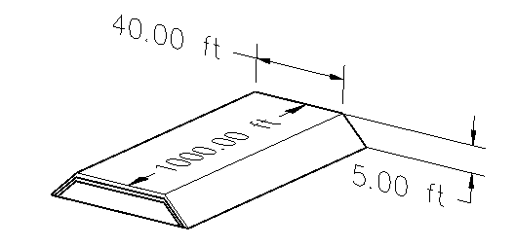

Figure 8. Oblique view of preliminary breakwater design.

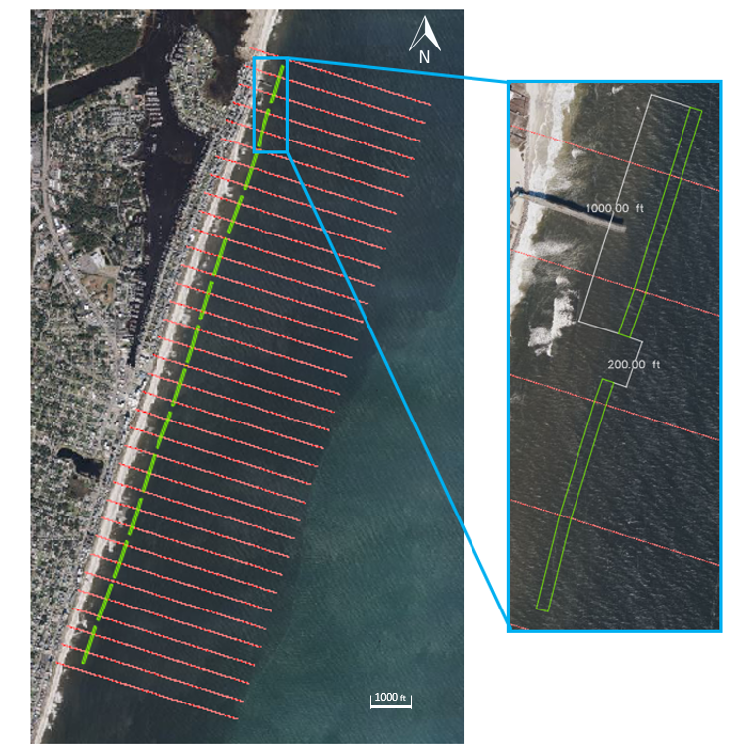

Figure 9. Potential locations of submerged living breakwaters at Carolina Beach.

* 1. **Project Cost Estimate**

The total project cost for constructing 17 submerged living breakwaters is estimated to be approximately $10.5 million (Table 2 - Table 5). This estimate considers construction (materials and labor), engineering design (labor and equipment), maintenance/monitoring (materials and labor), and contingency costs. Material and equipment costs are based on current market values. Mathis Quarries offers quarry run and rip rap that would be used to construct the core and filter layers (Mathis Quarries, Inc, 2022). A bushel of oysters in NC currently values between $3-7, so an average value of $5 per bushel was used for cost calculation (Fretwell, 2022). Labor rates were estimated based on the May 2021 OEWS State Occupational Employment and Wage Estimates for North Carolina. Equipment and licensing costs were quoted directly from the product website at an annual rate. Maintenance materials were estimated to be 10% of the original installation amount. Living breakwaters are generally considered to be self-sustaining as the benthic species will “provide a level of natural upkeep to the structure” (Naturally Resilient Communities, 2022). Maintenance and monitoring labor was estimated assuming the same NC labor rates for employees working 40 hours/week for 2 weeks every other year for the project lifespan of 50 years. A contingency cost is calculated as 10% of the project cost (including construction, engineering design, and maintenance/monitoring).

Table 2. Estimated costs for constructing and maintaining submerged living breakwaters. Material cost estimates are based on preliminary design that is subject to change. Cost analysis is based on current market rates/prices and does not account for inflation.

|  |  |  |  |  |  |  |  |  |  |
| --- | --- | --- | --- | --- | --- | --- | --- | --- | --- |
| **Construction** | | |  | | | | | | |
| **Materials** | | | **Unit Cost** | | **Required Amount** | **Description** | **Cost (USD)** |
|  | Quarry Run (per ton) | | $20 | | 17850 | Gray in color, crushed granite, mixed with 3/4-inch average size crushed stone gravel. | $357,000 |
|  | Rip Rap Class B (per ton) | | $29 | | 9520 | Gray in color, about the size of a cantaloupe. | $276,080 |
|  | Oyster Shells (per bushel) | | $5 | | 901000 | 1 US bushel = 1.24 cubic foot | $4,505,000 |
|  |  | | |  |  |  | $5,138,080 |
| **Labor** |  | | | **Hourly Rate** | **Number of Personnel** | **Hours Worked (10-week project)** |
|  | Field/Operation Engineers | | | $43.71 | 3 | 400 | $52,452.00 |
|  | Supervisors | | | $31.20 | 2 | 400 | $24,960.00 |
|  | General Laborers | | | $16.78 | 15 | 400 | $100,680.00 |
|  | Office Administrators | | | $20.17 | 5 | 400 | $40,340.00 |
|  | |  | | |  |  |  | $218,432.00 |

Table 3. Estimated costs for engineering design of submerged living breakwaters. Cost analysis is based on current market rates/prices and does not account for inflation.

|  |  |  |
| --- | --- | --- |
| **Engineer Design** | | |
| **Labor** |  | | **Hourly Rate** | | **Number of Personnel** | **Hours Worked (40 hr./week for one year)** |
|  | Engineers | | $43.71 | | 4 | 2080 | $363,667.20 | |
| $363,667.20 | | | | | | | | |
| **Equipment/Licenses** | | | **Unit Cost** | | **Required Amount** | **Description** | |  |
|  | GPS Surveying Unit + Tablet | | $2,250 | | 1 | Emlid Reach RS2 GNSS Receiver + Apple iPad | | $2,250.00 |
|  | MATLAB License | | $900 | | 4 | Standard Annual | | $3,600.00 |
|  | AutoCAD Civil3D License | | $2,550 | | 1 | Annual | | $2,550.00 |
|  | ArcGIS Pro License | | $700 | | 1 | GIS Professional Basic Annual | | $700.00 |
|  | Microsoft Office Suite | | $150 | | 4 | Annual | | $600.00 |
|  | | | | | $9,700.00 | | | | |
|  | | | | |  | | | | |

Table 4. Estimated costs for maintaining and monitoring submerged living breakwaters. Material cost estimates are based on preliminary design that is subject to change. Cost analysis is based on current market rates/prices and does not account for inflation.

|  |  |  |  |  |  |  |  |  |  |  |
| --- | --- | --- | --- | --- | --- | --- | --- | --- | --- | --- |
| **Life Cycle Costs (Maintenance & Monitoring)** | | | | | | | | | | |
| **Materials** | |  | **Unit Cost** | | | | | | **Required Amount** | | **Description** | |  |
|  | Quarry Run (per ton) | | $20 | | | 1785 | | | | | Gray in color, crushed granite, mixed with 3/4-inch average size crushed stone gravel. | | $35,700.00 |
|  | Rip Rap Class B (per ton) | | $29 | | | 952 | | | | | Gray in color, about the size of a cantaloupe. | | $27,608.00 |
|  | Oyster Shells (per bushel) | | $5 | | | 90100 | | | | | 1 US bushel = 1.24 cubic foot | | $450,500.00 |
| $513,808.00 | | | | | | | | | | | | | |
| **Labor** | |  | **Hourly Rate** | | | | | **Number of Personnel** | | | **Hours Worked (2 weeks biennially for 50 years)** |
|  | Field/Operation Engineers | | | $43.71 | | | 1 | | | | 10000 | $437,100.00 | |
|  | Supervisors | | | $31.20 | | | 2 | | | | 10000 | $624,000.00 | |
|  | General Laborers | | | $16.78 | | | 10 | | | | 10000 | $1,678,000.00 | |
|  | Administrators | | | $20.17 | | | 2 | | | | 10000 | $403,400.00 | |
|  |  | |  | |  | | | | | |  | $3,142,500.00 | |

Table 5. Estimated cost of contingency (10% of construction & engineering design costs). Total project cost including construction, engineering design, life cycle costs, and contingency.

|  |  |  |  |
| --- | --- | --- | --- |
| **Contingency** | | | |
| **10% Contingency** | | | | | **Percentage** | | | | **Total Cost** | | |
|  | Unexpected Expenses | | | | | 10% | | $9,386,187.20 | | | $938,618.72 | | | | |
|  | |  | |  | | |  | | |  | | |  | |
| **Total Project Cost** | | | | | | | | | | | | | | | $10,324,805.92 | |

* 1. **Potential Impacts**

Living breakwaters create “complex structured subtidal and intertidal habitat” and provide a “diverse mosaic of habitat conditions needed to catalyze increased biodiversity” (New York State Governor’s Office, 2013). The bio-enhanced armor units provide habitat variety and encourage the recruitment of other marine species such as bivalves, crustaceans, and fish. These habitats help drive the local economy through fishery production and recreational tourism activities (e.g., snorkeling). Additionally, the oyster armor layer will help improve water quality by filtering the water column. One oyster can filter up to 50 gallons of water per day by “cleaning it of pollutants and nutrients thereby increasing the overall quality of the water” (Naturally Resilient Communities, 2022).

Breakwaters are sand-trapping structures. Littoral transport decreases due to wave attenuation and weakened alongshore currents in the lee of the structure (Coastal Wiki, 2021). Over time, this can result in the widening of the beach which is beneficial for storm impact reduction, habitat creation, and recreation. If the beach is nourished, breakwaters can increase the longevity of the beach fill. Breakwaters can also result in the formation of a tombolo, however low-crested breakwaters allow more wave energy to penetrate the lee of the structure and prevent tombolo formation (USACE CEM, 2008).

The disruption of littoral transport will alter the equilibrium of the beach profile and could potentially lead to an increase in erosion along the beach, particularly in the downdrift. The project construction will also temporarily disturb the environment (benthic and pelagic) in the project area. Project construction will include machinery on and offshore, particularly vehicles and vessels transporting and placing the breakwater materials. Care must be taken to ensure minimal disruption to the surface and subsurface habitats during construction. The dissipation of wave energy due to the structure may cause the waves to be considered ‘un-surfable,’ which would negatively impact the recreation and tourism of the beach. However, the living breakwaters create a unique opportunity for recreational activities such as snorkeling and scuba diving.

1. **Beach Renourishment**
   1. **Structural Layout and Profile**

Renourishment and sediment fill comprises of the dune, berm, and current swash zone. The fill will follow a design template to provide adequate storm protection and mitigation while also resembling the organic environment without the addition of a hard structure. However, to successfully last the 50-year life span, there will need to be additional renourishments intermittently.

Per the June 2019 USACE Beach Renourishment Evaluation Report, the project area covers approximately 14,000 feet from First Avenue to Carolina Sands Drive. The average width of the project area, from the dune line inland, is 700 feet, and consists of a sacrificial berm and dune. The dune crown has a width of 25 feet at an elevation of 12.5 feet North American Vertical Datum 88 (NAVD88) and is integrated with a shoreline berm that has a crown width of 100 feet at elevation 9.5 feet NAVD88 and beach fill extending approximately 14,000 feet from the northern to the southern limits of Carolina Beach (USACE, 2019). Figure 10 shows the area of Carolina Beach where the renourishment project would take place, two potentials borrow area sites, and all in correlation with geography surrounding the project area via USACE Beach Renourishment Draft.

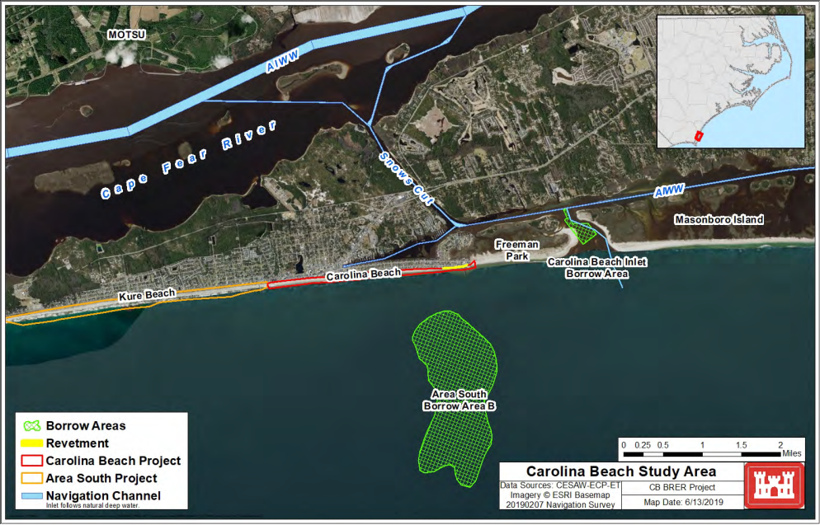

Figure 10. Shoreline map of Carolina Beach project area with locations of two potential borrow area sites of similar sediment. Source: USACE, 2019.

Such renourishment parameters have proved to be successful in storm mitigation, recreational area expansion, and habitat creation. Therefore, the same parameters and specifics would be used in this alternative design. Figure 11 displays the schematic diagram of the current beach profile at Transect 2 (T02) as an example and the design template (what cross-shore profile will be upon completion of renourishment).

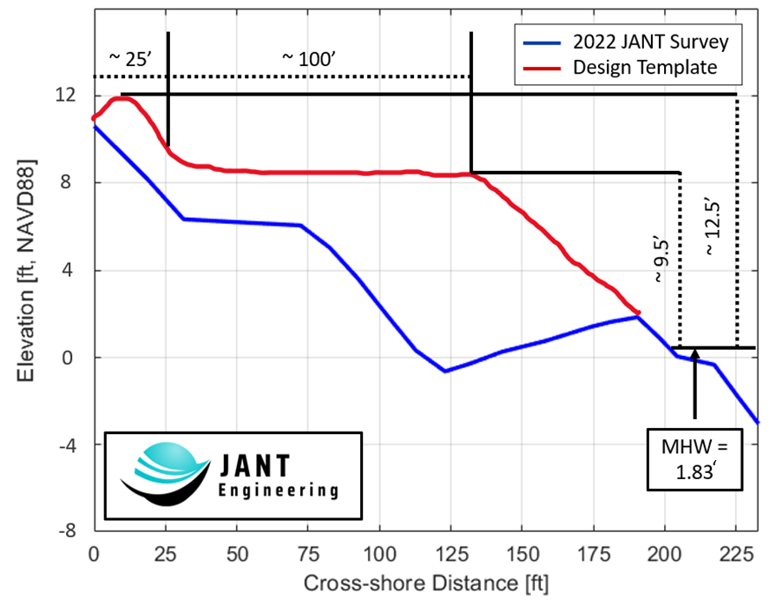

Figure 11. Beach renourishment design template over collected survey data from Transect 2 (T02).

* 1. **Design Justification**

The average volume of sand it will take to cover the project area is approximately 800,000 cubic yards. This was calculated by taking the average sand volume used in previous renourishments from years 2001 to 2016. Equation 3 explains how the average was determined where is the sand volume by year and is the number of years the data used. All values were obtained from that hosts records from all the previous beach renourishment projects along Carolina Beach via USACE.

Eq.3.

Table 6. Carolina Beach renourishment history using Carolina Beach Inlet borrow site since 1981. Source: USACE Appendices, 2019.

|  |  |  |  |
| --- | --- | --- | --- |
| **Year of Renourishment** | **Sand Volume (** | **Borrow Source Used** | **Dredge Depth Range (Elevation (ft.) MLLW)** |
| 1965 | 2,632,000 | Carolina Beach Harbor | N/A |
| 1981-1982 | 3,662,000 | Carolina Beach Inlet | -17 to -40 |
| 1985 | 764,162 | Carolina Beach Inlet | -17 to -40 |
| 1988 | 950,913 | Carolina Beach Inlet | -21 to -45 |
| 1991 | 1,008,763 | Carolina Beach Inlet | -19 to -40 |
| 1995 | 1,157,742 | Carolina Beach Inlet | -15 to -43 |
| 1998 | 1,204,646 | Carolina Beach Inlet | -20 to -42 |
| 2001 | 567,345 | Carolina Beach Inlet | -22 to -41 |
| 2004 | 800,387 | Carolina Beach Inlet | -20 to -40 |
| 2007 | 632,143 | Carolina Beach Inlet | -23 to -42 |
| 2010 | 689,600 | Carolina Beach Inlet | -23 to -40 |
| 2013 | 989,200 | Carolina Beach Inlet | -22 to -39 |
| 2016 | 881,470 | Carolina Beach Inlet | -25 to -37 |

* 1. **Estimated Project Costs**

Developing project costs will be based on using the Carolina Beach Inlet borrow site. Mobilization and demobilization for all necessary equipment follows a lump sum and cost of sediment placement by unit rate and are values obtained from previous renourishment projects along Carolina Beach from USACE. “Future costs utilizing the Carolina Inlet are based on the assumed unit cost ($8.50/CY) and the mobilization cost ($5,000,000) provided by cost engineering and are used in conjunction with the estimated nourishment volume and nourishment interval from Beach-fx to establish the FY2019 cost for each future nourishment.” (USACE Appendices, 2019). Table 7 - Table 10 are composed of costs that total what the initial and life span total project costs.

Table 7. Estimated costs for constructing and management for a beach renourishment. Material cost estimates are based on previous beach renourishments. Cost analysis is based on current market rates/prices and does not account for inflation.



Table 8. Estimated costs for engineering design of beach renourishment. Cost analysis is based on current market rates/prices and does not account for inflation.



Table 9. Estimated costs for maintaining and monitoring beach renourishment. Material cost estimates are based on previous beach renourishments. Cost analysis is based on current market rates/prices and does not account for inflation.



Table 10. Estimated cost of contingency (10% of construction & engineering design costs). Total project cost including construction, engineering design, life cycle costs, and contingency.



* 1. **Potential Impacts**

All organisms, whether living on the bottom or within the water column, are subject to impact during a renourishment project due to dredging when retrieving sediment and construction along the shore. There would be some potential adverse impacts to the inlet, nearshore, and swash zones however would not be permanent damages. “Any reduction in the numbers or biomass (or both) of intertidal macrofauna present immediately after beach placement may have localized limiting effects on surf-feeding fishes and shorebirds because of a reduced food supply. In such instances, those animals may be temporarily displaced to other locations, but would be expected to return following placement.” (USACE, 2019). With production being concentrated in small areas during the construction process, this will help keep impacts to the environment minimal. The same can be expressed for organisms that nest, prey, and migrate along the beach such as birds and mammal species. Foraging and roosting habitat for certain species would be affected short-term, with long-term benefits like increased habitat area.

Dredging and the positioning of sand along the project area will increase the turbidness of the water, however fish and other aquatic species are able to relocate, adapt to the new environment, and thrive quickly. Especially during different seasons of the year when fish species migrate to areas with warmer water temperatures. Dredging from the Carolina Beach Inlet would help improve navigational pathways and ease travel with larger vessels.

If dune heights are under the recommended height of the template, then dune grass and vegetation will be covered to raise dune elevation. This could result in lack of stability in the dune and less surface area to catch sand grain and retain material. The vegetation over time will grow through but there will need to be replacement of new vegetation following construction of the dune. With the placement of more sediment increasing the berm width, this provides more recreational area along the beach while also maintaining the aesthetic value of the beach.

Endangered species, such as the loggerhead sea turtle, must be accounted for with the highest regard. It is crucial to attempt dredging and beach nourishment construction during the season where sea turtles are not nesting. “By adhering to these environmental windows to the maximum extent practicable, all subsequent beach placement of sediment will occur outside of the North Carolina Sea Turtle nesting season of May 1 through November 15. The limits of the nesting season window are based on the known nesting sea turtle species within the state and the earliest and latest documented nesting events for those species” (USACE, 2019).

1. **Design Selection**

JANT Engineering was hired to create a design for a storm reduction project for a 100-year storm with a life expectancy of 50 years. Additionally, 100-year storm water levels and sea level rise were considered in the preliminary designs. A comparison of three alternatives was made to select the most beneficial solution for the storm reduction project. It was determined that the best solution is the submerged living breakwater. This option was the cheapest alternative over the 50-year life expectancy in comparison to the renourishment project. Similarly, this project costs less than potential storm damages from a 100-year storm. The submerged living breakwater and renourishment alternatives both have several benefits, including storm impact reduction and habitat creation for a resilient environment. These factors benefit the environment, as well as promote recreation and tourism. A submerged living breakwater also allows for alongshore sediment transport but keeps sand in the circulating cross-shore environment during a storm. Due to this, the beach can rebuild by natural recovery processes after storm events.

**References**

AUTODESK. “Civil 3D Software: Get Prices & Buy Official Civil 3D 2023.” *Autodesk*, 7 Oct. 2022, www.autodesk.com/products/civil-3d/overview?term=1-YEAR&tab=subscription&plc=CIV3D. Accessed 18 October 2022.

bathylogger. “EMLID Reach RS2 GNSS Receiver 3.5g.” Bathylogger, 13 Sept. 2022, bathylogger.com/product/emlid-reach-rs2/?gclid=Cj0KCQjwnbmaBhD-ARIsAGTPcfUqu3k9xwGoBbkqpru7tlFFqRebb22Qet69ZDXV9rM4D-_-olKUyD4aAo-REALw_wcB. Accessed 18 October 2022.

Coastal Wiki. “Detached Breakwaters.” *Detached Breakwaters - Coastal Wiki*, www.coastalwiki.org/wiki/Detached_breakwaters#Reasons_for_selecting_a_submerged.2Flow_breakwater. Accessed 18 October 2022.

Darrough, Mark. “In Pictures and Videos: Hurricane Isaias Hits Carolina Beach.” *Port City Daily*, 23 Dec. 2020, portcitydaily.com/local-news/2020/08/04/in-pictures-and-videos-hurricane-isaias-hits-carolina-beach/. Accessed 19 October 2022.

ESRI. “ArcGIS pro Pricing.” *Buy Now*, www.esri.com/en-us/arcgis/products/arcgis-pro/buy. Accessed 18 October 2022.

Fisheries, NOAA. “Eastern Oyster.” *Eastern Oyster*, NOAA Fisheries, 14 Oct. 2022, www.fisheries.noaa.gov/species/eastern-oyster#:~:text=Eastern%20oysters%20live%20in%20brackish,invertebrates%2C%20macrofauna%2C%20and%20birds. Accessed 16 October 2022.

Foley, Michael J.H. “Submerged Breakwater Modeling and Coral Reef Ecological Analysis for Harbor Protection.” May 2015. https://scholarspace.manoa.hawaii.edu/server/api/core/bitstreams/76b7af08-97d8-40bb-9914-d0085154504c/content. Accessed 18 October 2022.

Fretwell, Sammy, and Sarah Haselhorst. “Oyster Shells Sell for Top Dollar in Competitive Market Driven by Shortages; Biologists Scramble to Protect Shellfish.” *Pilot*, 29 Aug. 2022, 11:26 AM, www.pilotonline.com/news/environment/vp-nw-oyster-shells-market-20220829-uccw4a26o5e4xmhsve3qqprgem-story.html. Accessed 19 October 2022.

Governor’s Office of Storm Recovery. “Appendix D Breakwaters Project Benefit Cost Analysis.” *Governor’s Office of Storm Recovery*, 17 Jan. 2017. https://stormrecovery.ny.gov/sites/default/files/crp/community/documents/Appendix%20D%20-%20Breakwaters%20Project%20Benefit%20Cost%20Analysis.pdf. Accessed 17 October 2022.

Island Ecology. “Hurricanes and Carolina Beach.” *Island Ecology 2011*, UNCW Island Ecology 2011, sites.google.com/site/islandecology2011/hurricanes. Accessed 19 October 2022.

Liang, Lee Jia. “A Study on Submerged Breakwater Length, Offshore Distance and Crest Width Affecting the Shoreline Response.” *UTPedia*, Universiti Teknologi Petronas, 1 Jan. 2014, utpedia.utp.edu.my/13386/. Accessed 24 October 2022.

Mathis Quarries, Inc. “Price List.” *Mathis Quarries, Inc.*, 2022, www.mathisquarry.com/price-list. Accessed 18 October 2022.

Mathis Quarries, Inc. “Product Description.” *Mathis Quarries, Inc.*, 2022, www.mathisquarry.com/product-description. Accessed 18 October 2022.

MathWorks. “Pricing and Licensing.” *MATLAB & Simulink*, www.mathworks.com/pricing-licensing.html?prodcode=ML&intendeduse=comm. Accessed 18 October 2022.

Microsoft. “Microsoft 365 Business Standard.” *Microsoft 365*, www.microsoft.com/en-us/microsoft-365/business/microsoft-365-business-standard?activetab=pivot%3Aoverviewtab. Accessed 18 October 2022.

Naturally Resilient Communities, APA. “Living Breakwaters.” *Naturally Resilient Communities*, nrcsolutions.org/living-breakwaters/. Accessed 16 October 2022.

New York State Governor’s Office. “Living Breakwaters Project Background and Design.” *Living Breakwaters Project Background and Design*, Governor’s Office of Storm Recovery (GOSR), stormrecovery.ny.gov/living-breakwaters-project-background-and-design. Accessed 18 October 2022.

PND Engineers. “Breakwaters Including Partial Penetrating Wave Barriers”, *PND Engineers, Inc*., 2015, www.pndengineers.com/home/showpublisheddocument/413/636068632346830000#:~:text=The%20wave%20barrier%20was%20designed,32%20feet%20at%20low%20tide. Accessed 18 October 2022.

Sabdano, Parang, et.al., “Design of Submerged Breakwater.” http://download.garuda.kemdikbud.go.id/article.php?article=1400471&val=1269&title=DESIGN%20OF%20SUBMERGED%20BREAKWATER. Accessed 18 October 2022.

TETRA TECH. “Deficiency Correction Evaluation Report Appendix C Cost Estimates.” *USACE*, 2012. https://www.poa.usace.army.mil/Portals/34/docs/civilworks/currentproj/Cost%20Estimate%20Addendum%2020120201.pdf. Accessed 18 October 2022.

United States Department of Labor. “North Carolina - May 2021 OEWS State Occupational Employment and Wage Estimates.” *U.S. Bureau of Labor Statistics*, 31 March 2022, www.bls.gov/oes/current/oes_nc.htm#47-0000. Accessed 18 October 2022.

USACE, Appendices. *Carolina Beach, NC Beach Renourishment Evaluation Report Appendices.* Wilmington District – U.S. Army Corps of Engineers, June 2019. https://www.saw.usace.army.mil/Portals/59/docs/coastal_storm_damage_reduction/Carolina%20Beach/Carolina%20Beach%20%20-%20APPENDICES%20-%20DRAFT%20Beach%20Renourishment%20Evaluation%20Report%20-%20USACE%20-%20June%2024%202019%20reduced.pdf, PDF File. Accessed 16 October 2022.

USACE, *Carolina Beach, NC Beach Renourishment Evaluation Report.* Wilmington District - U.S. Army Corps of Engineers, 2019. https://www.saw.usace.army.mil/Portals/59/docs/coastal_storm_damage_reduction/Carolina%20Beach/Carolina%20Beach%20%20-%20DRAFT%20Beach%20Renourishment%20Evaluation%20Report%20-%20USACE%20-%20June%2024%202019.pdf, PDF File. Accessed 16 October 2022.

USACE, *Coastal Engineering Manual – Part V*. Washington, DC - U.S. Army Corps of Engineers, April 2008. https://www.publications.usace.army.mil/USACE-Publications/Engineer-Manuals/u43544q/636F617374616C20656E67696E656572696E67206D616E75616C/. Accessed 16 October 2022.

WECT Staff. “Photos: Hurricane Ian Causes Floods throughout Southeastern North Carolina.”*, WECT News 6*, 20 September 2022, www.wect.com/2022/09/30/hurricane-ian-causes-floods-throughout-southeastern-north-carolina/. Accessed 19 October 2022.