**Memorandum**

**To:** Bruce Oakley, Carolina Beach Town Manager

**From:** JANT Engineering

**Date:** October 19, 2022

**Subject:** Hydrodynamic Forcing Assessment

**___________________________________________________­­___________________________**

**INTRODUCTION**

The purpose of this technical memorandum is to provide a summary of findings pertaining to the hydrodynamic forcing characteristics of the project field site in Carolina Beach to designate a set of parameters to be used for structural design and analysis in our storm reduction project. These characteristics include the following:

* Wave conditions (wave height, period, direction)
* Seasonal variability of wave conditions
* 100-year storm water levels
* Sea level rise projections

The analysis considers a life expectancy of 50 years with hydrodynamic forces from 100-year storm water levels, wave parameters, and projected sea level rise.

**HYDRODYNAMIC FORCING**

1. **WAVE PARAMETERS**

Statistical wave parameters are required to design and test alternatives for functional performance and structural durability. The parameters considered are significant wave height (), peak wave period (), mean wave period (), peak wave direction (), and mean wave direction (). The most important parameters used for project design and testing tend to be significant wave height and peak wave period. The 2019 Federal Emergency Management Agency (FEMA) Flood Insurance Study (FIS) Report was used to determine significant wave height and peak wave period parameters that correspond to a 100-year storm. Historical wave data from nearby wave buoys (ILM2WAVE, MASE-01, and BHI-E) was used to substantiate the selected design parameters and supplement additional parameters.

1. **100-YEAR STORM WATER LEVELS**

The 100-year storm still-water level is required to test alternative designs against severe storm conditions. Storm-induced flooding must be also considered in order to limit the damage to beach profiles, transportation routes, and infrastructure on and off the beach. Astronomical tides, storm surge, wave setup, runoff, and ground elevation all influence still-water levels during a storm event. The 2019 FEMA FIS Report provides data concerning 100-year storm water levels and conditions. Transects along the New Hanover County coastline are modeled using wave conditions to find the still-water elevation for a 100-year storm (Figure 2, Appendix A.II) (FEMA, 2019). The results from this model are found in Table 5 in Appendix A.II.

1. **SEA LEVEL RISE PROJECTIONS**

Sea level rise (SLR) is on the forefront of environmental concerns and is a rapidly escalating issue for low-lying coastal areas. The state of North Carolina is planning 2 billion dollars’ worth of sea level rise solutions, including beach nourishment and flood reduction projects (“North Carolina’s Sea Level is Rising”). A summary of sea level rise and projections of sea level rise for New Hanover County are provided in Appendix A.III.

**CONCLUSION**

Based on this assessment of hydrodynamic forcing, the following parameters will be used for project design and functional analysis:

* Significant Wave Height (): 19.1 [ft, NAVD88]
* Peak Wave Period (): 11.2 [s]
* Mean Wave Period (): 16.72 [s]
* Peak Wave Direction (): 119.43 [deg N]
* Mean Wave Direction (): 108.99 [deg N]
* 100-Year Storm Water Level: 10.5 [ft, NAVD88]
* Sea Level Rise Projection: 2.5 [ft, MSL]

The significant wave height and peak wave period were selected according to the 100-year storm wave conditions found in the 2019 FEMA FIS Report. These values will be used for testing designs against 100-year storm conditions. Mean wave period, peak wave direction, and mean wave direction were derived by averaging the values obtained from the historical wave data across all seasons and buoys considered. Wave direction is relatively consistent with the dominant direction being east-southeast (ESE). This averaging method was used to obtain parameters representative of typical wave conditions. Testing alternatives under typical conditions is useful for estimating maintenance and life-cycle costs, particularly in the case that a 100-year storm does not occur during the 50-year life span of the project. The 100-year storm still-water level data ranges from 8.7 to 10.5 ft for the project area. The water level parameter was selected to be the upper value of this range in order to prevent functional and structural failure in a worst-case scenario 100-year storm. On average, sea level rises an inch every two years. With model limitations, it is challenging to derive an accurate estimate of sea level rise for the next 50 years. However, using a general rule of one inch for every two years, a Mean Sea Level (MSL) of 0.761 m (2.5 ft) was chosen.

**Appendix A. Hydrodynamic Forcing**

**Table of Contents**

1. Wave Parameters
2. 100-Year Water Levels
3. Sea Level Rise and Projections
4. References

**Appendix A. Hydrodynamic Forcing**

1. **Wave Parameters**

The 2019 FEMA FIS Report provides data and analyses of wave conditions corresponding to a 1% annual chance (100-year) storm event for New Hanover County, North Carolina. The report defines transects along the New Hanover coastline (Figure 2 in Appendix A.II). Transects 17-27 fall within the project domain and are used for assessing wave parameters. The initial wave conditions used for modeling the 100-year storm event were derived from the following methods/models:

* ADCIRC
* CHAMP / RUNUP 2.0 (2007)
* CHAMP 2.0
* Removal / Retreat
* WHAFIS 4.0

The resulting wave conditions are listed in Table 1. For transects 17-27, the values for significant wave height and peak wave period are consistent at 19.1 ft and 11.2 s, respectively.

Table 1. Wave parameters corresponding to coastal transects 17-27 in Figure 2. Source: FEMA FIS Report (2019)

|  |  |  |  |  |
| --- | --- | --- | --- | --- |
| **Coastal Transect** | **Starting Wave Conditions for the 1% Annual Chance** | | **Starting Still-water Elevations [ft, NAVD88]**  **Range of Still-water Elevations [ft, NAVD88]** | |
| **Significant Wave Height, [ft]** | **Peak Wave Period, [s]** | **1% Annual Chance**  **(100-yr)** | **2% Annual Chance**  **(50-yr)** |
| 17 | 19.1 | 11.2 | 10.2 | 13.6 |
| 8.9-10.2 | 11.7-13.6 |
| 19 | 19.1 | 11.2 | 10.2 | 13.6 |
| 10.2-10.3 | 13.6-14.0 |
| 21 | 19,1 | 11.2 | 10.1 | 13.6 |
| 10.1-10.4 | 13.6-14.0 |
| 23 | 19.1 | 11.2 | 10.2 | 13.8 |
| 8.7-10.4 | 11.5-14.1 |
| 25 | 19.l | 11.2 | 10.3 | 13.8 |
| 10.3-10.5 | 13.8-14.1 |
| 27 | 19.1 | 11.2 | 10.3 | 13.7 |
| 10.2-10.5 | 13.7-14.2 |

Additionally, data was gathered from three wave buoys off the North Carolina coast (Figure 1). These data are provided to supplement and support the selected design parameters. One buoy (ILM2WAVE) is maintained by the Coastal Ocean Research and Monitoring Program (CORMP), and two buoys (MASE-01 and BHI-E) are maintained by the University of North Carolina Wilmington in partnership with CORMP. Statistical wave parameters were retrieved from the CORMP database within the time frame of September 22, 2021, to September 21, 2022. This time frame was chosen to cover the four most recent seasons (Autumn 2021, Winter 2021-2022, Spring 2022, and Summer 2022) to have data that is accurately representative of the current wave state. The data was split according to the season it was collected (i.e., Fall, Winter, Spring, and Summer). MATLAB was used to find the minimum, maximum, and mean values of the wave parameters to acquire a range and average for each season. Mean wave statistics (, ) are only available from MASE-01 and BHI-E buoys. The data for ILM2WAVE, MASE-01, and BHI-E are respectively listed in Table 2 - Table 4.

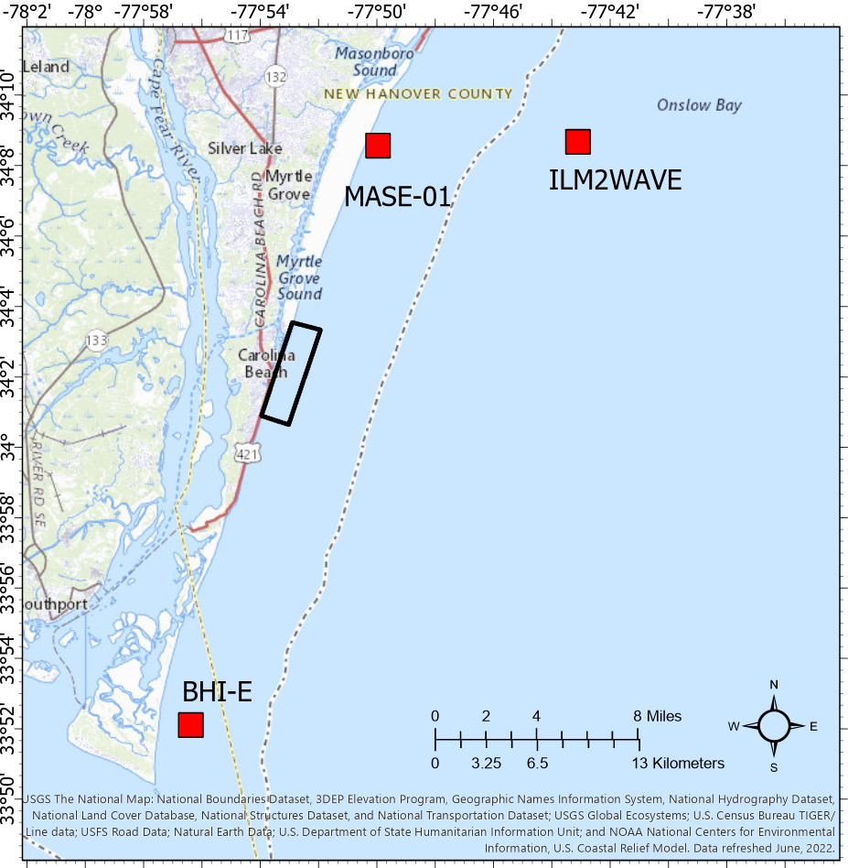

Figure 1. Wave buoys (red squares) near the field site at Carolina Beach (black box).

Table 2. Ranges and averages of wave parameters measured by the CORMP ILM2WAVE buoy from the most recent seasons (Autumn 2021 - Summer 2022). Parameters include significant wave height (), peak wave period (), and peak wave direction (). Source: [CORMP ILM2WAVE](https://cormp.org/?health=Off&quality=Off&units=Metric&duration=1%20year&maps=storm_tracks&legend=Off&forecast=Point&hti=&nhc=undefined&nhcWinds=undefined&sst=&current=&datum=MLLW&windPrediction=wind%20speed%20prediction&region=&bbox=-78.86535644531251,33.81110228864701,-77.21466064453126,34.52239858066334&iframe=null&mode=home&basemap=Streets&basemap_overlays=Bathymetry&layer_opacity=100&platform=ILM2WAVE).

|  |  |  |  |  |  |  |  |  |
| --- | --- | --- | --- | --- | --- | --- | --- | --- |
| **Year** | **Season** | **Range [m, MLLW]** | **Avg [m]** | **Range [s]** | **Avg [s]** | **Range [deg N]** | **Avg [deg N]** | **Avg [abbrev.]** |
| 2021 | Autumn | 0.26-2.95 | 0.88 | 1.85-20 | 8.43 | 3-358 | 118.45 | ESE |
| 2021-22 | Winter | 0.34-3.85 | 0.98 | 2.44-15.38 | 7.70 | 1-360 | 123.53 | ESE |
| 2022 | Spring | 0.37-2.84 | 0.91 | 2.33-16.67 | 7.10 | 1-353 | 134.76 | SE |
| 2022 | Summer | 0.33-2.01 | 0.82 | 2.5-16.67 | 7.33 | 20-347 | 135.05 | SE |

Table 3. Ranges and averages of wave parameters measured by the UNCW MASE-01 buoy from the most recent seasons (Autumn 2021 - Summer 2022). Parameters include significant wave height (), peak wave period (), mean wave period (), peak wave direction () and mean wave direction (). Source: [CORMP MASE-01](https://cormp.org/?health=Off&quality=Off&units=Metric&duration=1%20year&maps=storm_tracks&legend=Off&forecast=Point&hti=&nhc=undefined&nhcWinds=undefined&sst=&current=&datum=MLLW&windPrediction=wind%20speed%20prediction&region=&bbox=-78.64837646484376,33.69235234723729,-76.99768066406251,34.40464357107097&iframe=null&mode=home&basemap=Streets&basemap_overlays=Bathymetry&layer_opacity=100&platform=MASE-01).

|  |  |  |  |  |  |  |  |  |
| --- | --- | --- | --- | --- | --- | --- | --- | --- |
| **Year** | **Season** | **Range [m, MLLW]** | **Avg [m]** | **Range [s]** | **Avg [s]** | **Range [deg N]** | **Avg [deg N]** | **Avg [abbrev.]** |
| 2021 | Autumn | 0.20-3.67 | 0.66 | 2.22-34.12 | 8.68 | 7.68-261.29 | 113.73 | ESE |
| 2021-22 | Winter | 0.24-2.96 | 0.73 | 2.76-34.12 | 7.92 | 0.12-352.43 | 118.20 | ESE |
| 2022 | Spring | 0.22-2.62 | 0.69 | 2.48-25.60 | 7.40 | 46.94-334.09 | 123.01 | ESE |
| 2022 | Summer | 0.28-1.77 | 0.65 | 2.56-34.12 | 7.59 | 21.87-342.38 | 124.04 | SE |

|  |  |  |  |  |  |  |
| --- | --- | --- | --- | --- | --- | --- |
| **Year** | **Season** | **Range [s]** | **Avg [s]** | **Range [deg N]** | **Avg [deg N]** | **Avg [abbrev.]** |
| 2021 | Autumn | 2.48-13.24 | 5.10 | 51.60-235.65 | 113.00 | ESE |
| 2021-22 | Winter | 2.90-15.74 | 5.03 | 8.07-352.43 | 117.04 | ESE |
| 2022 | Spring | 2.76-10.46 | 4.60 | 69.17-170.22 | 124.53 | SE |
| 2022 | Summer | 3.00-14.28 | 7.60 | 78.81-126.83 | 161.95 | SSE |

Table 4. Ranges and averages of wave parameters measured by the UNCW BHI-E buoy from the most recent seasons (Autumn 2021 - Summer 2022). Parameters include significant wave height (), peak wave period (), mean wave period (), peak wave direction () and mean wave direction (). Source: [CORMP BHI-E](https://cormp.org/?health=Off&quality=Off&units=Metric&duration=1%20year&maps=storm_tracks&legend=Off&forecast=Point&hti=&nhc=undefined&nhcWinds=undefined&sst=&current=&datum=MLLW&windPrediction=wind%20speed%20prediction&region=&bbox=-78.64837646484376,33.69235234723729,-76.99768066406251,34.40464357107097&iframe=null&mode=home&basemap=Streets&basemap_overlays=Bathymetry&layer_opacity=100&platform=BHI-E).

|  |  |  |  |  |  |  |  |  |  |  |
| --- | --- | --- | --- | --- | --- | --- | --- | --- | --- | --- |
| **Year** | **Season** | **Range [m, MLLW]** | | | **Avg [m]** | **Range [s]** | **Avg [s]** | **Range [deg N]** | **Avg [deg N]** | **Avg [abbrev.]** |
| 2021 | Autumn | | 0.25-3.88 | 0.74 | | 2.68-34.12 | 8.82 | 5.07-349.49 | 104.42 | ESE |
| 2021-22 | Winter | | 0.26-2.93 | 0.80 | | 2.48-34.12 | 8.00 | 12.65-354.19 | 107.46 | ESE |
| 2022 | Spring | | 0.26-2.72 | 0.70 | | 2.16-34.12 | 7.72 | 1.48-346.32 | 113.97 | ESE |
| 2022 | Summer | | 0.28-3.76 | 0.62 | | 2.62-34.12 | 7.87 | 38.40-350.19 | 116.50 | ESE |

|  |  |  |  |  |  |  |
| --- | --- | --- | --- | --- | --- | --- |
| **Year** | **Season** | **Range [s]** | **Avg [s]** | **Range [deg N]** | **Avg [deg N]** | **Avg [abbrev.]** |
| 2021 | Autumn | 2.74-14.32 | 4.99 | 48.68-172.79 | 103.56 | ESE |
| 2021-22 | Winter | 2.92-13.16 | 4.89 | 8.80-107.27 | 13.16 | NNE |
| 2022 | Spring | 2.82-15.32 | 4.52 | 1.22-344.25 | 117.05 | ESE |
| 2022 | Summer | 2.94-16.72 | 4.47 | 29.05-120.56 | 120.56 | SE |

1. **100-Year Water Levels**

A hydrodynamic analysis and 1% recurrence interval of a 100-year storm was tested by the USACE HEC-RAS computer program (FEMA, 2019). The program was calibrated using historic storm water level data and tidal gauges. Other models used were ADCIRC, CHAMP 2.0, and WHAFIS 4.0 (FEMA, 2019). The historic data records mainly consist of storm surge data and astronomical tide constituents. Cross-shore transects were identified with varying alongshore spacing around 0.2 miles along Carolina Beach, NC. The more closely spaced transects are in areas of highly variable topography where the still-water elevation is expected to differ. The further spaced transects are located in areas of more topographic uniformity. The still-water levels were determined considering analyses of wave height, wave runup, wave setup, tides, and storm surge values. For consistent initial testing conditions, the model was set to have an initial significant wave height () of 19.1 ft (5.82 m) and peak wave period () of 11.2 seconds. The model output of water level for transects 17 through 27 are listed in Table 5.

Table 5. Ranges of still-water elevation for 100-year storm at transects 17-27. Source: FEMA FIS Report (2019)

|  |  |  |
| --- | --- | --- |
| **Coastal Transect** | **Range of Still-water Elevation** | |
| **[ft, NAVD88]** | **[m, NAVD88]** |
| 17 | 8.9-10.2 | 2.7-3.1 |
| 19 | 10.2-10.3 | 3.1 |
| 21 | 10.1-10.4 | 3.1-3.2 |
| 23 | 8.7-10.4 | 2.7-3.2 |
| 25 | 10.3-10.5 | 3.1-3.2 |
| 27 | 10.2-10.5 | 3.1-3.2 |

Figure 2. Transect map of New Hanover County used to determine still-water elevation. Transects 17 through 27 were used in analysis. Source: FEMA FIS Report (2019)

1. **Sea Level Rise and Projections**

In 2016, the sea level had risen 11 inches since 1950 around the New Hanover County area. This can be seen in Figure 3. In the last ten years, denoted by the red line in Figure 3, sea level has begun rising approximately one inch every two years.

Figure 3. Sea Level Rise in New Hanover County from 1950-2016. Source: SeaLevelRise.org

The rising sea level trend relative to Mean Sea Level (MSL) for Wilmington, North Carolina (~15 miles north of Carolina Beach) can be seen in Figure 4.

Figure 4. Relative Sea Level Trend from 1935 to 2021 at station 8658120. Source: NOAA

NOAA describes the relative sea level trend from 1935 until 2021 as an increase by 2.61 0.34 millimeters/year (0.103 0.01 inches/year). However, this is averaged from 1935. As stated previously, in the last decade, sea level rise has changed and has started increasing an inch every two years. This makes sea level rise difficult to predict in the future. Observations of the forecast for sea level rise in North Carolina indicate that there is a wide range of potential water levels in the future. Figure 5 illustrates the predicted range and mean until 2050.

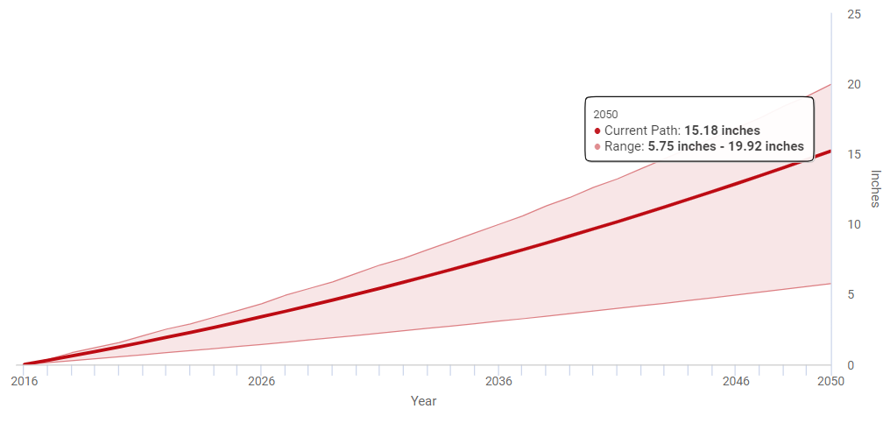

Figure 5. Sea level rise predictions from 2016-2050. Source: SeaLevelRise.org

It is challenging to predict for 50 years beyond of 2022, and current predictions are based on an average of one inch increase for every two years. For 50 years, a rise of 25 inches would be reasonably estimated based on the currently available data. Current MSL in meters as of July 2022 is 0.126 meters. With this rate of increase, an expected MSL in 50 years is 0.761 meters (current MSL plus expected rise in the next 50 years).

1. **References**

“Coastal Ocean Research and Monitoring Program.” *CORMP*, cormp.org/. Accessed 21 September 2022.

“Flood Insurance Study Status.” *FEMA*, www.fema.gov/flood-maps/change-your-flood-zone/status/flood-insurance-study/. Accessed 24 September 2022.

“North Carolina's Sea Level Is Rising.” *Sea Level Rise*, sealevelrise.org/states/north-carolina/. Accessed 21 September 2022.

“Sea Level Trends - NOAA Tides & Currents.” *Tides & Currents*, tidesandcurrents.noaa.gov/sltrends/sltrends.html/. Accessed 21 September 2022.