Tanner Elston
Assignment 2.2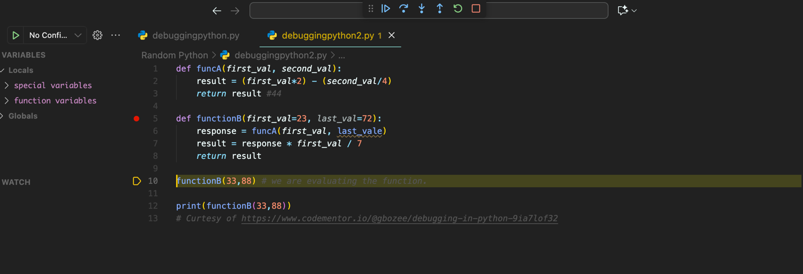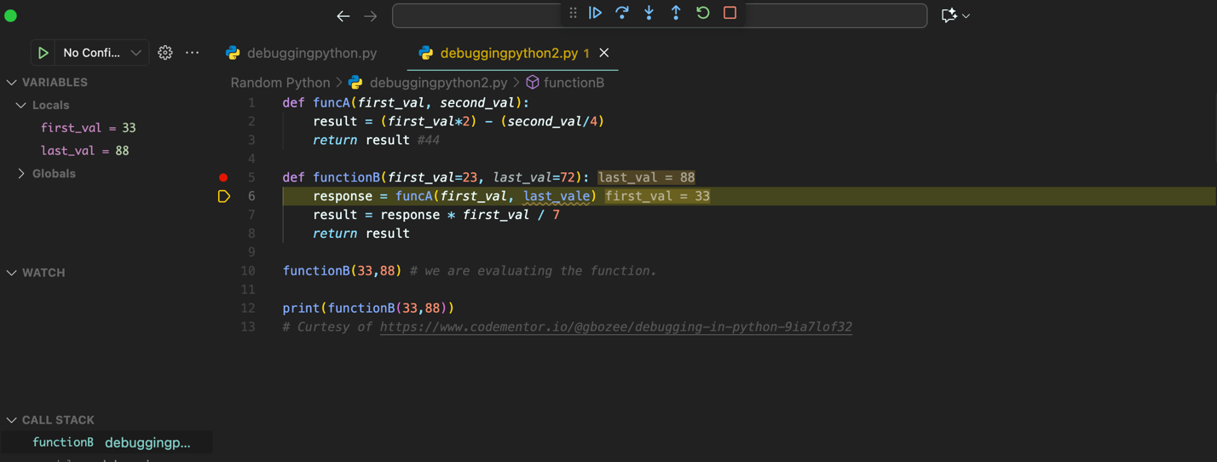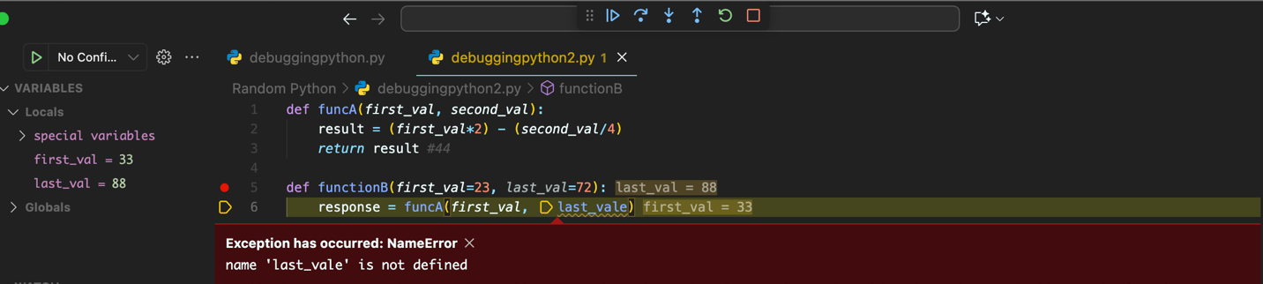
NameError, Align Parameter with Argument variable name.

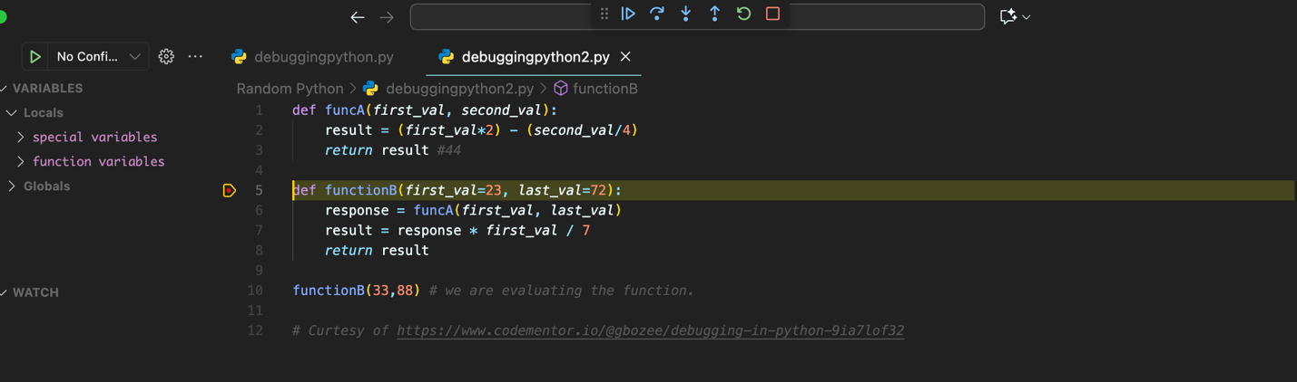

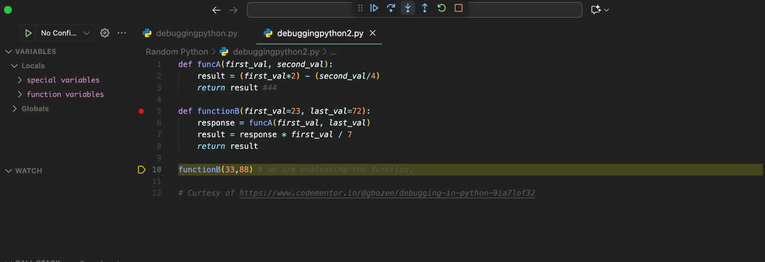
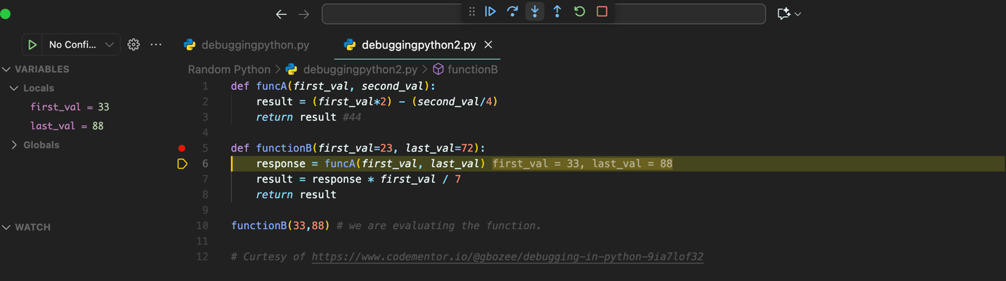
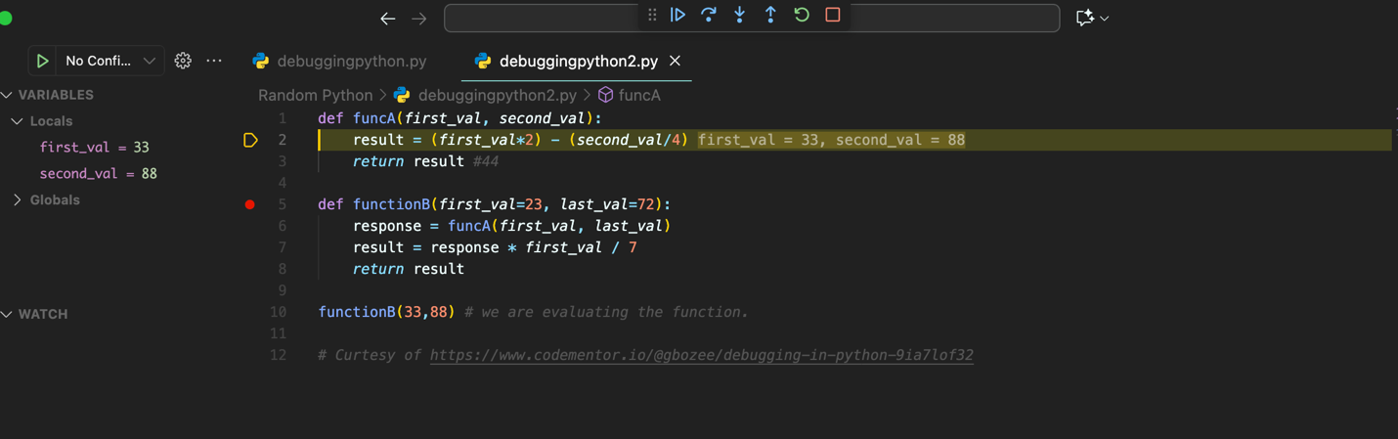
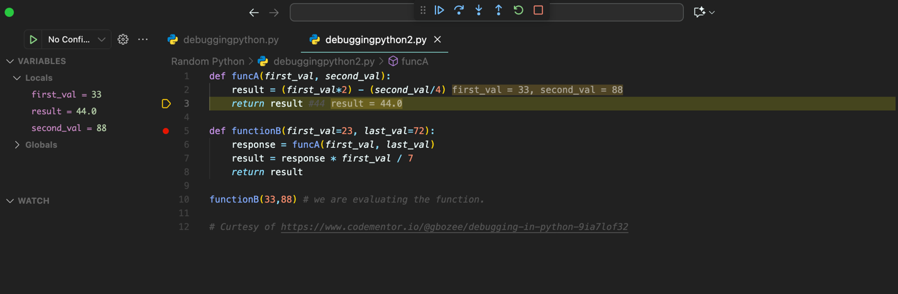

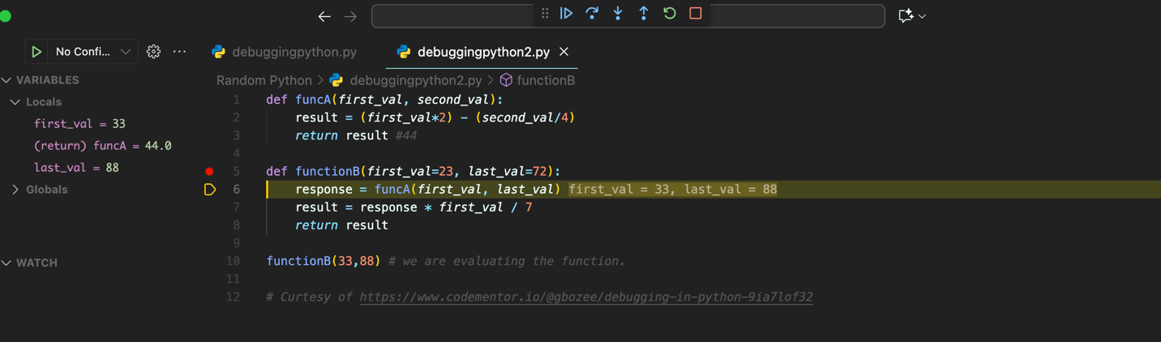

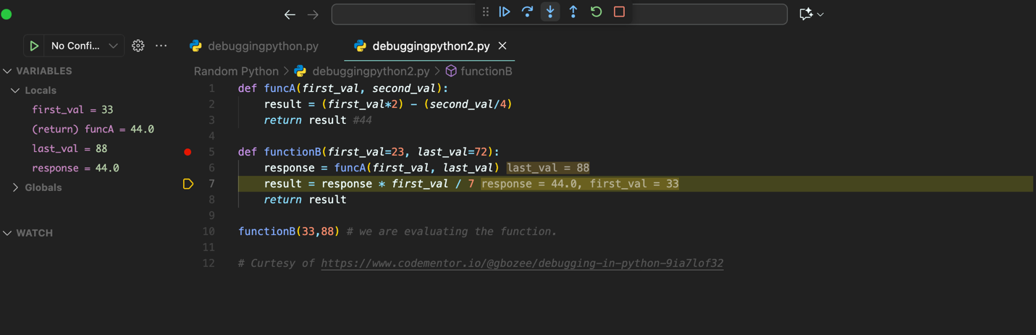

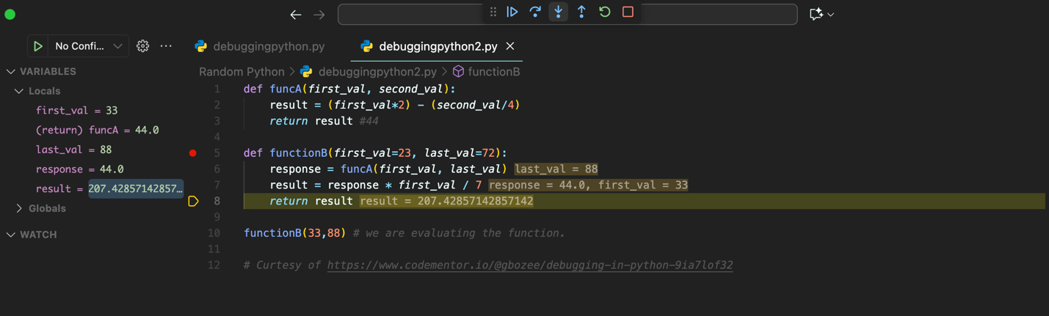

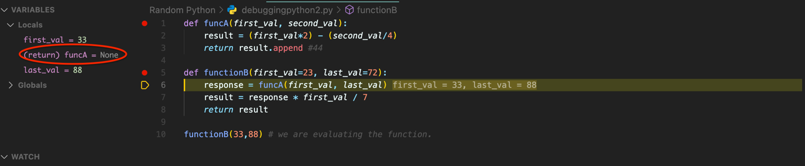
Append Method used on non-list variable, does not successfully pass funcA’s result into functionB’s response variable.

