Project: | Todo Application Test Plan
Course: | CSD 380 DevOps
Description: | Functional testing of the Todo web application based on the provided business requirements
Date: | 2026/09/30

Lane Dorscher – Module 4.2 Assignment – Test Plan Discussion
TABLE OF CONTENTS
Test 1 - View Todo List 2
View Todo List 2
Test 2 - Create a Todo Item 4
Create a Todo Item 4
Test 3 - Edit a Todo Item 6
Edit Existing Todo Task 6
Test 4 – Delete a Todo Item 8
Delete Existing Todo Task 8
Test 5 – Prevent an Empty Task 10
Prevent Empty Todo Submission 10

Test 1 - View Todo List
Requirement 1: View a list of todo task items.
Test 1 | View Todo List
 | Test Objective: Verify that a user can access the Todo application and view the Todo list | Developer: Lane Dorscher  Date tested: 2026/09/30 | Peer tester: Tanner Elston  Date tested: 2026/10/04
Step | Action | Expected results: | Developer pass/fail | Tester pass/fail  + Screenshot
1 | Open a supported web browser | Browser opens successfully | yes | yes  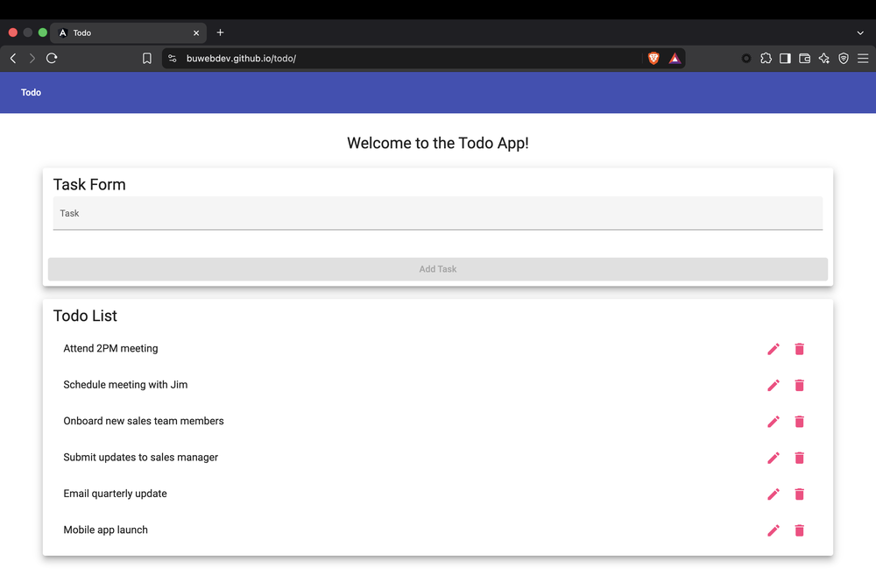
2 | Navigate to https://buwebdev.github.io/todo/. | Todo application loads without errors. | Yes | yes
3 | Locate the Todo List section. | Todo List section is visible on the page. | Yes | yes  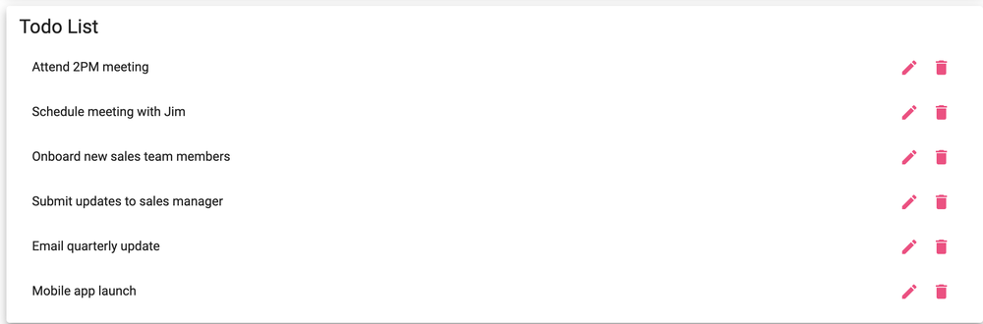
4 | Review the existing task items. | Existing Todo items are displayed in the list. | Yes | yes
5 | Refresh the browser. | Application reloads and the Todo List is displayed correctly. | Yes | yes
Comments | All five steps passed. The Todo List loaded with the six default tasks and displayed correctly again after a refresh. Step 1 tests the browser rather than the application, so it could be replaced with a step that checks something specific on the page, such as the number of tasks in the list.

Test 2 - Create a Todo Item
Requirement 2: Create a new todo task item
Test 2 | Create a Todo Item
 | Test Objective: Verify that a user can enter a new Todo item and add it to the Todo list. | Developer: Lane Dorscher  Date tested: 2026/09/30 | Peer tester: Tanner Elston  Date tested: 2026/10/04
Step | Action | Expected results: | Developer pass/fail | Tester pass/fail  + Screenshot
1 | Navigate to the Todo application. | Todo application loads successfully. | Yes | yes
2 | Click inside the Task Form text field. | Text field receives focus and allows input. | Yes | yes  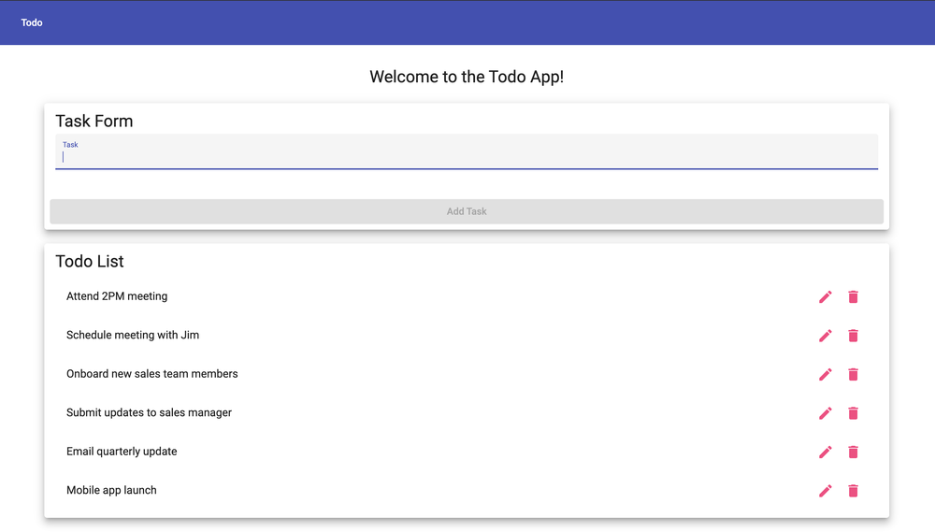
3 | Enter Complete DevOps Assignment. | Entered text appears correctly in the field. | Yes | yes  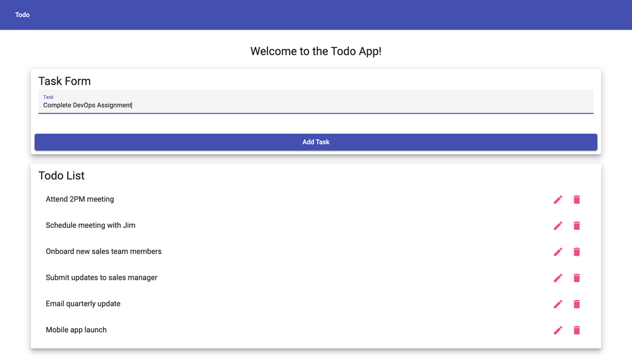
4 | Click Add Task. | Task is submitted without errors. | Yes | yes  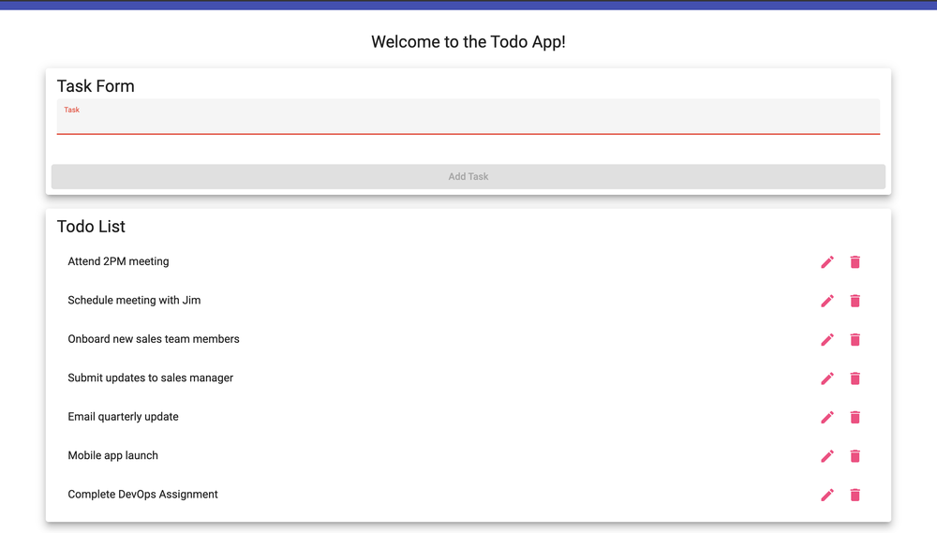
5 | Review the Todo List. | Complete DevOps Assignment appears as a new Todo item. | Yes | yes
Comments | All five steps passed, and Complete DevOps Assignment appeared at the bottom of the Todo List. The expected result for step 4 could be more specific, for example noting that the Task field clears and the Add Task button is disabled again after the task is added.

Test 3 - Edit a Todo Item
Requirement 3: Edit a todo task item.
Test 3 | Edit Existing Todo Task
 | Test Objective: Verify that a user can modify an existing Todo item and save the updated value. | Developer: Lane Dorscher  Date tested: 2026/09/30 | Peer tester: Tanner Elston  Date tested: 2026/10/04
Step | Action | Expected results: | Developer pass/fail | Tester pass/fail  + Screenshot
1 | Navigate to the Todo application. | Todo application loads successfully. | Yes | yes
2 | Locate an existing Todo item. | Locate an existing Todo item. | Yes | yes  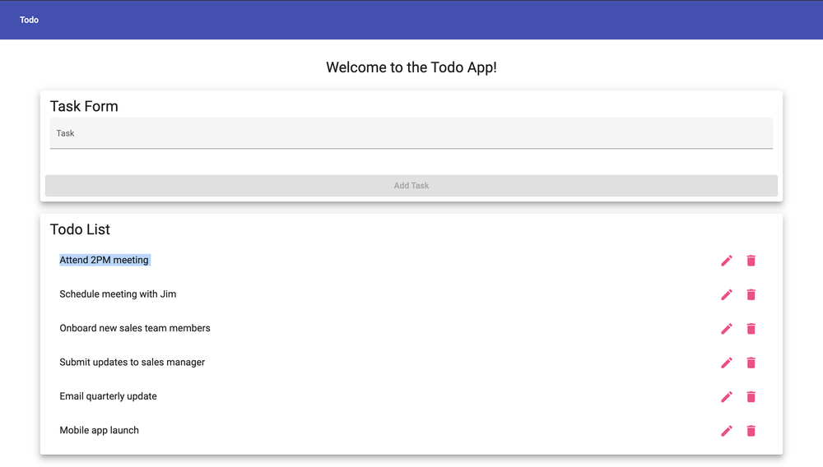
3 | Select the Todo item to edit it. | Edit form opens for the selected Todo item. | Yes | yes  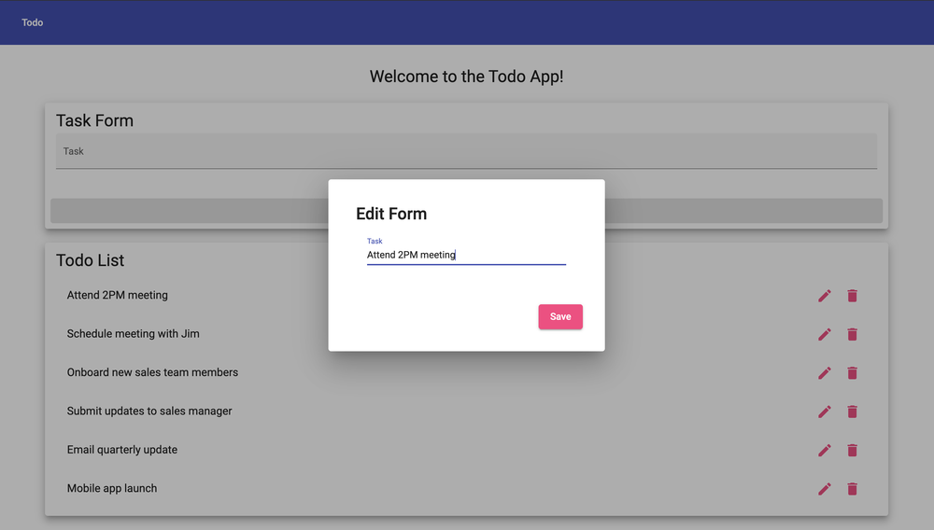
4 | Replace the existing text with Complete CSD 380 Assignment. | New text appears in the edit field. | Yes | yes  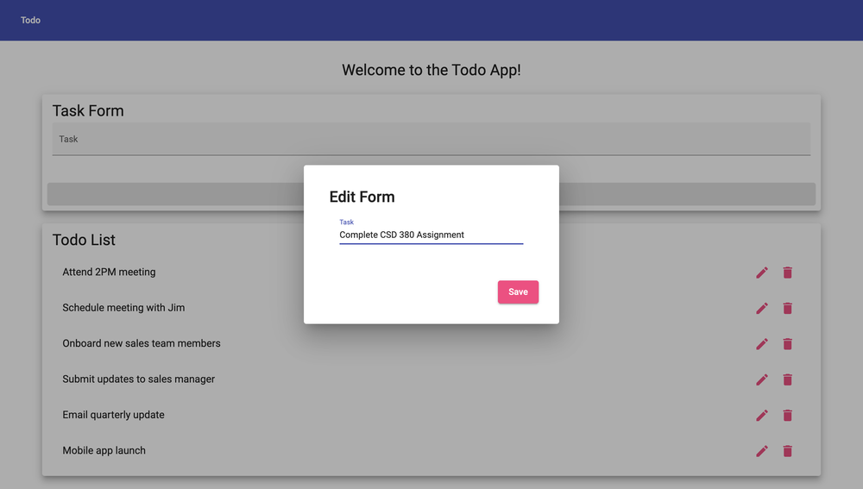
5 | Click Save. | Updated Todo item is saved without errors. | Yes | yes  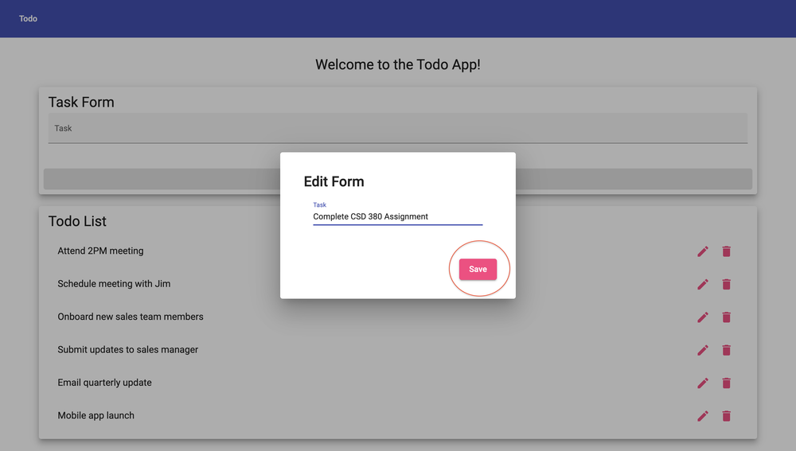
6 | Review the Todo List. | Updated text is displayed and the previous value is no longer shown. | Yes | yes  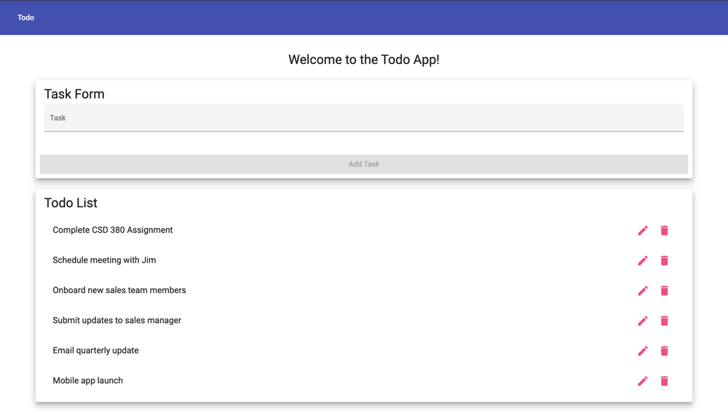
Comments | All six steps passed, and Complete CSD 380 Assignment replaced the original task in the same position. The expected result for step 2 repeats the action, so it could describe what the tester should see instead. Step 3 could also mention the pencil icon so the tester knows how to open the Edit Form.

Test 4 – Delete a Todo Item
Requirement 4: Delete a todo task item.
Test 4 | Delete Existing Todo Task
 | Test Objective: Verify that a user can delete an existing Todo item without removing other tasks. | Developer: Lane Dorscher  Date tested: 2026/09/30 | Peer tester: Tanner Elston  Date tested: 2026/10/04
Step | Action | Expected results: | Developer pass/fail | Tester pass/fail  + Screenshot
1 | Navigate to the Todo application. | Todo application loads successfully. | Yes | yes
2 | Add a new task named Delete Test Task. | Task appears in the Todo List. | Yes | yes  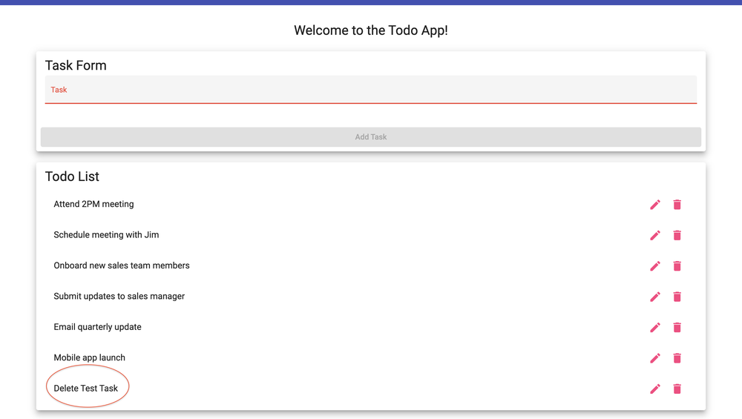
3 | Locate Delete Test Task in the list. | Correct Todo item is visible and selectable. | Yes | yes
4 | Select the delete option for Delete Test Task. | Application processes the delete request. | Yes | yes  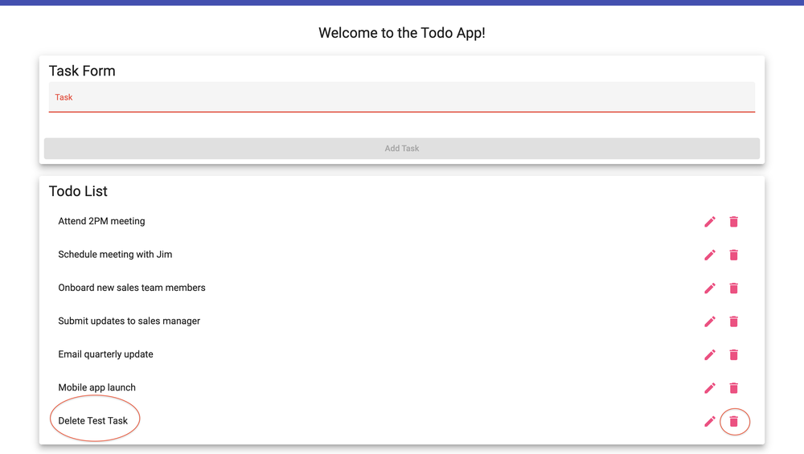
5 | Review the Todo List. | Delete Test Task is no longer displayed. | Yes | yes  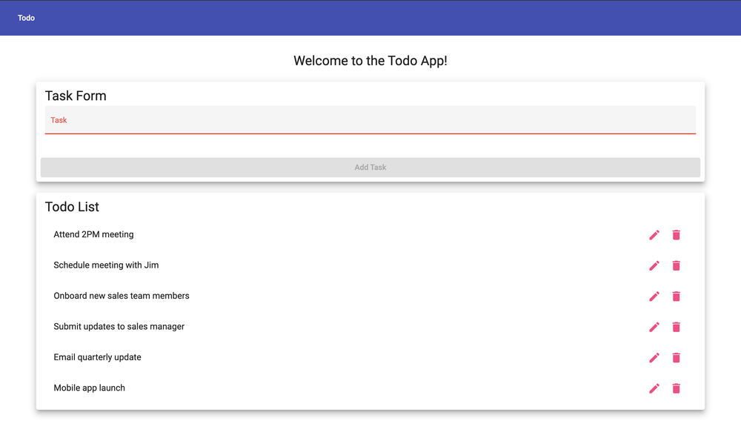
6 | Review the remaining Todo items. | Other Todo items remain in the list and are unchanged. | Yes | yes
Comments | All six steps passed. Delete Test Task was added and then removed, and the six default tasks stayed in the list unchanged. The expected result for step 4 is hard to verify on screen, so describing what the tester sees, such as the task disappearing from the list right away, would make it clearer.

Test 5 – Prevent an Empty Task
Requirement 6: Prevent users from submitting a task form without entering a todo item.
Test 5 | Prevent Empty Todo Submission
 | Test Objective: Verify that the application does not allow a user to create a Todo item without entering task information. | Developer: Lane Dorscher  Date tested: 2026/09/30 | Peer tester: Tanner Elston  Date tested: 2026/10/04
Step | Action | Expected results: | Developer pass/fail | Tester pass/fail  + Screenshot
1 | Navigate to the Todo application. | Todo application loads successfully. | Yes | yes
2 | Locate the Task Form. | Task Form and Add Task button are displayed. | Yes | yes  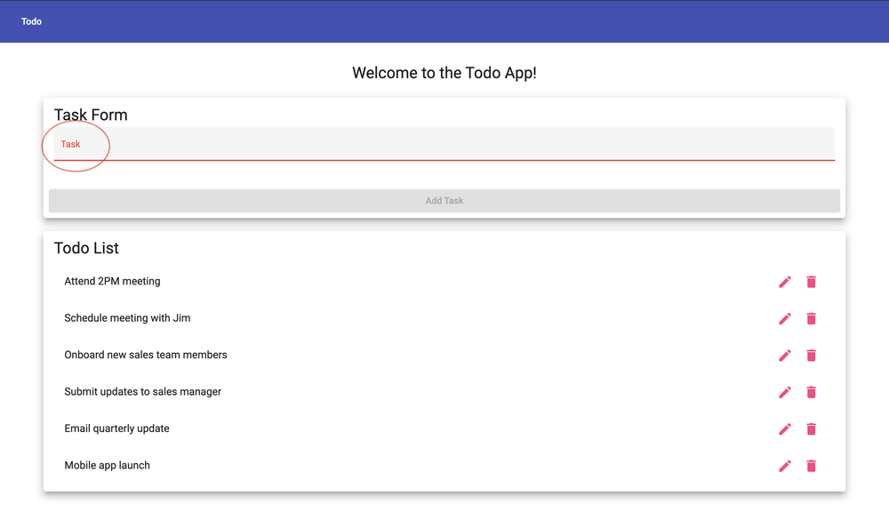
3 | Leave the task text field empty. | Text field remains empty. | Yes | yes
4 | Click Add Task. | Application prevents the empty task from being submitted. | Yes | yes  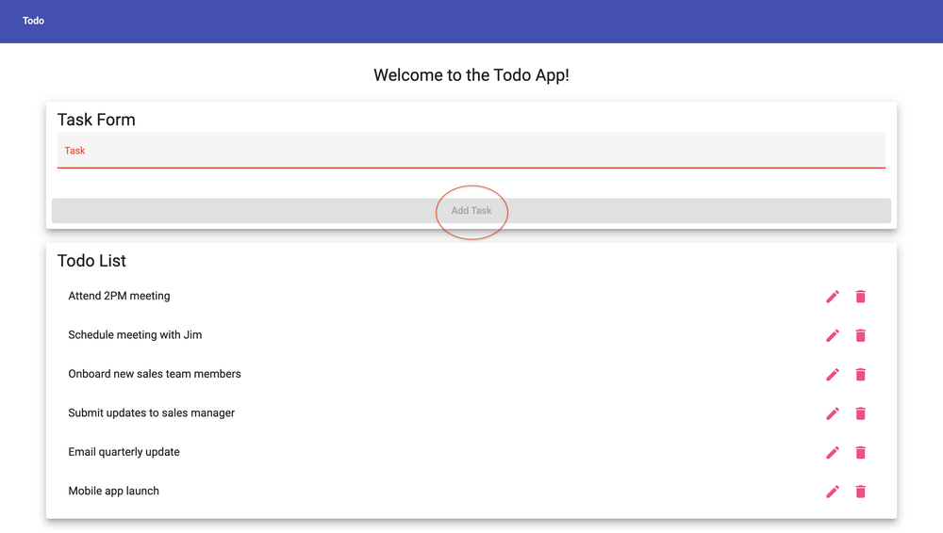
5 | Review the Todo List. | No blank Todo item is added to the list. | Yes | yes
Comments | All five steps passed. The Add Task button stays disabled while the Task field is empty, so no blank task can be added. One gap is that entering only spaces enables the button and adds a blank row to the list, so adding a step that tests a space-only entry would make this test cover that case.

