Student Name: Rakesh Shrestha
Assignment: Module 4.2 Assignment: Test Plan
Project: | Todo Application (https://buwebdev.github.io/todo/)
Course: | CSD380-T301 DevOps (2271-1)
Description: | Functional test plan for the Todo application covering all ten requirements in the Todo Business Requirements document. Test environment: Google Chrome (latest) on Windows 11.
Date: | 2026/10/03

TABLE OF CONTENTS
Test Plan Purpose and Requirements Coverage 2
Test 1: Open the Todo App and View the Task List 3
Test 2: Create a Task and Block an Empty Task 4
Test 3: Edit a Task and Block an Empty Edit 6
Test 4: Delete a Task 8
Test 5: Invalid URL Shows a Custom 404 Page 9
Test 6: Mobile and Tablet Views 11
Execution Notes and Reference 13

Test Plan Purpose
The assignment requires at least five functional tests. This plan includes six, which together cover all ten requirements in the Todo Business Requirements document: viewing, creating, editing, and deleting tasks; blocking empty entries on both the task form and the edit form; showing a custom 404 page for invalid URLs; supporting mobile and tablet screens; and reaching the site through https://buwebdev.github.io/todo/.
I wrote each step around the actual buttons and labels in the app and in the prototypes from the requirements document, such as the "Add Task" button, the "Edit Form" window, and the pencil and trash can icons, so anyone can repeat the tests and get the same results. I ran each test myself on 2026/10/03 and recorded the results in the Developer pass/fail column. The Tester pass/fail and Comments fields are left for the peer tester in Module 4.3. The tests are planned for Google Chrome on Windows 11.
Requirements Coverage Matrix
Requirement # | Business Requirement | Test Case
1 | View a list of todo task items | Test 1
2 | Create a new todo task item | Test 2
3 | Edit a todo task item | Test 3
4 | Delete a todo task item | Test 4
5 | For invalid URLs, provide users with a custom 404 error page | Test 5
6 | Prevent users from submitting a task form without entering a todo item | Test 2
7 | Prevent users from submitting the edit form without entering a todo item | Test 3
8 | Provide users with a view for mobile devices | Test 6
9 | Provide users with a view for tablet devices | Test 6
10 | Allow users to visit the website through https://buwebdev.github.io/todo/ | Test 1

Test 1  TC-01 | Open the Todo App and View the Task List
 | Test Objective: Verifies requirements 1 and 10. Verify the app loads at the required URL and shows the Todo task list.  Precondition: A current web browser and an internet connection.  Test Data: URL: https://buwebdev.github.io/todo/ | Developer: Rakesh Shrestha  Date tested: 2026/10/03 | Peer tester: Tanner Elston  Date tested: 2026/10/04
Step | Action | Expected results: | Developer pass/fail | Tester pass/fail  + Screenshot
1 | Open the browser and go to https://buwebdev.github.io/todo/. | The page loads with no error. The browser tab reads "Todo". | Yes | yes  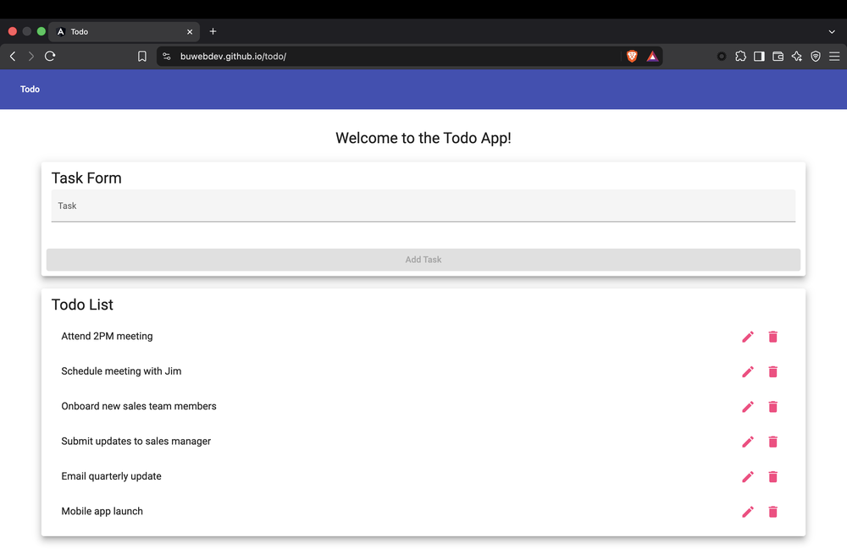
2 | Look at the top of the page. | A blue toolbar with a "Todo" button appears, along with the heading "Welcome to the Todo App!" | Yes | yes  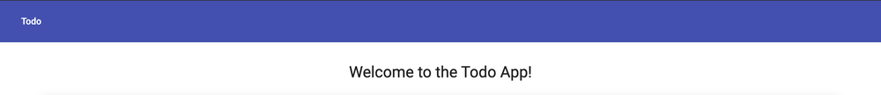
3 | Look at the "Todo List" card. | Six default tasks are listed, starting with "Attend 2PM meeting" and ending with "Mobile app launch." | Yes | yes  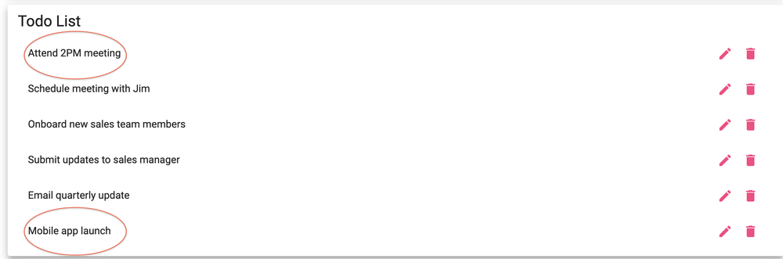
4 | Look at the right side of each task. | Each task has an edit (pencil) icon and a delete (trash can) icon. | Yes | yes  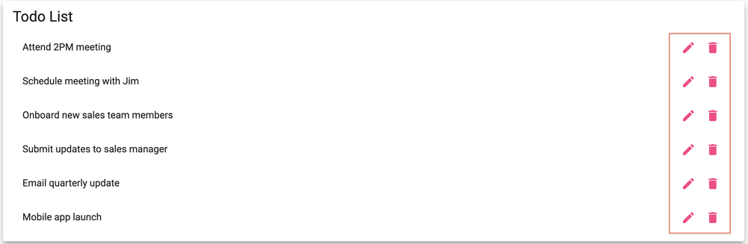
5 | Refresh the browser window. | The page reloads correctly and the same six tasks are shown. | Yes | yes  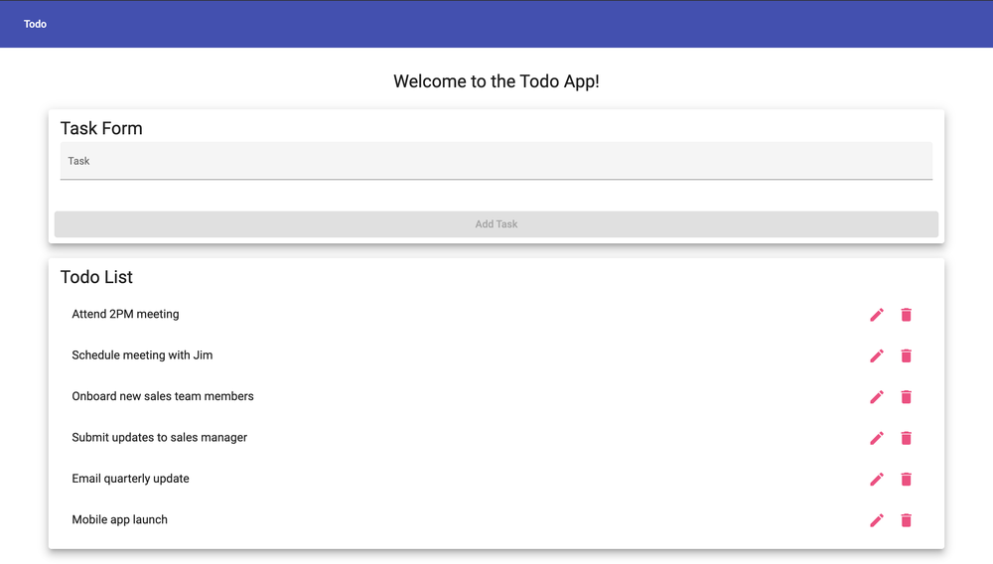
Comments | All five steps passed. The page loaded at the required URL with the Todo tab title, toolbar, heading, and the six default tasks with edit and delete icons, and everything reloaded correctly after a refresh. Splitting the page check into separate steps for the toolbar, the list, and the icons made each result easy to verify.

Test 2  TC-02 | Create a Task and Block an Empty Task
 | Test Objective: Verifies requirements 2 and 6. Verify a user can add a new task, and that the Task Form cannot be submitted when the Task field is empty.  Precondition: The Todo app is open and showing the six default tasks.  Test Data: Valid task: "Module 4.2 Test Task". Invalid input: an empty Task field. | Developer: Rakesh Shrestha  Date tested: 2026/10/03 | Peer tester: Tanner Elston  Date tested: 2026/10/04
Step | Action | Expected results: | Developer pass/fail | Tester pass/fail  + Screenshot
1 | With the Task field empty, look at the "Add Task" button in the Task Form. | The "Add Task" button is grayed out and cannot be clicked. | Yes | yes  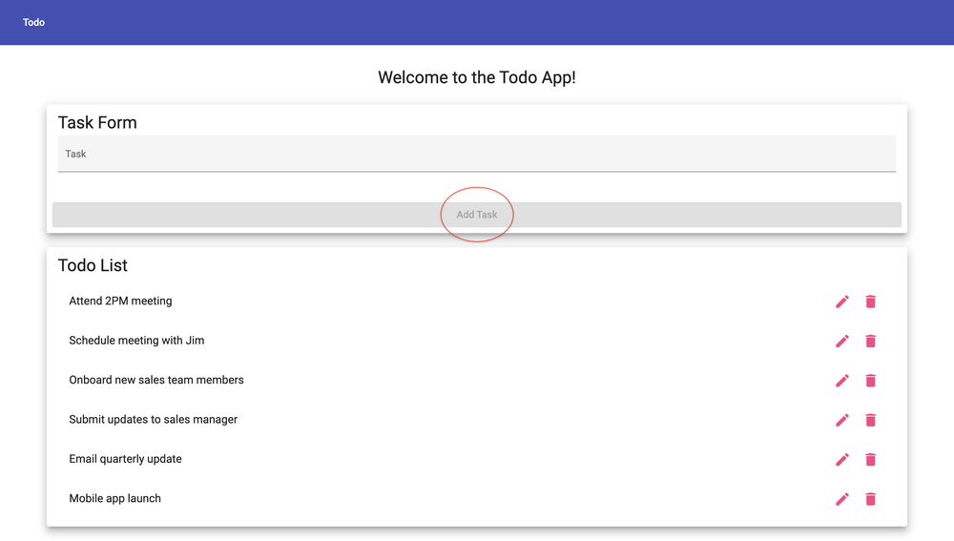
2 | Click inside the Task field, then click somewhere else on the page without typing. | The button stays disabled and nothing is added to the list. | Yes | yes  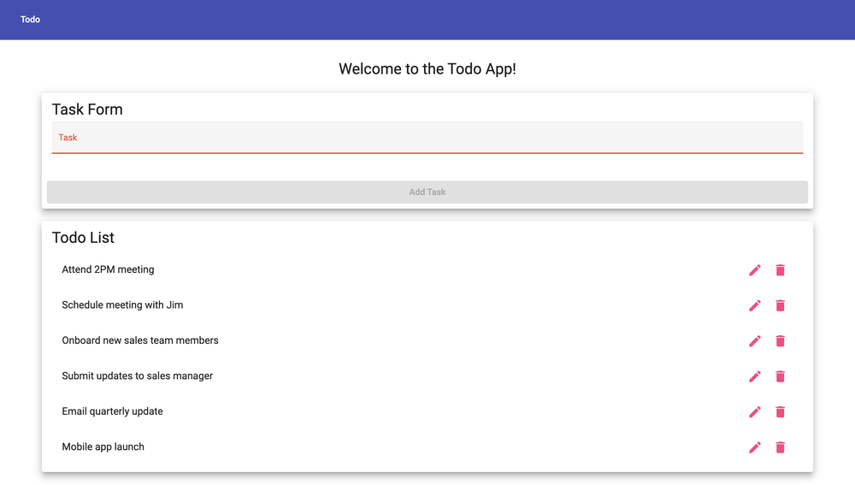
3 | Type "Module 4.2 Test Task" in the Task field. | The text shows in the field and the "Add Task" button becomes clickable. | Yes | yes  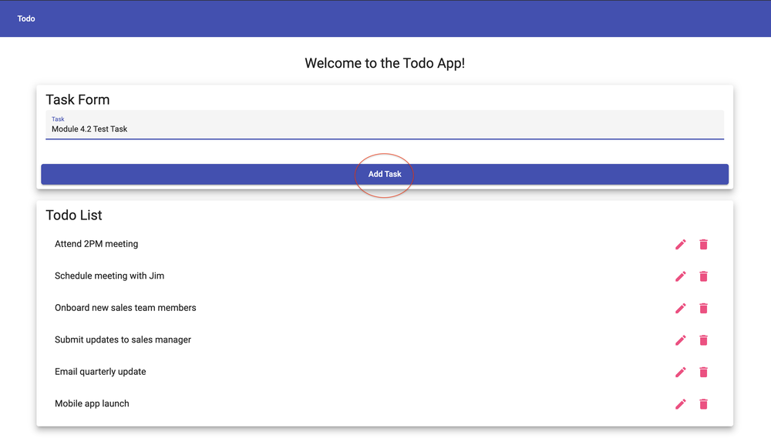
4 | Click "Add Task". | "Module 4.2 Test Task" appears at the bottom of the Todo List. | Yes | yes  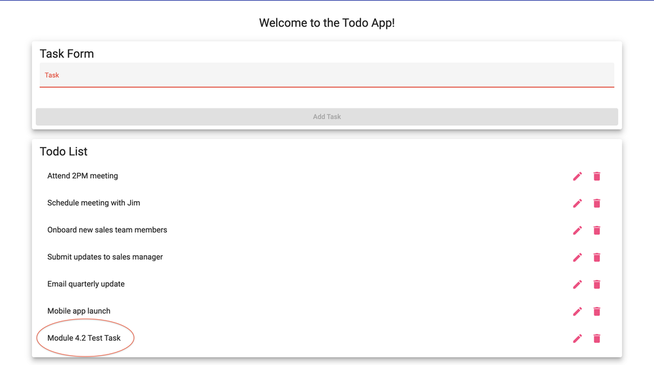
5 | Look at the Task field and count the tasks in the list. | The Task field is cleared, and the list now has seven tasks with no blank entries. | Yes | yes  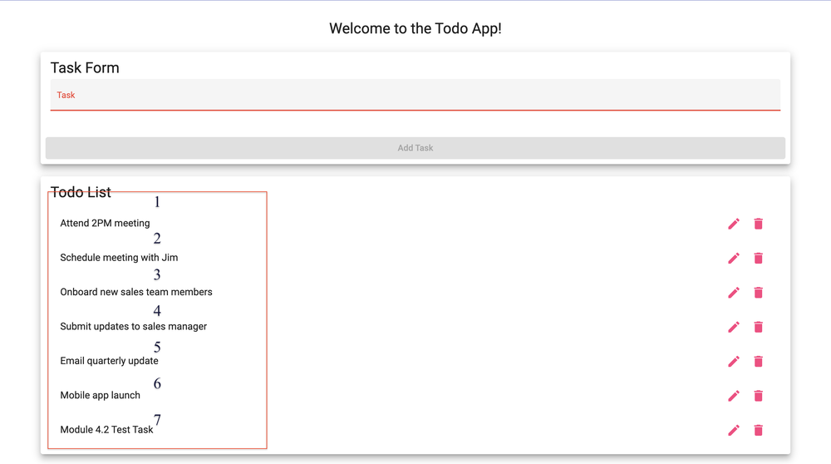
Comments | All five steps passed. The Add Task button stayed disabled with an empty field, and Module 4.2 Test Task was added as the seventh task with the field cleared afterward. One gap is that the form accepts an entry made of only spaces, which enables Add Task and adds a blank row, so a space-only step would make the empty-entry check more complete.

Test 3  TC-03 | Edit a Task and Block an Empty Edit
 | Test Objective: Verifies requirements 3 and 7. Verify a user can change a task through the Edit Form, and that the Edit Form cannot be saved with an empty task.  Precondition: Test 2 was just run in the same browser session, so "Module 4.2 Test Task" is in the list.  Test Data: Updated text: "Module 4.2 Updated Test Task". Invalid input: an empty Task field. | Developer: Rakesh Shrestha  Date tested: 2026/10/03 | Peer tester: Tanner Elston  Date tested: 2026/10/04
Step | Action | Expected results: | Developer pass/fail | Tester pass/fail  + Screenshot
1 | Click the pencil icon next to "Module 4.2 Test Task". | An "Edit Form" window opens with "Module 4.2 Test Task" already in the Task field. | Yes | yes  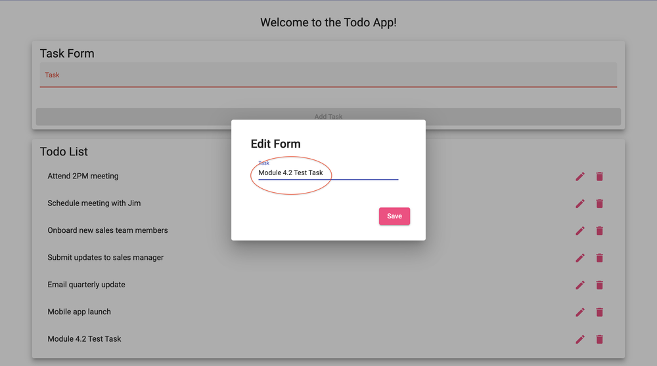
2 | Change the text to "Module 4.2 Updated Test Task" and click "Save". | The window closes and the task now reads "Module 4.2 Updated Test Task" in the same spot in the list. | Yes | yes  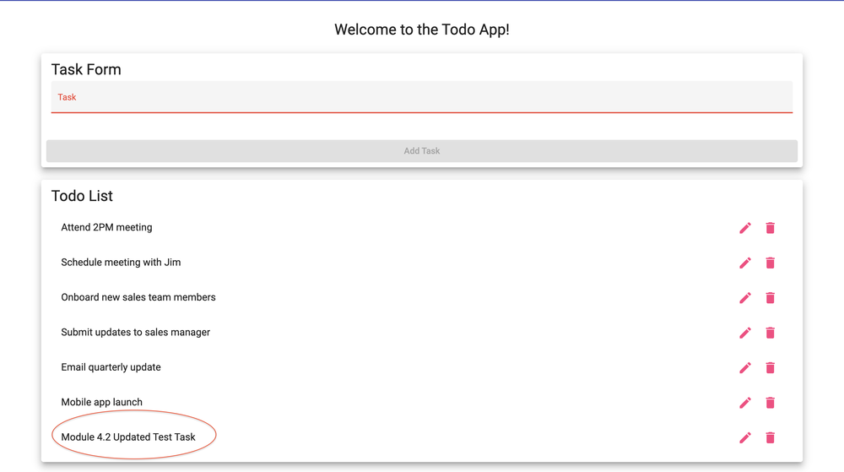
3 | Click the pencil icon next to the same task again. | The Edit Form opens with "Module 4.2 Updated Test Task" in the Task field. | Yes | yes  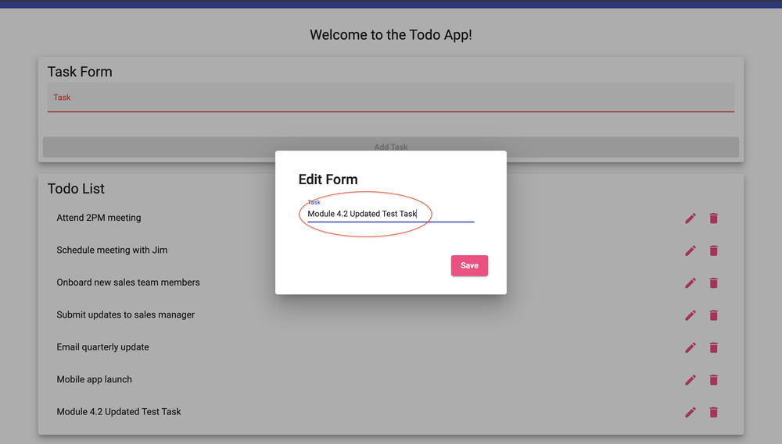
4 | Delete all of the text so the Task field is empty. | The Task field is empty. | Yes | yes  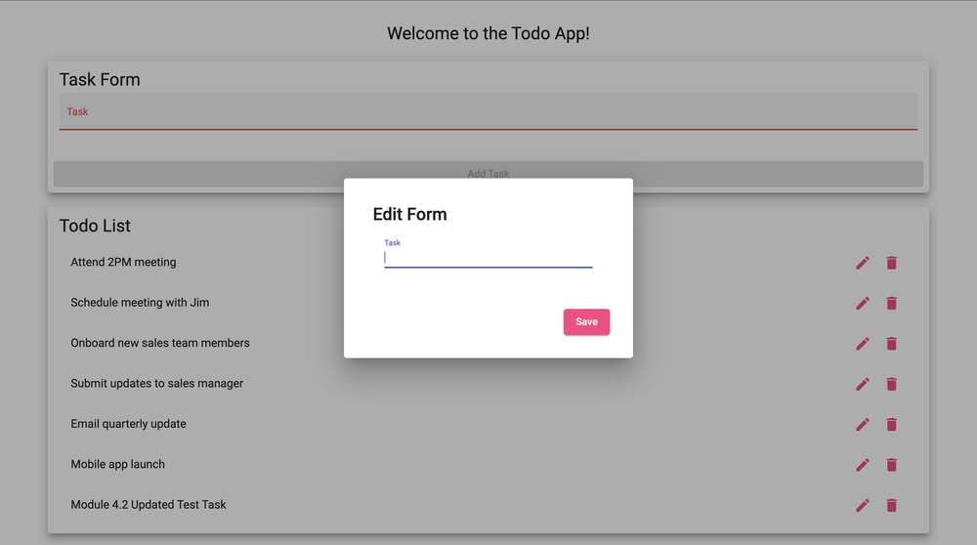
5 | Try to click "Save". | The Edit Form does not save the task when the Task field is empty, and no blank task is added to the list. | No  Save stayed active and closed the form. The task turned into a blank row. | no  Save stayed active and closed the form. The task became a blank row.  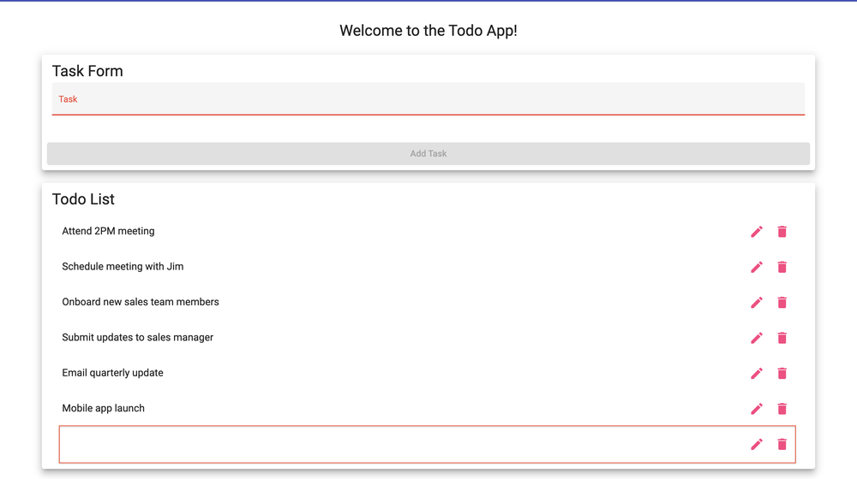
6 | Close the form if possible and check the task in the list. | The task still reads "Module 4.2 Updated Test Task." No blank task appears in the list. | No  Row 7 is now a blank task. | no  Row 7 is a blank task.
Comments | Steps 1 through 4 passed, and the edit to Module 4.2 Updated Test Task saved in the same position. Steps 5 and 6 failed the same way you recorded, since Save stayed active with an empty field and the task turned into a blank row, so Requirement 7 is not met. Describing what the user should see when the edit is rejected, such as a disabled Save button or an error message, would make the expected result easier to judge.

Test 4  TC-04 | Delete a Task
 | Test Objective: Verifies requirement 4. Verify a user can remove a task from the Todo List without affecting the other tasks.  Precondition: Test 3 was just run in the same session, so "Module 4.2 Updated Test Task" is in the list.  Test Data: Task to delete: "Module 4.2 Updated Test Task" | Developer: Rakesh Shrestha  Date tested: 2026/10/03 | Peer tester: Tanner Elston  Date tested: 2026/10/04
Step | Action | Expected results: | Developer pass/fail | Tester pass/fail  + Screenshot
1 | Count the tasks in the Todo List. | Seven tasks are listed. | Yes | yes  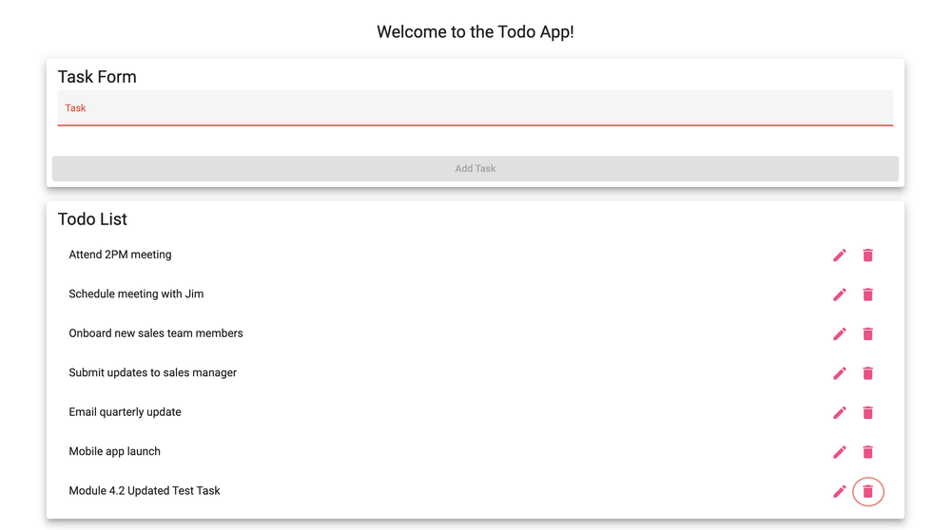
2 | Click the trash can icon next to "Module 4.2 Updated Test Task". | The task is removed from the list right away. | Yes  After Test 3 the task was blank, so I deleted that blank row in its place. | yes  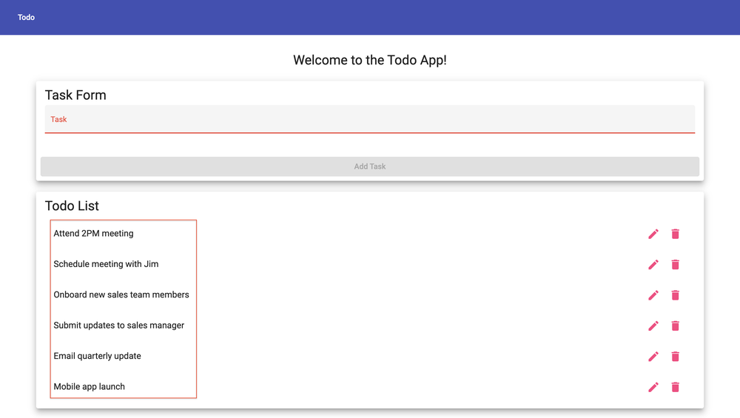
3 | Review the remaining tasks. | Six tasks remain, and they match the original default tasks. | Yes | yes
Comments | All three steps passed. The trash icon removed Module 4.2 Updated Test Task right away, and the six default tasks remained unchanged. Because this test depends on Tests 2 and 3, a failed edit can leave a blank row instead of the named task, so a setup step that adds the task directly would let Test 4 run on its own.

Test 5  TC-05 | Invalid URL Shows a Custom 404 Page
 | Test Objective: Verifies requirement 5. Verify that an invalid URL takes the user to the app's own 404 page instead of a blank page or a generic browser or server error.  Precondition: A current web browser and an internet connection.  Test Data: Invalid URLs: https://buwebdev.github.io/todo/not-a-real-page and https://buwebdev.github.io/todo/#/not-a-real-page | Developer: Rakesh Shrestha  Date tested: 2026/10/03 | Peer tester: Tanner Elston  Date tested: 2026/10/04
Step | Action | Expected results: | Developer pass/fail | Tester pass/fail  + Screenshot
1 | Open a new tab and go to https://buwebdev.github.io/todo/not-a-real-page. | A custom 404 page from the Todo app is shown, not a generic GitHub or browser error page. | Yes  Shows the app's own page at /todo/not-found. | yes  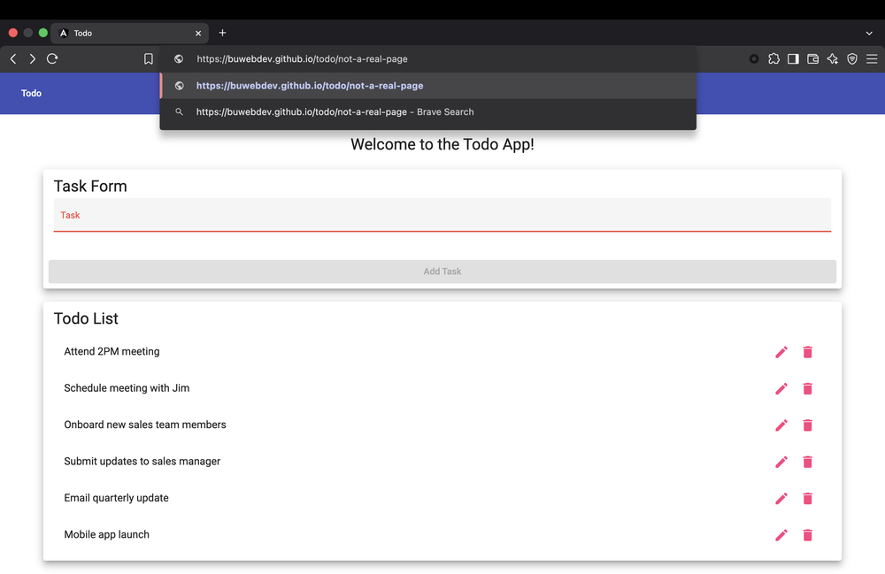  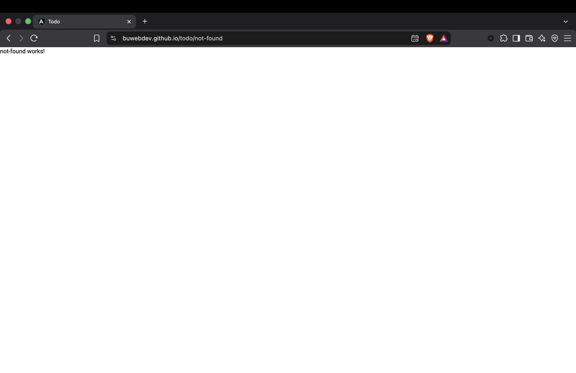
2 | Read the page that appears. | The page clearly tells the user the page was not found. | No  Page only says “not-found works!” with no message or link back. | no  Only shows “not-found works!” with no message or link home.
3 | Go to https://buwebdev.github.io/todo/#/not-a-real-page. | The same custom 404 page is shown. | No  The home page with the six tasks loaded instead of a 404 page. | no  The home page loaded instead of the 404 page.  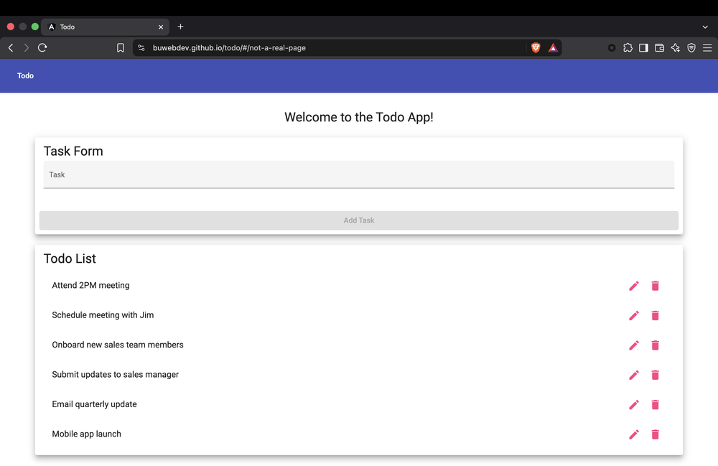
4 | Use the browser's Back button or go to the main URL again. | The Todo app loads normally with the six default tasks. | Yes  Back button went to /todo/not-a-real-page again. Typing the main URL loaded the app normally. | yes  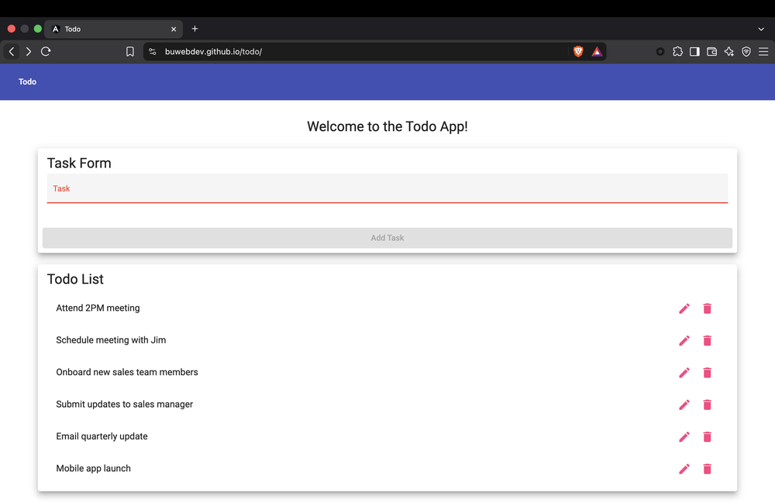
Comments | Steps 1 and 4 passed, but steps 2 and 3 failed. The invalid URL redirects to /todo/not-found, which only shows the placeholder text “not-found works!” with no message, toolbar, or link home, so Requirement 5 is only partly met. For step 3, the app uses path-based routing, so anything after the # is ignored and the home page loads, which means that step may be testing a URL style the app was never set up to handle.

Test 6  TC-06 | Mobile and Tablet Views
 | Test Objective: Verifies requirements 8 and 9. Verify the app adjusts to mobile and tablet screen sizes and stays usable.  Precondition: The Todo app is open in Google Chrome on a desktop or laptop.  Test Data: Mobile: iPhone 12 Pro (390 x 844). Tablet: iPad Mini (768 x 1024). | Developer: Rakesh Shrestha  Date tested: 2026/10/03 | Peer tester: Tanner Elston  Date tested: 2026/10/04
Step | Action | Expected results: | Developer pass/fail | Tester pass/fail  + Screenshot
1 | Press F12 (or Ctrl+Shift+I) to open Chrome DevTools, then click the device toolbar icon (or press Ctrl+Shift+M). | The page switches to a resizable device preview. | Yes | yes  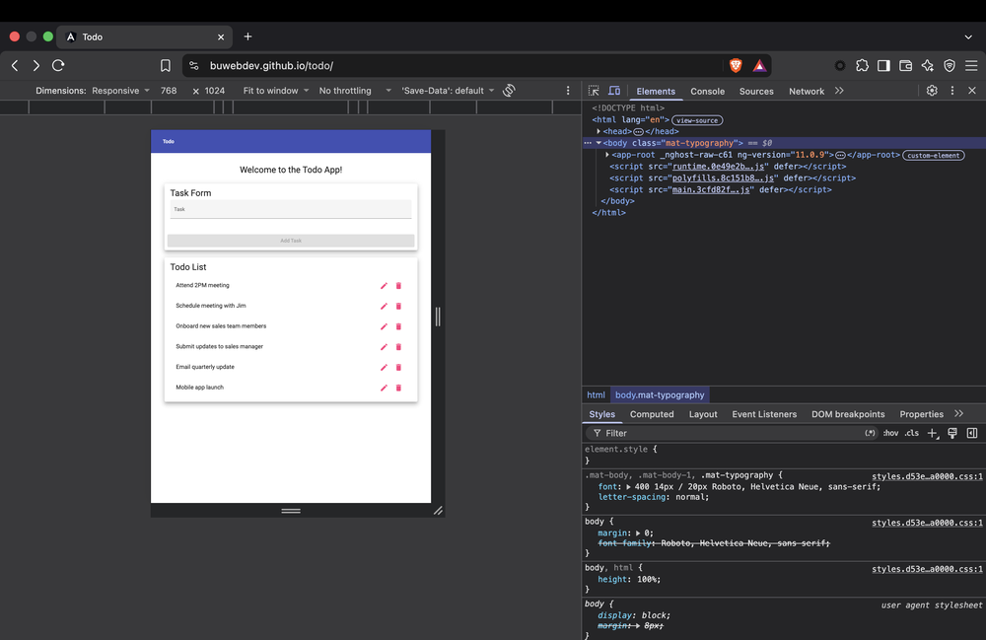
2 | Select "iPhone 12 Pro" from the device list. | The app fits the narrow screen with no sideways scrolling. | Yes | yes  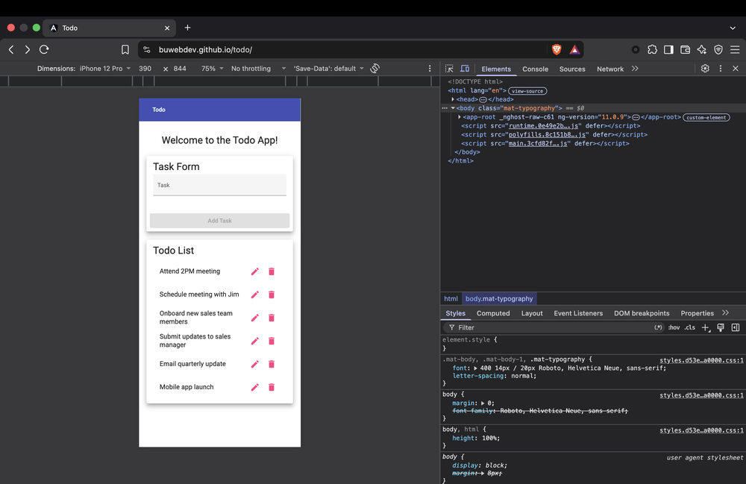
3 | Add a task called "Mobile test" and then delete it. | The Task field, the "Add Task" button, and the edit and delete icons are all readable and work. | Yes | yes  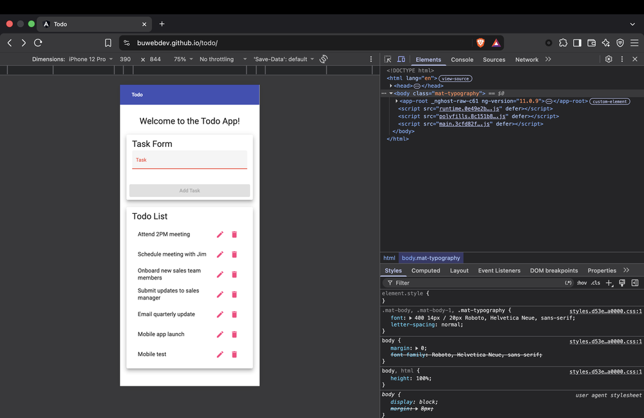  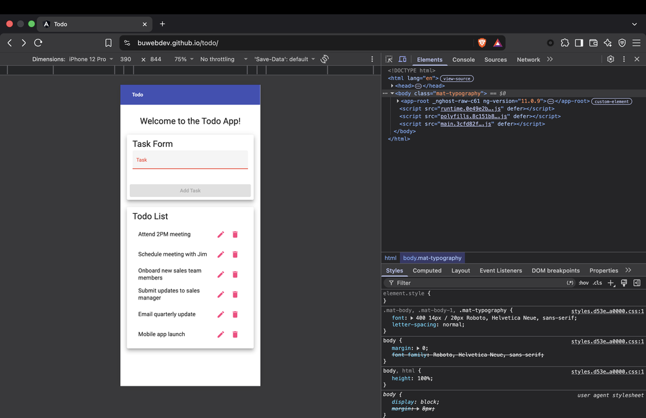
4 | Select "iPad Mini" from the device list. | The app fits the tablet screen with no sideways scrolling. | Yes | yes  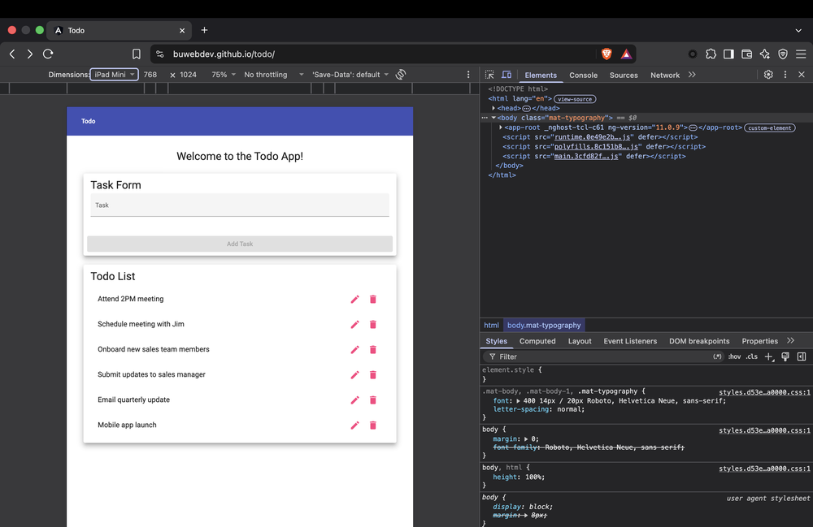
5 | Click the pencil icon on any task, then click "Save". | The Edit Form fits on the screen and the "Save" button can be reached and clicked. | Yes | yes  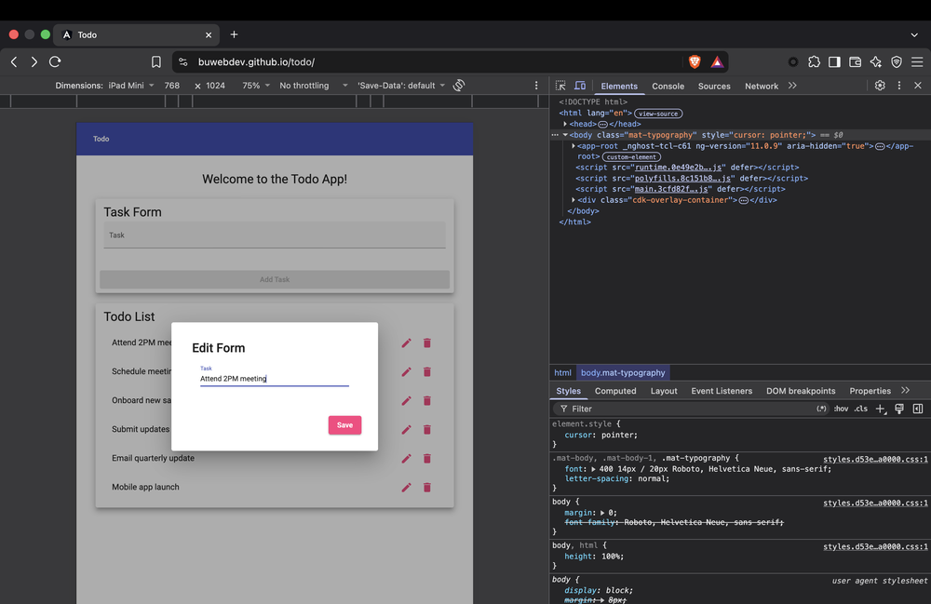  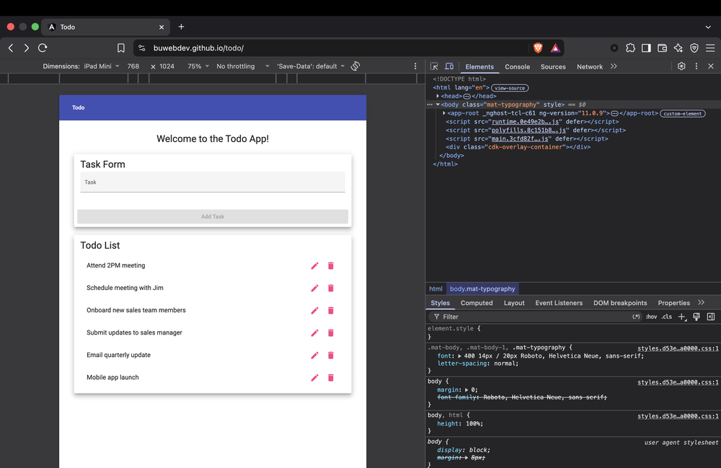
Comments | All five steps passed. The layout fit both the iPhone 12 Pro and iPad Mini screens with no sideways scrolling, Mobile test could be added and deleted in the phone view, and the Edit Form fit and saved in the tablet view. Checking the Edit Form in the phone view as well would cover the smallest screen for both forms.

Execution Notes
1. Run Test 2, Test 3, and Test 4 in order without refreshing the page. The app does not save tasks, so a refresh resets the list to the six default tasks and the test data from Test 2 would be lost.
2. Mark a step "yes" only when what happens matches the expected result exactly. If a step fails, write down the step number, what actually happened, and any error message, and attach a screenshot as the template asks.
3. A failed test is still a useful result. Chapter 10 of The DevOps Handbook explains that building automated tests into daily work creates a fast feedback loop that helps developers find problems early and fix them quickly (Kim et al., 2021). Writing these manual tests clearly is the first step toward automating them later.
Reference
Kim, G., Humble, J., Debois, P., Willis, J., & Forsgren, N. (2021). The DevOps handbook: How to create world-class agility, reliability, & security in technology organizations (2nd ed.). IT Revolution Press.

