Tanner Elston
CSD 402
Assignment 1.2
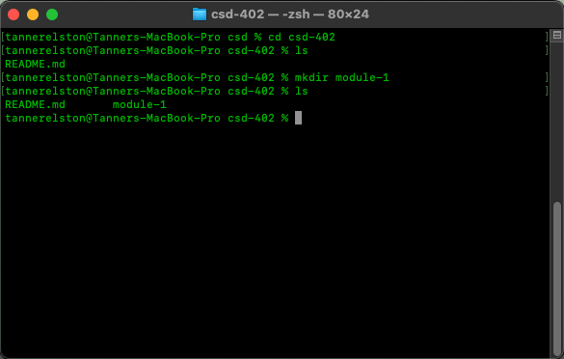
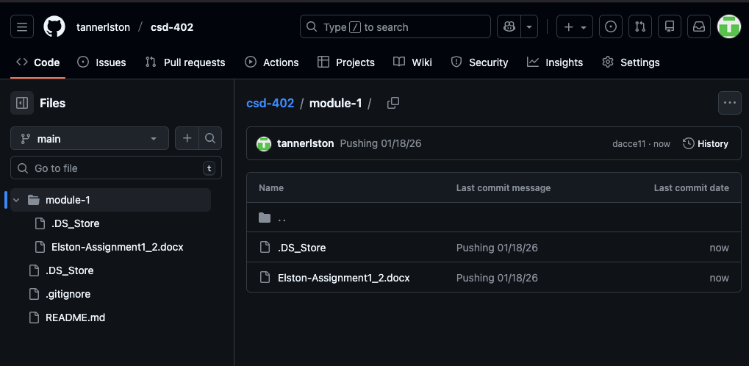
https://github.com/tannerlston/csd-402

