Distributed OpenStreetMap Data Store Design

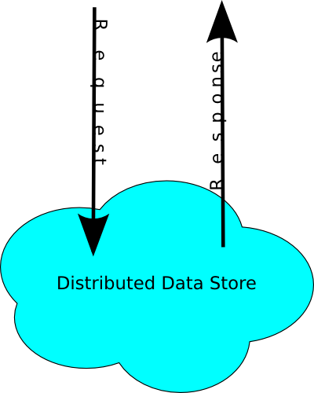
At a Glance

Requests and responses are XML+REST over HTTP made to a single box identified as “frontend”. The frontend delegates to potentially one box each to handle the data associated with changesets, ways, and relations, from here on refered to as changeset server, way server, and relation server, respectively. There are many node servers, split spatially (though with no guarantee).

Internal servers talk amongst themselves using Thrift RPC and Thrift binary representation of the objects (ways, nodes, etc.)

Each data store is a Berkeley DB database, typically with keys that correspond to ids and values that are serialized Thrift objects or ids.

Methods
GET capabilities

GET node/#id
Frontend queries all servers for node #id and returns as soon as one server responds.

PUT (?) node/#id
Frontend requests that all server modify node #id.

DELETE node/#id
Frontend requests that all servers delete node #id.

PUT node/create
Frontend finds the correct server based on latitude and longitude. This means the frontend is managing a database of how the world is being split up. This changes as the world can later be further split to maintain a manageable feature density at each node server.

The node server that stores this node manages a database that maps node ids to node objects. Versioning is handled by storing duplicate objects per key, and the current version is always the first object that Berkeley DB returns.

The frontend decides the node id to use in order to keep the node ids globally unique. This will be a simple counter (+ free node ids set if necessary, consisting of failed creations less than the current value of the counter).

GET node/#id/history
Frontend queries all servers for node #id and returns as soon as one server responds.

GET node/#id/#version
Frontend queries all servers for node #id and returns as soon as one server responds.

GET node/#id/ways
Frontend queries the way server, which maintains a reverse index of node id to ways that reference that node.

GET node/#id/relations
Frontend queries the relation server, which maintains a reverse index of node id to relations that reference that node.
GET nodes?nodes=#id,#id,...
GET way/#id
PUT (?) way/#id
The frontend requests that the way server update the given way. The way server will store the new version in addition to keeping old versions.

The way server compares this version to the previous version and updates the node->way mapping if necessary.

DELETE way/#id
The frontend requests that the way server delete the given way. This just means adding a new version with the “deleted” flag set.

The way server looks at the last version of the way and removes this way referenced to nodes the deleted way was referencing (that's a mouthful).

PUT way/create
Frontend requests that the way server add the given way to the database.

The way server manages a database that maps all way ids to way objects. Versioning is handled by storing duplicate objects per key, and the current version is always the first object that Berkeley DB returns.

The way server updates another database that maps nodes referenced in the way to the new way.

GET way/#id/history
GET way/#id/#version
GET way/#id/relations
GET way/#id/full
GET ways?ways=#id,#id,...
GET relation/#id
PUT (?) relation/#id
DELETE relation/#id
PUT relation/create
GET relation/#id/history
GET relation/#id/#version
GET relation/#id/relations
GET relation/#id/full
GET relations?relations=#id,#id,...
GET changeset/#id
PUT changeset/#id
PUT changeset/create
PUT (?) changeset/#id/close
POST changeset/#id/upload
GET changeset/#id/download
POST changeset/#id/expand_bbox
GET changesets
GET map
Frontend asks all node servers for all the nodes that are within the given bounds (we can't just go to certain servers since a node's lat/long may have been changed, making the usual lat/long to server mapping no longer apply to some nodes).

In parallel, the frontend queries the way and relation servers for all ways and relations referenced by the given nodes. This will be one call for each server that asks about all nodes (rather than one call to each server for each node).

GET trackpoints
GET changes
The frontend manages a log of all modifications.

