- 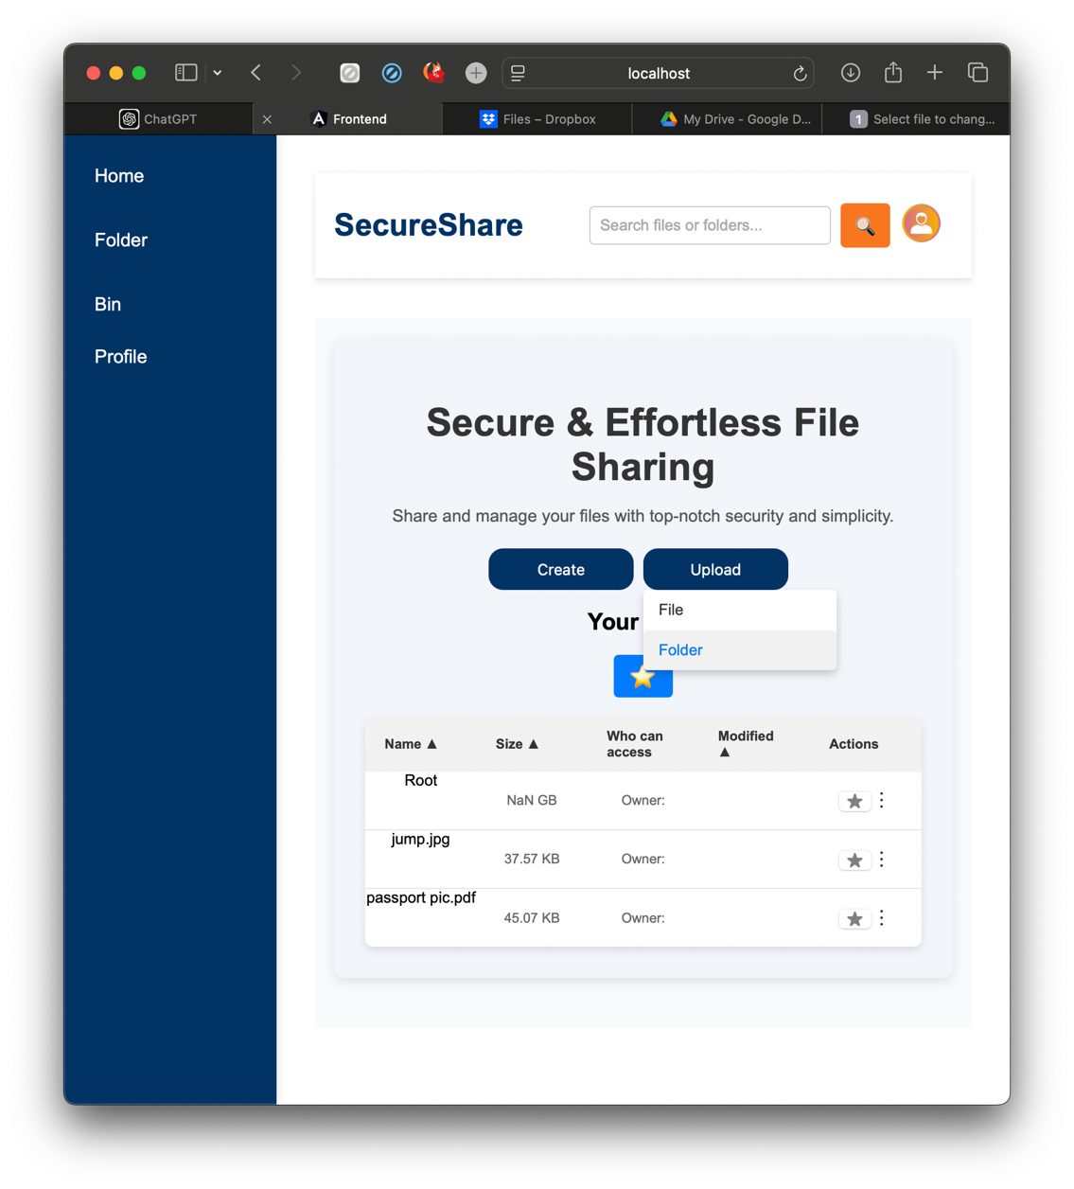
- 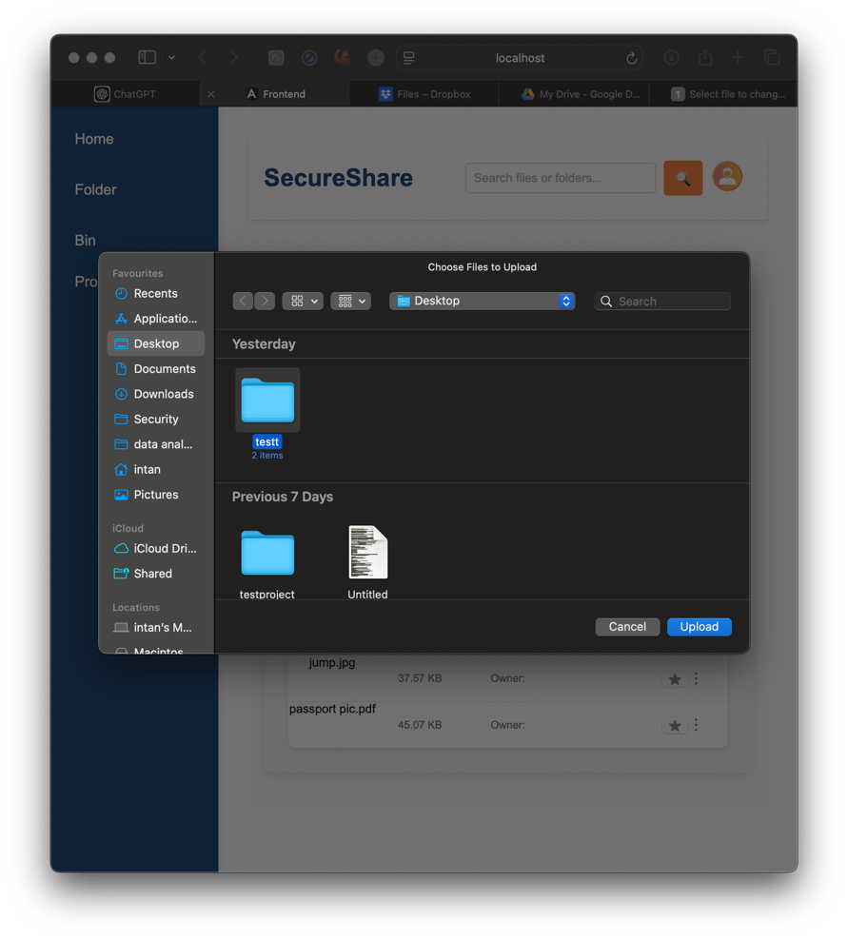

- 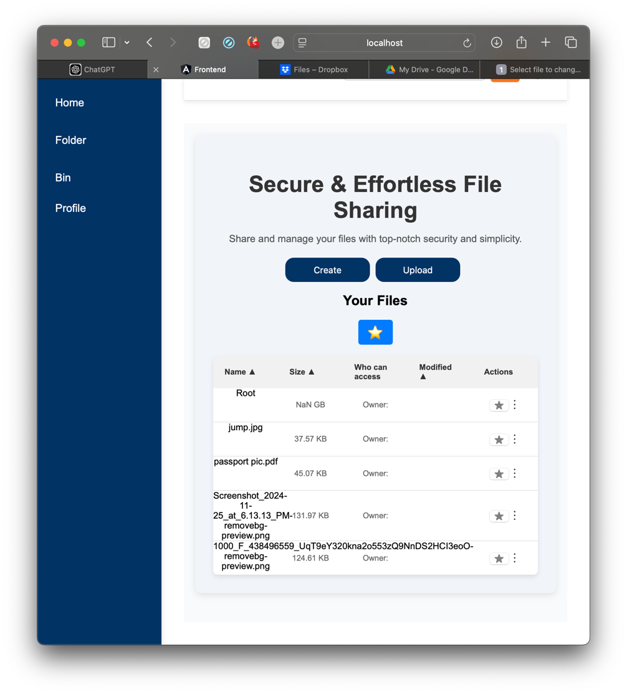
testt

Views.py :
def upload_folder(request):
if request.method == 'POST':
for key, file in request.FILES.items():
folder_path, filename = os.path.split(key)
upload_path = os.path.join(settings.MEDIA_ROOT, folder_path)
os.makedirs(upload_path, exist_ok=True)

with open(os.path.join(upload_path, filename), 'wb+') as destination:
for chunk in file.chunks():
destination.write(chunk)

return JsonResponse({'message': 'Folders uploaded successfully!'})
return JsonResponse({'error': 'Invalid request'}, status=400)
# File & folder Upload
class FileUploadView(APIView):
permission_classes = [IsAuthenticated]

def post(self, request):
try:
uploaded_files = request.FILES.getlist('files')
folder_paths = request.data.getlist('folders')
user_id = request.user.id
# Handle folder creation
if folder_paths:
for folder_path in folder_paths:
parent_folder = None
folder_hierarchy = folder_path.split('/')

for folder in folder_hierarchy:
folder_instance, created = Folder.objects.get_or_create(
name=folder,
parent_folder=parent_folder,
user_id=user_id
)
parent_folder = folder_instance
# Return success if only folders are uploaded
if not uploaded_files and folder_paths:
return Response({"message": "Folders uploaded successfully!"}, status=201)
# Allowed extensions and max size
allowed_extensions = ['jpg', 'jpeg', 'png', 'pdf', 'txt', 'docx', 'xlsx', 'csv', 'zip']
max_size = 20 * 1024 * 1024 # 20 MB limit
uploaded_file_data = []

for uploaded_file in uploaded_files:
relative_path = request.data.get(f"relative_path_{uploaded_file.name}", uploaded_file.name)
# Base upload directory
base_upload_dir = os.path.join(settings.MEDIA_ROOT, 'uploads')
target_folder = os.path.dirname(relative_path)
final_folder_path = os.path.join(base_upload_dir, target_folder)
os.makedirs(final_folder_path, exist_ok=True)
# Validate file
file_extension = uploaded_file.name.split('.')[-1].lower()
if file_extension not in allowed_extensions:
return Response({"error": f"Invalid file type: {uploaded_file.name}"}, status=400)
if uploaded_file.size > max_size:
return Response({"error": f"File size exceeds 20MB: {uploaded_file.name}"}, status=400)
# Save File
safe_file_name = f"{slugify(os.path.basename(relative_path))}.{file_extension}"
file_path = os.path.join(final_folder_path, safe_file_name)
with open(file_path, 'wb+') as destination:
for chunk in uploaded_file.chunks():
destination.write(chunk)
folder_path = os.path.dirname(relative_path)
parent_folder = Folder.objects.filter(user_id=user_id, name=os.path.basename(folder_path)).first()
file_instance = File.objects.create(
file=f"uploads/{relative_path}",
file_name=uploaded_file.name,
size=uploaded_file.size,
user_id=user_id,
file_path=file_path,
folder=parent_folder,
)
uploaded_file_data.append({
"file_id": file_instance.id,
"file_name": file_instance.file_name
})
return Response({
"message": "Files and folders uploaded successfully!",
"files": uploaded_file_data
}, status=201)
except Exception as e:
print("Upload Error:", str(e))
return Response({"error": str(e)}, status=500)
# ViewSet for files
class FileViewSet(viewsets.ModelViewSet):
serializer_class = FileSerializer
permission_classes = [permissions.IsAuthenticated]

def get_queryset(self):
return File.objects.filter(user=self.request.user, is_deleted=False)
# List user-uploaded files
class FileListView(APIView):
permission_classes = [IsAuthenticated]

def get(self, request):
files = File.objects.filter(user_id=request.user.id)
serializer = FileSerializer(files, many=True)
return Response(serializer.data)
class FolderListView(APIView):
permission_classes = [IsAuthenticated]

def get(self, request):
# Fetch folders and files
folders = Folder.objects.filter(user_id=request.user.id)
files = File.objects.filter(user_id=request.user.id, is_deleted=False)

folder_serializer = FolderSerializer(folders, many=True)
file_serializer = FileSerializer(files, many=True)

# Combine both folders and files
return Response({
'folders': folder_serializer.data,
'files': file_serializer.data
})
#create folder
@method_decorator(csrf_exempt, name='dispatch')
class FolderView(APIView):
permission_classes = [permissions.IsAuthenticated]

def post(self, request):
print("Request Data:", request.data) # Debugging
serializer = FolderSerializer(data=request.data)
if serializer.is_valid():
serializer.save(user=request.user)
return Response(serializer.data, status=status.HTTP_201_CREATED)
print("Validation Errors:", serializer.errors) # Debugging
return Response(serializer.errors, status=status.HTTP_400_BAD_REQUEST)
class FolderViewSet(viewsets.ModelViewSet):
queryset = Folder.objects.all()
serializer_class = FolderSerializer

def create(self, request, *args, **kwargs):
serializer = self.get_serializer(data=request.data)
if serializer.is_valid():
serializer.save()
return Response(serializer.data, status=status.HTTP_201_CREATED)
return Response(serializer.errors, status=status.HTTP_400_BAD_REQUEST)
class FolderContentView(APIView):
permission_classes = [permissions.IsAuthenticated]

def get(self, request, folder_id):
try:
# Fetch subfolders and files in the folder
subfolders = Folder.objects.filter(parent_folder_id=folder_id, user=request.user)
files = File.objects.filter(folder_id=folder_id, user=request.user, is_deleted=False)
# Serialize results
folder_serializer = FolderSerializer(subfolders, many=True)
file_serializer = FileSerializer(files, many=True)

return Response({
'folders': folder_serializer.data,
'files': file_serializer.data
})
except Folder.DoesNotExist:
return Response({'error': 'Folder not found'}, status=status.HTTP_404_NOT_FOUND)

class FolderListView(APIView):
permission_classes = [IsAuthenticated]

def get(self, request, *args, **kwargs):
# Fetch folders and files
folders = Folder.objects.filter(user=request.user)
files = File.objects.filter(user_id=request.user.id, is_deleted=False)

folder_serializer = FolderSerializer(folders, many=True)
file_serializer = FileSerializer(files, many=True)
# Combine both folders and files in one response
return Response({
'folders': folder_serializer.data,
'files': file_serializer.data
})
class FileView(View):
def get(self, request, file_id):
try:
# Retrieve the file instance from the database
file = File.objects.get(id=file_id)
# Check if the 'file_path' attribute is set and has a file
if not file.file_path or not file.file_path.name:
return HttpResponse("File not found", status=404)
file_path = file.file_path.path # This gets the absolute path of the
if os.path.exists(file_path):
# Return the file as an attachment for download
response = FileResponse(open(file_path, 'rb'), as_attachment=True)
return response
else:
return HttpResponse("File not found", status=404)
except File.DoesNotExist:
return HttpResponse("File not found", status=404)

folder component ts (this is where button upload was and file & folder show here:
export class FolderComponent implements OnInit {
files: any[] = []; // Array to store file data
errorMessage: string = ''; // For displaying errors
folderFiles: File[] = [];
showStarredFiles: boolean = false; // To toggle between main and starred view
starredFiles: any[] = []; // Holds starred files
selectedFileId: number | null = null;
newFileName: string = '';
apiUrl: string = 'http://127.0.0.1:8000/api';
uploadDropdownVisible: boolean = false;
uploading = false; // Track if upload is in progress
progress: number | null = null; // Track progress

// Get references to file inputs
@ViewChild('fileInput') fileInput!: ElementRef;
@ViewChild('folderInput') folderInput!: ElementRef;
//properties file preview
showPreview: boolean = false;
loading: boolean = false;
fileType: string = '';
previewUrl: string = '';
fileSize: string = '';
// To track sort order for each column
sortOrder: { [key: string]: 'asc' | 'desc' } = {
name: 'asc',
size: 'asc',
modified: 'asc',
};

isAuthenticated: boolean = false;
folders: any;
currentFolderId: string | undefined;

constructor(
private http: HttpClient,
private authService: AuthService,
private fileService: FileService,
private router: Router,
private uploadService: UploadService,
) {}

ngOnInit(): void {
// Check if the user is authenticated by checking the token in AuthService
this.isAuthenticated = !!this.authService.getToken();
//this.fetchFiles(); // Loads all files
this.fetchFilesAndFolders();
this.fetchStarredFiles();

if (!this.isAuthenticated) {
this.errorMessage = 'You are not authenticated. Please log in.';
}
// Fetch all files only if authenticated
if (this.isAuthenticated) {
this.fetchFilesAndFolders();
} else {
this.errorMessage = 'You are not authenticated. Please log in.';
}
}
getHeaders() {
const token = this.authService.getToken();
return {
headers: new HttpHeaders({
'Authorization': `Token ${token}`,
'Content-Type': 'application/json', // Ensure Content-Type is application/json
}),
};
}
// Toggle dropdown visibility for a specific file
toggleDropdown(file: any): void {
file.showDropdown = !file.showDropdown;
}
// Utility to format the file size to a readable format
formatFileSize(size: number): string {
if (size < 1024) return `${size} B`;
if (size < 1048576) return `${(size / 1024).toFixed(2)} KB`;
if (size < 1073741824) return `${(size / 1048576).toFixed(2)} MB`;
return `${(size / 1073741824).toFixed(2)} GB`;
}
// Toggle upload dropdown
toggleUploadDropdown(): void {
this.uploadDropdownVisible = !this.uploadDropdownVisible;
}
// Trigger file input click for files
onFileUploadClick(): void {
this.fileInput.nativeElement.click();
}
// Trigger file input click for folders
onFolderUploadClick(): void {
this.folderInput.nativeElement.click();
}
// Handle File Upload (when selecting a file)
onUploadFile(event: Event): void {
const input = event.target as HTMLInputElement;
if (input.files) {
const files = Array.from(input.files); // Convert FileList to File[]
this.uploading = true;
this.uploadService.uploadFiles(files).subscribe(
(event) => {
if (event.type === HttpEventType.UploadProgress) {
this.progress = Math.round((100 * event.loaded) / (event.total || 1));
} else if (event.type === HttpEventType.Response) {
console.log('File uploaded successfully:', event.body);
this.uploading = false;
this.progress = null;
}
},
(error) => {
console.error('Error uploading file:', error);
this.uploading = false;
this.progress = null;
});}}
// Handle Folder Upload (when selecting a folder)
onUploadFolder(event: any): void {

const files: FileList = event.target.files;
const folderData: { [key: string]: any[] } = {};

Array.from(files).forEach((file: File) => {
const folderName = file.webkitRelativePath.split('/')[0];
if (!folderData[folderName]) {
folderData[folderName] = [];
}
folderData[folderName].push(file);
});
// Pass folderData to the upload service
this.uploadService.uploadFolders(folderData).subscribe(
(response) => console.log('Upload success', response),
(error) => console.error('Upload failed', error)
);
}
onCreateFolder(parentFolderId: number | null = null): void {
const folderName = prompt('Enter folder name:');
if (!folderName || folderName.trim() === '') {
alert('Folder name cannot be empty.');
return;
}
const payload = {
name: folderName.trim(),
parent_folder: parentFolderId ?? null // Null if no parent
};
this.fileService.createFolder(payload).subscribe({
next: () => {
alert('Folder created successfully!');
this.loadFolderContents(parentFolderId); // Reload contents
},
error: (error) => {
console.error('Error creating folder:', error);
alert('Failed to create folder. Please try again.');
},
});
}
loadFolderContents(folderId: number | null = null): void {
const id = folderId ?? 0; // Default to 0 if null
this.fileService.getFolderContents(id).subscribe(
(data) => {
// Process folders
const folders = data.folders.map((folder: any) => ({
id: folder.id,
name: folder.name,
type: 'folder', // Explicitly mark as folder
parentFolder: folder.parent_folder,
createdAt: folder.created_at,
}));
// Process files
const files = data.files.map((file: any) => ({
id: file.id,
name: file.file_name,
size: file.size,
type: 'file', // Explicitly mark as file
createdAt: file.created_at,
}));
// Combine folders and files for display
this.files = [...folders, ...files].map((item) => ({
...item,
type: item.type || (item.id ? 'folder' : 'file') // Default to 'folder' if not explicitly a file
}));
},
(error) => {
console.error('Error fetching folder contents:', error);
}
);
}
loadFiles(): void {
this.fileService.getFiles().subscribe(
(files) => {
this.files = files;
},
(error) => {
console.error('Error loading files:', error);
}
);
}
//open the file when click
onOpenFile(file: File, event: Event): void {
event.preventDefault(); // Prevent default behavior (if it's a link)
const token = this.authService.getToken(); // Retrieve the token from AuthService
if (!token) {
alert('You are not authenticated. Please log in.');
return;
}
// Generate the file URL based on file ID
const fileUrl = `http://127.0.0.1:8000/api/files/view/${file.id}/`;
// Open the file in a new tab
window.open(fileUrl, '_blank');
}
//open folder
onOpenFolder(folderId: string): void {
// Find the folder and load its contents.
const folder = this.files.find(file => file.id === folderId && file.isFolder);
if (folder) {
// You might need to set a `currentFolder` property and load its children.
this.currentFolderId = folderId;
this.files = folder.contents || []; // Assume `contents` contains the child files/folders.
}
}
async fetchFilesAndFolders() {
const token = this.authService.getToken();
try {
const response = await axios.get(`${this.apiUrl}/folders/`, {
headers: { Authorization: `Token ${token}` },
});
const data = response.data;

// Process folders
const folders = data.folders.map((folder: any) => ({
id: folder.id,
name: folder.name,
type: 'folder', // Explicitly mark as folder
parentFolder: folder.parent_folder,
modified: folder.created_at,
}));
// Process files
const files = data.files.map((file: any) => ({
id: file.id,
name: file.file_name, // Adjust field to match backend
size: file.size,
type: 'file', // Explicitly mark as file
modified: file.created_at,
}));

// Merge folders and files into a single list
this.files = [...folders, ...files];
} catch (error) {
console.error('Error fetching folders and files:', error);
}
}
//file review
formatBytes(bytes: number, decimals = 2): string {
if (bytes === 0) return '0 Bytes';
const k = 1024;
const dm = decimals < 0 ? 0 : decimals;
const sizes = ['Bytes', 'KB', 'MB', 'GB', 'TB'];

const i = Math.floor(Math.log(bytes) / Math.log(k));
return parseFloat((bytes / Math.pow(k, i)).toFixed(dm)) + ' ' + sizes[i];
}
// Function to preview file metadata
previewFile(fileId: number): void {
this.loading = true; // Start loading indicator
this.fileService.getFileMetadata(fileId).subscribe(
(data) => {
this.previewUrl = data.url; // Set preview URL
this.fileType = data.type || 'application/octet-stream'; // Default MIME type
this.fileSize = this.formatBytes(data.size); // Format file size
this.showPreview = true; // Display the preview modal
this.loading = false; // Stop loading
},
(error: HttpErrorResponse) => {
console.error('Error fetching file preview:', error.message);
this.loading = false; // Stop loading on error
}
);
}
}

Upload servise ts :
class UploadService {
private uploadUrl = 'http://localhost:8000/api/upload/';

constructor(private http: HttpClient) {}

uploadFiles(files: File[]): Observable<any> {
const formData = new FormData();
files.forEach(file => {
formData.append('files', file, file.name); // Append each file to FormData
});
// POST request to upload files
return this.http.post(this.uploadUrl, formData, {
headers: new HttpHeaders(),
reportProgress: true,
observe: 'events',
});
}
uploadFolders(folderData: any): Observable<any> {
const formData = new FormData();

for (const folderName in folderData) {
folderData[folderName].forEach((file: File) => {
formData.append(`${folderName}/${file.name}`, file);
});
}

return this.http.post(this.uploadUrl, formData);
}
}

url
router = DefaultRouter()
router.register(r'files', FileViewSet, basename='file')
router.register(r'folders', FolderViewSet, basename='folder')

urlpatterns = [
path('api/', include(router.urls)),
path('upload/', FileUploadView.as_view(), name='file-upload'),
path('files/', FileListView.as_view(), name='file-list'),

path('files/share/', views.share_file, name='share_file'),
path('files/view/<int:file_id>/', FileView.as_view(), name='file-view'),
path('upload/', FileUploadView.as_view(), name='upload-file'),
path('file-preview/<int:file_id>/', FilePreviewView.as_view(), name='file_preview'),
path('file-metadata/<int:file_id>/', FileMetadataView.as_view(), name='file_metadata'),
path('folders/', views.FolderListView.as_view(), name='folder-list'), # GET
path('folders/create/', views.FolderView.as_view(), name='folder-create'), # POST
path('folders/<int:folder_id>/', views.FolderContentView.as_view(), name='folder_list'),
path('folders/', FolderView.as_view(), name='create-folder'),
path('upload-folder/', views.upload_folder, name='upload_folder'),
]

