

Bharati Vidyapeeth's College of Engineering

A 4, Rohtak Road, Paschim Vihar, New Delhi, Delhi 110063

**Minor Project 4th year**

STOCK MARKET PREDICTION USING SVM

Student's Name:

Harjot Singh (01111503113)  
Tannishk Sharma (00411503113)

Zeb Alam(04011503113)

INDEX

Introduction . . . . . . . . . . . . . . . . . . . . . . . . . . . . . . . . . . . . . . . . . . . . . 1

Algorithm . . . . . . . . . . . . . . . . . . . . . . . . . . . . . . . . . . . . . . . . . . . . . 2

Software Used  . . . . . . . . . . . . . . . . . . . . . . . . . . . . . . . . . . . . . . . . . . . . . 3

References . . . . . . . . . . . . . . . . . . . . . . . . . . . . . . . . . . . . . . . . . . . . . 3

Introduction

The purpose of the project is to predict the prices of Stocks and suggest whether to buy or sell a particular stock.

The data is Non linear and non stationary which poses as a problem in computation.

Methodolgies :  
Fundamental Analysis: Understanding the supply demand curve,debt/revenue ratio

Technical Analysis: Understanding historical price patterns

The Combination of Technical and Fundamental Analysis is used in SVM.

Support Vector Machine(SVM) is a renown supervised algorithm which is used to perform the task of classification. Support Vector Machine is used to perform various classification tasks such as Face Recognition, Pattern Matching, Image Analysis etc.

An SVM model is a representation of the data as points in space, mapped so that the data of the separate categories are divided by a clear gap that is as wide as possible.

New examples are then mapped into that same space and predicted to belong to a category based on which side of the gap they fall on.

In addition to performing linear classification, SVMs can efficiently perform a non-linear classification using what is called the [kernel trick](https://en.wikipedia.org/wiki/Kernel_trick), implicitly mapping their inputs into high-dimensional feature spaces.

Support vector machine constructs a hyperplane or set of hyperplanes in high-dimensional space, which can be used for classification, regression, or other tasks.

Algorithm

The simplest case of a SVM is linear SVM in which data are linearly separable or in other words it can be separated by a dividing hyper plane . Our Goal is to find the equation of hyper plane that best divides the group with maximum distance separable distance . Let the equation of hyper plane be given as wtx+b is defined for all data points that have a class yi = -1 ,

Wtx+b <-1

and for points with class yi = 1 ,

wtx+b > 1

Here we should have no points between hyper planes wtx+b = -1 and wtx+b = 1 , a region called ‘Margin ‘ . The dividing plane is the function wtx+b = 0 and we classify new points by the sign yi = sign(\wtx+b) . we want to select parameters for the hyper plane that maximize the size of the margin.

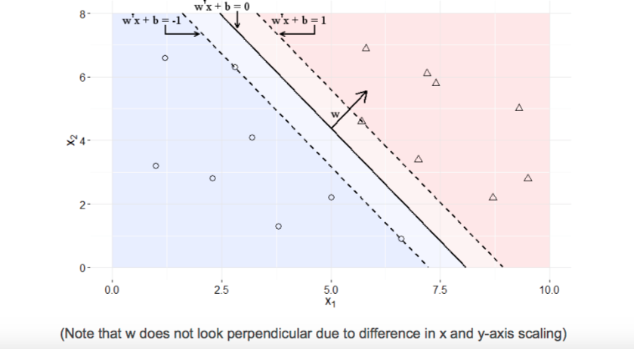

Software Requirements

* Python
* Sklearn
* Beautiful Soup

References

* [1]  “S&pdowjonesindices,”PDF,March312015.
* [2]  C.Y.Z.BenJacobsen,“Aremonthlyseasonalsreal?athreecenturyperspective,”2012.
* [3]  ——,“Thehalloweenindicator,’sellinmayandgoaway’:Anevenbiggerpuzzle,”October2012.
* [4]  G.F.BjoernKrollner,BruceVanstone,“Financialtimeseriesforecastingwithmachinelearningtechniques:A
  + survey,” in *European Symposium on Artificial Neural Networks: Computational and Machine Learning*, Bruges,
  + Belgium, April 2010.
* [5]  J.Brownlee.Atourofmachinelearningalgorithms.
* [6]  M. Buhmann, “Radial basis function.” Mathematisches Institut, Justus-Liebig-Universität Giessen, 2010.
* [7]  Y.-A.L.B.GianlucaBontempi,SouhaibBenTaieb,*MachineLearningStrategiesforTimeSeriesForecasting*,
  + Machine Learning Group, Computer Science Department, Univerite Libre de Bruxelles.
* [8]  M. Halls-Moore, “Support vector machines: A guide for beginners,” September 2014. [Online]. Available:
  + http://www.quantstart.com/articles/Support-Vector-Machines-A-Guide-for-Beginners
* [9]  K.jaeKim,“Financialtimeseriesforecastingusingsupportvectormachines,”*Neurocomputing*,vol.55,2003.
* [10]  M. W. W. James H. Stock, *Introduction to Econometrics*. Addison-Wesley, 2015.
* [11]  A. Kar, “Stock prediction using artificial neural networks,” *Dept. of Computer Science and Engineering, IIT* 
  + *Kanpur*.
* [12]  S. R. Y. Mayankkumar B Patel, “Stock prediction using artificial neural network,” *International Journal of* 
  + *Innovative Research in Science, Engineering, and Technology*, 2014.
* [13]  S. T. Narasimhan Jegadeesh, “Returns to buying winners and selling losers: Implications for stock market
  + efficiency,” *The Journal of Finance*, vol. 48, no. 1, pp. 65–91, March 1993.
* [14]  D. d. l. F. Rafael Rosillo, Javier Giner, “Stock market simulation using support vector machines,” *Journal of* 
  + *Forecasting*, vol. 33, pp. 488–500, July 2014.
* [15]  V.H.Shah,“Machinelearningtechniquesforstockpriceprediction,”pp.1–18,2007.
* [16]  *Long-Term Unemployment in the Great Recession*. U.S. Congress Joint Economic Committee, 2010.
* [17]  J.Zhang,“Applyingtimeseriesanalysisbuildsstockpriceforecastmodel,”*ModernAppliedScience*,vol.3,no.5,
  + 2009.
* [18]  A. M. Zvi Bodie, Alex Kane, *Investments*. McGraw-Hill, 2014.