Exercise 1: Control Structures
Scenario 1:
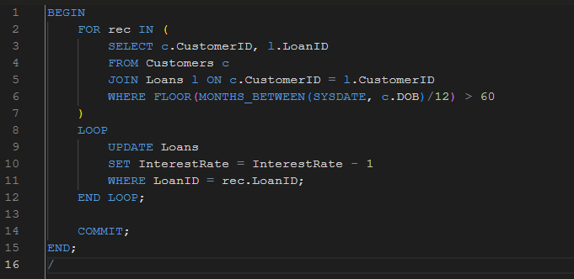
Output:
SELECT * FROM Loans;

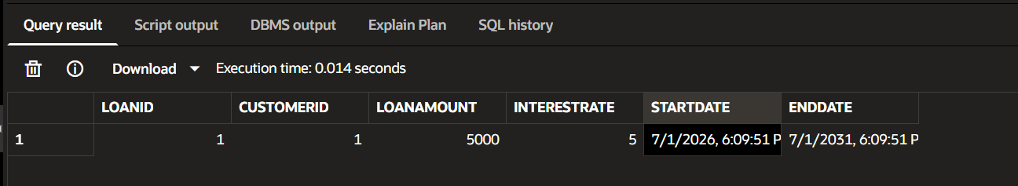
Scenario 2:
BEGIN
FOR rec IN (
SELECT CustomerID
FROM Customers
WHERE Balance > 10000
)
LOOP
UPDATE Customers
SET Balance = Balance
WHERE CustomerID = rec.CustomerID;

DBMS_OUTPUT.PUT_LINE('Customer ' || rec.CustomerID || ' promoted to VIP');
END LOOP;
COMMIT;
END;
/

Output:
PL/SQL procedure successfully completed.
Scenario 3:
BEGIN
FOR rec IN (
SELECT c.Name, l.LoanID, l.EndDate
FROM Customers c
JOIN Loans l ON c.CustomerID = l.CustomerID
WHERE l.EndDate BETWEEN SYSDATE AND SYSDATE+30
)
LOOP
DBMS_OUTPUT.PUT_LINE('Reminder to ' || rec.Name ||' for Loan ID ' || rec.LoanID || ' due on ' || rec.EndDate);
END LOOP;
END;
/

Output:
Reminder to John Doe for Loan ID 1 due on 16-JUL-26
PL/SQL procedure successfully completed.

Exercise 3: Stored Procedures
Scenario 1:
CREATE OR REPLACE PROCEDURE ProcessMonthlyInterest
IS
BEGIN
UPDATE Accounts
SET Balance = Balance * 1.01
WHERE AccountType='Savings';

COMMIT;
END;
/

Output:
Procedure PROCESSMONTHLYINTEREST compiled
SELECT AccountID, AccountType, Balance
FROM Accounts;
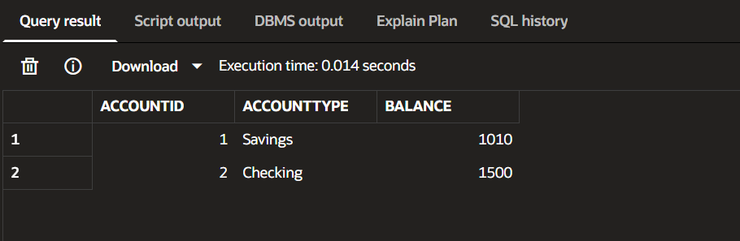
Scenario 2:
CREATE OR REPLACE PROCEDURE UpdateEmployeeBonus(
p_dept VARCHAR2,
p_bonus NUMBER)
IS
BEGIN
UPDATE Employees
SET Salary = Salary + Salary*p_bonus/100
WHERE Department = p_dept;

COMMIT;
END;
/
BEGIN
UpdateEmployeeBonus('HR',10);
END;
/
SELECT EmployeeID, Name, Salary, Department
FROM Employees;

Output:
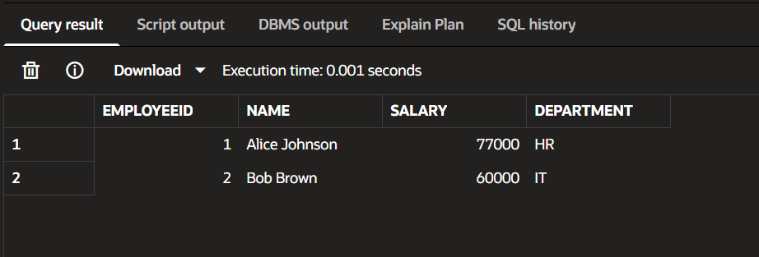
Scenario 3:
CREATE OR REPLACE PROCEDURE TransferFunds(
p_from NUMBER,
p_to NUMBER,
p_amount NUMBER)
IS
v_balance NUMBER;
BEGIN
SELECT Balance INTO v_balance
FROM Accounts
WHERE AccountID = p_from;

IF v_balance >= p_amount THEN
UPDATE Accounts
SET Balance = Balance-p_amount
WHERE AccountID=p_from;
UPDATE Accounts
SET Balance = Balance+p_amount
WHERE AccountID=p_to;
COMMIT;
ELSE
DBMS_OUTPUT.PUT_LINE(
'Insufficient Balance');
END IF;
END;
/

Output:
BEGIN
TransferFunds(1,2,500);
END;
/
SELECT AccountID, Balance
FROM Accounts;

PL/SQL procedure successfully completed.
