**Matplotlib: The Complete Guide to Professional Data Visualization**

Matplotlib stands as the foundational plotting library in the Python ecosystem, powering countless data visualizations across scientific research, business analytics, and educational materials worldwide. This comprehensive documentation provides everything you need to master Matplotlib, from fundamental concepts to advanced customization techniques.

* **Library Overview: Why Matplotlib Dominates Python Visualization**

**Matplotlib** has been the cornerstone of Python data visualization since 2003, when John D. Hunter created it to bring MATLAB-style plotting capabilities to Python. What began as a scientific plotting tool has evolved into the most comprehensive and flexible visualization library in Python, serving millions of users globally.

* **Core Strengths**

**Publication-Ready Quality**:

Matplotlib produces high-resolution, professional-grade graphics suitable for scientific journals, business presentations, and academic publications. The library supports multiple output formats including PNG, PDF, SVG, and EPS.

**Unparalleled Flexibility**:

Unlike many visualization libraries that limit you to predefined chart types, Matplotlib gives you complete control over every aspect of your plots. You can customize colors, fonts, line styles, markers, axes, grids, and virtually any visual element.

**Seamless Integration**:

Works flawlessly with the entire Python scientific stack including NumPy, pandas, SciPy, and Jupyter notebooks, making it the natural choice for data scientists and researchers.

**Extensive Chart Types**:

From basic line plots to complex 3D surfaces, heatmaps, and interactive visualizations, Matplotlib supports over 50 different plot types and countless customization options.

**Two-Level Architecture**:

Offers both a simple MATLAB-style interface (pyplot) for quick plotting and a powerful object-oriented interface for complex, multi-panel figures.

**Primary Use Cases**

* **Scientific Research**: Creating publication-quality figures for academic papers and presentations
* **Business Analytics**: Developing dashboards, reports, and data-driven presentations
* **Educational Materials**: Illustrating mathematical concepts and statistical analyses
* **Exploratory Data Analysis**: Quickly visualizing datasets to identify patterns and outliers
* **Real-time Monitoring**: Building animated plots for live data streams
* **Interactive Applications**: Embedding plots in desktop and web applications
* **Essential Graph Types: Your Complete Reference**

**1. Line Plot - Visualizing Trends and Relationships**

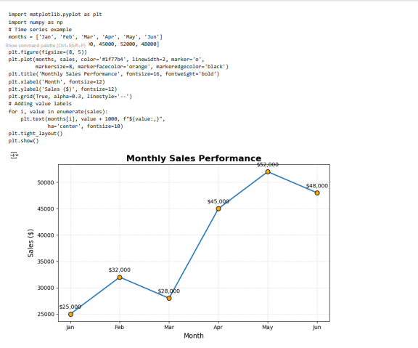

**Basic Implementation**:

**Advanced Customization**:

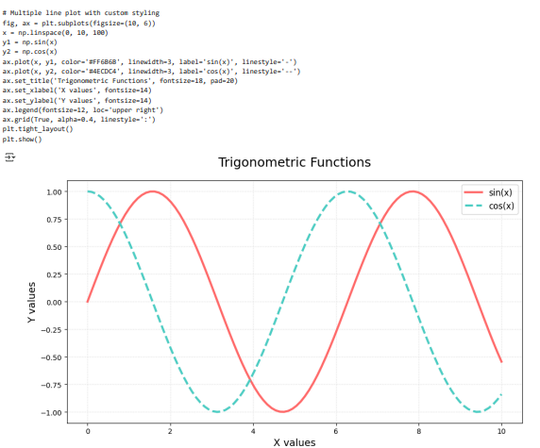

**2. Scatter Plot - Exploring Correlations and Distributions**

**Basic Implementation**:

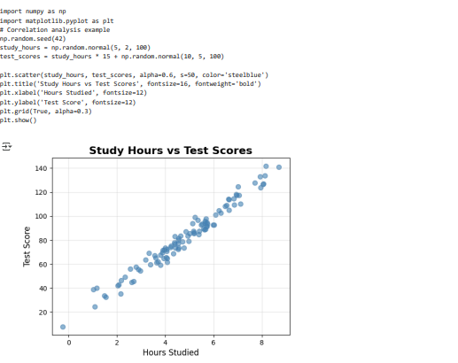

**Advanced Customization**: 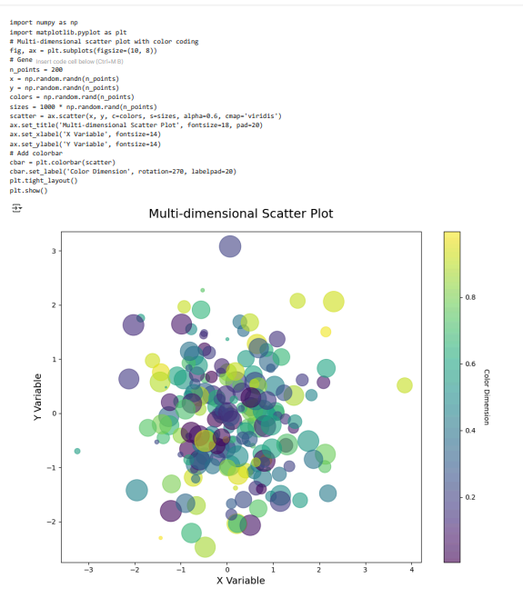

**3. Bar Chart - Comparing Categories**

* Comparing sales across different regions
* Showing survey response distributions
* Analyzing market share by competitor
* Displaying performance metrics across teams
* Presenting budget allocations by department

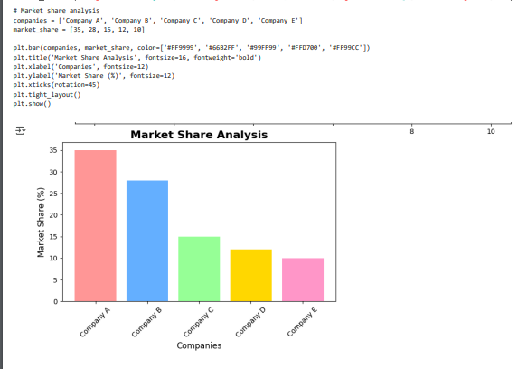**Advanced Horizontal Bar Chart**:

**Basic Implementation**:

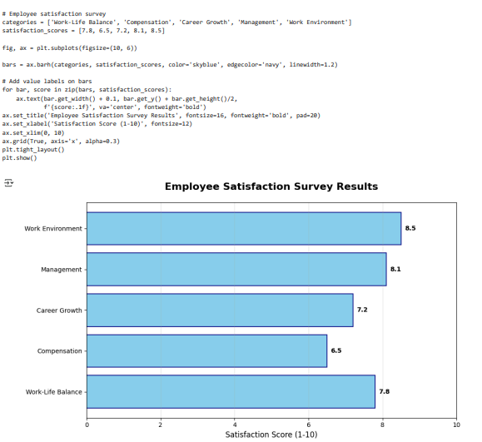

**4. Histogram - Understanding Data Distributions**

* Analyzing test score distributions
* Understanding income distributions in populations
* Examining response times in applications
* Identifying data quality issues
* Statistical analysis and hypothesis testing

**Purpose**:

**When to Use**:

**Basic Implementation**:

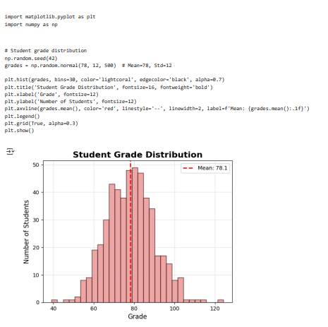

**Multiple Distribution Comparison**:

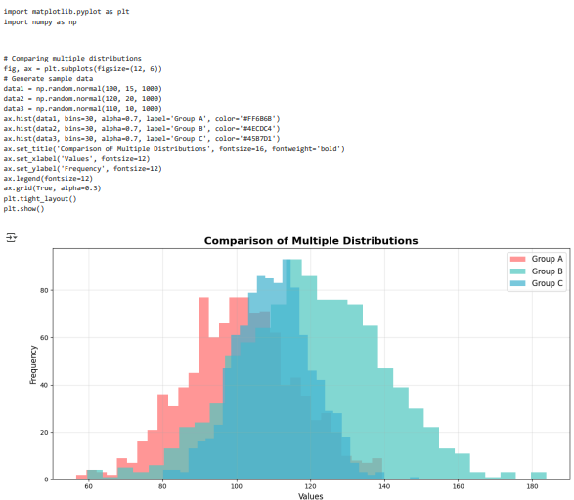

**5. Pie Chart - Showing Proportional Relationships**

**Basic Implementation**:

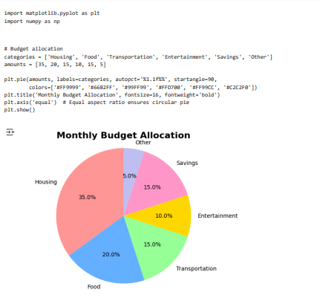

**Advanced Exploded Pie Chart**:

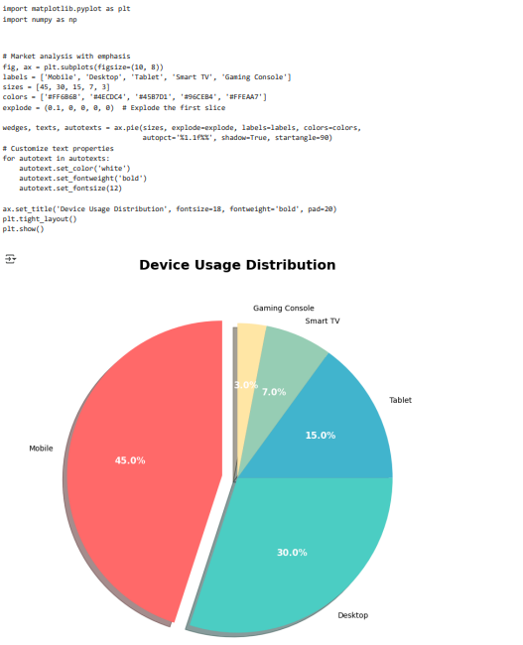

**6. Box Plot - Statistical Distribution Analysis**

* Comparing distributions across different groups
* Identifying outliers and data quality issues
* Statistical hypothesis testing
* Understanding data spread and skewness
* Quality control in manufacturing

**Basic Implementation**:

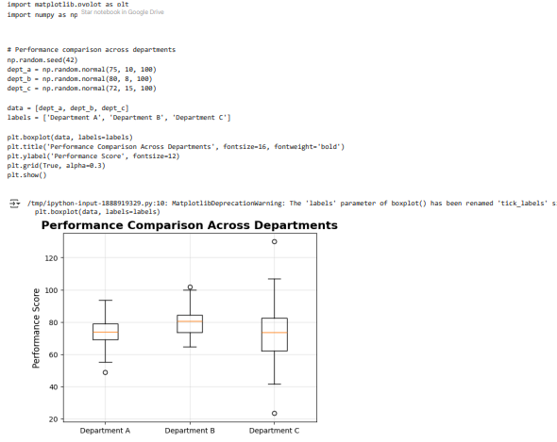

**Advanced Styled Box Plot**:

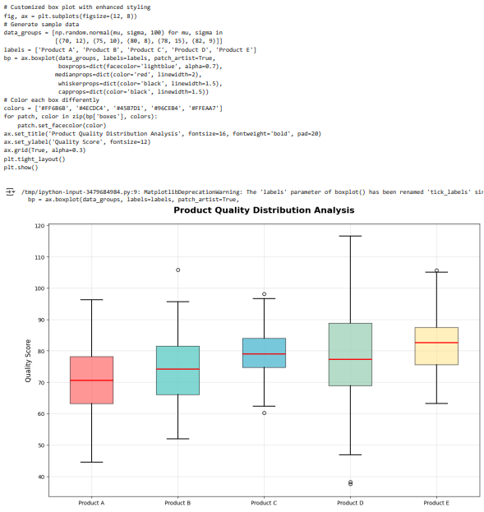



**7. Heatmap - Visualizing Matrix Data**

**Correlation Matrix Heatmap**:

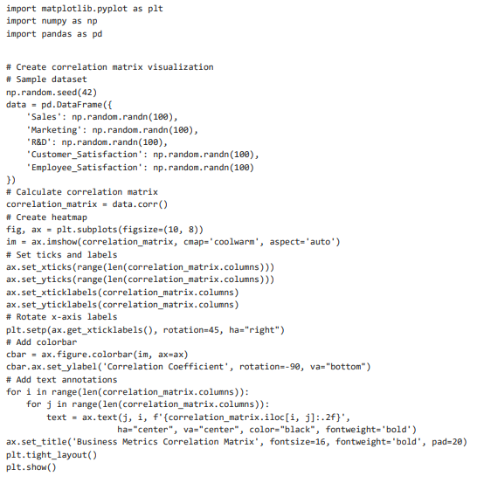

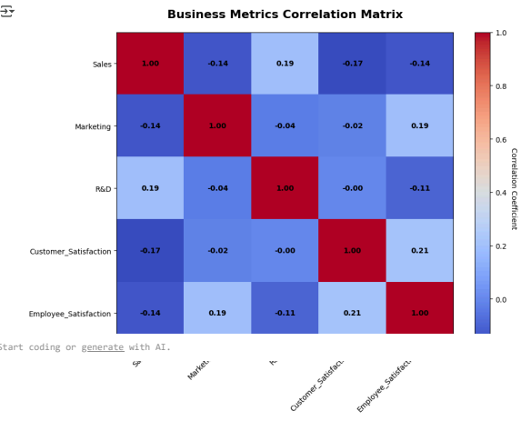

**8. Area/Stack Plot - Cumulative Data Visualization**

Area plots show cumulative data over time, making them perfect for displaying how individual components contribute to a total over intervals.

**Purpose**:

**When to Use**:

* Revenue breakdown by product lines over time
* Population demographics over years
* Resource usage patterns
* Environmental data analysis
* Portfolio composition changes

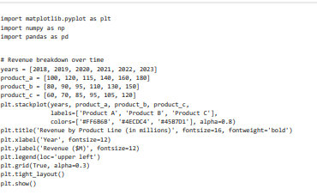**Implementation**:

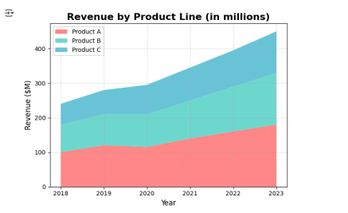

**9. 3D Plotting - Multi-dimensional Visualization**

**3D Surface Plot**:

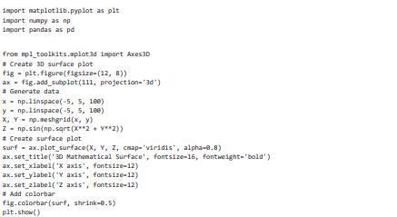

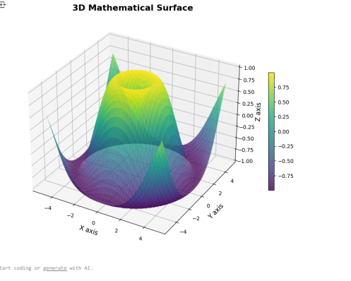

**Essential Functions and Parameters**

* **Quick Reference Guide**

|  |  |  |  |
| --- | --- | --- | --- |
| Chart Type | Function | Key Parameters | Best Use Cases |
| Line Plot | plt.plot() | linewidth, marker, color, linestyle | Time series, trends, continuous data |
| Scatter Plot | plt.scatter() | s (size), c (color), alpha, marker | Correlations, distributions, outliers |
| Bar Chart | plt.bar() | color, edgecolor, width, alpha | Categorical comparisons, rankings |
| Histogram | plt.hist() | bins, alpha, color, density | Data distributions, frequency analysis |
| Pie Chart | plt.pie() | autopct, startangle, explode, colors | Proportions, percentages, compositions |
| Box Plot | plt.boxplot() | patch_artist, boxprops, medianprops | Statistical distributions, outliers |
| Heatmap | plt.imshow() | cmap, aspect, interpolation | Correlation matrices, 2D data |
| 3D Plot | ax.plot3D() | projection='3d', cmap, alpha | Multi-dimensional data, surfaces |

* **Best Practices for Professional Visualizations**
* Conclusion

Matplotlib represents the pinnacle of flexibility and capability in Python data visualization. From simple line plots to complex multi-panel dashboards with custom styling, interactive elements, and publication-ready output, Matplotlib provides the foundation for virtually any visualization need.

This comprehensive guide has equipped you with:

* Deep understanding of core chart types and their applications
* Advanced customization techniques for professional presentations
* Animation capabilities for dynamic data storytelling
* Best practices for creating accessible, impactful visualizations
* Performance optimization strategies for large datasets

Whether you're conducting exploratory data analysis, creating business reports, or publishing scientific research, Matplotlib's extensive capabilities ensure you can transform your data into compelling visual narratives that drive insights and inform decisions.

Continue exploring Matplotlib's extensive documentation and gallery for inspiration and advanced techniques. The journey from basic plots to sophisticated, publication-quality visualizations is one of continuous learning and creative expression—and Matplotlib provides all the tools you need to excel in that journey.