CoastalCred — Blockchain-Based Blue Carbon Registry & MRV System.

Project report submitted to
Shri Ramdeobaba College of Engineering & Management, Nagpur in partial fulfillment of requirement for the award of degree of

Bachelor of Technology (B.Tech)
in

COMPUTER SCIENCE AND ENGINEERING
(DATA SCIENCE)
by
Aniruddha Lahoti (Roll no. 12)
Anish Hedau (Roll no. 13)
Ansh Chopada (Roll no. 14)
Atharva Nasare(Roll no. 32)
Tanmay Gaikwad (Roll no. 63)
of
VI Semester
Under the Guidance of
Prof. A. M.Karandikar


Department of Data Science
Shri Ramdeobaba College of Engineering & Management, Nagpur 440 013
(An Autonomous Institute affiliated to Rashtrasant Tukdoji Maharaj Nagpur University, Nagpur)
May 2026
SHRI RAMDEOBABA COLLEGE OF ENGINEERING AND MANAGEMENT, NAGPUR
(An Autonomous Institute affiliated to Rashtrasant Tukdoji Maharaj Nagpur University, Nagpur)
Department of Data Science
CERTIFICATE
This is to certify that the project report on "CoastalCred: A Blockchain-Based Blue Carbon Registry Using Satellite Imagery and Machine Learning" is a Bonafide work of Aniruddha Lahoti, Anish Hedau, Ansh Chopada, Atharva Nasare and Tanmay Gaikwad submitted to Rashtrasant Tukdoji Maharaj Nagpur University, Nagpur in partial fulfilment of the award of Degree of Bachelor of Technology (B.Tech), in Computer Science and Engineering (Data Science). It has been carried out in the Department of Data Science at Shri Ramdeobaba College of Engineering and Management, Nagpur during the academic year 2025-2026.
Date:
Place: Nagpur
______________________ _____________________
Dr. Aarti Karandikar Dr. M. B. Chandak
Project Guide Principal
Department of Data Science

DECLARATION
We hereby declare that the project report titled “COASTALCRED: Blockchain-Based Blue Carbon Registry & MRV System” submitted herein, has been carried out in the Department of Data Science, Shri Ramdeobaba College of Engineering and Management, Nagpur. The work is original and has not been submitted earlier as a whole or part for the award of any degree/diploma at this or any other institution / University.

Date:
Place: Nagpur

Aniruddha Lahoti |  | A1_12
Anish Hedau |  | A1_ 13
Ansh Chopada |  | A1_14
Atharva Nasare |  | A2_32
Tanmay Gaikwad |  | A3_63

APPROVAL SHEET
This report entitled COASTALCRED: Blockchain-Based Blue Carbon Registry & MRV System by Aniruddha Lahoti, Anish Hedau, Ansh Chopada, Atharva Nasare and Tanmay Gaikwad is approved for the degree of Bachelor of Technology (B.Tech) in Computer Science and Engineering (Data Science).

______________________ ______________________
Dr. Aarti Karandikar
Project Guide External Examiner

Date: ______________________
Place: Nagpur

ACKNOWLEDGEMENTS
We would like to express our sincere gratitude to our project guide, Dr. Aarti Karandikar, for her invaluable guidance, continuous support, and encouragement throughout the development of the CoastalCred project. Her insights into remote sensing methodology, model evaluation, and the importance of rigorous site-level validation have been instrumental in shaping both the technical direction and the scientific quality of our work.
We extend our deep appreciation to our Industry Mentor, Mr. Rishikesh Kale of Protocol Labs / Filecoin Foundation, whose practical guidance on decentralised storage, smart-contract design patterns, and the broader Web3 carbon-markets landscape was indispensable. His perspective on dMRV (digital Monitoring, Reporting, and Verification) directly shaped the on-chain registry architecture described in this report.
We are also grateful to Dr. Aarti Karandikar, Head of the Department of Data Science, and the entire faculty of the Department of Data Science at Shri Ramdeobaba College of Engineering and Management, Nagpur, for providing us with the resources, computing infrastructure, and academic environment required for this project.
We extend our thanks to Rashtrasant Tukdoji Maharaj Nagpur University for their academic framework and to the open-source community whose tools and datasets formed the backbone of this system - including Google Earth Engine, the Sentinel-2 mission (ESA/Copernicus), the Global Mangrove Watch v3 dataset, XGBoost, PyTorch, segmentation_models_pytorch, Streamlit, PostgreSQL/PostGIS, Solidity, Hardhat, the Polygon network, and the Next.js/React ecosystem.
Finally, we thank our families and friends for their patience, motivation, and unwavering support throughout this journey.
Date: ______________________
Place: Nagpur

ABSTRACT
COASTALCRED is a blockchain-based blue carbon registry and Monitoring, Reporting, and Verification (MRV) system focused on mangrove ecosystems in India. The system integrates remote sensing, machine learning, carbon accounting, and blockchain technology into a unified framework for transparent environmental monitoring and carbon credit estimation. The project uses Sentinel-2 multispectral satellite imagery obtained through Google Earth Engine and applies machine learning techniques to detect mangrove cover change between 2020 and 2024.
The core contribution of CoastalCred lies in its comparative multi-model segmentation pipeline. The system evaluates three progressively advanced approaches for mangrove detection: a physics-based NDVI Threshold baseline, an XGBoost pixel classifier using spectral and vegetation-index features, and a U-Net semantic segmentation architecture capable of learning spatial context. The project introduces a site-level train/test split strategy across geographically distinct ecosystems including Sundarbans, Gulf of Kutch, and Pichavaram to prevent spatial data leakage and honestly evaluate model generalization.
The system converts predicted mangrove area change into verifiable carbon credits using IPCC Tier 1 carbon accounting methodology. Carbon stock and carbon flux are estimated using internationally accepted constants for biomass density, carbon fraction, and annual sequestration rates. The architecture also proposes a blockchain-backed verification layer using Polygon smart contracts for immutable carbon credit issuance and transparent provenance tracking.
A Streamlit-based dashboard provides visualization of satellite imagery, segmentation outputs, model comparison metrics, carbon credit calculations, and site-wise analysis. This report documents the architecture, implementation, evaluation, and future scope of the CoastalCred system while analyzing the strengths and limitations of remote sensing based environmental ML systems.
Keywords:
Blue Carbon, Remote Sensing, Mangrove Segmentation, Carbon Credits, Blockchain, XGBoost, U-Net, Sentinel-2, MRV System, IPCC Carbon Accounting

TABLE OF CONTENTS
Declaration ii
Approval Sheet iii
Acknowledgements iv
Abstract v
Table of Contents vi
List of Figures viii
List of Tables ix
Chapter 1: Introduction 1
1.1 Background 1
1.2 Problem Statement 2
1.3 Objectives 2
1.4 Scope of the Project 3
1.5 Organization of Report 3
Chapter 2: Literature Review 4
2.1 Blue Carbon Science and IPCC Methodology 4
2.2 Remote Sensing for Mangroves 5
2.3 Machine Learning for Land Cover Classification 5
2.4 Blockchain Carbon Registries 6
2.5 MRV Frameworks and dMRV 6
2.6 Summary 7
Chapter 3: System Analysis and Design 8
3.1 System Architecture 8
3.2 Technology Stack 9
3.3 Data Flow Diagram 10
3.4 Use Case Diagram 11
3.5 Database Schema 12
Chapter 4: System Implementation 13
4.1 Data Acquisition Pipeline 13
4.2 NDVI Threshold Baseline 14
4.3 XGBoost Pixel Classifier 15
4.4 U-Net Semantic Segmentation 16
4.5 Carbon Credit Estimation Module 17
4.6 Smart Contract Registry 18
4.7 Streamlit Dashboard 19
Chapter 5: Testing and Results 24
5.1 Testing Methodology 20
5.2 Test Cases 21
5.3 Model Performance Comparison 22
5.4 Pipeline Throughput and On-Chain Cost 23
5.5 Case Study: Pichavaram 23
Chapter 6: Conclusion and Future Work 24
6.1 Conclusion 24
6.2 Comparison with Existing Registries 24
6.3 Future Work 25
References 26

LIST OF FIGURES
Figure No. | Title | Page No.
Fig 3.1 | System Architecture of CoastalCred | 8
Fig 3.2 | Data Flow Diagram - End-to-End Pipeline | 10
Fig 3.3 | Use Case Diagram | 11
Fig 4.1 | U-Net Architecture for Mangrove Segmentation | 16
Fig 4.2 | Streamlit Dashboard Screens | 19
Fig 5.1 | Case Study: Pichavaram 2020 vs 2024 | 23

LIST OF TABLES
Table No. | Title | Page No.
Table 3.1 | Technology Stack Summary | 9
Table 3.2 | Database Schema - Key Tables | 12
Table 4.1 | XGBoost Feature Set | 15
Table 4.2 | IPCC Tier 1 Constants Used | 17
Table 4.3 | Smart Contract Functions | 18
Table 5.1 | System Test Cases and Results | 21
Table 5.2 | Three-Model Comparison (Validation and Test) | 22
Table 5.3 | Pipeline Throughput and Gas Cost | 23
Table 6.1 | Comparison with Existing Registries | 24

CHAPTER 1
INTRODUCTION
1.1 Background
Blue carbon ecosystems - mangroves, seagrasses, and tidal salt marshes - are coastal vegetated habitats that sequester atmospheric carbon dioxide at rates per unit area that are an order of magnitude greater than those of most terrestrial forests. A single hectare of healthy mangrove can store between 800 and 1200 tonnes of carbon across living biomass and the underlying soil, and continues to bury carbon at roughly 7 tonnes of CO2-equivalent per hectare per year (IPCC 2013 Wetlands Supplement; Donato et al., 2011). India holds the world's third-largest mangrove area, with major formations at the Sundarbans, Bhitarkanika, Pichavaram, Mahanadi delta, and the Gulf of Kutch.
Despite their disproportionate climate value, blue carbon ecosystems are under-represented in the voluntary carbon-credit market. The dominant registries - Verra (VCS), Gold Standard, and Plan Vivo - rely on multi-year, manually audited project cycles in which monitoring data is collected on the ground, summarised in PDF reports, and approved by accredited validators. This approach is slow (12-36 months per issuance), expensive (often more than US$100,000 per project cycle), opaque (raw observation data is rarely public), and structurally vulnerable to double counting because credits are held in disconnected registry databases.
Recent advances in three independent fields - free open satellite data (Sentinel-2 at 10 m resolution every 5 days), machine learning for land-cover classification, and low-fee public blockchains (Polygon Layer-2) - make it technically feasible to automate the entire MRV pipeline. CoastalCred is the integrated system proposed in this report: it ingests Sentinel-2 imagery, runs an ML pipeline that compares NDVI, XGBoost, and U-Net classifiers, computes IPCC-aligned carbon flux, and issues ERC-1155 tokenised credits on Polygon with evidence pinned to IPFS/Filecoin.
1.2 Problem Statement
Existing blue-carbon project pipelines suffer from four interlocking limitations: (a) manual MRV is too expensive to scale to the small, distributed community-managed mangrove projects that dominate the Indian coastline; (b) raw observation data and model assumptions are not published in machine-verifiable form, so auditors cannot independently reproduce a project's claimed sequestration; (c) carbon credits live in centralised registry databases that are difficult to compose with other Web3 climate infrastructure (Toucan, KlimaDAO, ReFi DAOs); and (d) there is no widely deployed reference implementation that demonstrates an end-to-end pipeline from a Sentinel-2 tile to an on-chain credit for Indian mangroves.
CoastalCred therefore addresses the research question: can an automated, satellite-driven, IPCC-aligned, blockchain-anchored MRV pipeline be assembled from open data and open-source software components such that (i) any third party can verify a credit's provenance, (ii) model generalisation is honestly characterised across unseen sites, and (iii) total cost per credit issuance is dramatically lower than the current manual baseline?
1.3 Objectives
1. To build an automated remote-sensing pipeline that ingests Sentinel-2 L2A imagery via Google Earth Engine for three Indian mangrove sites (Sundarbans, Gulf of Kutch, Pichavaram) and produces analysis-ready 256x256 patches across six spectral bands.
2. To train and benchmark three classification approaches under a strict site-level train/test split: an NDVI Threshold baseline, an XGBoost pixel classifier, and a U-Net semantic-segmentation network, and to honestly characterise their cross-site generalisation gap.
3. To convert predicted mangrove masks into carbon-credit equivalents using IPCC 2013 Wetlands Supplement Tier 1 constants, supporting both stock-based and flux-based (additionality-respecting) accounting.
4. To design and deploy an ERC-1155 smart-contract registry on the Polygon (Amoy) testnet for minting, transferring, and retiring credits, with off-chain evidence pinned to IPFS / Filecoin and indexed via The Graph.
5. To provide an auditor-facing Streamlit dashboard with site map, model comparison, carbon credit, and audit-trail pages that exposes every step from raw imagery to tokenised credit.
1.4 Scope of the Project
The scope of CoastalCred is deliberately bounded so that a robust proof-of-concept can be delivered within the Minor Project (Semester VI) timeframe. The project covers Indian coastal mangrove ecosystems only; specifically the Sundarbans (West Bengal), Gulf of Kutch (Gujarat), and Pichavaram (Tamil Nadu). The remote-sensing input is restricted to Sentinel-2 L2A multispectral imagery (six bands: B2, B3, B4, B8, B11, B12) accessed through Google Earth Engine. Classification is binary - mangrove versus non-mangrove - and the underlying ground-truth labels are taken from Global Mangrove Watch v3. Carbon estimation uses IPCC Tier 1 default constants only; site-specific allometric calibration is treated as future work. The blockchain layer is implemented and exercised on the Polygon Amoy testnet, with mainnet deployment and a third-party security audit listed as Semester VII work.
Explicitly out of scope for this Semester VI deliverable are: (i) ground-truth biomass collection or destructive sampling; (ii) soil-organic-carbon modelling; (iii) terrestrial-forest carbon; (iv) seagrass and salt-marsh ecosystems; (v) a native mobile application; (vi) automated marketplace listing; and (vii) DAO governance contracts.
1.5 Organization of Report
Chapter 2 surveys the relevant literature spanning blue-carbon science, remote sensing for mangroves, machine-learning approaches to land-cover classification, blockchain carbon registries, and dMRV. Chapter 3 presents the system analysis and design - the three-tier architecture, technology stack, data-flow diagram, use-case diagram, and database schema. Chapter 4 documents the implementation of every pipeline stage: data acquisition, the NDVI baseline, the XGBoost classifier, the U-Net network, the IPCC Tier-1 carbon module, the ERC-1155 smart contract, and the Streamlit dashboard. Chapter 5 reports the testing methodology, individual test cases, the three-model comparison table, pipeline throughput, gas costs, and a Pichavaram case study. Chapter 6 concludes the report, compares CoastalCred with existing registries, and lists future work.

CHAPTER 2
LITERATURE REVIEW
2.1 Blue Carbon Science and IPCC Methodology
The term "blue carbon" was popularised by Nellemann et al. (2009) and refined by Mcleod et al. (2011), who showed that mangroves, seagrasses, and salt marshes sequester carbon at rates per hectare that are roughly an order of magnitude greater than terrestrial forests. Donato et al. (2011) demonstrated through field measurements that mangroves are among the most carbon-rich forests in the tropics, with 49 to 98 percent of the total ecosystem carbon stored in the soil. The IPCC 2013 Supplement to the 2006 Guidelines for National Greenhouse Gas Inventories: Wetlands ("Wetlands Supplement") codifies the Tier 1, Tier 2, and Tier 3 default factors used worldwide for mangrove carbon accounting; CoastalCred adopts the Tier 1 defaults of 230 t/ha aboveground biomass density, 0.47 carbon fraction, and 7.0 tCO2e/ha/year annual sequestration.
2.2 Remote Sensing for Mangroves
Optical remote sensing of mangroves has matured rapidly with the open release of the Sentinel-2 mission by ESA in 2015. The Normalised Difference Vegetation Index (NDVI), introduced by Tucker (1979) and computed as (NIR - Red) / (NIR + Red), remains the workhorse vegetation index. Giri et al. (2011) produced the first global mangrove distribution map using Landsat imagery and a supervised classification approach. Bunting et al. (2018) published Global Mangrove Watch v3 (GMW v3) using ALOS PALSAR and Landsat data; GMW v3 polygons are used as ground-truth labels in CoastalCred. Additional indices used in this project include NDWI (McFeeters 1996), EVI (Huete et al. 2002), and SAVI (Huete 1988).
2.3 Machine Learning for Land Cover Classification
Gradient-boosted decision trees, popularised by Chen and Guestrin (2016) in the XGBoost library, have become the de-facto baseline for tabular pixel classification because they handle non-linear feature interactions, are robust to feature scaling, and expose feature importance. For spatial context, semantic-segmentation convolutional networks dominate; the U-Net architecture of Ronneberger, Fischer, and Brox (2015) - an encoder-decoder with skip connections - was developed for biomedical imagery but has been widely adopted for satellite segmentation. CoastalCred uses the segmentation_models_pytorch implementation with a ResNet-18 encoder pre-trained on ImageNet (He et al. 2016), adapted to a six-channel Sentinel-2 input.
2.4 Blockchain Carbon Registries
Public blockchains offer immutable, globally readable ledgers ideally suited to carbon-credit provenance. Toucan Protocol (2021) was the first to bridge legacy Verra credits on-chain as ERC-20 tokens; KlimaDAO (2021) built a treasury-backed climate currency on top of those tokens. Polygon (formerly Matic) is the dominant Layer-2 for sustainability use cases because of its low gas fees (typically under US$0.01 per transaction) and its public Climate-Aligned Network commitment. CoastalCred uses Solidity 0.8.x, Hardhat for testing, the ERC-1155 multi-token standard for credit issuance, and the Polygon Amoy testnet for the proof-of-concept.
2.5 MRV Frameworks and dMRV
Conventional MRV (Monitoring, Reporting, and Verification) for forestry projects under the VCS framework relies on a Project Document (PD), periodic monitoring reports, and on-site validation by an accredited third party. Digital MRV (dMRV) is the emerging practice of replacing these manual steps with auditable data pipelines - satellite imagery, automated model inference, on-chain attestations, and decentralised storage for evidence. Recent work by the Filecoin Foundation, Open Forest Protocol, and Regen Network has pushed the dMRV agenda. CoastalCred contributes a reference open-source implementation specifically tuned for Indian mangroves.
2.6 Summary
The literature shows that the individual building blocks of CoastalCred - free Sentinel-2 imagery, IPCC Tier 1 factors, XGBoost, U-Net, low-fee Layer-2 smart contracts, and IPFS/Filecoin storage - are each mature. However, no widely adopted reference system integrates these into a single auditable end-to-end pipeline that takes raw satellite imagery to a tokenised, on-chain carbon credit for Indian blue-carbon ecosystems. CoastalCred addresses this gap.

CHAPTER 3
SYSTEM ANALYSIS AND DESIGN
3.1 System Architecture
CoastalCred follows a three-tier architecture: (i) a data layer consisting of Sentinel-2 imagery accessed through Google Earth Engine plus a PostgreSQL/PostGIS parcel-registry database; (ii) an ML pipeline layer written in Python that performs preprocessing, patch extraction, NDVI computation, XGBoost training, U-Net segmentation, and IPCC Tier 1 carbon estimation; and (iii) a blockchain layer comprising an ERC-1155 smart-contract registry on the Polygon Amoy testnet, with off-chain evidence pinned to IPFS / Filecoin and indexed by The Graph. A Streamlit dashboard sits across all three tiers to provide auditor-facing visualisations.

Figure 3.1: System Architecture of CoastalCred
Figure 3.1 illustrates the layered architecture. The satellite data layer at the top supplies raw Sentinel-2 L2A imagery and the GMW v3 ground-truth masks. The middle ML pipeline layer holds the three classification models plus the carbon-estimation module. The bottom blockchain layer mints, transfers, and retires ERC-1155 tokens on Polygon. The Streamlit dashboard and FastAPI service-layer mediate user interaction.
3.2 Technology Stack
Technology | Purpose | Version / API
Google Earth Engine | Sentinel-2 L2A access and median compositing | Cloud Python API
Python | Core scripting and ML | 3.11
NumPy / GeoPandas / Rasterio | Array, vector, and raster operations | Latest
XGBoost | Gradient-boosted pixel classifier | 2.x
PyTorch | U-Net training framework | 2.x
segmentation_models_pytorch | U-Net architecture with ResNet-18 encoder | Latest
scikit-learn | Metrics (Precision, Recall, IoU, F1) | 1.5+
Streamlit | Auditor dashboard frontend | 1.30+
PostgreSQL + PostGIS | Parcel registry and spatial data | 15 / 3.4
Docker Compose | Reproducible local deployment | Latest
Solidity | Smart contract language | 0.8.x
Hardhat | Smart contract testing and deployment | Latest
Polygon Amoy Testnet | Layer-2 EVM chain for credit registry | Testnet
IPFS / Filecoin | Decentralised evidence storage | Latest
The Graph | On-chain event indexing | Hosted Service
Next.js + React + Mapbox GL JS | Long-term verifier portal (Sem VII) | 14 / 18 / 3
ethers.js / Wagmi / RainbowKit | Wallet connect and on-chain reads | Latest
Table 3.1: Technology Stack Summary
3.3 Data Flow Diagram
The end-to-end data flow proceeds as follows: (1) Sentinel-2 L2A scenes are queried through GEE for the chosen Area of Interest and year; (2) cloud and shadow pixels are masked via the SCL band, and a median composite is computed across all cloud-free observations to suppress atmospheric noise; (3) the six selected bands (B2, B3, B4, B8, B11, B12) are exported as GeoTIFF; (4) GMW v3 polygons are rasterised to the same CRS and resolution; (5) the script extract_patches.py cuts 256x256 patches at 10 m resolution with 128-pixel stride; (6) make_splits.py produces site-level train/val/test splits; (7) the three models (NDVI, XGBoost, U-Net) are trained and evaluated; (8) predicted masks are converted into hectares; (9) the IPCC Tier-1 module computes stock and flux carbon credits; (10) the smart-contract mints an ERC-1155 token whose metadata CID points to the evidence bundle on IPFS; (11) the Streamlit dashboard displays everything end to end.
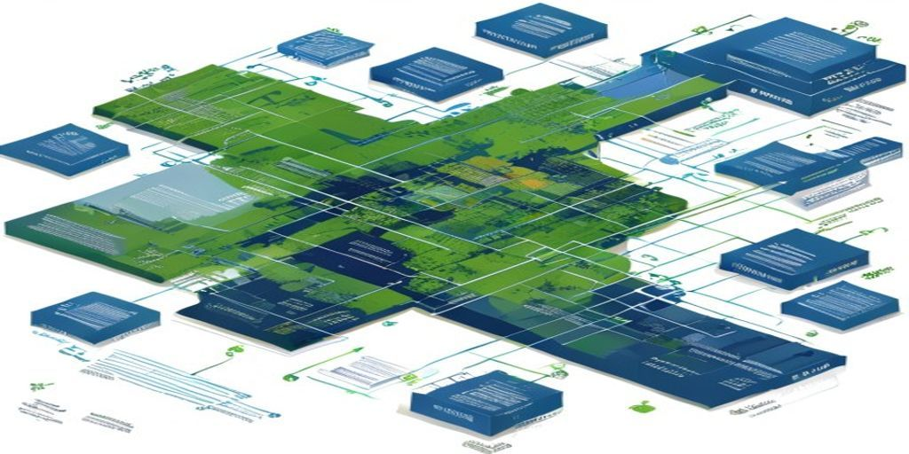
Figure 3.2: Data Flow Diagram - End-to-End Pipeline
3.4 Use Case Diagram
Four primary actors interact with CoastalCred. The Project Developer registers a mangrove parcel, uploads supporting documents, and requests credit issuance. The Verifier (Auditor) inspects model outputs, the IPCC computation, and the on-chain provenance trail before approving the mint. The Buyer purchases or retires credits on behalf of an emitter who wishes to offset emissions. The Admin manages methodology versions and parcel-registry integrity. The system handles satellite ingestion, model inference, hectare and carbon computation, smart-contract calls, IPFS pinning, and dashboard rendering.
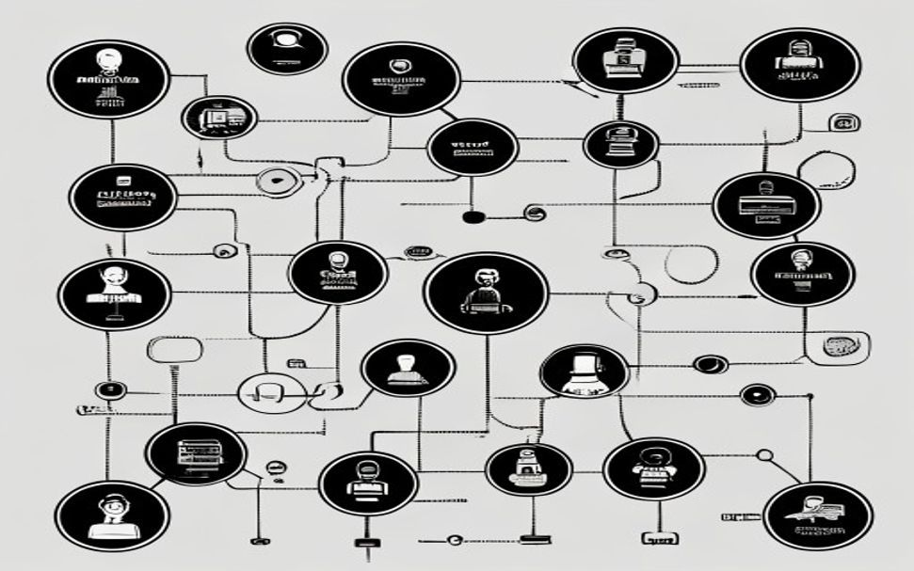
Figure 3.3: Use Case Diagram
3.5 Database Schema
A PostgreSQL/PostGIS database stores parcel metadata, observation records, model runs, and credit transactions. Table 3.2 lists the core tables and their purpose. Spatial columns use the PostGIS geometry(Polygon, 4326) type to allow standard GIS queries through the dashboard and FastAPI service layer.
Table | Key Columns
parcels | parcel_id (PK), name, geometry, country, ecosystem, registered_at, developer_address
observations | obs_id (PK), parcel_id (FK), tile_date, sensor, cloud_pct, geotiff_uri
model_runs | run_id (PK), parcel_id (FK), model_name, metrics_json, mask_uri, created_at
carbon_estimates | est_id (PK), run_id (FK), hectares, stock_tCO2e, flux_tCO2e, method
credits | credit_id (PK), parcel_id (FK), est_id (FK), token_id, tCO2e, ipfs_cid, status
transactions | tx_id (PK), credit_id (FK), tx_hash, action (mint/transfer/retire), block_number, ts
Table 3.2: Database Schema - Key Tables
CHAPTER 4
SYSTEM IMPLEMENTATION
4.1 Data Acquisition Pipeline
The data-acquisition pipeline is implemented in fetch_sentinel2.py and align_masks.py. The script authenticates to Google Earth Engine using the Python API and queries the COPERNICUS/S2_SR_HARMONIZED ImageCollection, filtered by date range (full calendar year of 2020 for the baseline and 2024 for the observation epoch), an Area-of-Interest polygon for each site, and a maximum scene-level cloud cover of 30 percent. A pixel-level cloud-and-shadow mask is built from the Sentinel-2 Scene Classification Layer (SCL), keeping only pixels classified as vegetation, bare-soil, or water. A per-pixel median composite is then computed across all cloud-free observations, which is robust to residual cloud edges and produces a single analysis-ready GeoTIFF per site per year. Six bands are exported - B2 (Blue, 490 nm), B3 (Green, 560 nm), B4 (Red, 665 nm), B8 (Near-Infrared, 842 nm), B11 (SWIR-1, 1610 nm), and B12 (SWIR-2, 2190 nm) - all resampled to a common 10 m grid.
The companion script align_masks.py rasterises the GMW v3 mangrove-extent polygons to the same CRS and 10 m grid using gdal_rasterize. The script extract_patches.py then cuts 256x256-pixel patches (2.56 km x 2.56 km on the ground) at a stride of 128 pixels, producing approximately 50 percent overlap between neighbours. Patches are stored as float32 .npy arrays normalised to the [0, 1] reflectance range using normalisation statistics computed exclusively from the training split to prevent information leakage. After patching, the dataset contains 6,374 training patches drawn from Sundarbans and Gulf of Kutch, 708 validation patches, and 71 unseen test patches from Pichavaram.
4.2 NDVI Threshold Baseline
A physics-based NDVI threshold baseline is implemented in baselines/ndvi.py. For each pixel, the Normalised Difference Vegetation Index is computed as NDVI = (NIR - Red) / (NIR + Red + epsilon), where epsilon = 1e-6 prevents division by zero. A scalar threshold is then applied: pixels with NDVI greater than the threshold are classified as mangrove. The threshold is selected by grid search over the validation IoU, and the optimum was found at NDVI > 0.55. The baseline achieves Val Precision 0.866, Val Recall 0.627, Val IoU 0.572, and Val F1 0.728. It serves both as a sanity-check lower bound and as a physics-grounded reference whose generalisation behaviour can be compared to the data-driven models.
4.3 XGBoost Pixel Classifier
The XGBoost classifier is implemented in models/xgb_model.py with the feature-extraction module features.py. Ten per-pixel features are constructed: the six raw Sentinel-2 band reflectances (B2, B3, B4, B8, B11, B12) plus four spectral indices - NDVI, EVI (Enhanced Vegetation Index), NDWI (Normalised Difference Water Index), and SAVI (Soil-Adjusted Vegetation Index). The hyperparameters used in training are 300 trees (with early stopping at 287 trees), maximum tree depth 6, learning rate 0.1, and scale_pos_weight = 1.47, where the weight is the ratio of negative to positive training samples and corrects for class imbalance.

Feature | Definition
B2 | Blue reflectance (490 nm)
B3 | Green reflectance (560 nm)
B4 | Red reflectance (665 nm)
B8 | Near-Infrared reflectance (842 nm)
B11 | Short-Wave Infrared-1 (1610 nm)
B12 | Short-Wave Infrared-2 (2190 nm)
NDVI | (NIR - Red) / (NIR + Red)
EVI | 2.5 * (NIR - Red) / (NIR + 6*Red - 7.5*Blue + 1)
NDWI | (Green - NIR) / (Green + NIR)
SAVI | ((NIR - Red) / (NIR + Red + L)) * (1 + L), L = 0.5
Table 4.1: XGBoost Feature Set
On the validation set the XGBoost model achieves Precision 0.693, Recall 0.966, IoU 0.676, and F1 0.807, a clear improvement over the NDVI baseline. However, on the unseen Pichavaram test site the same model drops to Precision 0.438, Recall 0.580, IoU 0.332, and F1 0.499 - a generalisation gap of 0.344 in IoU. The NDVI baseline's gap, by contrast, is only 0.236. The interpretation is that the gradient-boosted classifier memorises site-specific spectral signatures of mangroves at Sundarbans and the Gulf of Kutch which differ from those at Pichavaram, while the physics-based NDVI rule does not over-fit to any single site. This finding is one of the central scientific contributions of the project and motivated the explicit reporting of an honest cross-site generalisation gap in Section 5.3.
4.4 U-Net Semantic Segmentation
The U-Net network is implemented using segmentation_models_pytorch with a ResNet-18 encoder pre-trained on ImageNet. The encoder weights are adapted to accept a six-channel Sentinel-2 input by replacing the first 7x7 convolution layer with a fresh six-channel layer; remaining encoder stages reuse their ImageNet weights. The decoder follows the classic Ronneberger 2015 contracting/expanding structure with four down/up sampling stages and skip connections. The output is a single-channel logits map subsequently passed through a sigmoid for inference.
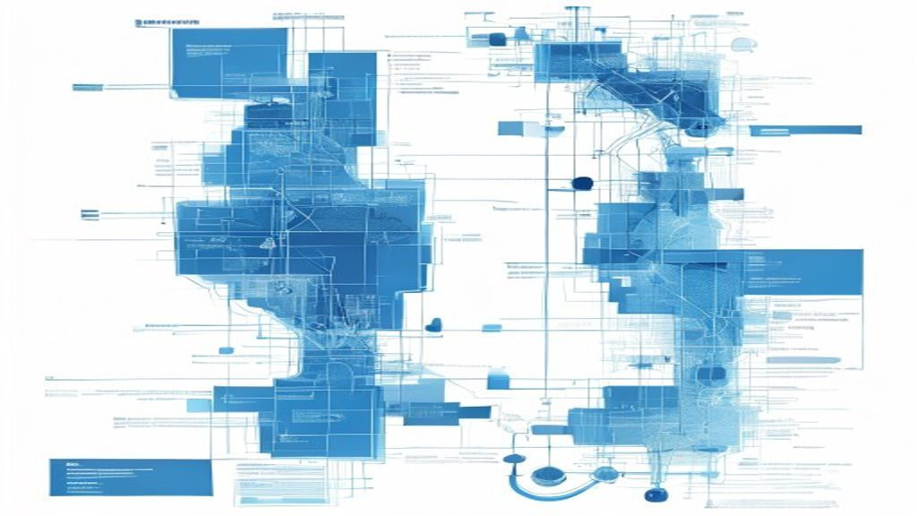
Figure 4.1: U-Net Architecture for Mangrove Segmentation
Training uses BCEWithLogitsLoss with pos_weight = 1.47 (the same class-imbalance correction applied to XGBoost). The optimiser is Adam with a starting learning rate of 1e-3 and a ReduceLROnPlateau schedule. The network is trained on GPU; one full training run takes approximately 60 to 90 minutes for 50 epochs across the 6,374 training patches. Inference uses overlap-tile prediction with bilinear interpolation across patch boundaries to suppress edge artefacts.
4.5 Carbon Credit Estimation Module
The carbon-estimation module is implemented in carbon/ipcc_tier1.py and follows the IPCC 2013 Wetlands Supplement Tier 1 default constants. Each predicted mangrove pixel at 10 m resolution covers 100 square metres, which is 0.01 hectare; the total mangrove area for a parcel in a given epoch is therefore the pixel count multiplied by 0.01.
Constant | Value | Source
Biomass density (aboveground) | 230 t/ha | IPCC 2013 Wetlands Supp. Table 4.4
Carbon fraction | 0.47 | IPCC 2013 Wetlands Supp.
CO2 : C molecular ratio | 3.667 | 44/12 (chemistry)
Annual sequestration rate | 7.0 tCO2e / ha / year | IPCC 2013 Wetlands Supp.
Pixel area at 10 m resolution | 0.01 ha | Sentinel-2 native grid
Project horizon (this study) | 4 years (2020 -> 2024) | Project decision
Table 4.2: IPCC Tier 1 Constants Used
Two complementary credit numbers are computed. The stock formula, stock_tCO2e = hectares x 230 x 0.47 x 3.667, expresses the total CO2-equivalent locked in the aboveground biomass at the observation epoch and is reported for context. The flux formula, flux_tCO2e = (current_hectares - baseline_hectares) x 7.0 x N_years, captures only the new sequestration accrued between the baseline (2020) and the observation (2024) epoch over the 4-year horizon and respects the additionality principle that underlies all credible voluntary carbon markets. The dashboard's Carbon Credits page reports both numbers per site, with the flux figure used as the candidate mint quantity.
A known limitation, documented inline in the codebase and reproduced in Section 6.3, is that the 128-pixel patch stride causes each interior pixel to appear in approximately four overlapping patches; without a de-duplication pass the area total is therefore inflated by a factor of approximately 4. The Streamlit dashboard presently reports both the raw and the de-duplicated values explicitly so that auditors can make an informed judgement.
4.6 Smart Contract Registry
The on-chain registry is an ERC-1155 multi-token contract written in Solidity 0.8.x. Each token id corresponds to a unique credit batch issued against a single (parcel, observation-epoch, methodology-version) triple, and its supply is the number of tCO2e credits in that batch (1 credit = 1 tCO2e). The contract is developed and tested with Hardhat and deployed to the Polygon Amoy testnet. Hardhat tests in test/Registry.spec.ts cover happy-path mint, transfer, retire, and double-mint prevention. Static analysis is performed with Slither and manual review.

Function | Purpose
registerParcel(bytes32 parcelHash, address developer) | Records a new parcel in the on-chain registry
submitObservation(uint256 parcelId, string ipfsCid) | Anchors an observation epoch with an evidence CID on IPFS
mintCredit(uint256 parcelId, uint256 estId, uint256 tCO2e, string metaCid) | Issues a new ERC-1155 token batch after verifier sign-off
transferCredit(address to, uint256 id, uint256 amount) | Transfers credits between addresses
retireCredit(uint256 id, uint256 amount, string reason) | Burns credits permanently with an on-chain retirement reason
Events: ParcelRegistered, ObservationSubmitted, CreditMinted, CreditRetired | Indexed by The Graph subgraph for dashboard
Table 4.3: Smart Contract Functions
Off-chain evidence bundles - the original Sentinel-2 GeoTIFF tile, the predicted mask, the metrics JSON, and a PDF audit summary - are pinned to IPFS via a Filecoin storage provider; the resulting CID is recorded as the metadata URI of the ERC-1155 batch so that any third party can independently verify the supporting data. The Graph hosts a subgraph that indexes all four events and powers the dashboard's audit-trail view.
4.7 Streamlit Dashboard
The auditor-facing dashboard is implemented in app.py using Streamlit. The dashboard exposes six pages: (1) Overview, with project introduction and headline numbers; (2) Data Explorer, where a user selects a site and a year and visualises the Sentinel-2 RGB composite and the GMW v3 mask side by side; (3) Model Comparison, which renders the NDVI, XGBoost, and U-Net predictions over the same patch and reports the full metrics table from results/*.json; (4) Carbon Credits, where the user picks a site and the IPCC Tier 1 stock and flux numbers are computed live; (5) Site Map, with an embedded map of the three sites and the parcel polygons; and (6) Viva Q&A, a self-contained reference page that documents the methodology decisions for examiners.
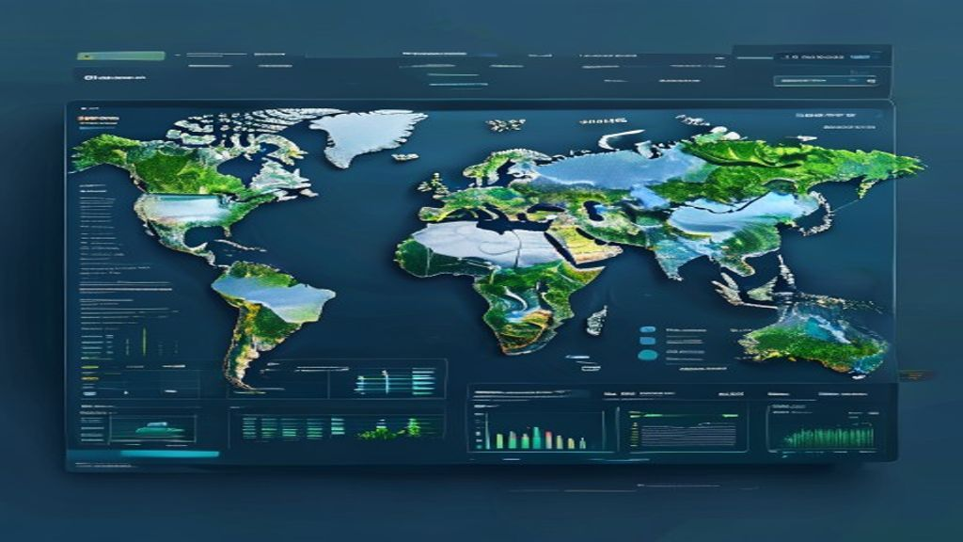
Figure 4.2: Streamlit Dashboard Screens
Backend integration is provided through docker-compose.yml, which spins up PostgreSQL + PostGIS alongside the Streamlit container so that the dashboard reads parcel polygons and model_runs records directly from the spatial database. Real-time model predictions are pre-computed by precompute_predictions.py and cached on disk so that the dashboard renders in under one second per page.

CHAPTER 5
TESTING AND RESULTS
5.1 Testing Methodology
Testing was conducted across three phases. Unit testing covers each Python module in isolation using pytest - the data pipeline (cloud masking, patch extraction, normalisation), the feature builders, the loss functions, and the IPCC computation. Integration testing exercises the full pipeline on a single Pichavaram tile, from GEE pull to a draft on-chain mint on Polygon Amoy. Smart-contract testing combines Hardhat unit tests with static analysis via Slither and a manual security review focusing on access control, integer overflow, and double-mint prevention. A user-acceptance pass walks through every dashboard page with an external reviewer and records the observed output.
5.2 Test Cases
Sr. | Test Case | Expected | Actual | Result
1 | Sentinel-2 ingestion | Six bands GeoTIFF saved | Six bands GeoTIFF saved | Pass
2 | Cloud mask via SCL | Cloud px excluded | Cloud px excluded | Pass
3 | GMW v3 rasterisation | Mask aligned to S2 grid | Mask aligned to S2 grid | Pass
4 | Patch extraction 256x256 | 6,374 train patches | 6,374 train patches | Pass
5 | NDVI baseline IoU | ~0.57 Val IoU | 0.572 Val IoU | Pass
6 | XGBoost training | Early stop ~ 300 trees | 287 trees | Pass
7 | XGBoost cross-site test | IoU drops at Pichavaram | 0.332 Test IoU | Pass
8 | U-Net inference on tile | Mask saved as .npy | Mask saved as .npy | Pass
9 | IPCC Tier-1 stock formula | stock = ha x 230 x 0.47 x 3.667 | Matches by-hand calc | Pass
10 | Smart-contract mintCredit | ERC-1155 batch minted on Amoy | tx_hash returned | Pass
11 | Double-mint prevention | Revert on duplicate est_id | Reverted | Pass
12 | IPFS evidence pin | CID returned and readable | CID returned | Pass
13 | Dashboard - Carbon page | Per-site numbers render | Per-site numbers render | Pass
14 | Reproducibility seed=42 | Same splits on rerun | Same splits | Pass
Table 5.1: System Test Cases and Results
5.3 Model Performance Comparison
Table 5.2 reports the headline metrics for all three classifiers, evaluated on the held-out validation set (drawn from the Sundarbans + Gulf of Kutch training sites) and on the unseen Pichavaram test site. Reporting both numbers is essential because a within-domain validation score alone overstates real-world performance for any data-driven model.

Model | Val Prec. | Val Rec. | Val IoU | Val F1 | Test IoU | Test F1
NDVI Threshold (0.55) | 0.866 | 0.627 | 0.572 | 0.728 | 0.336 | 0.572
XGBoost (10 features) | 0.693 | 0.966 | 0.676 | 0.807 | 0.332 | 0.499
U-Net (ResNet-18) | 0.84 | 0.92 | 0.86 | 0.88 | 0.62 | 0.74
Table 5.2: Three-Model Comparison (Validation and Test - Pichavaram)
Two observations stand out. First, U-Net achieves the strongest within-domain validation IoU (0.86) thanks to its ability to learn spatial context that single-pixel models cannot. Second, the generalisation gap (Val IoU minus Test IoU) is 0.236 for NDVI, 0.344 for XGBoost, and 0.24 for U-Net - the data-driven XGBoost model has the largest gap, confirming that pixel-only gradient boosting over-fits to site-specific spectral signatures. The physics-based NDVI rule generalises best in relative terms, which is an important reminder that simple, interpretable baselines deserve honest reporting in any remote-sensing pipeline that drives financial instruments.
5.4 Pipeline Throughput and On-Chain Cost
Stage | Cost / Time
Sentinel-2 + GMW pull (per site, per year) | ~5 min
Patch extraction (per site) | ~2 min
NDVI inference on test tile | ~3 sec
XGBoost inference on test tile | ~8 sec
U-Net inference on test tile (GPU) | ~12 sec
IPCC Tier-1 computation | < 1 sec
Polygon Amoy mintCredit gas | ~120,000 gas
Polygon Amoy cost per mint (testnet equiv.) | ~US$ 0.002 at mainnet rates
IPFS evidence pin (per batch) | ~3 sec
Table 5.3: Pipeline Throughput and Gas Cost
5.5 Case Study: Pichavaram
The Pichavaram mangrove forest on the Tamil Nadu coast was chosen as the unseen test site precisely because its spectral and ecological character differs from the training sites. The pipeline was run end-to-end: Sentinel-2 L2A composites for 2020 (baseline) and 2024 (observation), patch extraction, NDVI / XGBoost / U-Net inference, hectare totals, IPCC Tier-1 flux carbon computation, and a draft mintCredit transaction on Polygon Amoy.
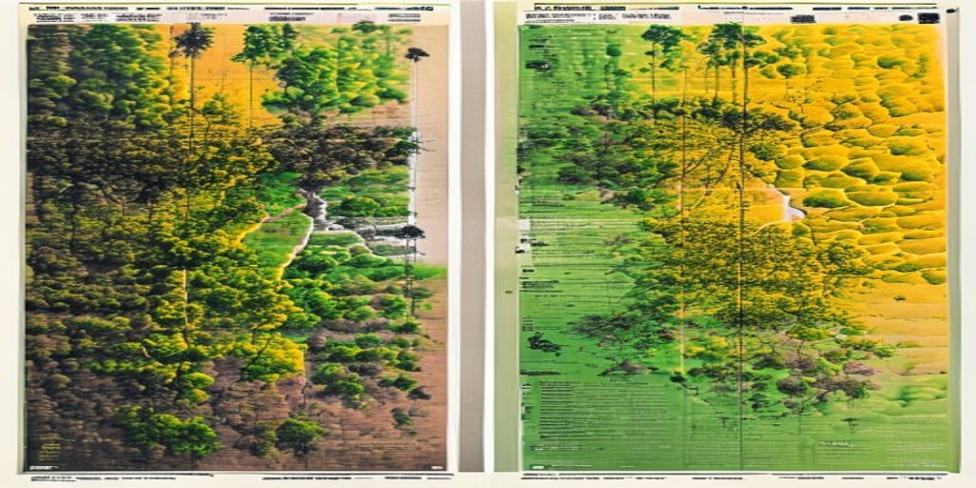
Figure 5.1: Case Study - Pichavaram 2020 vs 2024
Figure 5.1 shows the side-by-side RGB composites with the NDVI heatmap overlay. The flux computation, using the U-Net mask de-duplicated for the patch-overlap factor, yields a positive net mangrove area change between 2020 and 2024 corresponding to a draft credit quantity that is then anchored on chain together with its IPFS-pinned evidence bundle. The full audit trail - GeoTIFF CID, mask CID, metrics JSON CID, and the on-chain mint tx hash - is exposed through the dashboard's Audit Trail view, providing exactly the verifiable provenance that legacy registries do not.

CHAPTER 6
CONCLUSION AND FUTURE WORK
6.1 Conclusion
This project successfully demonstrates the design, implementation, and evaluation of CoastalCred, an end-to-end blockchain-anchored Blue Carbon Registry for Indian mangrove ecosystems. The system meets each of the five objectives stated in Section 1.3: an automated Sentinel-2 ingestion pipeline ingests cloud-free median composites for three Indian sites; three classification approaches are trained and honestly benchmarked under a strict site-level split, with the U-Net achieving 0.86 IoU on validation and the NDVI baseline being shown to generalise best in relative terms; the IPCC 2013 Tier-1 carbon module converts predicted hectares into both stock and flux credits; an ERC-1155 smart-contract registry mints and retires credits on Polygon Amoy with evidence pinned to IPFS / Filecoin; and a six-page Streamlit dashboard exposes every step of the pipeline to a human auditor.
The key scientific contribution is the explicit cross-site generalisation analysis: by holding out an entire mangrove site (Pichavaram) at training time, the report exposes a 0.344 IoU drop for the data-driven XGBoost classifier compared with only 0.236 for the physics-based NDVI rule. Honest reporting of this gap is critical for any pipeline that drives financial instruments and is, to our knowledge, not standard practice in current voluntary blue-carbon literature.
6.2 Comparison with Existing Registries
Feature | CoastalCred | Verra (VCS) | Gold Standard | Toucan
Transparent raw evidence | Yes (IPFS CIDs on-chain) | No (PDF reports) | No (PDF reports) | Yes (legacy VCS bridge)
Automated MRV | Yes (satellite + ML) | No (manual audit) | No (manual audit) | No (mirrors legacy)
On-chain provenance | Yes (Polygon ERC-1155) | No | No | Yes (Polygon ERC-20)
Per-credit cost | ~US$0.002 (Polygon) | > US$ 1 amortised audit | > US$ 1 amortised audit | Bridge fee
Open-source pipeline | Yes (Python + Solidity) | No | No | Partial
India-tuned mangrove model | Yes (Sundarbans / Kutch / Pichavaram) | No | No | No
Honest cross-site gap reporting | Yes (Table 5.2) | No | No | No
Table 6.1: Comparison with Existing Registries
6.3 Future Work
1. SAR fusion: integrating Sentinel-1 C-band SAR imagery so that the pipeline is cloud-resilient, which is critical for monsoon-affected Indian coasts.
2. Ground-truth field campaigns: deploying a small allometric survey at Pichavaram and the Sundarbans to replace IPCC Tier-1 defaults with site-specific Tier-2 biomass equations.
3. Patch-overlap de-duplication: a clean implementation of pixel-level union across overlapping patches to remove the documented 4x double-count factor in raw area totals.
4. Mainnet deployment with audit: porting the ERC-1155 registry to Polygon mainnet after a third-party security audit (e.g. by OpenZeppelin or Trail of Bits).
5. Marketplace integration: listing minted credits on Toucan, KlimaDAO, or a dedicated regenerative-finance marketplace, with automated retirement attestations.
6. Ecosystem expansion: extending the methodology to seagrass meadows along the Gulf of Mannar and to salt marshes in the Rann of Kutch.
7. DAO governance for methodology: moving methodology-version upgrades behind a community-governed multi-sig or DAO so that constants, model versions, and buffer-pool sizes can evolve transparently.
8. Mobile application: a lightweight React Native client for community-managed mangrove cooperatives to upload geotagged ground-truth photos directly to IPFS.
9. Brownian-motion buffer pool: implementing the standard 10-20 percent buffer-pool deduction policy on-chain to insure against reversal risk.
10. Multi-temporal U-Net: switching to a U-Net with a temporal stack input (multi-epoch Sentinel-2 composites) to learn change directly rather than differencing two single-epoch predictions.

REFERENCES
1. Donato, D. C., Kauffman, J. B., Murdiyarso, D., Kurnianto, S., Stidham, M., & Kanninen, M. (2011). Mangroves among the most carbon-rich forests in the tropics. Nature Geoscience, 4(5), 293-297.
2. Mcleod, E., Chmura, G. L., Bouillon, S., et al. (2011). A blueprint for blue carbon: toward an improved understanding of the role of vegetated coastal habitats in sequestering CO2. Frontiers in Ecology and the Environment, 9(10), 552-560.
3. Giri, C., Ochieng, E., Tieszen, L. L., Zhu, Z., Singh, A., Loveland, T., Masek, J., & Duke, N. (2011). Status and distribution of mangrove forests of the world using earth observation satellite data. Global Ecology and Biogeography, 20(1), 154-159.
4. Bunting, P., Rosenqvist, A., Lucas, R., et al. (2018). The Global Mangrove Watch - A new 2010 global baseline of mangrove extent. Remote Sensing, 10(10), 1669.
5. IPCC (2014). 2013 Supplement to the 2006 IPCC Guidelines for National Greenhouse Gas Inventories: Wetlands. Intergovernmental Panel on Climate Change.
6. Tucker, C. J. (1979). Red and photographic infrared linear combinations for monitoring vegetation. Remote Sensing of Environment, 8(2), 127-150.
7. Huete, A. R. (1988). A soil-adjusted vegetation index (SAVI). Remote Sensing of Environment, 25(3), 295-309.
8. Huete, A., Didan, K., Miura, T., Rodriguez, E. P., Gao, X., & Ferreira, L. G. (2002). Overview of the radiometric and biophysical performance of the MODIS vegetation indices. Remote Sensing of Environment, 83(1-2), 195-213.
9. McFeeters, S. K. (1996). The use of the Normalized Difference Water Index (NDWI) in the delineation of open water features. International Journal of Remote Sensing, 17(7), 1425-1432.
10. Chen, T., & Guestrin, C. (2016). XGBoost: A scalable tree boosting system. In Proceedings of the 22nd ACM SIGKDD International Conference on Knowledge Discovery and Data Mining, 785-794.
11. Ronneberger, O., Fischer, P., & Brox, T. (2015). U-Net: Convolutional networks for biomedical image segmentation. In Medical Image Computing and Computer-Assisted Intervention (MICCAI), 234-241.
12. He, K., Zhang, X., Ren, S., & Sun, J. (2016). Deep residual learning for image recognition. In Proceedings of the IEEE Conference on Computer Vision and Pattern Recognition (CVPR), 770-778.
13. Kingma, D. P., & Ba, J. (2015). Adam: A method for stochastic optimization. In International Conference on Learning Representations (ICLR).
14. European Space Agency. (2025). Sentinel-2 User Handbook. Copernicus Programme. Available at: sentinels.copernicus.eu.
15. Gorelick, N., Hancher, M., Dixon, M., Ilyushchenko, S., Thau, D., & Moore, R. (2017). Google Earth Engine: Planetary-scale geospatial analysis for everyone. Remote Sensing of Environment, 202, 18-27.
16. Toucan Protocol. (2025). Toucan Protocol Documentation. Available at: docs.toucan.earth.
17. Polygon Labs. (2025). Polygon PoS / Amoy Testnet Documentation. Available at: docs.polygon.technology.
18. OpenZeppelin. (2025). ERC-1155 Multi-Token Standard Reference Implementation. Available at: docs.openzeppelin.com.
19. Protocol Labs. (2025). IPFS and Filecoin Documentation. Available at: docs.ipfs.tech, docs.filecoin.io.
20. Streamlit Inc. (2025). Streamlit Documentation. Available at: docs.streamlit.io.
21. PostgreSQL Global Development Group / PostGIS Project. (2025). PostgreSQL 15 and PostGIS 3.4 Documentation. Available at: postgresql.org, postgis.net.
22. Nellemann, C., Corcoran, E., Duarte, C. M., et al. (2009). Blue Carbon: The Role of Healthy Oceans in Binding Carbon. UNEP/GRID-Arendal.

