Structure

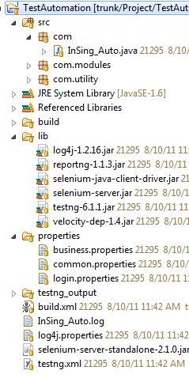

- src: include java file
- lib: include selenium library, testng library, log4j library, reportng library (and velocity-dep)
- properties: configuration for parameter used for testing
- testng_output: report generate after complete testing
- build.xml
  - Do not change anything in this file or contact me if you want to change
  - Right click and choose Run as Ant to start automation testing
- testing.xml: change the flow/ steps of testing
- log4j.properties: do not change anything in this file, just used for log the history generate(InSing_Auto.log)
- Selenium-server-standalone-2.1.0.jar: run the selenium server

How to create the new automation test ?

- Create new class in src folder
- Add Logger for that class if not exists
- Create new method with annotation @Test
- Every method should have 2 part
  - Action/ Step: describe the actions
    - Use InSing_Auto.selenium to simulation user action
    - Use Utility.delay() instead of waitForPageToLoad()
  - Assertion:
    - Should use Assert.assertEquals() or Assert. assertNotEquals ()
    - Should use Assert.assertTrue() or Assert.assertFalse()
- Edit testing.xml (Ref: http://testng.org/doc/documentation-main.html)
- Choose build.xml -> right click -> Run as Ant build
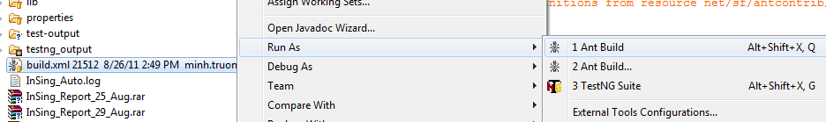
- After completed, open testing_output\html\index.html to view report result

Handle SSL certificate when start selenium server for Firefox

- Close all Firefox instance
- Open command line (Start > Run > cmd)
- Type “cd” to location firefox’s installed folder
- Type “firefox.exe -profilemanager”
- Click create New button, example “InSing” in folder “C:\InSing”
- Then double click on that to start Firefox
- Redirect to https://tools02.test.insing.com/
- Then accept all certificate request, addon, …
- Close the Firefox again
- Start selenium server again, by open new command line and type:
java -jar selenium-server-standalone-2.1.0.jar -firefoxProfileTemplate C:\InSing

Example Script for News module

- Create News.java in com.modules
- Create Logger: private Logger Log = Logger.getLogger(News.class);
- Create test method
@Test
public void openNews()
{
InSing_Auto.selenium.open("news");
Utility.delay();
Assert.assertEquals(InSing_Auto.selenium.getTitle(), "Singapore News , Local Breaking News, Headlines, World, Business, Sports & Entertainment News - inSing.com");
Log.info("verify Movie homepage title");

}
- Config in testing.xml
<test name="News" preserve-order="true">
<classes>
<class name="com.modules.News" >
<methods>
<include name="openNews" />
</methods>
</class>
</classes>
</test>

- Run and finish

