An Internship Report
Of
Data Science Master Virtual Internship

Submitted
To

School of Computer Science and Engineering
IILM University, Greater Noida, U.P.

In partial fulfilment of the requirement of degree of
B.Tech (Computer Science and Engineering)

By

Roll Number of Student: 2410031602
Name of Student: TANNU KUMARI
Batch: 2024-2028

CANDIDATE'S DECLARATION
I, TANNU KUMARI, do hereby declare that the internship report titled “Data Science Master Virtual Internship” has been completed by me to fulfil the requirement for the award of the degree of Bachelor of Technology in Computer Science and Engineering. All the references have been quoted and I have not taken as such any material from any other source. I affirm that this report is my own and has not been submitted to any other institute for any degree/diploma requirement, and further I shall be solely responsible for any kind of copyright violation in this regard.
Signature:-
Student Name: TANNU KUMARI
Roll No.: 2410031602

ACKNOWLEDGEMENT
I am using this opportunity to express my gratitude to everyone who supported me throughout the Internship Program. I am thankful for their aspiring guidance, invaluably constructive criticism and friendly advice during this work. I am sincerely grateful to them for sharing their truthful and illuminating views on a number of issues related to this work.
I would like to thank the AICTE – EduSkills Virtual Internship Program team, EduSkills Academy, and Siemens for providing me the opportunity and the structured platform to learn and gain hands-on exposure in the domain of Data Science. I am also thankful to my institute, IILM University, Greater Noida, and the faculty of the School of Computer Science and Engineering for their continuous support and encouragement.
I express my gratitude to my parents for their blessings.
Signature:-
Student Name: TANNU KUMARI
Roll No.: 2410031602

TABLE OF CONTENTS

1. Candidate's Declaration i
2. Acknowledgement ii
3. Internship Completion Certificate -
4. Project Description 1
4.1 Introduction 1
4.2 Organization Profile 2
4.3 Problem Statement 3
4.4 Project Objectives 3
4.5 Scope of the Project 4
4.6 Technologies and Tools Used 4
4.7 System Architecture 5
4.8 Methodology 6
4.9 Expected Outcomes 7
4.10 Certificate of Completion 8
5. Bibliography/References 9

3. INTERNSHIP COMPLETION CERTIFICATE
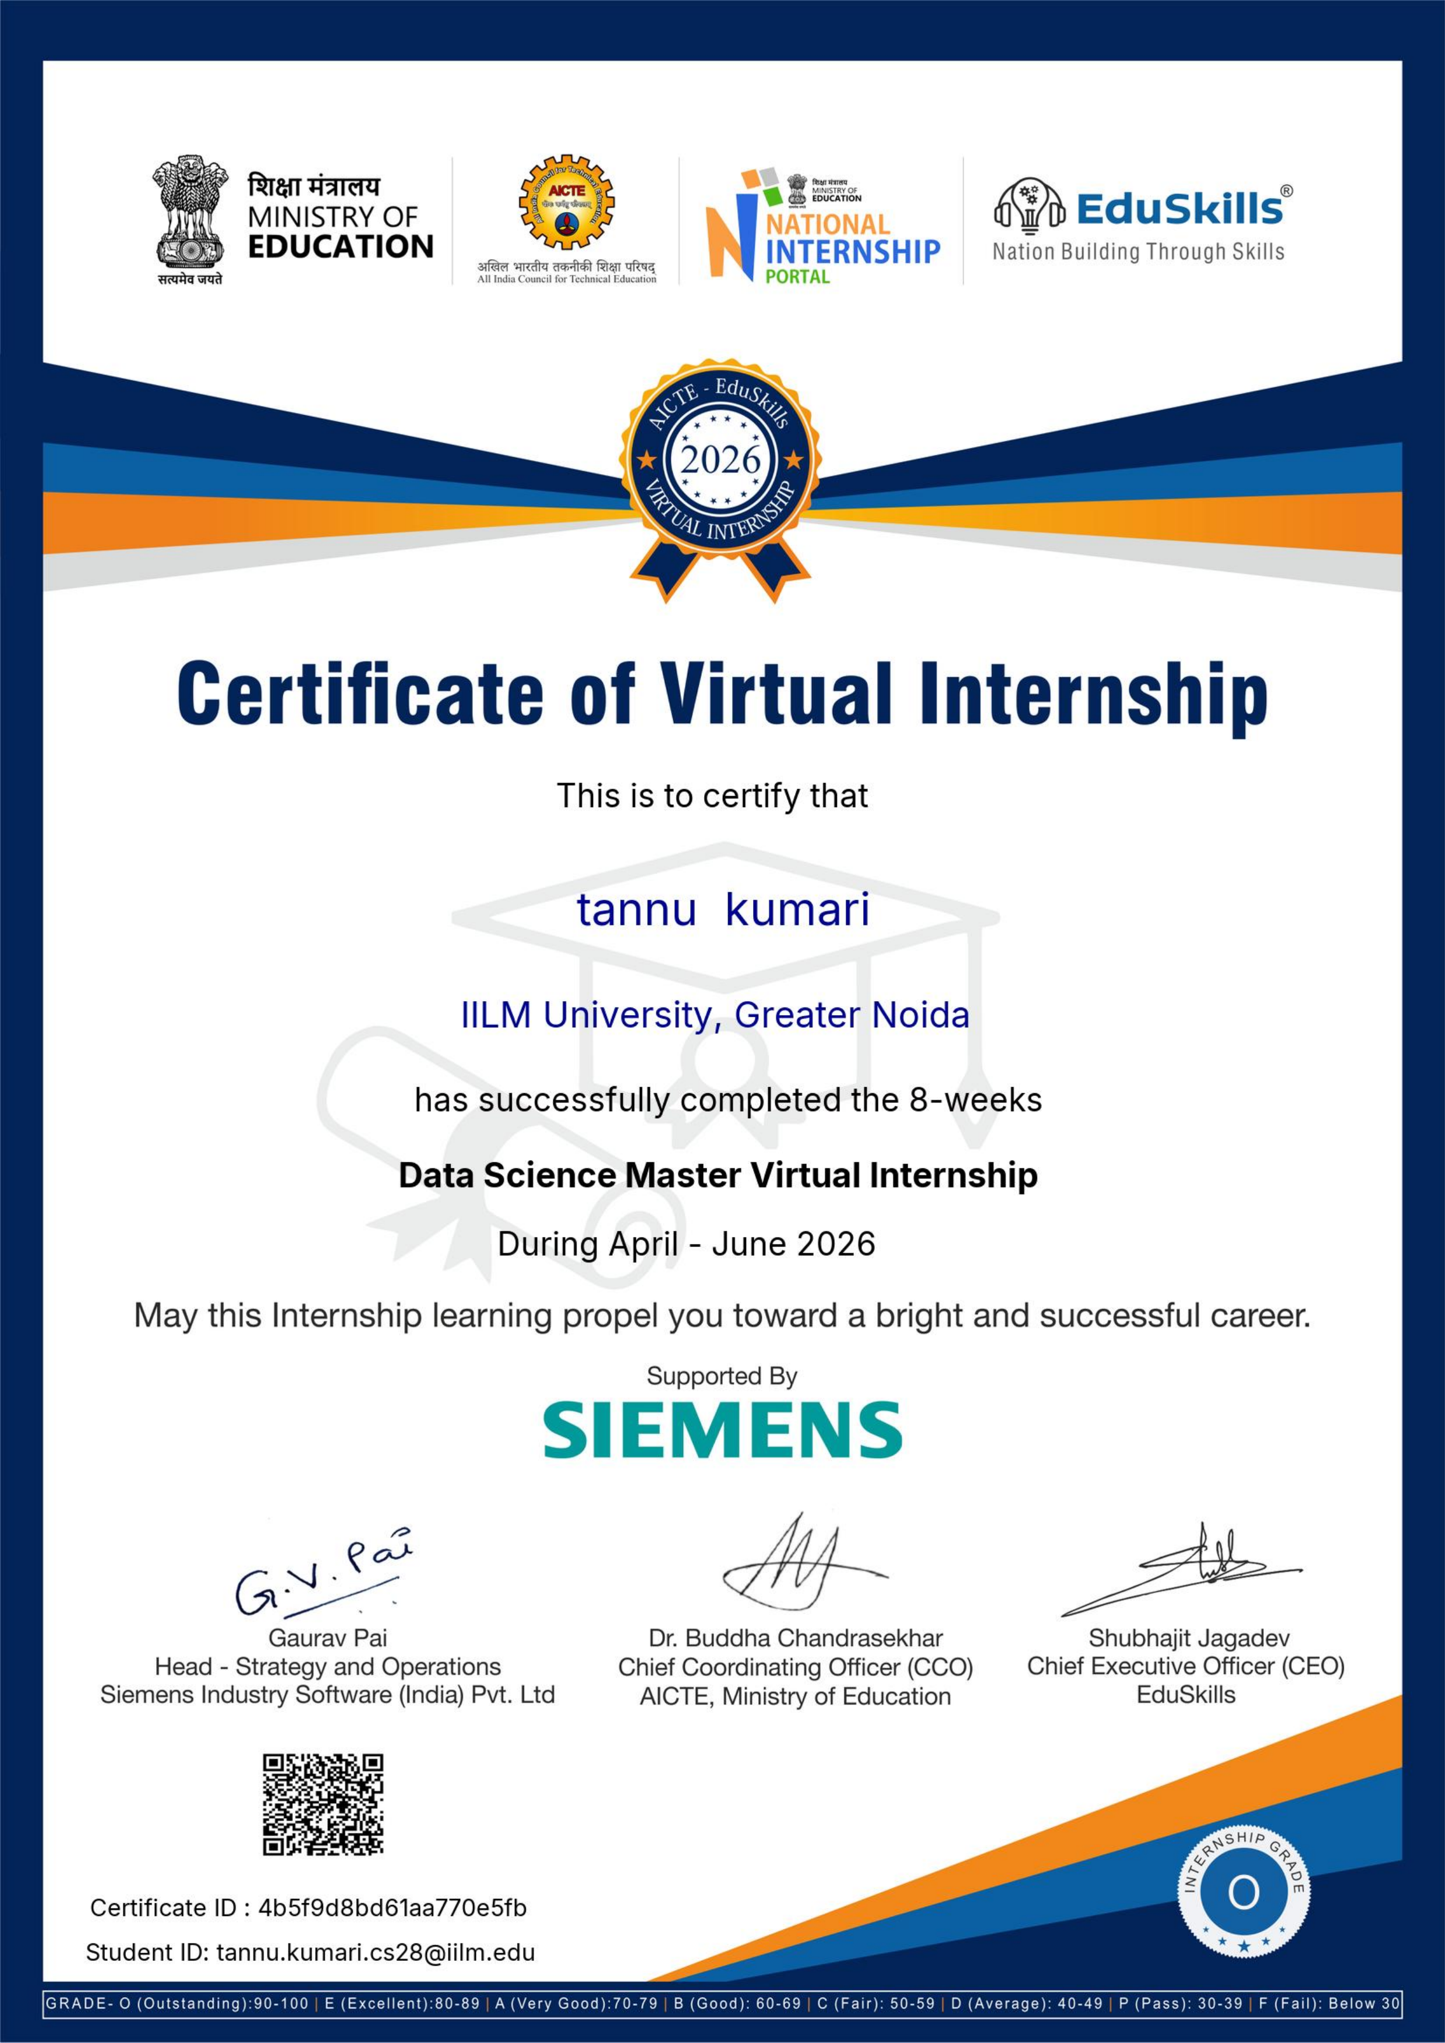

4. PROJECT DESCRIPTION

4.1 Introduction
This report presents a detailed account of the 8-week Virtual Internship undertaken under the AICTE – EduSkills Virtual Internship Program, in the domain of “Data Science Master”, supported by Siemens. The internship was carried out from April 2026 to June 2026 as part of the requirement of the Bachelor of Technology (Computer Science and Engineering) programme at IILM University, Greater Noida.
The primary aim of this internship was to build a strong practical foundation in data science – covering statistics, data wrangling, exploratory data analysis, and machine learning – and to apply it to real-world problems using both code-based tools (Python) and the no-code RapidMiner platform, which is delivered as part of Siemens' Altair/RapidMiner Academy.
The internship followed a structured, week-wise curriculum combining conceptual learning with hands-on assignments and a capstone project. On successful completion of all the requirements, including the Final Credential Validation, a Virtual Internship Certificate with an “Outstanding” grade was awarded by EduSkills Academy under the patronage of AICTE and the National Internship Portal.

4.2 Organization Profile
EduSkills Academy is an ISO 9001:2015 and ISO/IEC 20000-1:2018 certified organization working under the theme “Nation Building Through Skills”. EduSkills partners with the All India Council for Technical Education (AICTE) to run the AICTE – EduSkills Virtual Internship Program under the patronage of the AICTE National Internship Portal. For the Data Science Master track, EduSkills collaborates with Siemens, whose Altair/RapidMiner Academy delivers an industry-aligned curriculum through structured learning modules, hands-on exercises, and a final capstone project, helping students build practical, job-ready data science capability.

4.3 Problem Statement
Although a large number of students learn statistics and machine-learning theory during their academic coursework, very few get structured, hands-on exposure to the complete data science lifecycle – from cleaning messy real-world data, to exploring and visualizing it, to building and evaluating predictive models. Concepts such as regression, classification, and model tuning are often understood only at a theoretical level, with little practice applying them to real datasets using industry-standard tools. The problem addressed by this internship was to practically learn and apply the end-to-end data science workflow – from raw data to actionable, well-communicated insight – using both Python and the RapidMiner no-code platform.

4.4 Project Objectives
- To understand core statistical concepts and apply them to real-world data science problems.
- To clean, wrangle, and prepare real-world datasets using Python, Pandas, and NumPy.
- To perform exploratory data analysis (EDA) and visualize data using Matplotlib and Seaborn.
- To build no-code machine-learning workflows using RapidMiner Studio.
- To build and apply regression models to predict continuous outcomes.
- To build and apply classification models to predict categorical outcomes.
- To evaluate, validate, and tune models using standard performance metrics and cross-validation.
- To communicate data-driven insights clearly through visualizations and reports.
- To complete an end-to-end capstone project applying the full data science pipeline.
- To successfully clear the Final Credential Validation / Internship Grade Point Assessment.

4.5 Scope of the Project
The scope of this internship spans the complete data science workflow – starting from foundational statistics, moving through data wrangling and exploratory data analysis, and extending into predictive modeling using both no-code (RapidMiner) and code-based (Python) approaches. It further covers model evaluation, tuning, and the communication of insights, culminating in an end-to-end capstone project. The internship was limited to a virtual, simulation/lab-based learning environment provided by Siemens' Altair/RapidMiner Academy and EduSkills Academy, and did not involve deployment on any live organizational production system.

4.6 Technologies and Tools Used
- Programming & Analysis: Python, Pandas, NumPy
- Data Visualization: Matplotlib, Seaborn
- Machine Learning: Scikit-learn, RapidMiner Studio
- Statistics: Descriptive statistics, hypothesis testing, and inferential methods
- Model Evaluation: Cross-validation, performance metrics, hyperparameter tuning
- Learning Platform: Siemens Altair/RapidMiner Academy learning modules and capstone project

4.7 System Architecture
The general architecture followed during the internship for the Data Science Master learning track can be summarized in the following layers:
- Data Collection Layer: Raw structured and unstructured datasets are gathered for analysis.
- Cleaning & Preprocessing Layer: Missing values, outliers, and inconsistent formatting are handled to prepare clean datasets.
- Exploratory Analysis Layer: Statistical summaries and visualizations reveal patterns and relationships in the data.
- Model Building Layer: Regression and classification models are trained using Python and RapidMiner.
- Evaluation & Tuning Layer: Model performance is validated and optimized using metrics and hyperparameter tuning.
- Insight & Reporting Layer: Findings are visualized and communicated as part of the capstone project.
- Assessment Layer: Weekly modules and a Final Credential Validation / Internship Grade Point Assessment track progress and final grading.

4.8 Methodology
The internship followed a structured, week-wise methodology combining conceptual learning, hands-on labs, and a capstone project, culminating in a Final Credential Validation, as summarized in the table below.
Week | Module | Description
1 | Foundations of Data Science & Statistics | Core statistical concepts and first-principles thinking underpinning data science, including descriptive statistics, probability, and data types.
2 | Data Wrangling with Python | Cleaning, transforming, and preparing real-world datasets using Python, Pandas, and NumPy.
3 | Exploratory Data Analysis & Visualization | Uncovering patterns and relationships in data through statistical summaries and visualizations using Matplotlib and Seaborn.
4 | Introduction to RapidMiner & No-Code ML | Building machine-learning workflows using RapidMiner Studio's no-code, drag-and-drop environment.
5 | Supervised Learning – Regression Models | Building and applying regression models to predict continuous outcomes.
6 | Supervised Learning – Classification Models | Building and applying classification models to predict categorical outcomes.
7 | Model Evaluation, Tuning & Optimization | Validating models using performance metrics, cross-validation, and hyperparameter tuning.
8 | Capstone Project | Applying the complete data science workflow to an end-to-end, real-world case study.
Final | Final Credential Validation | Final Credential Validation / Internship Grade Point Assessment.
Note: There was no stipend associated with this internship.
Each week combined conceptual learning with hands-on exercises to build practical skill. In the final phase, a Final Credential Validation / Internship Grade Point Assessment was conducted, and the overall grade was based on performance across the weekly modules, the capstone project, and this final assessment.

4.9 Expected Outcomes
- Ability to apply core statistical concepts to real-world data science problems.
- Practical skill in cleaning, wrangling, and exploring real-world datasets using Python (Pandas & NumPy).
- Practical understanding of building machine-learning models using RapidMiner and Python.
- Hands-on exposure to regression, classification, and model evaluation techniques.
- Capability to visualize data and communicate insights clearly through charts and reports.
- Skill to build an end-to-end data science pipeline, from raw data to actionable insight.
- A completed capstone project, along with successful clearance of the Final Credential Validation / Internship Grade Point Assessment, resulting in an “Outstanding” grade.

4.10 Certificates of Completion
The Internship Completion Certificate issued by EduSkills Academy, confirming successful completion of the 8-week AICTE – EduSkills Virtual Internship Program in Data Science Master (supported by Siemens), is attached in Chapter 3 of this report. The certificate records a Certificate ID of 4b5f9d8bd61aa770e5fb and a Student ID of tannu.kumari.cs28@iilm.edu, with an “Outstanding” grade for the period April–June 2026.

5. BIBLIOGRAPHY/REFERENCES
1. EduSkills Academy, “AICTE – EduSkills Virtual Internship Program – Data Science Master,” 2026.
2. EduSkills Academy, “Certificate of Virtual Internship – Data Science Master,” Certificate ID: 4b5f9d8bd61aa770e5fb, Student ID: tannu.kumari.cs28@iilm.edu, 2026.
3. RapidMiner Documentation, https://docs.rapidminer.com/
4. Python Software Foundation, https://www.python.org/
5. Pandas Documentation, https://pandas.pydata.org/
6. Scikit-learn Documentation, https://scikit-learn.org/
7. Siemens Digital Industries Software, https://www.sw.siemens.com/

