SELENIUM WEB UI AUTOMATION TESTING REPORT

JavaScript | Selenium WebDriver
Report Detail | Information
Prepared by | Tanny Rajbangshi
Course | Software Quality Assurance (SQA)
Application | DemoQA
Environment | Windows, Google Chrome, Node.js

1. Objective
To automate two basic web UI scenarios using Selenium WebDriver and verify the expected application responses.

2. Test Summary
ID | Test Scenario | Expected Result | Status
TC-001 | Text Box Submission | Submitted name is displayed | Confirm after execution
TC-002 | Double-Click Button | Double-click confirmation is displayed | PASS

3. Test Environment & Preconditions
Node.js and selenium-webdriver are installed; Chrome is available; the DemoQA pages are accessible.
Test Case | URL | Run Command
TC-001 | https://demoqa.com/text-box | node q1_textbox.js
TC-002 | https://demoqa.com/buttons | node q2_double_click.js

4. TC-001 — Text Box Submission
Objective: Enter a name, submit the form, and verify the displayed output.
Test Data | Expected Output
Tanny Rajbangshi | Name:Tanny Rajbangshi
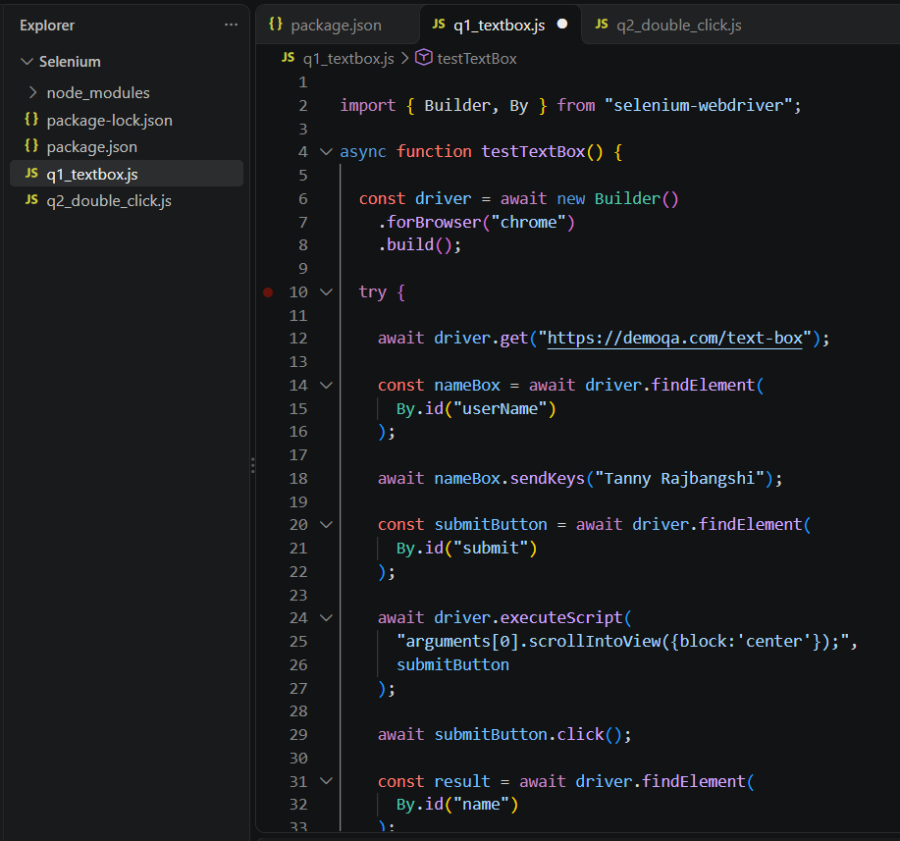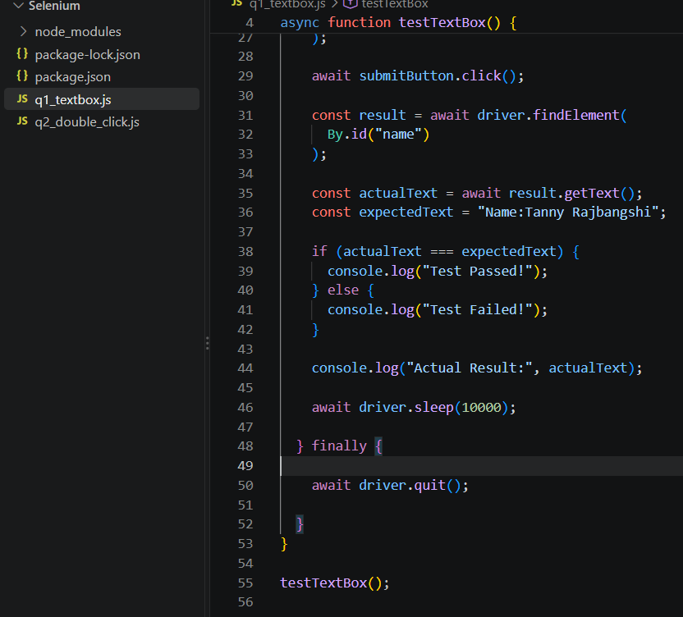
TC-001 BROWSER SCREENSHOT:
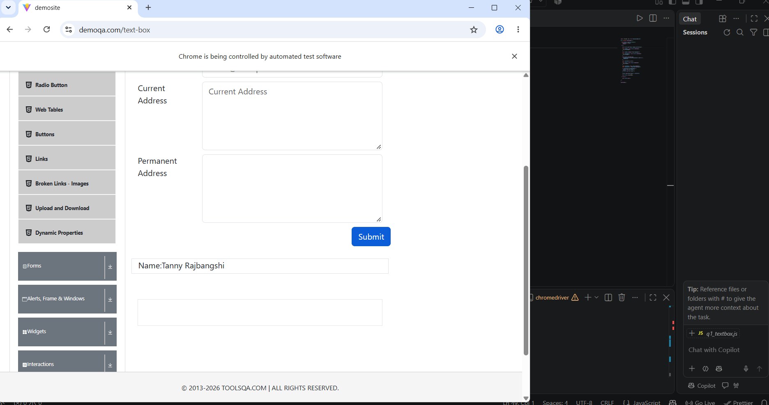

TC-001 TERMINAL SCREENSHOT:
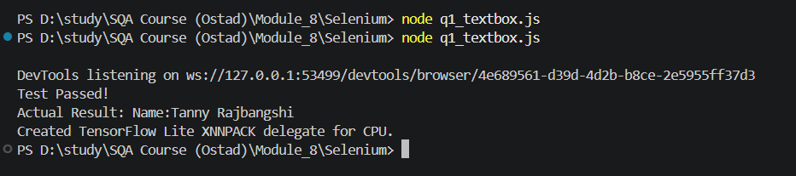

5. TC-002 — Double-Click Button
Objective: Double-click the target button and verify the confirmation message.
Expected Output | Actual Output | Status
You have done a double click | You have done a double click | PASS

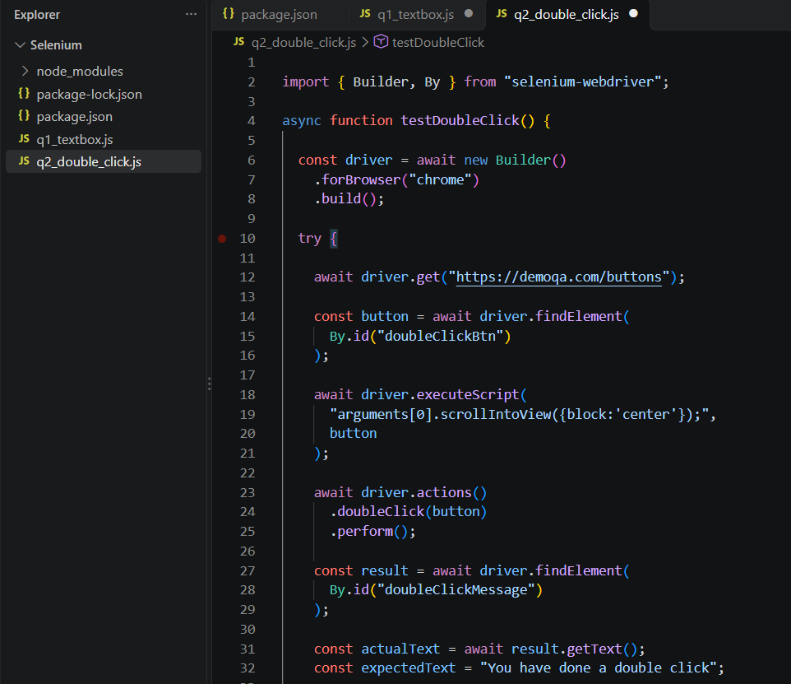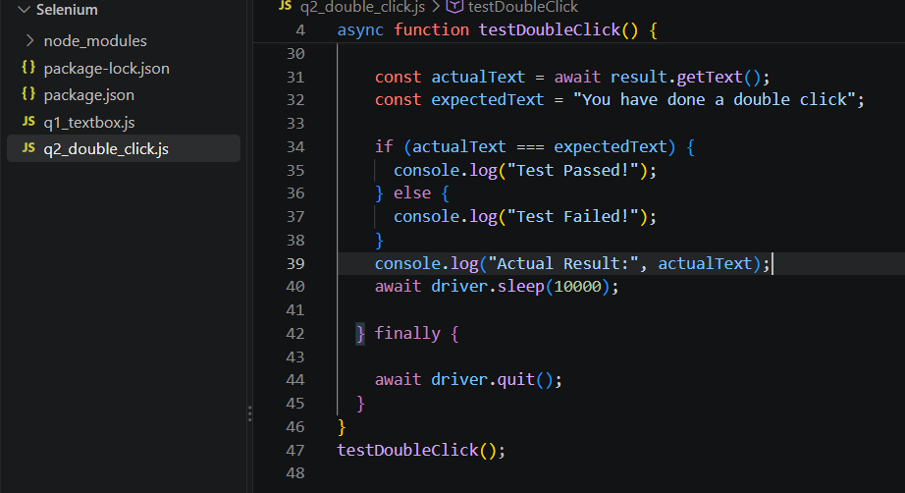
TC-002 BROWSER SCREENSHOT:
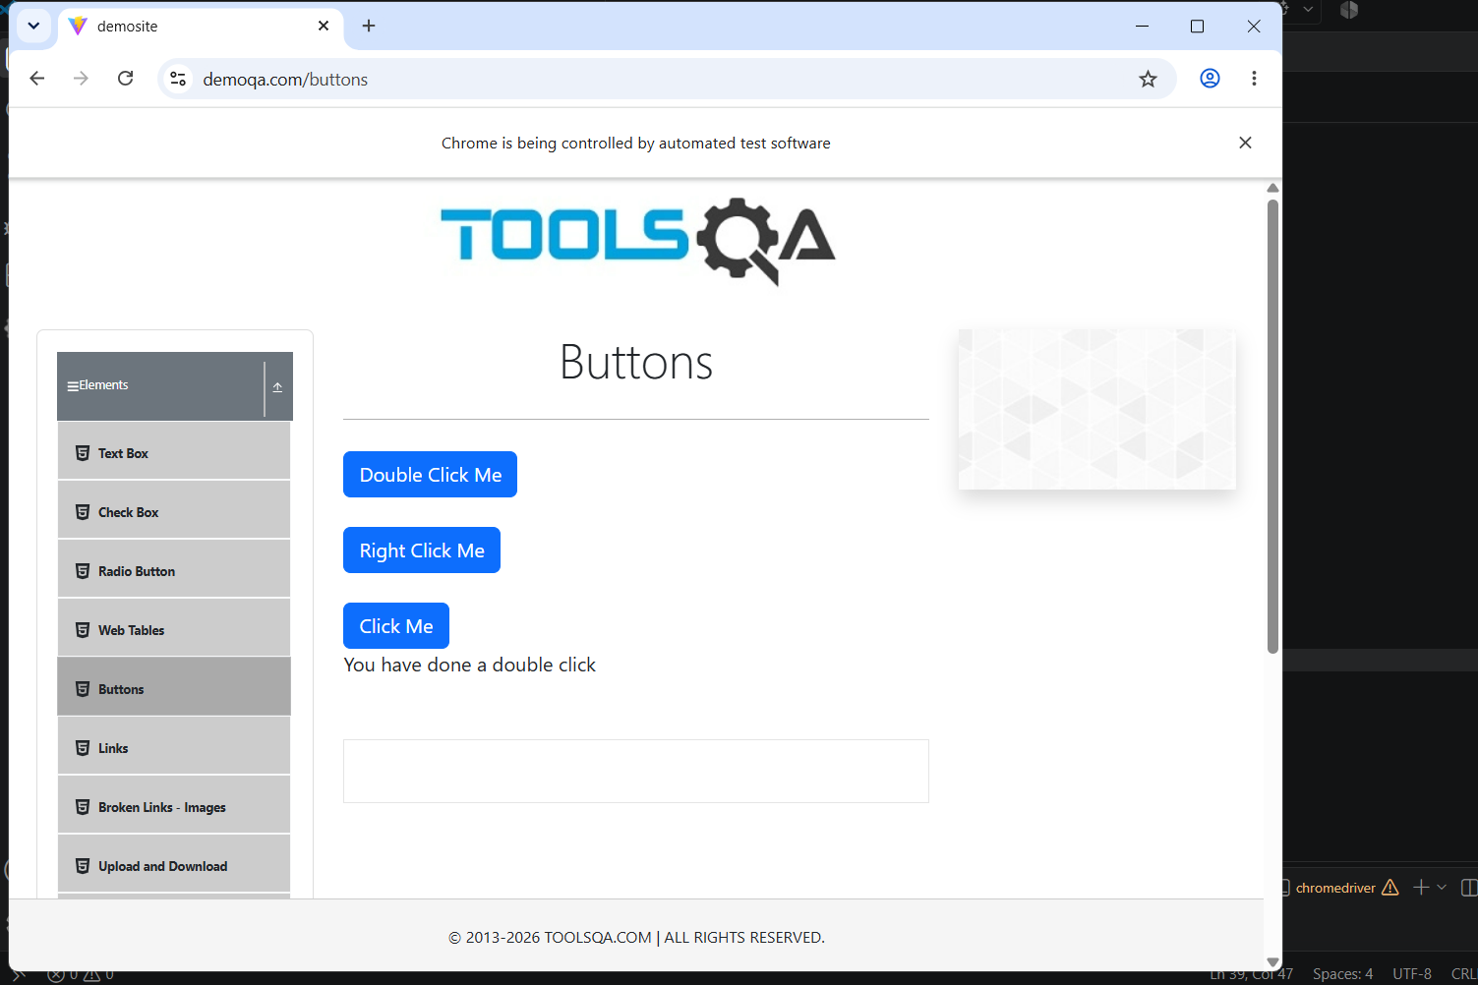

TC-002 TERMINAL SCREENSHOT:
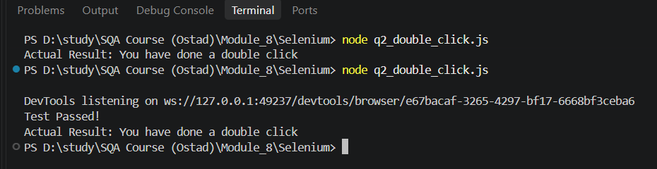

6. Conclusion
Both Selenium automation test cases were designed to validate essential web UI interactions. TC-002 passed successfully, and TC-001 will be confirmed after execution. These tests demonstrate the use of JavaScript and Selenium WebDriver for basic functional testing.

