Infosys Springboard Virtual Internship 6.0 Completion Report

NAME: TANOOR KIRAN

BATCH: 10

MONTHS: 25 NOVEMBER -26 FEBURARY

INTERNSHIP DURATION: 8 WEEKS

PROJECT TITLE: INVENTRA_INTELLIGENT_INVENTORY_MANAGEMENT SYSTEM

INTERNSHIP TITLE: JAVA FULL STACK

Project Title

INVENTRA – Intelligent Inventory Management System

- Project Objective

  - Design and develop a centralized intelligent inventory management system to digitally monitor, control, and optimize stock handling processes
  - Enable real-time inventory tracking to provide accurate visibility of stock availability, movement, and usage patterns
  - Minimize human errors, stock mismatches, and data redundancy by replacing manual record-keeping with an automated digital solution
  - Implement role-based authentication and authorization to ensure secure and controlled access for administrators, managers, and staff
  - Develop a transaction management module to record item issuance, returns, and stock updates with complete traceability

- Project description in detail

Inventra – Intelligent Inventory Management System is a smart digital platform developed to modernize and streamline traditional inventory handling processes. In many organizations, inventory is still managed using manual registers or basic spreadsheets, which often results in stock mismatches, delayed updates, data redundancy, and lack of real-time visibility. Inventra addresses these issues by providing a centralized, automated, and secure inventory management solution.

The system allows authorized users to manage inventory items with complete control over stock records. Each product entry includes detailed attributes such as item name, category, quantity, supplier information, and stock status. Through an intuitive interface, users can easily add new items, update stock levels, delete outdated records, and search for products, ensuring efficient day-to-day inventory operations.

Inventra incorporates a role-based authentication system to maintain data security and controlled access. Administrators can manage users and oversee the entire inventory, while staff members can perform permitted operations such as stock updates and transaction entries. This structure ensures both accountability and data protection within the system.

A core feature of Inventra is its transaction tracking module, which records all stock movements, including item issuance and returns. Every transaction is logged with timestamps and user details, enabling full traceability and reducing the risk of stock discrepancies or misuse. The system automatically updates inventory quantities after each transaction, ensuring that stock information remains accurate and up to date.

To enhance decision-making, Inventra provides an interactive dashboard with data visualization tools. The dashboard displays key insights such as total stock, low-stock items, frequently used products, and category-wise distribution. Visual elements like charts and summary cards help users quickly understand inventory trends and plan restocking efficiently.

Additionally, the system includes a smart alert mechanism that notifies users when stock levels fall below predefined thresholds. This helps prevent stockouts and ensures smooth operational flow. The system is designed with a scalable architecture, allowing it to be adapted for various environments such as educational institutions, warehouses, retail stores, and corporate offices.

4.Timeline Overview

Week | Activities Planned | Activities Completed
Week 1 | Requirement analysis, problem identification, and system architecture design. | Conducted detailed study of existing inventory challenges, finalized system requirements, and designed overall system architecture and module breakdown
Week 2 | Database schema design and backend setup | Designed normalized relational database schema for items, users, and transactions; configured backend development environment and API structure
Week 3 | Authentication system and role-based access control | Implemented secure login system, user registration, password encryption, and role- based authorization for Admin and Staff users
Week 4 | Inventory management module development | Developed core inventory features including item addition, stock updates, deletion, category classification, and search functionality
Week 5 | Transaction management system | Implemented item issue and return tracking with automatic stock quantity adjustments and complete transaction history logging
Week 6 | Dashboard development and data visualization | Built interactive dashboard displaying total stock, category-wise distribution, low-stock alerts, and item usage statistics using graphical charts
Week 7 | System testing, debugging, and performance optimization | Performed unit testing and integration testing, resolved functional errors, optimized database queries, and improved system responsiveness
Week 8 | Final system integration, documentation, and deployment | Integrated all modules, prepared technical documentation and user guide, conducted final system demo, and completed project submission

5a. Key Milestones

Milestone | Description | Date Achieved
Project Kickoff | Initial project briefing, requirement analysis, system planning, and technology stack finalization | 6-OCT-25

Milestone | Description | Date Achieved
Database &  Backend Setup Completed | Successful design of database schema and implementation of core backend structure with API connectivity | Week-1
Authentication Module  Completed | Implementation of secure login system with role-based access control for Admin and Staff users | Week-2
Inventory Module  Prototype Ready | Development of core inventory features including item management and stock updates | Week-3
Transaction Tracking System Completed | Implementation of issue/return logging with automatic stock adjustment and history tracking | Week-4
Dashboard & Analytics Integration | Deployment of interactive dashboard with stock insights, charts, and alert indicators | Week-5
System Testing & Optimization  Completed | Completion of functional testing, bug fixes, and performance improvements | Week-6
Final System Deployment & Documentation | Full system integration, preparation of documentation, and successful project demonstration | Week-7

5b. Project execution details

The Inventra – Intelligent Inventory Management System was developed using a structured full- stack architecture to ensure scalability, security, and maintainability. The system was divided into key modules including authentication, inventory management, transaction tracking, and analytics dashboard.

The backend was implemented using Java (Spring Boot) to develop RESTful APIs that handle business logic, user requests, and database interactions. A MySQL relational database was used to store and manage system data, including user details, inventory records, product categories, and transaction logs. The database schema was designed using normalized tables with proper foreign key relationships to maintain data consistency and integrity.

A secure authentication and authorization system was implemented to protect system access. User credentials were securely stored with password encryption, and role-based access control (RBAC) was enforced to differentiate permissions between Admin and Staff users. Administrators have full control over inventory and user management, while staff members are restricted to operational tasks such as updating stock and recording transactions.

The inventory management module enables users to add new products, edit existing item details, manage stock quantities, assign categories, and perform item searches. Backend validation ensures that stock values remain consistent, and all changes are reflected in real time.

The transaction tracking module was developed to monitor item movement within the system. It records issuance and return operations with detailed information including item ID, quantity, user performing the action, and timestamp. The system automatically updates inventory levels after each transaction, ensuring accurate and up-to-date stock information.

The frontend was developed using React.js, providing a responsive and user-friendly interface. The React application communicates with backend APIs to fetch and display inventory data dynamically. An interactive dashboard with charts and summary cards was created to visualize important insights such as total stock, low-stock items, category-wise distribution, and recent transactions.

Testing was conducted at multiple levels, including backend API testing, frontend functionality testing, and integration testing between the React frontend and Java backend. Performance was optimized through efficient SQL queries, proper indexing, and API response handling.

Finally, all modules were integrated and deployed in a test environment for demonstration. Comprehensive technical documentation and a user guide were prepared to ensure smooth system usage and future scalability.

- Snapshots / Screenshots

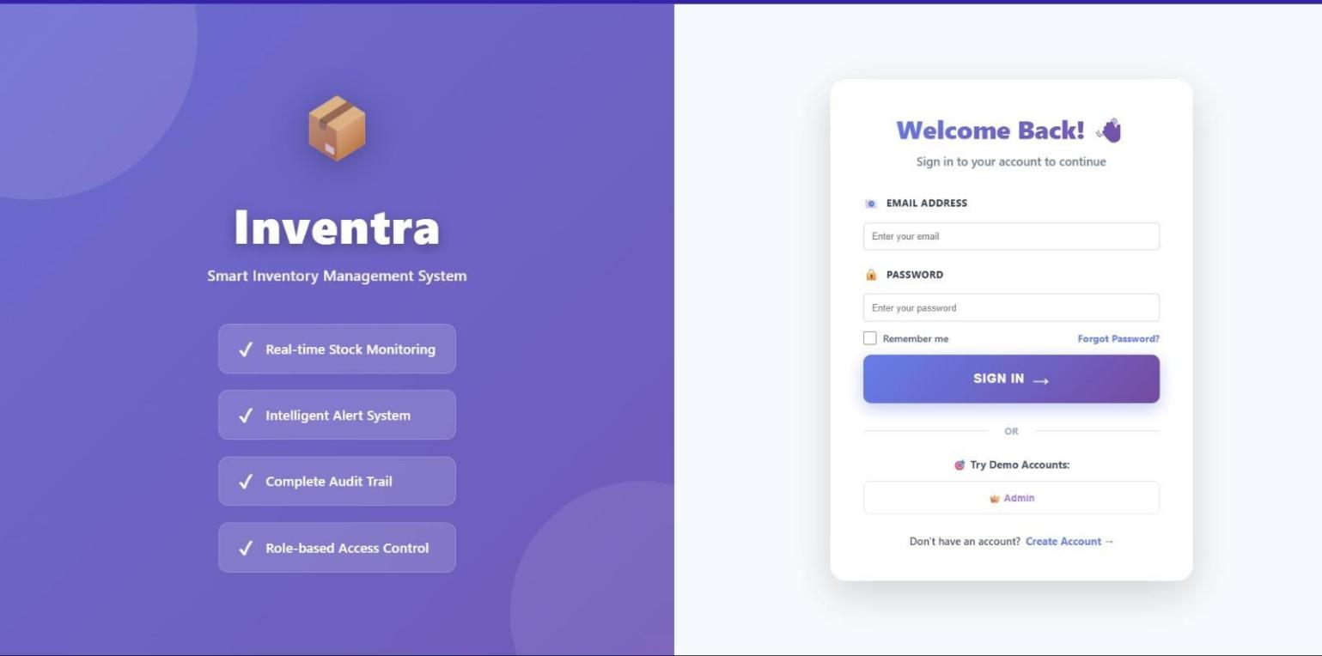

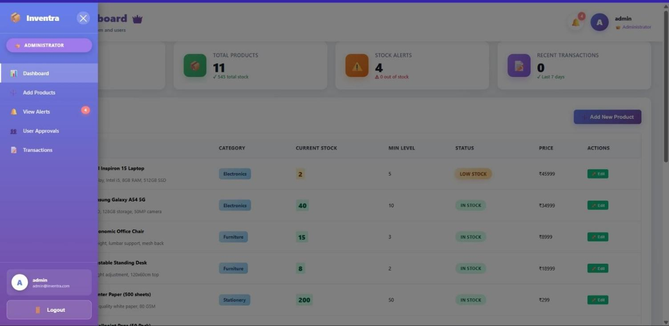

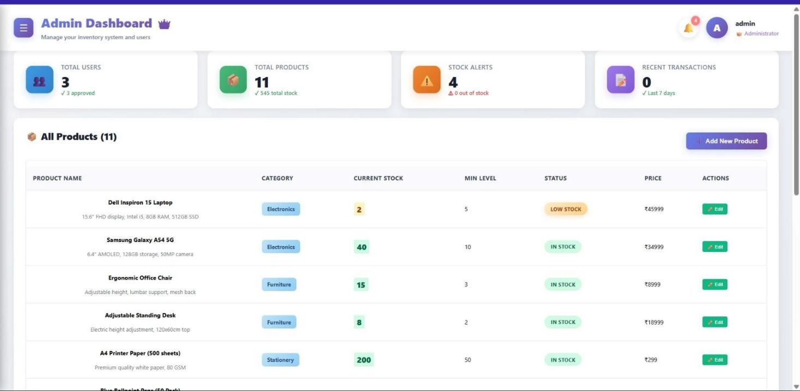

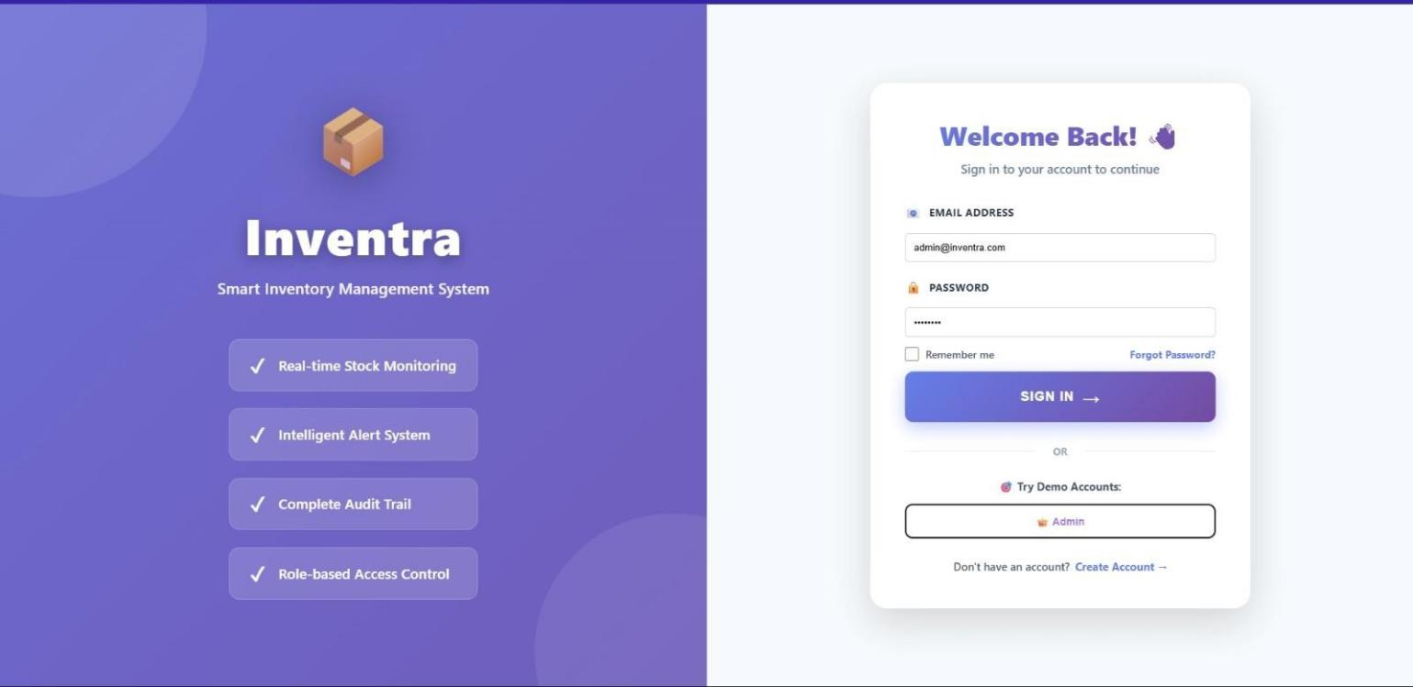

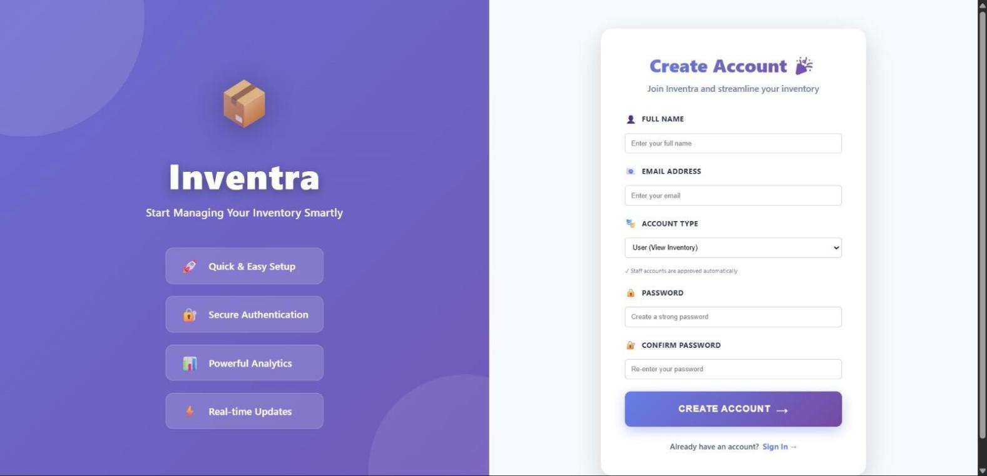

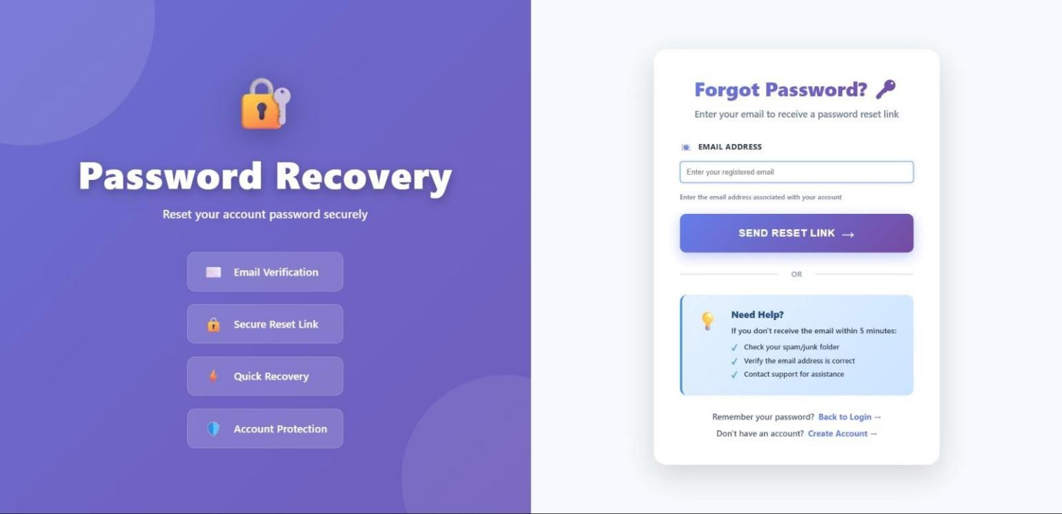

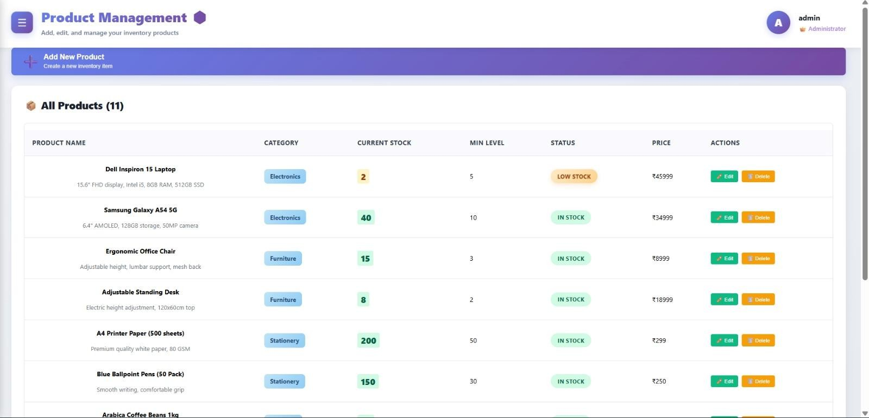

- Learnings & Skills Acquired

  - Gained practical experience in designing and managing relational databases using MySQL

  - Developed strong understanding of backend development using Java and Spring Boot for building RESTful
APIs

  - Learned to implement secure authentication and role-based authorization mechanisms

  - Acquired skills in frontend development using React.js for building responsive and dynamic user
interfaces

  - Improved knowledge of API integration between frontend and backend systems

  - Understood real-world implementation of inventory management logic and stock control systems

  - Learned to design and display data visualizations and dashboards for better decision-making

  - Enhanced ability in debugging, testing, and optimizing system performance

  - Gained experience in full-stack application architecture and module integration

  - Improved team collaboration, documentation, and project presentation skills

- Challenges Face

Challenge 1: Designing an Efficient Database Structure
Problem: Managing relationships between users, inventory items, and transactions without data redundancy
Solution: Designed a normalized MySQL schema with proper foreign keys and indexing to maintain data integrity and improve query performance

Challenge 2: Maintaining Accurate Real-Time Stock Updates
Problem: Ensuring inventory quantities remain correct after every issue and return transaction
Solution: Implemented backend logic in Java to automatically update stock levels and validate quantity constraints

Challenge 3: Implementing Secure Role-Based Access Control

Problem: Preventing unauthorized users from accessing or modifying sensitive inventory data
Solution: Developed a role-based authentication system with encrypted passwords and controlled API access

Challenge 4: Integrating React Frontend with Java Backend

Problem: Handling smooth data exchange between frontend and backend services
Solution: Built RESTful APIs and implemented proper error handling and response management for seamless integration

- Testimonials from team

Working on the Inventra project was a valuable learning experience for the entire team. Each member contributed to different modules such as backend development, frontend design, and database management, which helped us understand how a real-world full-stack system is built and integrated.

Regular discussions, planning sessions, and collaborative debugging helped us overcome technical challenges efficiently. The project improved our practical knowledge in Java, MySQL, and React, while also strengthening our problem-solving abilities.

This experience enhanced our teamwork, communication, and project documentation skills, making us more confident in handling industry-level software development projects.

- Conclusion

The Inventra – Intelligent Inventory Management System successfully demonstrates how digital technology can transform traditional inventory handling into a smart, efficient, and data-driven process. By integrating a Java-based backend, a MySQL relational database, and a React frontend, the system delivers a complete full-stack solution for real-time inventory monitoring and control.

The project effectively addressed common challenges in manual inventory systems such as stock mismatches, lack of transparency, and delayed updates. Through features like role-based authentication, transaction tracking, automated stock updates, and visual dashboards, Inventra ensures accuracy, accountability, and ease of management.

Developing this system provided hands-on experience in backend API development, database design, frontend integration, and system testing. It also strengthened our understanding of how different components of a software system interact to create a reliable and scalable application.

Overall, Inventra stands as a practical and scalable solution that can be adapted for use in institutions, warehouses, retail stores, and other organizations requiring efficient inventory control. The project not only met its technical objectives but also enhanced our readiness to work on real-world software development challenges.

- Acknowledgements

We would like to express our sincere gratitude to our project mentor and faculty members for their continuous guidance, encouragement, and valuable feedback throughout the development of the Inventra – Intelligent Inventory Management System. Their technical insights and support played a crucial role in helping us overcome challenges and improve the quality of our work.

We also thank our institution for providing the necessary resources and learning environment that enabled

us to successfully complete this project. The opportunity to work on a real-time, practical system has significantly enhanced our technical knowledge and confidence.

Finally, we appreciate the teamwork, dedication, and collaborative efforts of all team members, whose consistent contributions made the successful completion of this project possible.

