Predicting Radiolytic Gas Generation in Disposed Molten Salt Reactor Fuels

1. Radiolysis in the disposal problem
Molten salt reactors (MSRs) introduce a new spent-fuel form: the salt itself is the fuel matrix. When a chloride or fluoride salt loop is taken out of service, the salt inventory must be conditioned, packaged, and either stored on site for the medium term or moved into a geological repository. Two features distinguish this waste form from oxide pellets in zircaloy cladding.
The first is that the radiolytic chemistry continues after discharge. The representation of the radiolytic source term over time is shown in Figure 1. The $β/γ$ activity from cesium-137 and strontium-90 deposits energy into the salt for centuries; the $α$ activity from plutonium-239, americium-241, curium-244, and the higher actinides deposits energy into the salt for tens of thousands of years. In a sealed disposal container neither energy source can escape, and the radiolytic radicals it produces, such as solvated electrons, chlorine atoms, fluorine atoms, halogen radical anions, etc., drive chain-propagation reactions whose end products are molecular $Cl​_{2}$ or $F​_{2}$ gas. These gases pressurize the container, oxidize the wall, and in the limiting case can rupture the package.
The second feature is that the U(III)/U(IV) redox buffer, which dominates the active-reactor radiolytic mass balance and keeps the cover-gas $Cl​_{2}$ inventory at the ppb level during normal operation, is not available during disposal. The buffer is either consumed during operation, deliberately extracted before disposal, or rendered unreactive by solidification. The chain-propagation efficiency $η$ in the disposal regime is therefore set by the residual chemistry of the host salt and the long-lived fission-product / actinide cocktail, not by the engineered U cycle.
A defensible prediction of $Cl​_{2}$ or $F​_{2}$ inventory in a sealed disposal container, as a function of time after discharge, salt composition, container temperature, and accumulated dose, is the central scientific question this summary addresses. The present work is a transfer of the calibrated radiolysis framework developed for active-reactor predictions into the disposal regime.
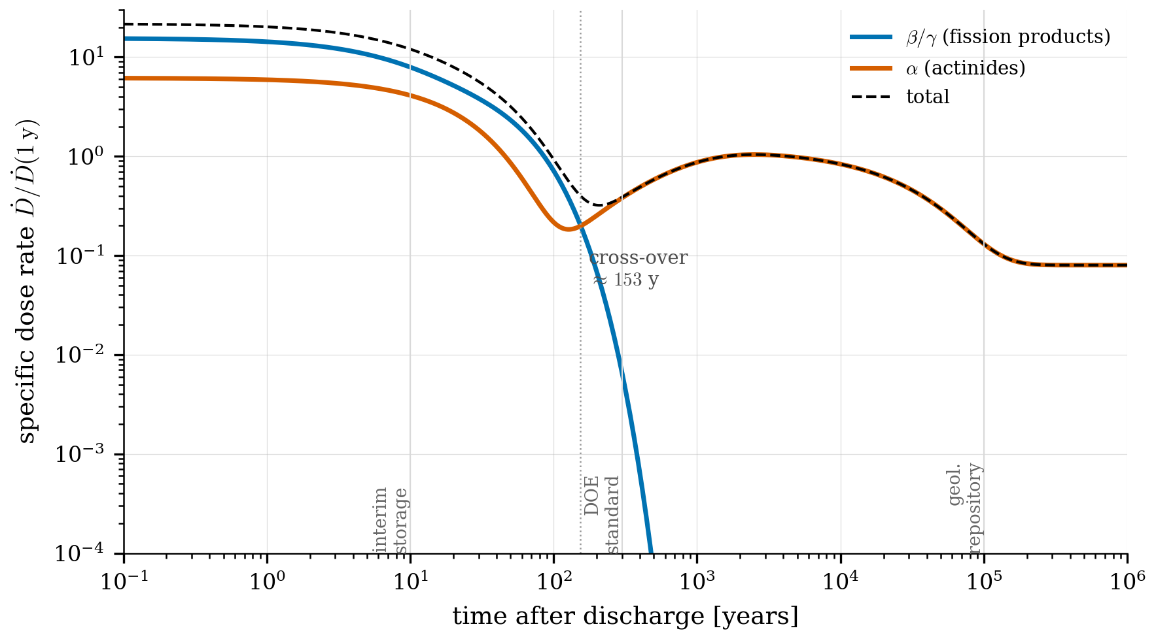
Figure 1. Specific dose rate as a function of time after discharge from a representative MSR fuel salt. The $β/γ$ contribution follows the Cs-137/Sr-90 decay; the $α$ contribution is dominated by Cm-244 in the first decades and by Am-241 ingrowth and Pu-239 longer-lived activity thereafter. The cross-over near ~150 years marks the transition from $γ$-dominant to $α$-dominant radiolysis chemistry. This is a transition the current pulse-radiolysis literature does not cover.

2. Approach: hierarchical Bayesian mechanism-adequacy estimation (HBMAE)-calibrated kernel extrapolated to disposal conditions
The framework underlying the predictions is the HBMAE calibration of the chloride and fluoride radiolysis kernels against the digitized pulse-radiolysis and chronic-irradiation literature. The calibrated kernels reproduce the published Arrhenius parameters of the dominant $Cr​^{3+}, Zn​^{2+}, Nd​^{3+}, Cf​^{3+}$ reduction reactions and capture the cross-laboratory systematic offset of the Pikaev 1982 Soviet measurements relative to the modern Brookhaven LEAF data.
The extrapolation is not trivial. Pulse-radiolysis experiments are conducted at salt-loop temperatures (400-600 $​^{∘}$C) and at dose rates on the order of 1 kGy per pulse (instantaneous) or 1-10 kGy/h (chronic gamma irradiation). Sealed disposal containers operate at 100-300 $​^{∘}$C and, after the first decade, at integrated dose rates that decline through 1 $μGy/h$ and below. The kernel must therefore extrapolate over four to five decades in dose rate, over more than 300 $​^{∘}$C in temperature, and from a $γ$-dominant to an $α$-dominant energy-deposition regime. The first two extrapolations are amenable to the Arrhenius and dose-rate scaling already encoded in the kernel; the third is not, because the secondary-electron / radical inventory produced by α tracks differs from the inventory produced by $γ$ tracks through linear-energy-transfer (LET) effects.
Figure 2 situates the operational, laboratory, and disposal regimes on a (temperature, dose-rate) plane, with the extrapolation gap explicit. The figure makes precise the calibration question: which posterior parameters are constrained by the existing data within the operational box, and which require LET-corrected α-radiolysis data or low-temperature low-dose-rate confirmation experiments to be transferable to disposal conditions.
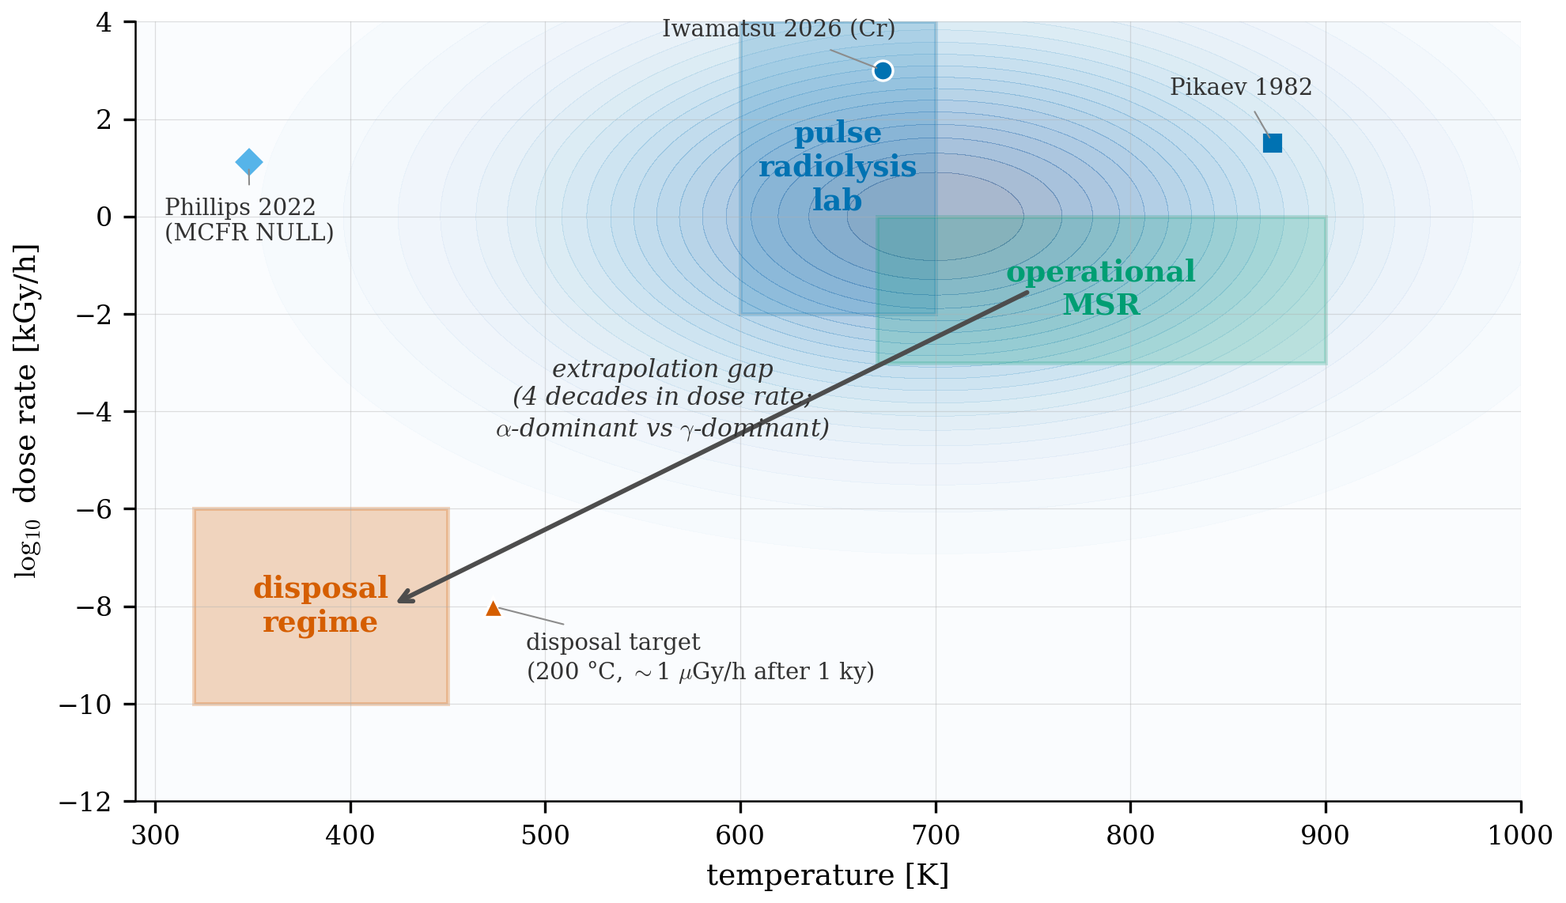
Figure 2. Operational, laboratory, and disposal radiolysis regimes on a (temperature, dose-rate) plane. The blue contour is a schematic of the calibration-coverage posterior under the HBMAE framework: the central region (high dose rate, $T∼700 K$) is anchored by Iwamatsu Cr/Zn data, with the Pikaev cross-laboratory anchor at higher temperatures. The operational MSR regime sits inside the calibration envelope; the disposal regime (200 °C, $∼1$ $μ$Gy/h after one millennium) is four decades below the experimental floor in dose rate and α-dominant rather than γ-dominant. The arrow indicates the extrapolation that the calibrated kernel must cover for a defensible disposal prediction.
The Bayesian framework propagates this extrapolation explicitly. Each posterior sample on the chloride or fluoride Arrhenius pair produces a corresponding sample of the disposal-regime gas-generation rate; the predictive band quoted below is the 5–95th percentile of that ensemble, not a single nominal trajectory.

3. Findings
Two illustrative cases are presented in Figure 3.
For a chloride fuel without active U(III)/U(IV) buffering, i.e., either a buffer-exhausted salt or a chloride waste-form in which U has been separated, the predicted Cl$​_{2}$ partial pressure in a $1 m​^{3}$ sealed disposal container holding two metric tonnes of salt and $100 L$ of head-space reaches the $10​^{5} Pa$ container-design pressure at approximately one to ten years after discharge in the posterior median, and as early as approximately three months in the upper-90th-percentile tail. The chain-propagation efficiency $η$ without U buffering is inferred at the level of ${10}^{-1}$ from the unbuffered terms of the chloride kernel; a 10 ppm-level scavenger (Te, S, O$​^{2-}$ from impurities or fission products) reduces this by a factor of ${10}^{3}$ or better, but in any case the absence of the U cycle removes the buffer that kept the operational MCFR prediction ten orders of magnitude below the limit. The implication for disposal package design is that the chloride waste form requires either an engineered redox buffer in the solidified matrix, a venting design that releases $Cl​_{2}$ to a getter, or a hot-cell handling step that reduces the inventory by a controlled fluorination.
For a fluoride fuel held at 200 $​^{∘}$C in the same sealed-container geometry, the F$​_{2}$ steady-state partial pressure is approximately ${10}^{3}$ Pa median, with a 90% posterior band spanning $3×{10}^{2}$ Pa to $3×{10}^{3}$ Pa, and is essentially time-independent over the disposal interval because F$​_{2}$ recombination at metal walls (Toth and Felker 1990 activation energy 39 kJ/mol, calibrated pre-exponential $A_{rec}≈250$ h$​^{-1}$) is fast on the disposal timescale. The fluoride margin against the ${10}^{5}$ Pa container limit is therefore approximately two orders of magnitude, comfortably below the operational design pressure in the median but not in the upper-tail posterior. The dominant uncertainty contributor is the $6×$-temperature extrapolation of the Toth-Felker recombination Arrhenius from 423 K (where it is calibrated) to 473 K (the disposal target). A confirmation experiment at $T∼200 ^{∘}$C in a fluoride salt analog would compress this uncertainty.
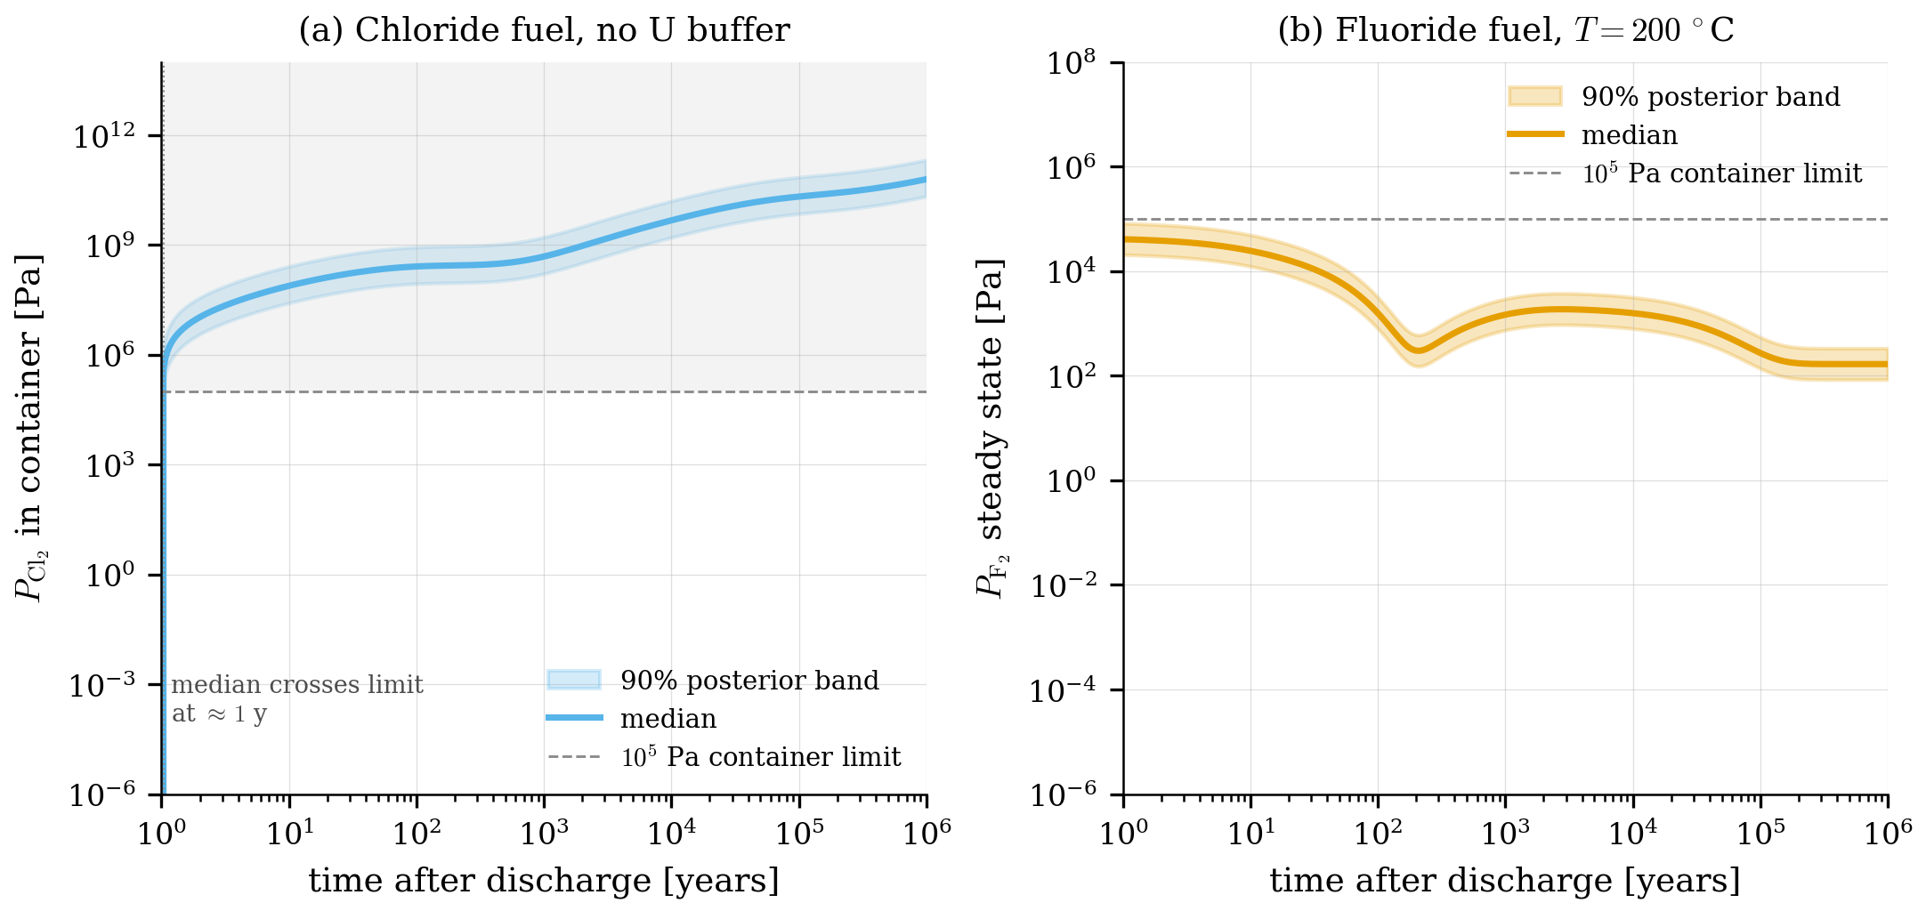
Figure 3. Posterior-predictive gas inventory in a sealed 1 m$​^{3}$ disposal container holding 2 metric tonnes of (a) chloride fuel salt without U(III)/U(IV) buffer and (b) fluoride fuel salt at 200 $​^{∘}$C, as a function of time after discharge. Median predictions are heavy lines; the 90% band reflects the joint posterior on $G_{Cl^{•}}$, chain-propagation efficiency $η$, $G_{F_{2}}$, and the calibrated recombination kinetics. The chloride case crosses the ${10}^{5}$ Pa container-design pressure at $∼1-10$ years in the posterior median; the fluoride case sits at $∼{10}^{3}$ Pa indefinitely. The figure assumes no engineered buffer and an integrated dose-rate trajectory consistent withFigure 1.
The dose-rate cross-over at $∼$ 150 years (Figure 1) introduces a regime change in the chloride prediction: between one year and 150 years the $β/γ$ flux dominates and the calibrated kernel applies essentially unmodified, while beyond 150 years the α activity takes over and the linear-energy-transfer correction enters. The correction is between a factor of one and a factor of five depending on the radical-yield ratio assumed for high-LET tracks. The fluoride prediction is less sensitive to the cross-over because the steady-state balance is set by the recombination Arrhenius, not by the integrated dose.

4. Implications for the disposal program
The principal conclusions for a fuel-salt disposal radiolysis modeling are:
- Chloride and fluoride disposal forms face qualitatively different radiolytic-gas constraints. Chloride salt without an engineered buffer accumulates $Cl​_{2}$ approximately linearly with integrated dose; the standard ${10}^{5}$ Pa container design pressure is exceeded within years in posterior median. Fluoride salt reaches a much lower steady-state $F​_{2}$ pressure set by metal-wall recombination and remains close to two orders of magnitude below container limit. A defensible disposal program for chloride fuel therefore requires either engineered post-discharge reduction of U(IV) back to U(III) to restore the redox buffer in the disposal matrix, or a venting design coupled to a $Cl​_{2}$ getter, or a solidification process that converts the chloride waste form to a stable chemical species (e.g. U-glass or apatite incorporation) before sealing the container.
- The dose-rate cross-over near 150 years matters. Disposal-program calculations that use only the prompt β/γ dose rate and assume exponential decay to negligible levels will under-predict the α-dominant tail. A geological-repository assessment must propagate the actinide α-radiolysis explicitly for ${10}^{4}$-${10}^{5}$ years; the $α/γ$ G-value ratio under track-structure radiolysis is the key parameter that current data do not constrain.
- The calibrated kernel is ready for screening-level disposal predictions. The HBMAE-calibrated chloride and fluoride kernels recover published Arrhenius parameters within published $σ$ across the operational regime [1, 2], and the Bayesian posterior propagates the disposal-regime predictions with explicit uncertainty. The dominant uncertainty contributors are identified (chain-propagation efficiency $η$ in chloride, the 6$×$-temperature recombination-Arrhenius extrapolation in fluoride, the LET-correction across the α/γ cross-over) and a prioritized list of confirmation experiments is provided below.
- Three confirmation experiments would tighten the disposal predictions by more than an order of magnitude: (i) a chloride-salt gamma-irradiation at 200 $​^{∘}$C without a U buffer, to directly measure $η$ in the absence of the redox cycle; (ii) a fluoride-salt recombination-kinetics experiment in the 150-250 $​^{∘}$C window, to confirm the Toth-Felker Arrhenius outside its calibration band; and
- an α-emitter doped salt (Cm-244 spike) at the 100 $μ$Gy/h level, to provide the first LET-corrected radiolytic G-value in a disposal-relevant matrix. Each can be performed within existing INL hot-cell capability over a 12- to 24-month program.
Several extensions are outside the present screening framework and constitute the next stages of the work. The first is the coupling of the gas-phase radiolysis prediction to the container-corrosion chemistry, $Cl​_{2}$ does not merely pressurize the container, it also attacks the inner wall through Cl + Fe or Cl + Ni surface reactions whose rates set the cumulative loss of confinement over the disposal timescale. The second is the explicit inclusion of fission-product chemistry in the disposal-phase ODE: Cs, I, Te, Sr, and the lanthanides are redox-active on the disposal-time scale, and their participation in the Cl$​_{2}$/F$​_{2}$ mass balance is not currently modeled. The third is the validation of the framework against an independent dataset: the present HBMAE calibration uses the entire digitized pulse-radiolysis and chronic-irradiation corpus, so an honest hold-out for disposal-regime prediction requires either a new experiment (per the confirmation experiments listed above) or the digitization of an additional independent legacy dataset, of which the most promising is the Akiyama 1994 LiF-NaF-KF pulse-radiolysis data.

