## Problem 1 – Registration Form

Create a Web form (HTML5 + CSS3 + images) that looks and behaves like the screenshots below:

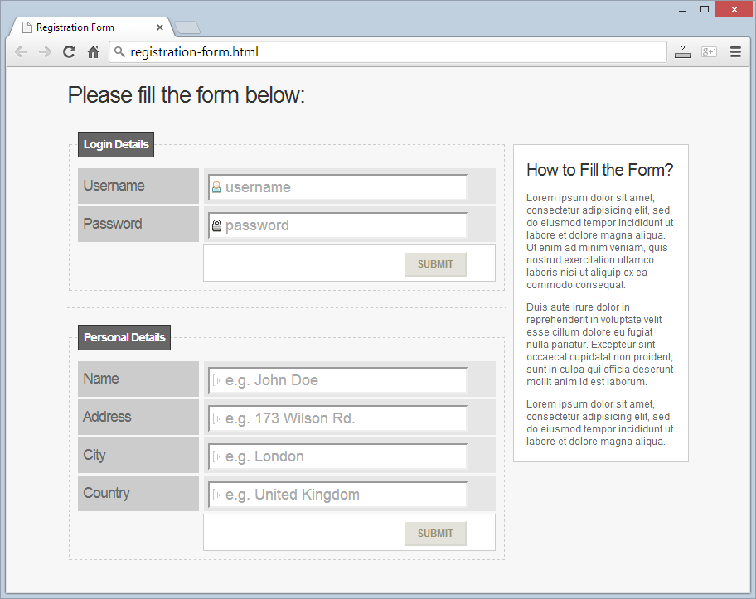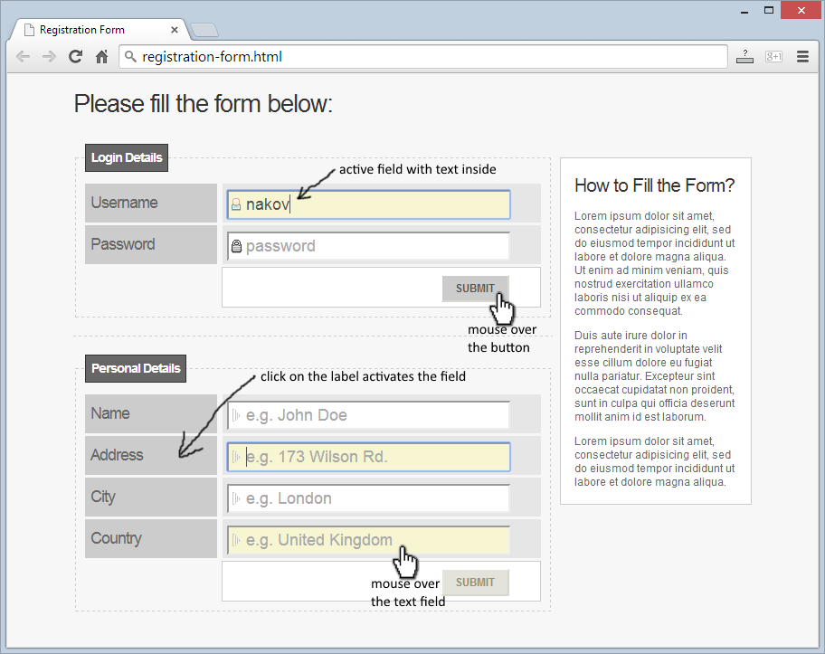

### Input

You are given the above screenshots and all required images.

### Output

The output should be valid HTML5 + CSS3 + images that implement the above Web form.

### Constraints

* Font: Arial / Helvetica / sans-serif.
* Form validation is not required.
* The site should open correctly in Chrome 35.
* Responsive design is not required.
* Pixel-perfect implementation is not required.