Dog Breeds Android App

Potential problems with running:
After opening the project in Android Studio, there could be some potential AS bugs that you need to fix in order to run. (Same as all the other projects you open in AS)
- Android Studio may say no corresponding version found. In this case, just click update and install the version.
- Some “R.layout.__” maybe red and not found. That’s because I have used butterknife, a third-party library, sometimes this problem will occur. Do “Build -> Clean Project” can solve this.
- “Dagger...Component” maybe red. It is because this is a generated class by the Dagger2 library. Before running, it is not compiled and generated yet. So do “Build -> Rebuild Project” to let it compile and the error will be removed.

If there is no problem, or all the flaws are clear, simply run the project with an emulator or a real phone.

Overview of the project:
I have leveraged plenty of libraries along with the MVP (Model-View-Presenter) framework to implement the project. Third-party libraries include:
OKHttp + Retrofit (Internet connection)
RxJava, RxAndroid (Mainly for thread management)
Gson (Parse JSON file)
Butterknife (Simplify some initialization)
BaseRecyclerViewAdapterHelper (Handle RecycleView adapter easier)
Design + cardview + circleimageview (Fancy layouts)
Dagger2( for building an able-to-use-everywhere dependency tree. Retrofits, Adapters are inside )
plus some customized views.

It is probably an overkill for such a straightforward app whose main purpose is to demonstrate some dog data. But I would like to demonstrate my skills a little bit.

I can proudly say that the maintainability, testability ,and extensibility are very good. If I want to create some more pages with new data, I can do it easily based on my current app structure.

Perhaps for the first time, it will be a little bit difficult to fully figure out my code structure. So I have provided a UML diagram for you to read. With the help of the blueprint(UML diagram), I hope the code framework can be more straightforward to understand. The UML diagram is based on the DogBreedActivity workflow in my program. Other fragments and activities are similar.

My thought about the server links and some bugs:
Let me be straightforward. The links that provided through “dog.ceo” websites are unprofessional, to be more specific, the granularity of the link is far from ideal. The bug that I am going to mention is also related to this.

The links that are related to this project:
https://dog.ceo/dog-api/ (base link)
/api/breeds/list (Returns an array of all the dog breeds’ name)
/api/breed/{breed name}/images (Returns an array of all the images from the breed)
/api/breed/{breed name}/images/random (Returns a random dog image from the breed)

These are all the links that I can use.

2 problems with the links:
- . No right item link
For my main page, I should show list items like this:
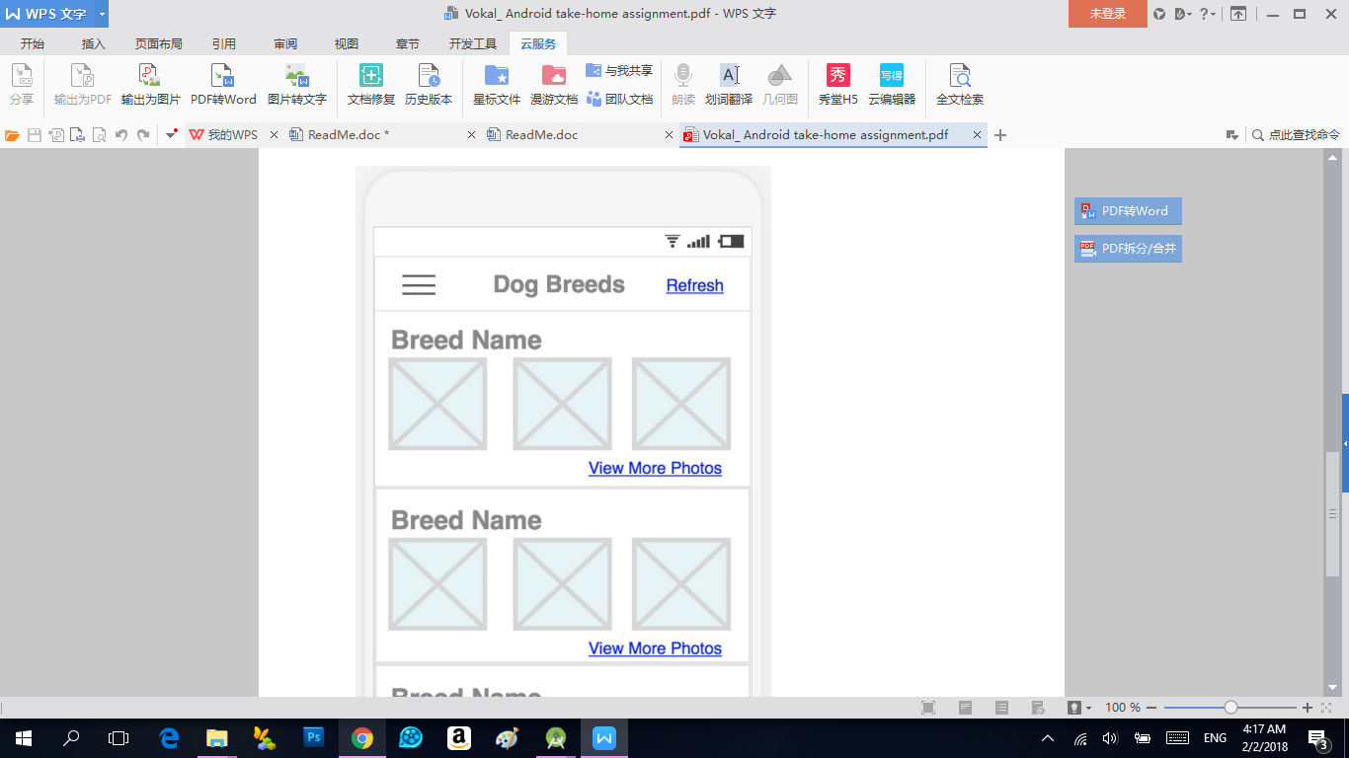
However, there is no link provided that directly offers me a JSON data that contains one breed name and three breed images. So I have to get the list of all the dog breeds’ name and for each of the breed name, I concatenate three random images of this breed name. I should not load all the images of every breed at first, or it will take too long.
But even I load three random images for each breed, it still takes extra time for the mobile side to do the work. This work could be done on the server side in advance so that the mobile side can just present the data without spending resource to process and merge data. Users can have a better experience this way.

- . No Pagination loading
Some system-level bugs may occur when refreshing (either to drag refresh or to click the button to refresh), such as OOM(Out of memory) Exception, especially on phones that have low memory.
I have already considered threads and thread safety. The culprit is there are no pagination loading links. Every time when a user refreshes the data, it will load all the data again from the internet, because only one link for all breed names is provided.

If I can develop the server side as well, I will add a sub-link that this:
/api/breeds/list/{pre_page}/{page}
Where “pre_page” stands for how many items returned in one page
And “page” represents a page number.
There are 80 breed names, no matter how users swipe the phone, they cannot see all 80 items at once. And they probably only want to see 10 breeds one time. After they reach the 10th item, we can load more. This method(Pagination) will not only provide a faster loading experience but also save tremendous memory which can also largely avoid OOM and some other system-level exceptions.

When refreshing playing my app, please be patient and wait until the Toast is gone. The data is too much even for loading once, maybe the initial loading is not finished yet when users click refreshing.

