TicTacToe Android

Potential problems with running:

After opening the project in Android Studio, there could be some potential AS bugs that you need to fix in order to run. (Same as all the other projects you open in AS)
- Android Studio may say no corresponding version found. In this case, just click update and install the version.
- Some “R.layout.__” maybe red and not found. That’s because AS is slow to load, do “Build -> Clean Project” can solve this.
- “DaggerApplicationComponent” maybe red. It is because this is a generated class by the Dagger2 library. Before running, it is not compiled and generated yet. So do “Build -> Rebuild Project” to let it compile and the error will be removed.

If there is no problem, or all the flaws are clear, simply run the project with an emulator or a real phone.

Overview of the project:
For the general Android part, I used Dagger2, ButterKnife, along with the MVP framework to implement the project. In order to simplify coding and decouple the view and logic of the app. Probably an overkill for such a straightforward app with only one major function. But I would like to demonstrate my skills a little bit. (Maybe in the future, there are some testing, maintenance or expansion needs, then it could be helpful)
I have added comments to almost every function.

The program is very flexible.
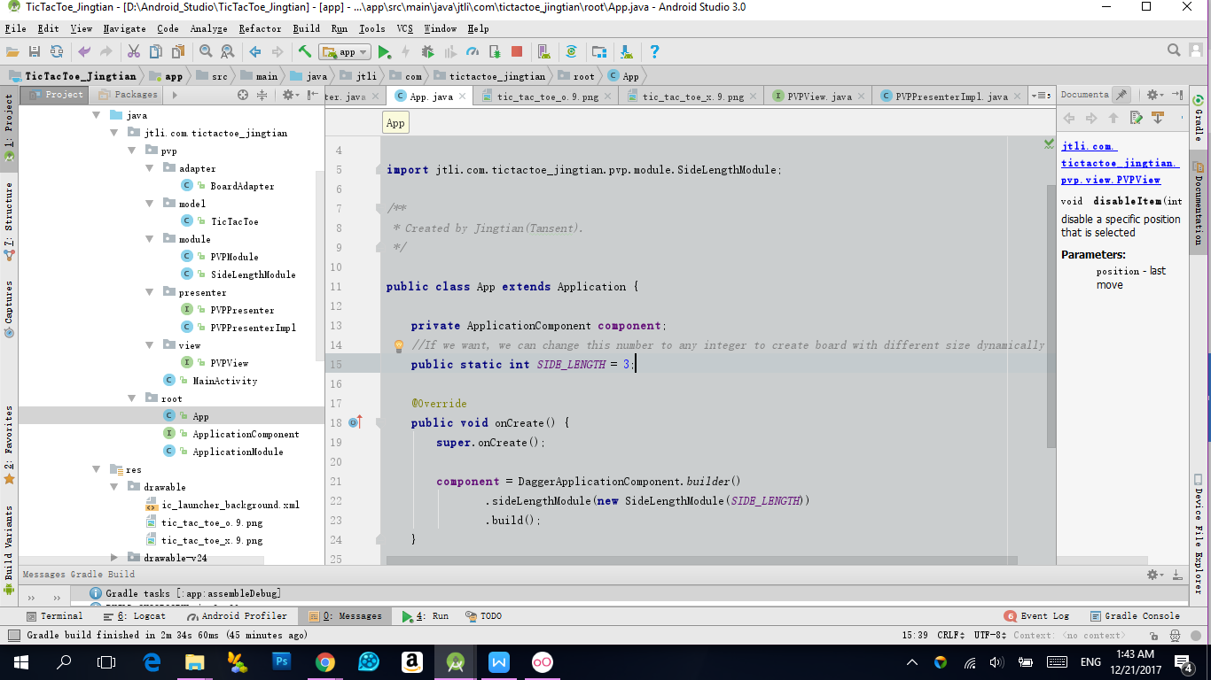
Just change the SIDE_LENGTH variable in App class to make the board be larger or smaller. By default, SIDE_LENGTH is 3, so the default board is 3*3. (If there is a new requirement to let users define the board size, it can be done easily)

I did not spend much effort on images and art design, most areas I just use pure color. I can photoshop, just do not feel this is the purpose of the project. Pictures are .9patched for scaling and shrinking.
Core TicTacToe Algorithm Thought:
I implemented an algorithm which has a time complexity of O(1), regardless of the side length of the square board.
I would like to explain my algorithm here.

Initially, the most straightforward way of judging if the game has a winner is to implement a 2D array, which stands for the board. (I have created a client-server Gobang game with spells, traps, and bombs when I was in my Junior year undergraduate, I had a lot of fun playing it with my friends. FYI, https://github.com/tansent/GoBang . Gobang decides a winner who makes a 5 pieces line first on a very large board, the line can be a row, column or diagonal )
Then after every move, check if a 3 continuous line with the same shape has been made. This way, we need to check a row, a column, a diagonal and an anti-diagonal. Time Complexity would be O(N+N+N+N) = O(4N) -> O(N)

But after some thinking, unlike games such as Gobang, I found that there is a unique attribute in TicTacToe. A winning condition will take an ENTIRE line, column, or diagonal. That is to say, if player1 has placed a piece on a row and player2 also places a piece on the same row, it is impossible for neither player1 or player2 win on this row. So there is no need to maintain a 2-dimensional array, rather just a 2 one-dimensional arrays that each element in the corresponding array stands for the total value in each row and each column, plus 2 variable recording diagonal and anti-diagonal. The value means how close the game can reach a winning condition. Once the absolute value becomes N, the side length of the square board, a winner is decided. If all grids have been taken but there is still no winner, it is a draw game.
Also, 2 players are fundamentally opposite. Player1’s piece on the row will neutralize player2’s winning possibility based on the same row, and vise versa. So, instead of marking 2 players as “player1” and “player2”, or “O” and “X”, I mark them as integer 1 and -1. This way, they can neutralize each other just as the opposite attribute.

public int move(int row, int col, int player) {
rows[row] += player == 1 ? 1 : -1;
cols[col] += player == 1 ? 1 : -1;
if (row == col) diagonal += player == 1 ? 1 : -1;
if (row + col + 1 == N) antiDiagonal += player == 1 ? 1 : -1;
if ( Math.abs(rows[row]) == N || Math.abs(cols[col]) ==N || Math.abs(diagonal) == N || Math.abs(antiDiagonal) == N) {
return player;
}
return 0;
}

Based on the input (the position), I only need to decide if the integer value row, col, diagonal or anti-diagonal has reached the value of N. Time Complexity: O(1+1+1+1) -> O(1).

