This document contains the story plots of the major types of genres present in the dataset, Bhaav.

1.

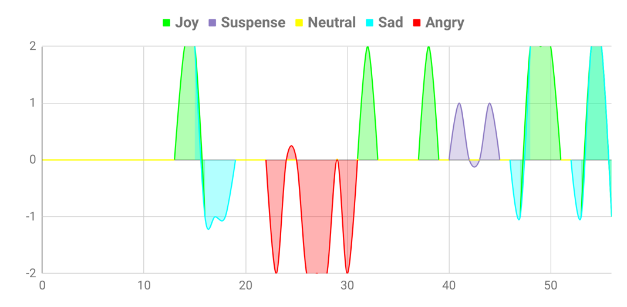

Story Type: Patriotic

2.

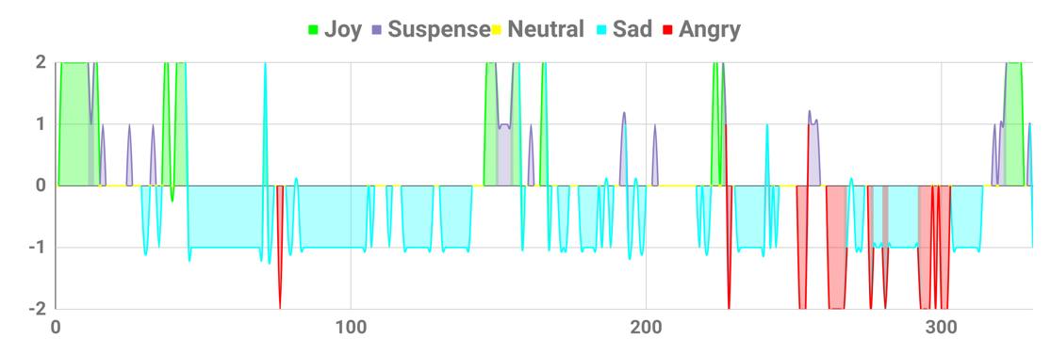

Story Type : Idealist

3.

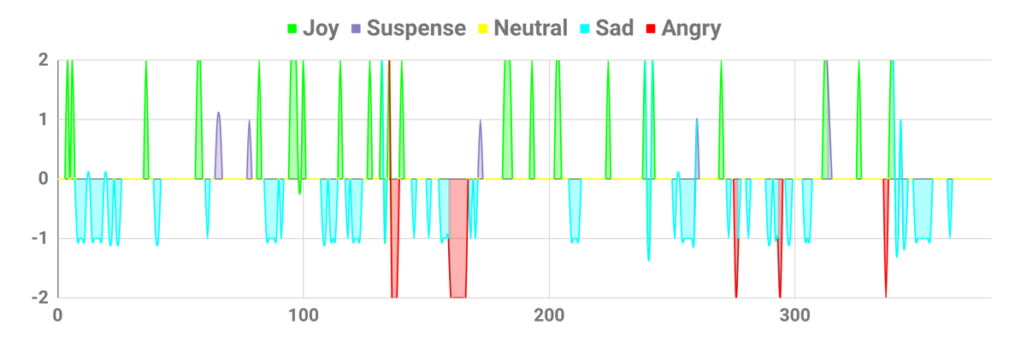

Story Type: Romantic

4.

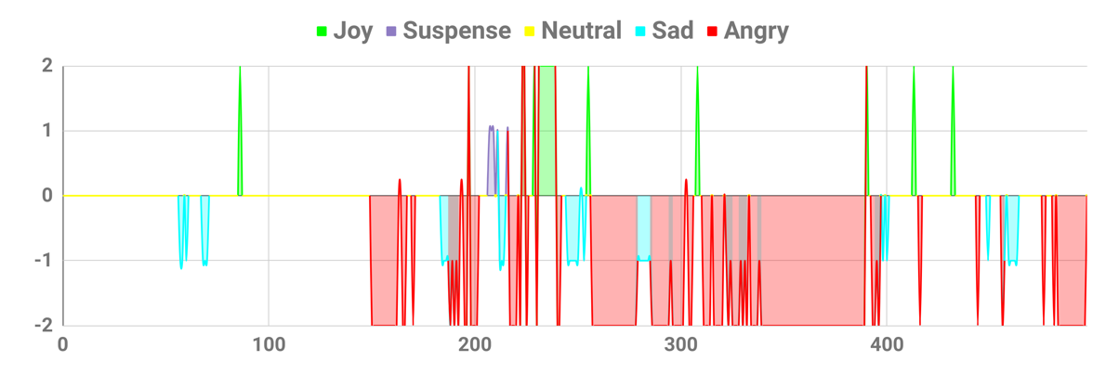

Story Type: Exploiter and Exploited

5.

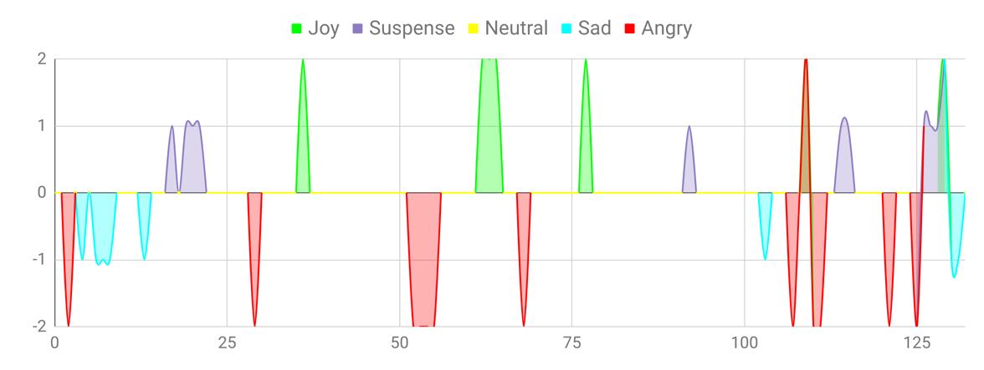

Story Type: Ethical

6.

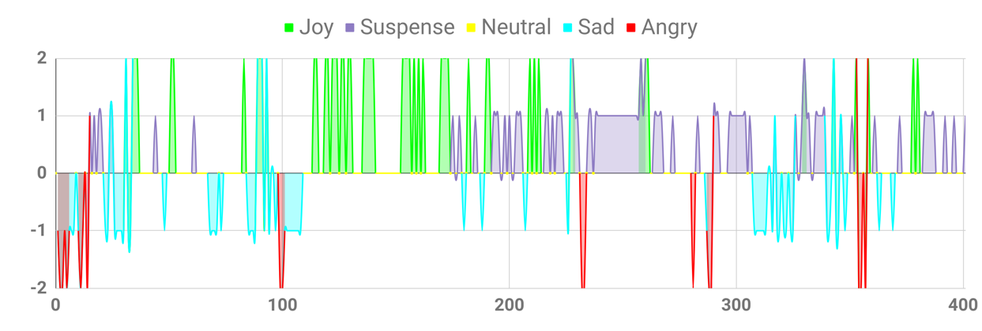

Story Type: Historical Inspirational Story

7.

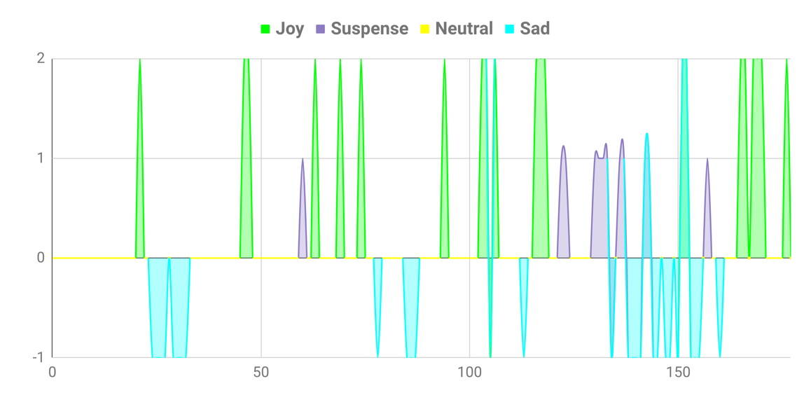

Story Type: Biographical

The graphs clearly depict the various emotions present in the database. The emotions present in the different genres of the stories presented by these graphs are quite intuitive. For example, an inspirational story, normally, is expected to be positive in nature. This intuition is appropriately captured in the following figure:

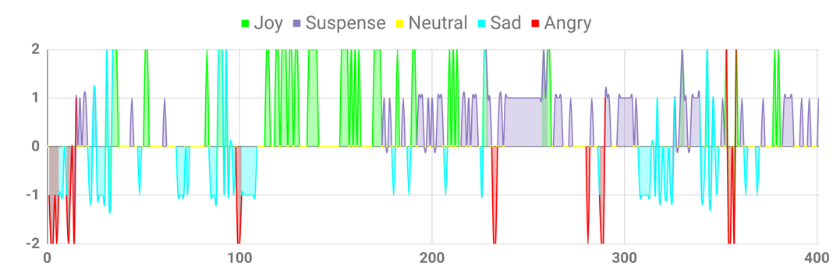

According to expectations, most of the story lies in the positive quadrants (x). Another interesting feature of the plot is the abundance of suspense in the later part of the story. However, this becomes clear when one reads the story in question, “Alladin and his magical lamp”. This is a story about a boy, Alladin, who finds a magical lamp in which he gets a genie. There are plenty of instances of suspense in this story where the reader does not know what will happen next. Finally, this story using the element of surprise leads the reader through the hardships that Alladin faces and how he overcomes those challenges in order to get what he wants. Thus, this story motivates reader to face the challenges in front of oneself.