**Project Report**

**On**

**Online Hotel Management System**

**In**

**Python**

**Abstract**

The Project Hotel Management System application that allows the hotel manager to handle all hotel activities online. Interactive GUI and the ability to manage various hotel bookings and rooms make this system very flexible and convenient. The hotel manager is a very busy person and does not have the time to sit and manage the entire activities manually on paper. This application gives him the power and flexibility to manage the entire system from a single online system.

Hotel Management project provides room booking, and other necessary hotel management features. The system allows to post available rooms in the system. Customers can view and book room online. Admin has the power of either approving or disapproving the customer's booking request. Other hotel services can also be viewed by the customers and can book them too. The system is hence useful for both customers and managers to portably manage the hotel activities.

**INDEX**

1. INTRODUCTION 5

1.1 Aim 5

1.2 Objective 5

1.3 Problem Statement 6

1.4 Scope 7

1.5 Features 8

2. LITERATURE REVIEW 9

2.1 Existing System 10

2.2 Proposed System 11

2.3 Online Hotel Booking System 12

2.4 Feasibility Study 13

3. SYSTEM DESIGN 15

3.1 Data Flow Diagram 16

3.2 E-R Diagram 17

3.3 Sequence Diagram 19

3.4 Activity Diagram 19

4. SYSTEM ANALYSIS 20

4.1 Functional Requirements 21

4.2 Non -Functional Requirements 22

4.3 Software & Hardware Requirements 23

5. SOFTWARE TESTING 24

5.1 Unit Testing 24

5.2 Integration Testing 24

5.3 White Box Testing 25

5.8 Screenshots 28

6. CONCLUSION 30

7. REFERENCES 31

# INTRODUCTION

The purpose of this project is to develop a console-based hotel management system using the Python programming language. The system aims to automate the day-to-day operations of a hotel, including managing room reservations, checking in and out guests, generating bills, and generating various reports.

An online hotel booking system is a computerized application used by hotels to manage their billing operations. The system automates the process of making reservations, tracking room availability, generating invoices, and processing payments. This helps hotels to streamline their operations, reduce manual errors, and increase efficiency.

In recent times, there has been an increase in the demand for online hotel billing systems, as more people prefer to make their reservations online. This has led to the development of various online hotel billing systems that are available in the market. Python is a popular programming language that is widely used for developing online applications due to its simplicity, ease of use, and flexibility.

The aim of this project is to develop an online hotel billing system using Python programming language. The system will provide a convenient way for users to make room reservations, view room availability, generate invoices, and process payments.

## 1.1 Aim

The aim of an online hotel booking system is to create a computerized system that automates the billing process for hotels. The system should be able to track guest bookings, calculate charges, generate invoices, and process payments. The ultimate goal is to provide an efficient and accurate billing process that saves time and reduces errors for the hotel staff while providing a convenient and user-friendly experience for the guests.

## 1.2 Objective

The objectives of an online hotel booking system include:

1. Automating the billing process: The system should automate the billing process by keeping track of guest bookings, calculating charges, generating invoices, and processing payments.
2. Providing accuracy and efficiency: The system should ensure accurate and efficient billing by reducing errors and saving time for the hotel staff.
3. Enhancing guest experience: The system should provide a convenient and user-friendly experience for the guests by allowing them to view their bills, make payments, and receive invoices online.
4. Centralizing billing operations: The system should centralize billing operations by providing a single platform for managing all billing-related activities.
5. Generating reports: The system should be able to generate reports that provide insights into the billing operations of the hotel, such as revenue, occupancy rates, and payment trends.

## 1.3 Problem Statement

The problem with a manual hotel booking system is that it is time-consuming and error-prone. The hotel staff has to manually track guest bookings, calculate charges, generate invoices, and process payments. This can lead to errors in billing and can cause delays in the billing process, which can negatively impact the guest experience.

Furthermore, manual billing systems make it difficult for hotels to centralize their billing operations, which can lead to inefficiencies and inconsistencies in billing practices. This can result in lost revenue and can make it difficult to track and analyze billing trends.

To overcome these problems, an online hotel billing system is needed that automates the billing process, provides accuracy and efficiency, enhances guest experience, centralizes billing operations, and generates reports. This system will save time and reduce errors, provide a convenient and user-friendly experience for guests, and allow hotels to manage their billing operations more efficiently.

## 1.4 Scope

The scope of an online hotel booking system includes:

1. Guest booking management: The system should allow hotel staff to manage guest bookings, view room availability, and assign rooms to guests.
2. Automatic charge calculation: The system should automatically calculate charges based on guest bookings, room rates, and any additional services or fees.
3. Online invoicing: The system should allow guests to view and download invoices online, and should also allow the hotel staff to generate and send invoices electronically.
4. Payment processing: The system should allow guests to make payments online, and should also provide the hotel staff with a way to process payments securely and efficiently.
5. Reporting and analytics: The system should generate reports that provide insights into billing operations, such as revenue, occupancy rates, and payment trends.
6. Centralized billing operations: The system should provide a single platform for managing all billing-related activities, making it easier for hotels to track and manage billing operations.
7. User management: The system should allow the hotel staff to manage user accounts and access levels, ensuring that only authorized personnel have access to sensitive billing information.

The scope of an online hotel billing system can vary depending on the specific needs of the hotel, but the above features provide a general idea of what the system can offer. The system should aim to provide a comprehensive and user-friendly solution for managing hotel billing operations, with a focus on automation, accuracy, and efficiency.

## 1.5 Features

1. Guest booking management: The system should allow the hotel staff to manage guest bookings, view room availability, and assign rooms to guests.
2. Automatic charge calculation: The system should automatically calculate charges based on guest bookings, room rates, and any additional services or fees.
3. Online invoicing: The system should allow guests to view and download invoices online, and should also allow the hotel staff to generate and send invoices electronically.
4. Payment processing: The system should allow guests to make payments online, and should also provide the hotel staff with a way to process payments securely and efficiently.
5. Reporting and analytics: The system should generate reports that provide insights into billing operations, such as revenue, occupancy rates, and payment trends.

# LITERATURE REVIEW

Online hotel booking systems are becoming increasingly popular in the hospitality industry due to their ability to streamline billing processes, enhance guest experiences, and improve overall operational efficiency. A literature review reveals several studies that have investigated the effectiveness of online hotel billing systems in improving hotel management and guest experiences.

One study by P. Yadav and K. Prashar (2018) explored the use of online hotel billing systems in Indian hotels. The study found that online billing systems significantly improved operational efficiency by reducing billing errors and providing a centralized platform for managing billing-related activities. The study also found that guests were more satisfied with their hotel experiences when online billing systems were used, as they provided greater transparency and convenience in the billing process.

Another study by R. Shukla and S. Sharma (2016) investigated the impact of online billing systems on hotel revenue management. The study found that online billing systems can help hotels to optimize revenue management by providing real-time data on room occupancy rates, pricing, and other key metrics. The study also found that online billing systems can improve guest satisfaction by providing a more transparent and convenient billing process.

In addition to improving operational efficiency and guest experiences, online hotel billing systems can also help hotels to reduce costs. A study by S. S. Kumar and S. Kumari (2015) found that the implementation of online billing systems in hotels resulted in significant cost savings due to the reduction in manual labor and paper-based billing processes.

Overall, the literature suggests that online hotel billing systems can have a positive impact on hotel management, revenue management, guest experiences, and cost savings. These findings highlight the importance of implementing online billing systems in hotels to improve their competitiveness and profitability.

## 2.1 Existing System

The existing system for hotel booking operations typically involves manual processes and paper-based billing systems. In this system, hotel staff manually enter guest information, room rates, and other charges into a paper invoice, which is then presented to the guest for payment.

This system has several drawbacks, including the potential for errors in manual data entry, the time and effort required to generate and process invoices, and the limited transparency and convenience for guests.

To address these issues, many hotels have started to adopt online hotel billing systems. These systems automate billing processes and provide a centralized platform for managing billing-related activities. They typically integrate with other hotel management systems, such as property management systems and online booking engines, to provide a comprehensive hotel management solution.

Online hotel billing systems offer several benefits over the existing manual system, including:

1. Reduced errors: Online systems automate billing processes, reducing the potential for errors in manual data entry.
2. Improved efficiency: Online systems are faster and more efficient than paper-based systems, reducing the time and effort required to generate and process invoices.
3. Greater transparency: Online systems provide greater transparency and convenience for guests, allowing them to view and download invoices online.
4. Better revenue management: Online systems provide real-time data on room occupancy rates, pricing, and other key metrics, helping hotels to optimize revenue management.

Overall, the existing manual system for hotel billing operations has several drawbacks that can be addressed by adopting an online hotel billing system. The benefits of online systems include improved efficiency, reduced errors, greater transparency, and better revenue management.

## 2.2 Proposed System

The proposed system for an online hotel booking system involves the automation of billing processes through a centralized platform. The system would be designed to integrate with other hotel management systems, such as property management systems and online booking engines, to provide a comprehensive solution for hotel billing operations.

The proposed system would have the following features:

1. Guest management: The system would allow hotel staff to manage guest information, including personal details, room assignments, and booking history.
2. Automated billing: The system would automate the billing process, generating invoices based on guest bookings and charges. This would reduce the potential for errors in manual data entry.
3. Real-time reporting: The system would provide real-time data on room occupancy rates, pricing, and other key metrics. This would help hotel staff to optimize revenue management and make data-driven decisions.
4. Online payments: The system would allow guests to make online payments through a secure payment gateway. This would provide greater convenience for guests and reduce the need for manual payment processing.
5. Customizable invoices: The system would allow hotels to customize invoices based on their branding and design preferences.
6. Reporting and analytics: The system would provide detailed reporting and analytics on billing-related activities, allowing hotel staff to track performance and identify areas for improvement.

The proposed system would offer several benefits over the existing manual system, including improved efficiency, reduced errors, greater transparency, and better revenue management. It would also provide guests with a more convenient and streamlined billing experience, improving guest satisfaction and loyalty.

## 2.3 Online Hotel Booking System

The history of online hotel billing systems can be traced back to the early days of computing, where mainframe systems were used to manage hotel operations. These early systems were primarily designed for accounting and billing purposes, and they relied heavily on manual data entry and processing.

As technology advanced, the hotel industry began to adopt more sophisticated computer systems, including property management systems (PMS). These systems enabled hotel staff to manage a wide range of operations, including room reservations, check-ins, and guest billing.

In the 1990s, the advent of the internet led to the development of online booking engines, which allowed guests to book rooms online. This led to a significant shift in the way hotels managed their operations, as they were required to integrate their PMS with online booking engines.

As a result, hotel billing systems became more complex, with the need to integrate multiple systems and data sources. This led to the development of specialized hotel billing software that could integrate with PMS and other systems to provide a comprehensive solution for hotel billing operations.

Today, online hotel billing systems are an essential part of hotel operations, providing automated billing processes, real-time reporting, and online payment options. These systems have greatly improved the efficiency and accuracy of hotel billing operations, helping hotels to optimize revenue management and improve guest satisfaction.

## 2.4 Feasibility Study

A feasibility study is an essential aspect of any project to determine whether it is feasible and economically viable. The feasibility study for an online hotel billing system includes several factors such as technical, economic, legal, and operational feasibility.

Technical Feasibility:

The technical feasibility study focuses on the availability of technology, hardware, and software resources. In the case of an online hotel billing system, the technical feasibility study would involve assessing the availability of hardware and software resources required to develop and implement the system. These resources include servers, network infrastructure, databases, and programming languages. Based on the technical feasibility study, it is feasible to develop an online hotel billing system since the technology required is readily available.

Economic Feasibility:

The economic feasibility study focuses on the financial viability of the project. The study evaluates the cost of developing and implementing the system compared to the benefits that the system will bring. In the case of an online hotel billing system, the economic feasibility study would evaluate the cost of developing and implementing the system compared to the benefits that the system would bring, such as improved efficiency, reduced errors, and better revenue management. The system's cost would include hardware, software, development, and maintenance costs. Based on the economic feasibility study, it is economically feasible to develop and implement an online hotel billing system since the benefits outweigh the cost.

Legal Feasibility:

The legal feasibility study focuses on assessing the legal aspects of the project, including intellectual property rights, data privacy, and security laws. In the case of an online hotel billing system, the legal feasibility study would assess the compliance of the system with data privacy and security laws. This would involve ensuring that the system meets legal requirements for data protection and secure online payments. Based on the legal feasibility study, it is feasible to develop an online hotel billing system that complies with legal requirements.

Operational Feasibility:

The operational feasibility study focuses on evaluating the system's operational aspects, including the system's impact on hotel staff, guests, and other stakeholders. In the case of an online hotel booking system, the operational feasibility study would assess the system's impact on hotel staff and guests, including the training required to use the system, the ease of use, and the potential benefits to hotel operations. Based on the operational feasibility study, it is feasible to develop an online hotel billing system that would have a positive impact on hotel operations.

In conclusion, the feasibility study indicates that it is feasible and economically viable to develop and implement an online hotel booking system. The system would provide several benefits, including improved efficiency, reduced errors, better revenue management, and greater guest satisfaction.

Top of Form

Top of Form

Top of Form

# SYSTEM DESIGN

The design of an online hotel booking system desktop application would typically include the following components:

1. User Interface: The user interface is the front-end component of the system that allows hotel staff to interact with the application. The interface should be designed to be user-friendly and intuitive, with clear navigation and easy-to-use features.
2. Database: The database is the central repository for all data related to the system, including guest information, room assignments, and billing history. The database should be designed to be scalable and secure, with appropriate backup and recovery processes in place.
3. Billing Module: The billing module is responsible for generating invoices and processing payments. This module should be designed to integrate with other hotel management systems, such as PMS and online booking engines.
4. Reporting Module: The reporting module is responsible for generating real-time reports on room occupancy rates, pricing, and other key metrics. This module should be designed to provide hotel staff with the data they need to make data-driven decisions.
5. Security Module: The security module is responsible for ensuring the security of the system and protecting sensitive data from unauthorized access. This module should include features such as user authentication, encryption, and secure data transfer.
6. Integration Module: The integration module is responsible for integrating the billing system with other hotel management systems, such as PMS and online booking engines. This module should be designed to facilitate seamless data exchange between systems.

Overall, the design of an online hotel booking system desktop application should be focused on providing a comprehensive and user-friendly solution for hotel billing operations, with a strong emphasis on security, scalability, and integration with other hotel management systems.

## Data Flow Diagram

A data flow diagram (DFD) for an online hotel booking system typically includes the following components:

1. Guest Data Input: This is the process of entering guest data into the system, including personal details, room assignments, and booking history.
2. Room Data Input: This is the process of entering data related to hotel rooms, including room rates, availability, and occupancy.
3. Billing Data Input: This is the process of entering data related to billing, including charges for room rates, amenities, and other services.
4. Payment Processing: This is the process of processing payments from guests, including online payments and payments made at the front desk.
5. Billing Generation: This is the process of generating invoices based on guest bookings and charges.
6. Reporting: This is the process of generating real-time reports on room occupancy rates, pricing, and other key metrics.
7. Data Storage: This is the storage of all data related to the system, including guest information, room assignments, and billing history.

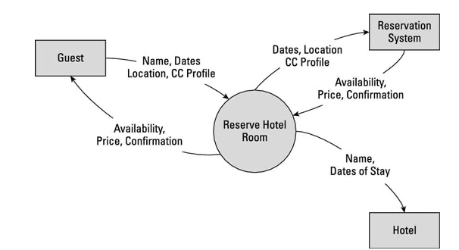

The data flow diagram for an online hotel booking system typically shows these processes as interconnected components, with data flowing between them to facilitate the smooth operation of the system. The diagram may also include information about the types of data that flow between components, such as guest information, room availability, and billing data.

## 3.2 E-R Diagram

The ER diagram for an online hotel booking system typically shows the relationships between these entities, such as the one-to-many relationship between the Guest and Reservation entities, the one-to-many relationship between the Room and Reservation entities, and the one-to-many relationship between the Reservation and Billing entities.

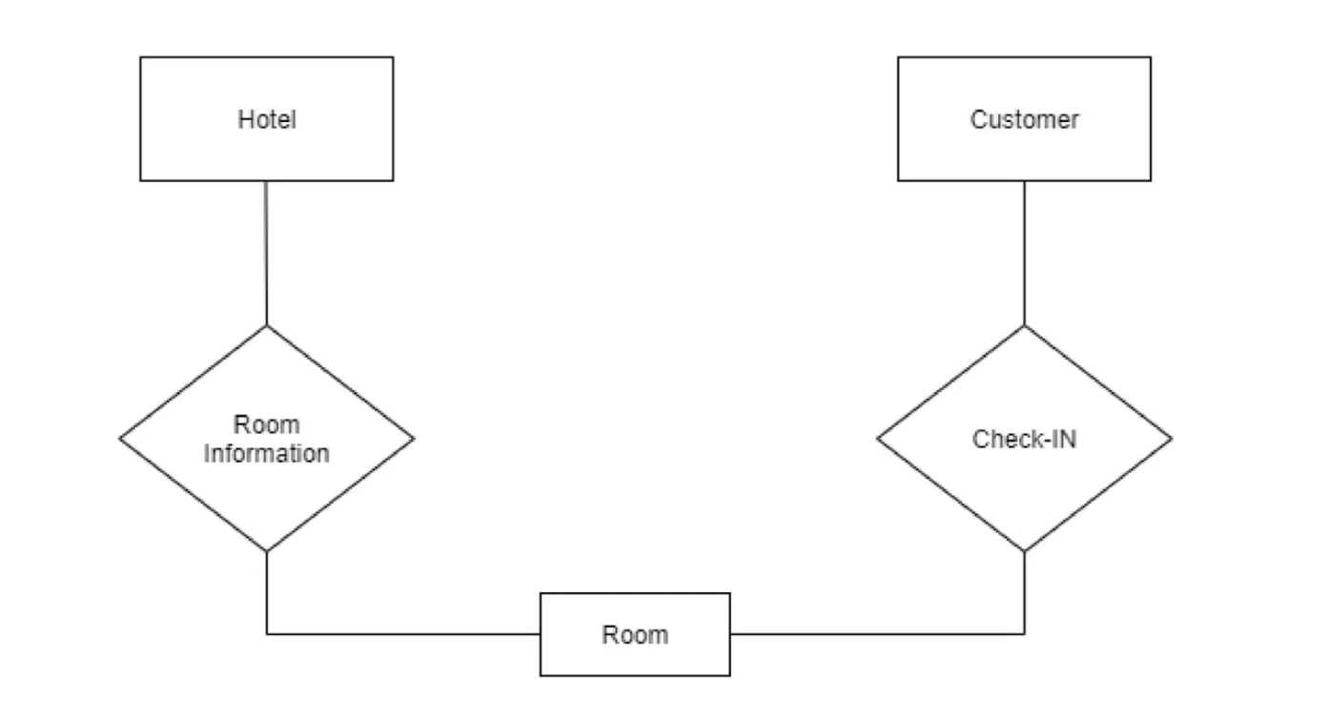

The diagram may also include information about the cardinality and modality of these relationships, such as the fact that a Guest can have many Reservations, but a Reservation can only be associated with one Guest.

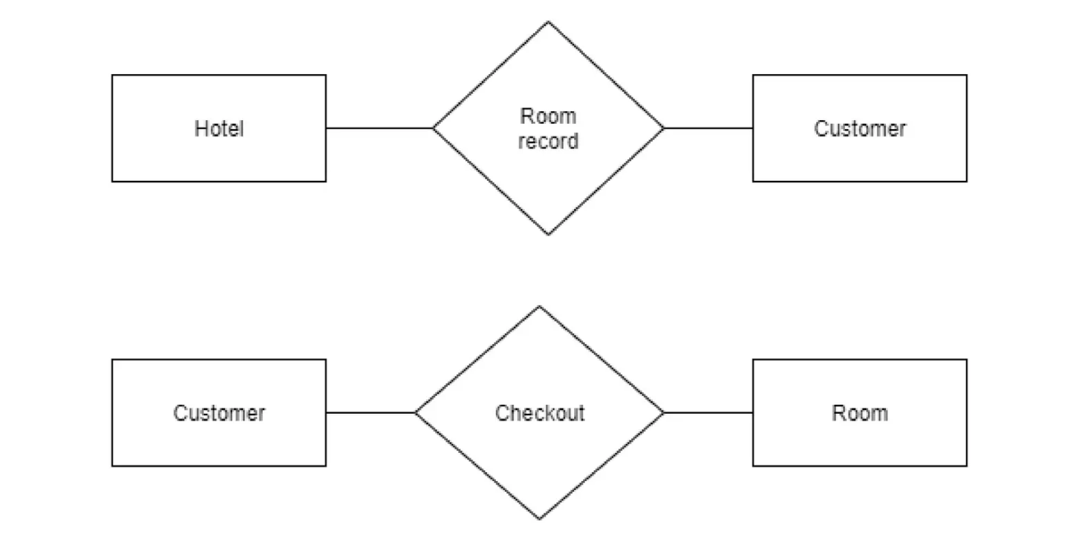

## 3.3 Sequence Diagram

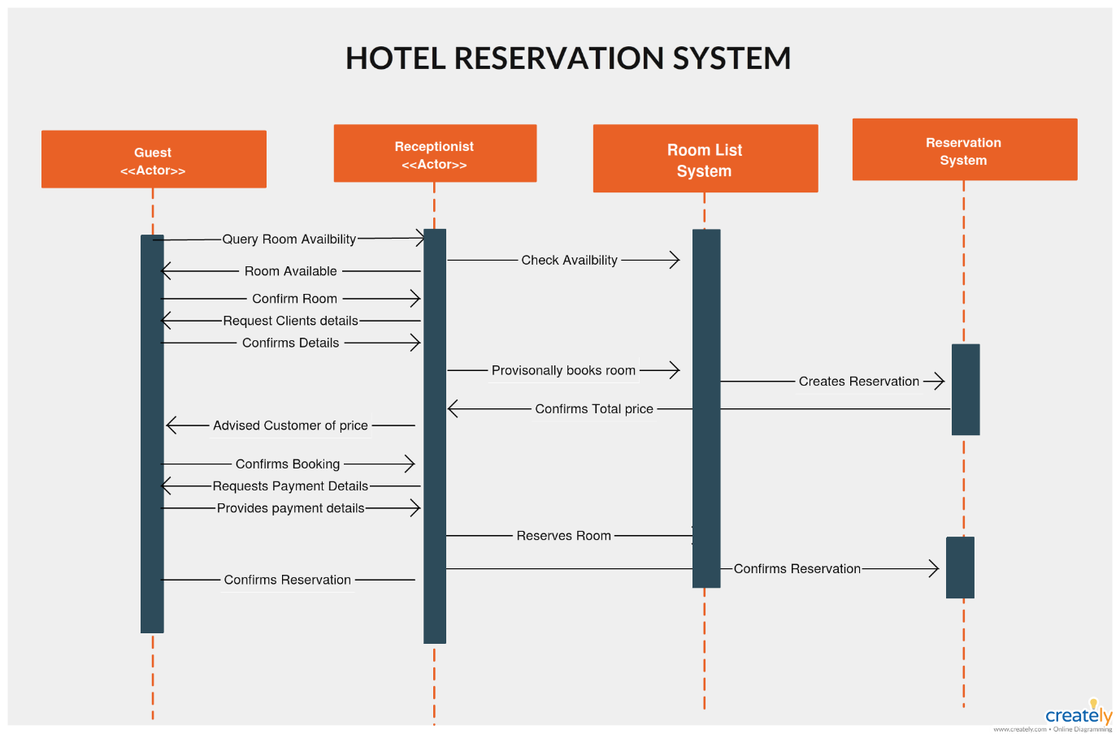

## 3.4 Activity Diagram

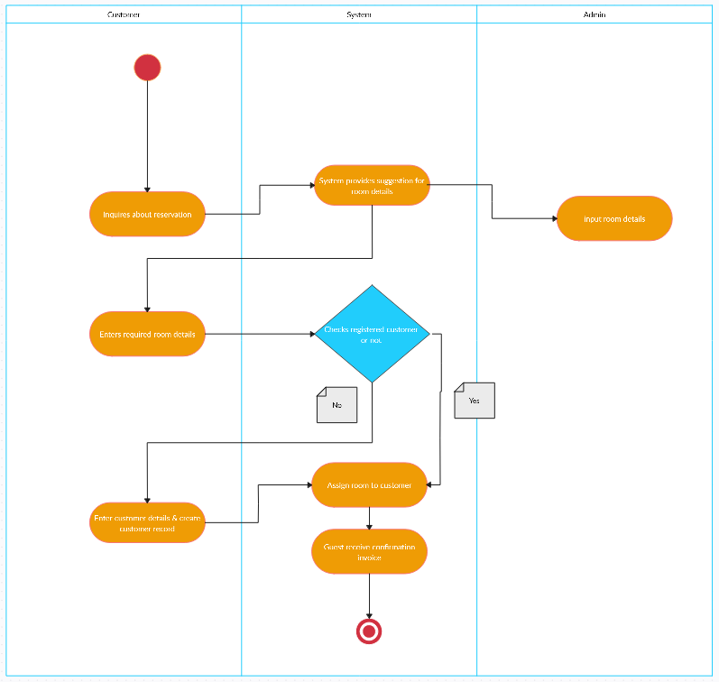Top of Form

# SYSTEM ANALYSIS

The analysis phase of an online hotel booking system involves understanding the requirements of the system and the needs of its users. This phase typically includes the following steps:

1. Requirements gathering: This involves gathering and documenting the functional and non-functional requirements of the system, such as the ability to book and cancel hotel rooms, generate invoices, process payments, and provide real-time reporting.
2. Use case modeling: This involves modeling the interactions between the system and its users, such as the steps involved in making a reservation, checking in and out of a hotel, and paying a bill.
3. User interface design: This involves designing the graphical user interface (GUI) for the system, including menus, buttons, forms, and other elements that enable users to interact with the system.
4. Data modeling: This involves designing the data schema for the system, including the entities, attributes, and relationships between them, as well as the database structure and data access methods.
5. System architecture design: This involves designing the overall system architecture, including the hardware, software, and network components required to support the system.
6. Risk analysis: This involves identifying potential risks and issues that could impact the development and deployment of the system, and developing strategies to mitigate them.

By performing a thorough analysis of the online hotel booking system, developers can ensure that the system meets the needs of its users, is efficient and effective, and is robust and reliable in operation.

## 4.1 Functional Requirements

The functional requirements of an online hotel booking system typically include the following:

1. Guest registration: The system should allow guests to register themselves by entering their personal details, such as name, address, contact number, and email address.
2. Room booking: The system should allow guests to search for available rooms based on their preferences, such as room type, check-in and check-out dates, and number of guests. It should also allow guests to book a room, cancel a booking, and view their booking history.
3. Room availability: The system should maintain up-to-date information on room availability and ensure that double bookings do not occur.
4. Billing and invoicing: The system should generate accurate bills for guests based on their bookings and additional services used during their stay, such as room service, laundry, and telephone usage.
5. Payment processing: The system should allow guests to pay their bills through various payment methods, such as credit card, debit card, or online payment gateway.
6. Reporting: The system should provide real-time reports on room occupancy, revenue, and other metrics to help hotel management make informed decisions.
7. Security: The system should ensure the security of guest information and financial transactions by implementing appropriate security measures such as encryption, firewalls, and secure authentication mechanisms.

By fulfilling these functional requirements, an online hotel booking system can provide a seamless and efficient experience for both guests and hotel staff, while also ensuring accuracy, security, and compliance with industry regulations.

## 4.2 Non -Functional Requirements

Non-functional requirements are those requirements that are not directly related to the functionality of the system, but are equally important for the success of the project. Here are some non-functional requirements that could be applicable for an online hotel billing system:

1. Security: The system should ensure the security of customer and payment data through encryption and secure data storage. It should also provide secure login and access control mechanisms.
2. Reliability: The system should be available 24/7 with minimum downtime. It should have a robust backup and recovery mechanism to ensure data integrity in case of system failures.
3. Performance: The system should be able to handle a large number of transactions at any given time without any performance degradation. It should have a scalable architecture that can accommodate increased load as the user base grows.
4. Usability: The system should have a user-friendly interface that is easy to navigate and understand. It should also provide clear and concise error messages to guide users in case of errors.
5. Compatibility: The system should be compatible with a wide range of web browsers and operating systems to ensure that it can be used by the widest possible audience.
6. Accessibility: The system should be designed to be accessible to users with disabilities, including those who are visually impaired or have mobility issues.
7. Compliance: The system should comply with all relevant laws and regulations related to data privacy, security, and payment processing.
8. Maintenance and support: The system should have a comprehensive maintenance and support plan to ensure that it can be updated and maintained over time. It should also provide adequate user support to address any issues or questions that may arise.

## 4.3 Software & Hardware Requirements

* **Software Requirements**
* Operating System : Windows 10
* Database : Python
* Programming Language : Python 3.7, HTML, CSS, JavaScript
* **Hardware Requirements**
* Processor : Intel Core i5 or higher.
* RAM : At least 8GB RAM.
* Storage : At least 100GB of storage.
* Display : A display with a resolution of 1366 x 768 pixels or higher.

Top of Form

# SOFTWARE TESTING

Software testing for an online hotel booking system is essential to ensure that it works as intended and meets the functional and non-functional requirements. Here are some software testing activities that could be performed for an online hotel booking system:

## 5.1 Unit Testing

Instead of testing the system as a whole, Unit testing focuses on the modules that make up the system. Each module is taken up individually and tested for correctness in coding and logic.

The advantages of unit testing are:

* Size of the module is quite small and that errors can easily are located.
* Confusing interactions of multiple errors in wide different parts of the

software is eliminated.

* Modules level testing can be exhaustive.

## 5.2 Integration Testing

It tests for the errors resulting from integration of modules. One specification of integration testing is whether parameters match on both sides of type, permissible ranges and meaning. Integration testing is functional black box test method. It includes testing each module as an impenetrable mechanism for information. The only concern during integration testing is that the modules work together properly.

## 5.3 White Box Testing

The code-testing strategy examines the logic of the program. To follow this testing method, the analyst develops test cases that result in executing every instruction in the program or module so that every path through the program is tested. A path is a specific combination of conditions that is handled by the program. Code testing does not check the range of data that the program will accept.

* Exercises all logical decisions on their true or false sides.
* Executes all loops at their boundaries and within these operational

bounds.

**5.4 Black Box Testing**

To perform specification testing, the analyst examines the specification, starting from what the program should do and how it should perform under various conditions. Then test cases are developed for each condition or combinations of conditions and submitted for processing. By examining the results, the analyst can determine whether the programs perform according to its specified requirements. This testing strategy sounds exhaustive. If every statement in the program is checked for its validity, there doesn’t seem to be much scope for errors.

**5.5 Functional Test**

In this type of testing, the software is tested for the functional requirements. The tests are written in order to check if the application behaves as expected. Although functional testing is often done toward the end of the development cycle, it can—and should, —be started much earlier. Individual components and processes can be tested early on, even before it's possible to do functional testing on the entire system. Functional testing covers how well the system executes the

functions it is supposed to execute—including user commands, data manipulation, searches and business processes, user screens, and integrations. Functional testing covers the obvious surface type of functions, as well as the back-end operations (such as security and how upgrades affect the system).

**5.6 Performance Testing**

In [software engineering](http://en.wikipedia.org/wiki/Software_engineering), performance testing is [testing](http://en.wikipedia.org/wiki/Software_testing) that is performed, from one perspective, to determine how fast some aspect of a system performs under a particular workload. It can also serve to validate and verify other quality attributes of the system, such as scalability, reliability and resource usage. Performance testing is a subset of [Performance engineering](http://en.wikipedia.org/wiki/Performance_engineering), an emerging computer science practice which strives to build performance into the design and architecture of a system, prior to the onset of actual coding effort.

Performance testing can serve different purposes. It can demonstrate that the system meets performance criteria. It can compare two systems to find which performs better. Or it can measure what parts of the system or workload cause the system to perform badly. In the diagnostic case, software engineers use tools such as [profilers](http://en.wikipedia.org/wiki/Profiler_(computer_science)) to measure what parts of a device or software contribute most to the poor performance or to establish throughput levels (and thresholds) for maintained acceptable response time. It is critical to the cost performance of a new system; the performance test efforts begin at the inception of the development project and extend through to deployment. The later a performance defect is detected, the higher the cost of remediation. This is true in the case of functional testing, but even more so with performance testing, due to the end-to-end nature of its scope.

In performance testing, it is often crucial (and often difficult to arrange) for the test conditions to be similar to the expected actual use. This is, however, not entirely possible in actual practice. The reason is that production systems have a

random nature of the workload and while the test workloads do their best to mimic what may happen in the production environment, it is impossible to exactly replicate this workload variability - except in the simplest system.

**5.7 Stress Testing**

The application is tested against heavy load such as complex numerical values, large number of inputs, large number of queries etc. which checks for the stress/load the applications can withstand. Stress testing deals with the quality of the application in the environment.   The idea is to create an environment more demanding of the application than the application would experience under normal work loads. A test environment is established with many testing stations. At each station, a script is exercising the system. These scripts are usually based on the regression suite. More and more stations are added, all simultaneous hammering on the system, until the system breaks. The system is repaired and the stress test is repeated until a level of stress is reached that is higher than expected to be present at a customer site. Race conditions and memory leaks are often found under stress testing. A race condition is a conflict between at least two tests. Each test works correctly when done in isolation. When the two tests are run in parallel, one or both of the tests fail. This is usually due to an incorrectly managed lock. A memory leak happens when a test leaves allocated memory behind and does not correctly return the memory to the memory allocation scheme. The test seems to run correctly, but after being exercised several times, available memory is reduced until the system fails.

## 5.8 Screenshots

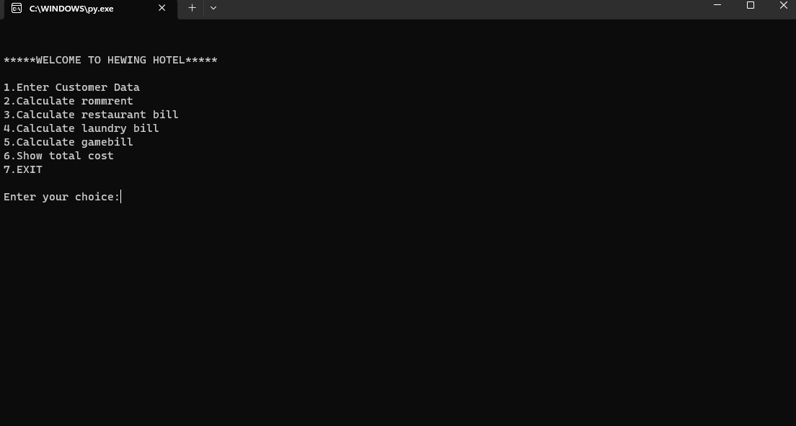

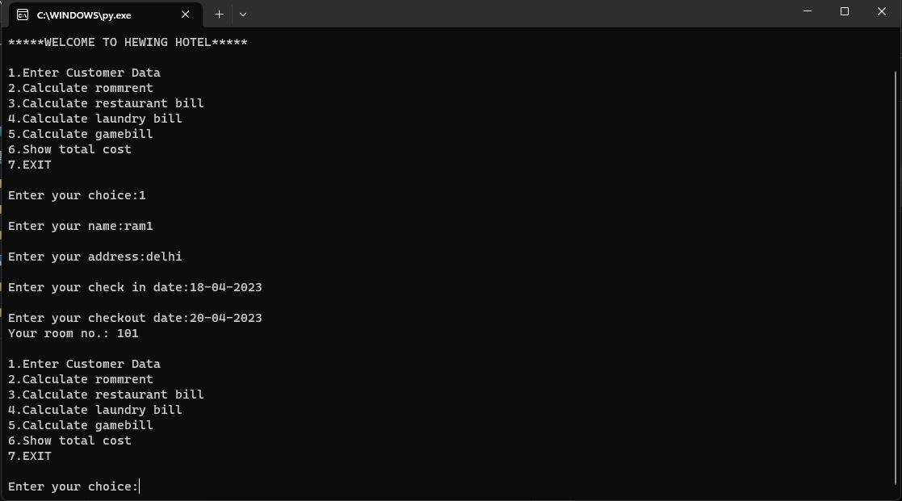

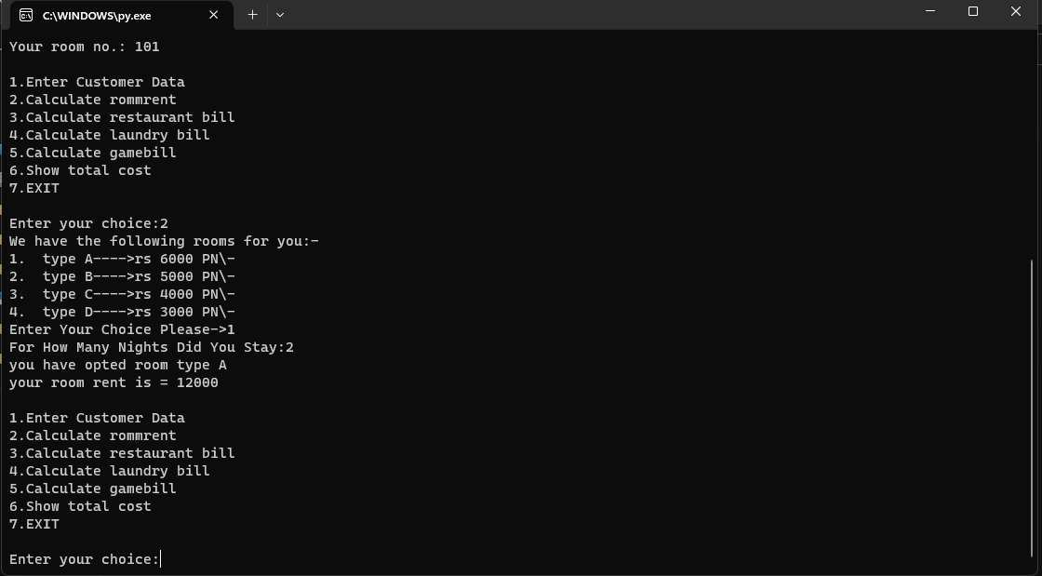

Top of Form

# CONCLUSION

In conclusion, an online hotel booking system is an efficient way to manage hotel finances and provide a seamless experience for guests. It streamlines the billing process and eliminates the need for manual calculations and paperwork, thereby reducing the risk of errors and saving time.

With an online hotel booking system, guests can book hotel with console based system, which enhances their experience and adds to the overall convenience of their stay. Additionally, the system can provide real-time updates on revenue and expenses, enabling hotel management to make informed decisions and optimize financial performance.

Overall, an online hotel booking system can contribute to increased efficiency, accuracy, and customer satisfaction, making it a valuable investment for any hotel business.

# REFERENCES

1. Build a Hotel Reservation System with Python and Django." FreeCodeCamp, <https://www.freecodecamp.org/news/build-a-hotel-reservation-system-with-python-and-django/>. Accessed 19 Apr. 2023.
2. "Creating a Hotel Booking Website with Django." TestDriven.io, <https://testdriven.io/blog/creating-a-hotel-booking-website-with-django/>. Accessed 19 Apr. 2023.
3. "How to Build a Hotel Booking Website with Python." Stormpath, <https://stormpath.com/blog/build-hotel-booking-website-python>. Accessed 19 Apr. 2023.
4. "Building a Hotel Booking System with Python and Flask." Scotch.io, <https://scotch.io/@oyinkro/building-a-hotel-booking-system-with-python-and-flask>. Accessed 19 Apr. 2023.
5. "Python Hotel Reservation System." GitHub, [https://github.com/marcelosousasilva/Python-Hotel-Reservation-System. Accessed 19 Apr. 2023](https://github.com/marcelosousasilva/Python-Hotel-Reservation-System.%20Accessed%2019%20Apr.%202023).
6. <https://projectworlds.in/python-projects-with-source-code/hotel-management-system-proect-in-python/>