Paracetamol in water: how much is good vs bad?
AquaTrace · KL Ocean Hackathon · 8 October 2026
Units: 1 mg/L = 1,000 µg/L = 1,000,000 ng/L

The answer
Good: below 1 µg/L · Warning: 1–10 µg/L · Bad: 10 µg/L or more
The "bad" line is the PNEC for aquatic life, 10 µg/L (0.01 mg/L), from Albarano et al. (2025), the newest estimate, based on 55 aquatic species. A less strict alternative is the NORMAN database value of 46 µg/L.

Key terms
- PNEC (predicted no-effect concentration): below this level, aquatic life should be safe.
- HC5 (hazardous concentration for 5% of species): the level at which about 5% of aquatic species start to be affected.
- RQ (risk quotient): measured concentration ÷ PNEC. Below 0.1 = low risk, 0.1 to 1 = medium, 1 or more = high.

Risk bands
Band | Risk quotient | µg/L | mg/L | What it means
Low | RQ < 0.1 | below 1 | below 0.001 | Normal river water
Medium | 0.1 ≤ RQ < 1 | 1 to 10 | 0.001 to 0.01 | Sewage-impacted water: keep watching
High | RQ ≥ 1 | 10 or more | 0.01 or more | Risk to aquatic life: confirm by HPLC and find the source

Key limits
Limit | µg/L | Protects | Source
PNEC, aquatic life (newest) | 10 | Aquatic life | Albarano et al. 2025 [1]
PNEC, NORMAN database | 46 | Aquatic life | Env. Sci. Europe 2024 [2]
HC5: 5% of species affected | 50 | Aquatic life | Albarano et al. 2025 [1]
Drinking-water guideline | 175 | Human health | Australia AGWR 2008 [3]
Drinking-water guidance | 200 | Human health | Minnesota Dept. of Health 2015 [4]
Aquatic-life limits are 4–20 times stricter than the human drinking-water limits. For river water, use the aquatic-life limit.

Where real water falls
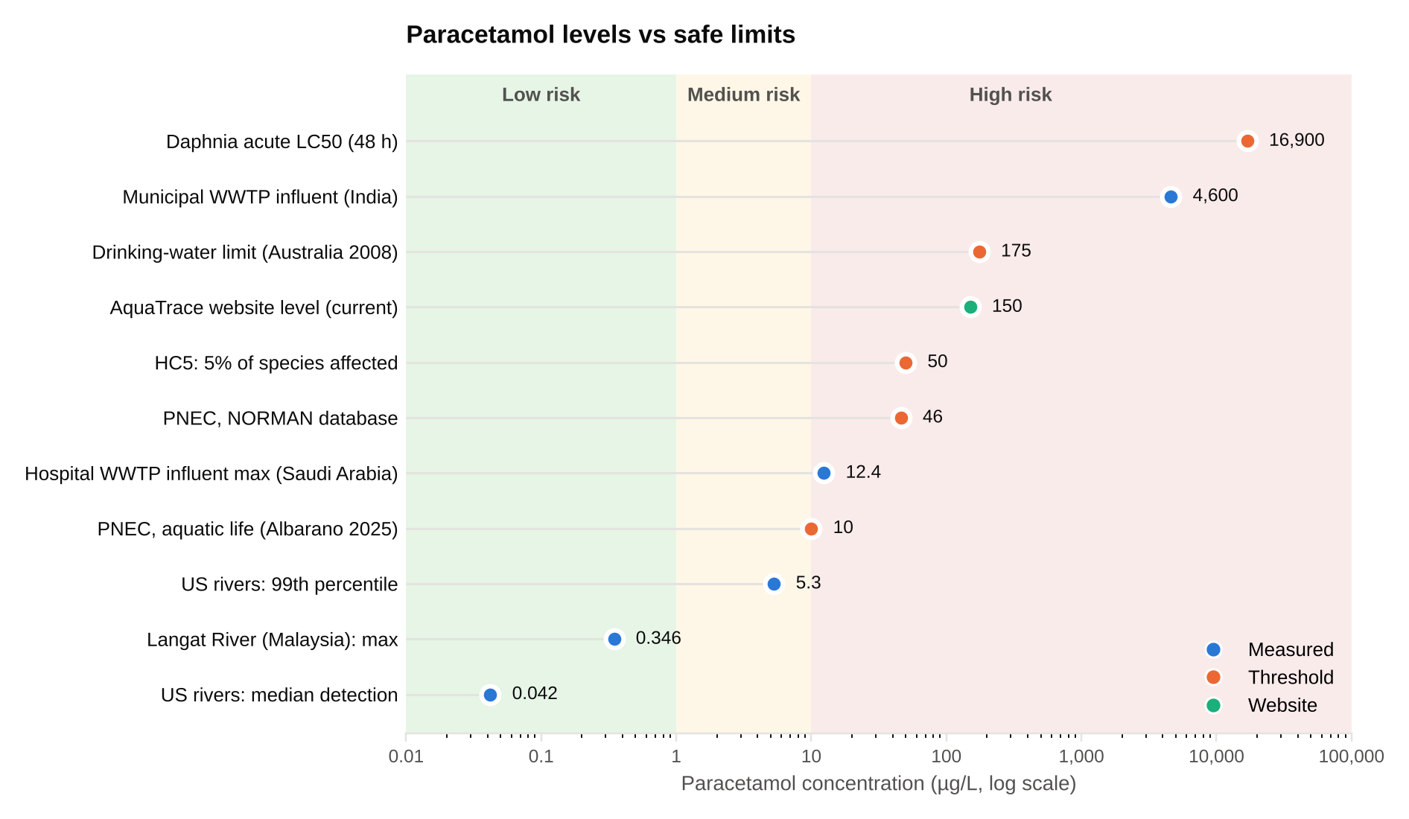
Level | µg/L | Type | Source
US rivers: median detection | 0.042 | Measured | US Water Quality Portal [5]
Langat River (Malaysia): maximum | 0.346 | Measured | Al-Odaini et al. 2013 [6]
US rivers: 99th percentile | 5.3 | Measured | US Water Quality Portal [5]
PNEC, aquatic life | 10 | Threshold | Albarano et al. 2025 [1]
Hospital WWTP influent max (Saudi Arabia) | 12.4 | Measured | Al Qarni et al. 2016 [7]
PNEC, NORMAN database | 46 | Threshold | Env. Sci. Europe 2024 [2]
HC5: 5% of species affected | 50 | Threshold | Albarano et al. 2025 [1]
AquaTrace website level (current placeholder) | 150 | Website | AquaTrace website code
Drinking-water limit | 175 | Threshold | Australia AGWR 2008 [3]
Municipal WWTP influent (Mysuru, India) | 4,600 | Measured | Shipingana et al. 2022 [8]
Daphnia magna acute LC50 (48 h) | 16,900 | Threshold | Kim 2006 [9]
Most river water sits in the low band. Untreated sewage and hospital wastewater sit well above the PNEC. Sewage treatment removes more than 98% of paracetamol [7].

How we chose the lab standards
An instrument such as HPLC or UV-Vis does not show a concentration directly. It shows a signal: a peak area (HPLC) or an absorbance (UV-Vis). To turn a signal into a concentration, we first measure solutions whose concentration we already know, called standards. The line that links signal to concentration is the calibration curve.

1. How a calibration curve works
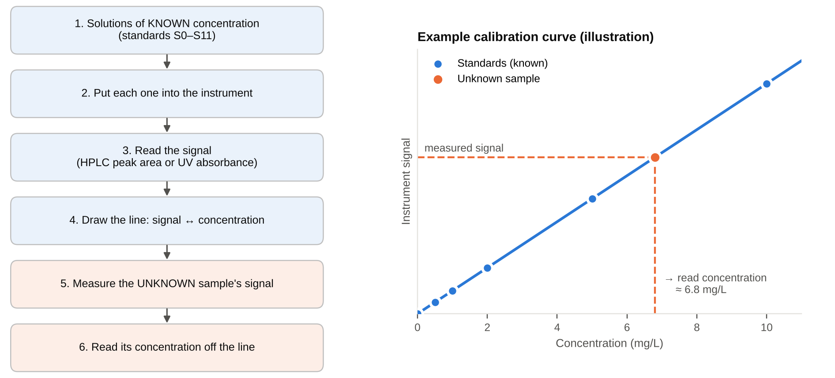
Why it is built this way:
- The line can only be trusted between the lowest and the highest standard. Reading inside that range (interpolation) is reliable; reading beyond it (extrapolation) is guessing. So the standards must cover every level we care about.
- The blank (S0) shows the signal with no paracetamol. It sets the baseline and reveals contamination.
- Standards placed exactly on the decision lines give the most accurate answer where it matters most: is a sample above or below the safe limit?

2. The standards
Standard | mg/L | µg/L | Measured with | Why this level
S0 | 0 | 0 | All instruments | Blank: baseline with no paracetamol
S1 | 0.01 | 10 | HPLC | PNEC (aquatic-life decision line); also the lowest level HPLC can measure reliably
S2 | 0.05 | 50 | HPLC | HC5: about 5% of species affected
S3 | 0.1 | 100 | HPLC | Between the HC5 and the drinking-water limit (0.175 mg/L)
S4 | 0.5 | 500 | HPLC | Raw sewage / hospital drain level
S5 | 1 | 1,000 | HPLC + UV-Vis | Overlap point 1 (UV-Vis is near its lower limit here)
S6 | 2 | 2,000 | UV-Vis | Start of the UV-Vis linear range
S7 | 5 | 5,000 | HPLC + UV-Vis | Overlap point 2
S8 | 10 | 10,000 | HPLC + UV-Vis | Overlap point 3 (dilute before HPLC if above its calibrated range)
S9 | 15 | 15,000 | UV-Vis | UV-Vis calibration
S10 | 20 | 20,000 | UV-Vis | UV-Vis calibration
S11 | 24 | 24,000 | UV-Vis | End of the UV-Vis linear range
The overlap standards (S5, S7, S8) are measured by both instruments, which gives paired UV-Vis and HPLC data for the machine-learning step.

3. The four jobs of the standards
Job | Standards | Why it matters
Environmental risk | S1, S2, S3 (0.01–0.1 mg/L) | The curve must cover the decision lines (PNEC, HC5), so a result near them is measured, not guessed.
HPLC limit | S1 (0.01 mg/L) | The lowest level HPLC can measure reliably (LOQ 0.01 mg/L) [10]. It checks that our instrument can reach the PNEC.
UV-Vis range | S5–S11 (1–24 mg/L) | UV-Vis is only linear between 2 and 24 mg/L [11]; it cannot see lower levels.
Sewage level | S4–S8 (0.5–10 mg/L) | Raw sewage and hospital wastewater can reach mg/L levels, so the curve must cover them too.

4. Why S1 = 0.01 mg/L (the PNEC)
PNEC means predicted no-effect concentration. Below this level, according to this risk assessment, paracetamol is not expected to cause noticeable harm to aquatic life.
We include 0.01 mg/L because it is an environmental decision line, not because it is a round number. If a river sample comes back near 0.01 mg/L, the calibration must be accurate right there. It is also the lowest level HPLC can measure reliably [10], so this standard also tests whether our method can reach the decision line at all.

5. Why S2 = 0.05 mg/L (the HC5)
HC5 means hazardous concentration for 5% of species. At about this level, roughly 5% of aquatic species begin to be affected, based on the species sensitivity distribution (SSD) below. It is a second, higher warning line.
Concentration | Name | What it means
0.01 mg/L | PNEC | Decision line: no noticeable effect on aquatic life is expected below it
0.05 mg/L | HC5 | Risk line: about 5% of species begin to be affected

6. How the HC5 is calculated
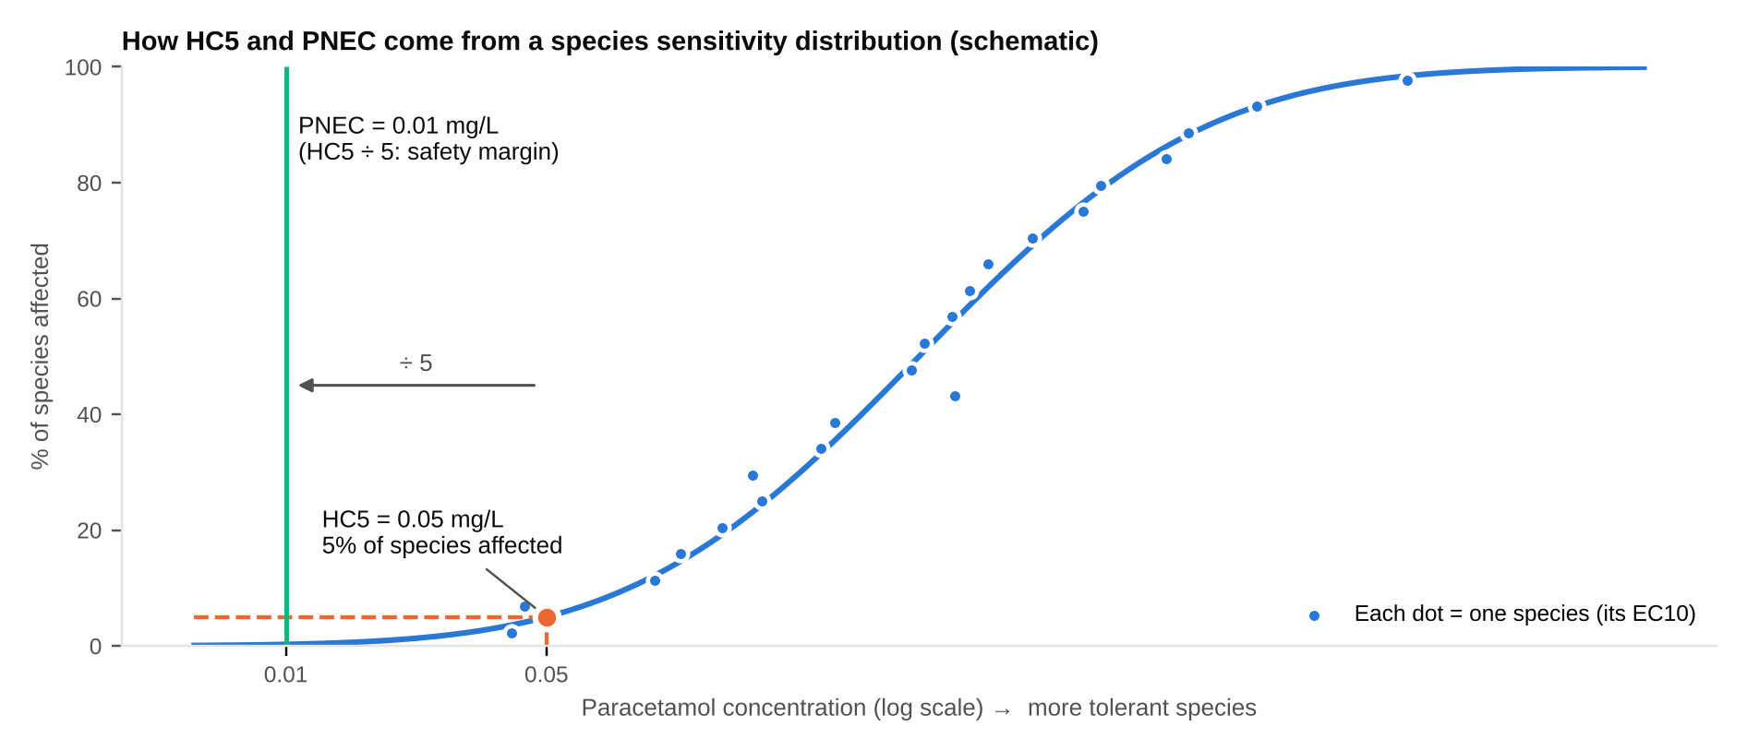
- The study did not test just one fish. It collected test results for 55 aquatic species [1].
- For each species it used the EC10: the concentration that causes a 10% effect in a lab test (for example, 10% less growth or reproduction).
- The species are sorted from most sensitive to most tolerant and a curve is fitted through them. This curve is the species sensitivity distribution (SSD).
- The HC5 is the point where the curve crosses 5%: about 5% of species are affected at this level, and 95% are not.
Important: HC5 = 0.05 mg/L does not mean that all animals die at 0.05 mg/L. It is a statistical point on the curve, an ecotoxicological risk threshold.
The figure is a schematic: the curve shape is illustrative, and only the 0.01 and 0.05 mg/L values come from Albarano et al. (2025).

7. Why the PNEC (0.01) is lower than the HC5 (0.05)
0.05 ÷ 5 = 0.01, so the PNEC is 5 times lower than the HC5. The PNEC is deliberately more conservative: it keeps a safety margin.
Why a safety margin is needed:
- 55 species is only a sample. Real rivers hold thousands of species, and the most sensitive one may never have been tested.
- Lab tests are short and use clean water. Real rivers contain mixtures of medicines and other stresses (heat, low oxygen) at the same time.
- EU risk-assessment guidance allows the HC5 from an SSD to be divided by a factor between 5 and 1 [12]. Albarano's values (0.05 → 0.01) sit at the most protective end, a factor of 5. The abstract does not name the factor; the ratio of the two values shows it.

Note for Penang
Paracetamol has never been measured in Penang. The four USM theses (Khasawneh 2022, Teoh 2022, Sharifah 2023, Amir Irham 2024) measured atenolol, carbamazepine, diclofenac and ketoprofen only. The team's CenFac HPLC results will be the first Penang paracetamol data.

Sources
- Albarano L. et al. (2025). Environmental risk assessment of paracetamol in aquatic ecosystems using species sensitivity distribution and global occurrence data. Journal of Hazardous Materials. doi 10.1016/j.jhazmat.2025.140107 https://www.iris.unisa.it/handle/11386/4949119
- Environmental Sciences Europe (2024). Risk quotients based on the lowest long-term PNECs from the NORMAN database, Table 4. https://enveurope.springeropen.com/articles/10.1186/s12302-024-01015-3/tables/4
- Australian Guidelines for Water Recycling (2008), as listed in EPA Victoria (2023), Appendix A, Table 12. https://app.production.epa-vic-gov-au.sdp3.sdp.vic.gov.au/sites/default/files/epa/publications/appendix_a_emerging-contaminants-in-recycled-water_31may2023.pdf
- Minnesota Department of Health (2015). Toxicological summary for acetaminophen. https://www.health.mn.gov/communities/environment/risk/docs/guidance/dwec/sumacetamin.pdf
- US Water Quality Portal (USGS, EPA). AquaTrace analysis of 15,854 river site-days, 1999–2025. https://www.waterqualitydata.us/
- Al-Odaini N.A. et al. (2013). The occurrence of human pharmaceuticals in wastewater effluents and surface water of Langat River and its tributaries, Malaysia. Int. J. Environmental Analytical Chemistry. https://www.ingentaconnect.com/content/tandf/geac/2013/00000093/00000003/art00001
- Al Qarni H. et al. (2016). Investigating the removal of some pharmaceutical compounds in hospital wastewater treatment plants operating in Saudi Arabia. Environmental Science and Pollution Research. https://link.springer.com/article/10.1007/s11356-016-6389-7
- Shipingana L.N.N. et al. (2022). Quantitative assessment of pharmaceutical drugs in a municipal wastewater and overview of associated risks. Applied Water Science. https://link.springer.com/article/10.1007/s13201-022-01570-1
- Kim P.-G. (2006). Ecotoxicological risk assessment for acetaminophen in Kyongahn River. Journal of Environmental Health Sciences. https://www.koreascience.or.kr/article/JAKO200604623620474.page?lang=en
- Nguyen T.D. et al. (2023). Simultaneous determination of paracetamol and diclofenac in wastewater by high-performance liquid chromatography method. Vietnam Journal of Science and Technology 61(4), 599–608. (HPLC-UV 243 nm, LOQ 0.01 mg/L.) https://vjs.ac.vn/jst/article/view/16418
- Sharma S. et al. (2013). Development and validation of a UV spectroscopic method for analysis of paracetamol in bulk powder and tablet. Oriental Journal of Chemistry. (Linear 2–24 mg/L.) https://www.orientjchem.org/?p=11983
- EU Technical Guidance Document on Risk Assessment, assessment factors to derive PNEC freshwater: species sensitivity distribution method, factor 5–1, to be justified case by case (as presented by ISPRA). https://www.isprambiente.gov.it/contentfiles/00001900/1903-c1984-m3-u1.pdf

