Exp 1, Testing on the lena image

Input image: 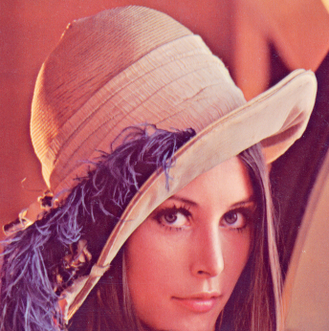

Step 1: convert image from RGB to HSV and get the V-channel

V-channel: 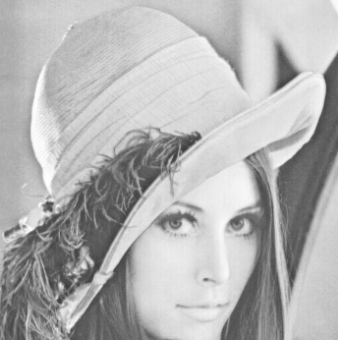

Step2: create the *circle* mask in a *square* image where the radial of the circle will be:

with is the width and height of the **image**

2.1 Calculate the distance from any pixel to center of the *image*

2.2, Normalize

2.3, Calculate intensity

2.4, change the center of the circle depended on size of image and the circle radial when the image is not square.

2.4.1, Calculate new coordinates of the circle:

2.4.2, Calculate new coordinates of the circle depended on size of image and the circle radial when the image is not square:

2.4.3, The coordinates of the region of mask which will be maintained:

2.4.4, Extract the final mask

Result :

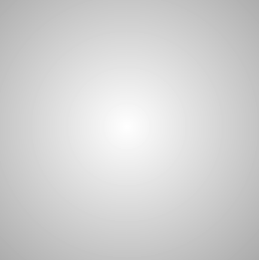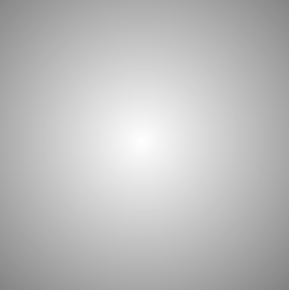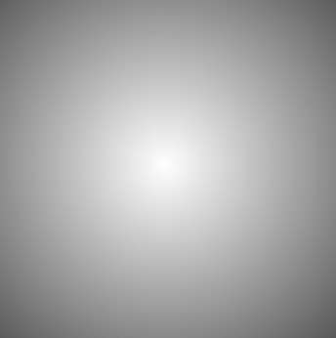

Level4

Level3

Level2

Level1

Step 3 : apply mask to lena image

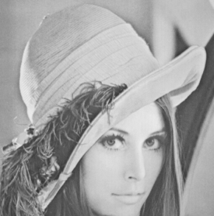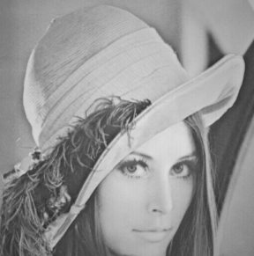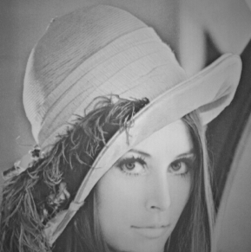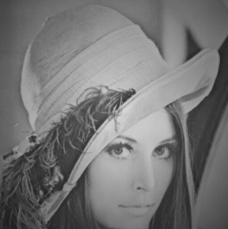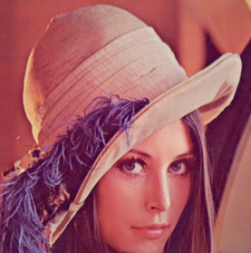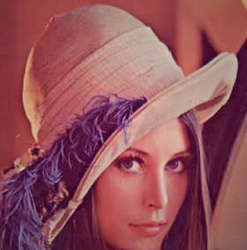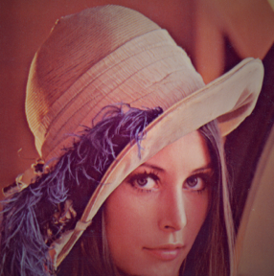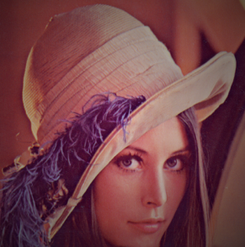

Level4

Level3

Level2

Level1

Step 4, Calculate IHED

4.1, Conver image from RGB to HSV

Extract the Illuinance Background is using a Low-Pass-Filter which has a big kernel to generate the illumination background

The used median Low-Pass-Filter has a big-size kernel. I used the kernel size with:

with is the height, width of the input image, respectively.