VIETNAM GENERAL CONFEDERATION OF LABOR

**TON DUC THANG UNIVERSITY FACULTY OF**

**INFORMATION TECHNOLOGY**



**SOFTWARE TECHNOLOGY**

**FLOWER SHOP MANAGEMENT SOFTWARE**

*Instructing Lecturer*: **Mr. DANG MINH THANG**

*Student’s name*: **PHAM TIEN DAT - 517H0042**

**NGUYEN TAN TAI - 51702227**

Class **:17050211**

Course **:21**

**HO CHI MINH CITY, YEAR 2019.**

VIETNAM GENERAL CONFEDERATION OF LABOR

**TON DUC THANG UNIVERSITY FACULTY OF**

**INFORMATION TECHNOLOGY**



**SOFTWARE TECHNOLOGY**

**FLOWER SHOP MANAGEMENT SOFTWARE**

*Instructing Lecturer*: **Mr. DANG MINH THANG**

*Student’s name*: **PHAM TIEN DAT - 517H0042**

**NGUYEN TAN TAI - 51702227**

Class **:17050211**

Course **:21**

**HO CHI MINH CITY, YEAR 2019.**

**ACKNOWLEDGEMENT**

In order to make this report complete and achieve good results, we have received the support and assistance of many teachers and classmates.

With deep affection, sincerity, we express deep gratitude to all individuals and agencies who have helped us in our study and research.

First of all, I would like to express a special appreciation to Ton Duc Thang University’s teachers for their conscientious guidance and advices throughout the last semester by gave me their modern outlook and meticulous supervision to carry out the job perfectly.

Especially we would like to send our sincere thanks to Mr. Dang Minh Thang has paid attention, help, guide us to complete the report well over the past time.

We would like to express our sincere gratitude to the leadership of Ton Duc Thang University for supporting, helping and facilitating us to complete the report well during the study period.

With limited time and experience, this report can not avoid mistakes. We are looking forward to receiving advice and comments from teachers so that we can improve our awareness, better serve the practical work later.

We sincerely thank you!

**THE PROJECT WAS COMPLETED AT TON DUC THANG UNIVERSITY**

I pledge that this is a product of our own project and is under the guidance of Mr. Dang Minh Thang. The content of research, results in this subject is honest and not published in any form before. The data in the tables used for the analysis, comment, and evaluation were collected by the authors themselves from various sources indicated in the reference section.

Besides, in my project, I also use many comments, evaluations as well as figures of other authors, organizations. Their documental sources are all quoted.

*Ho Chi Minh City, December 1st 2019*

*Authors*

*(Sign and write full name)*

*Pham Tien Dat*

*Nguyen Tan Tai*

**EVALUATION AND INSTRUCTION LECTURER**

**Confirmation of the instructor**

Ho Chi Minh City, December 1st 2019

(Sign and write full name)

**The assessment of the teacher marked**

Ho Chi Minh City, December 1tst 2019

(Sign and write full name)

**TABLE OF CONTENTS**

**ACKNOWLEDGEMENT** i

**THE PROJECT WAS COMPLETED AT TON DUC THANG UNIVERSITY** ii

**EVALUATION AND INSTRUCTION LECTURER** iii

**TABLE OF CONTENTS** 1

**CHAPTER 1 – REQUIREMENTS ENGINEERING** 3

**1.1. Online flowers shop requirement:** 3

**1.2. Functional Requirement:** 14

**1.3. Non-functional Requirement:** 15

**CHAPTER 2 – DIAGRAMS** 15

**2.1. Use case Diagram:** 15

**2.1.1. Customer Use case:** 15

**2.1.2. Admin Use case:** 16

**2.2. Activity Diagram:** 17

**2.3. Class Diagram:** 18

**2.4. ERD Diagram:** 19

**2.5. Sequence Diagram:** 20

**CHAPTER 3: USE CASE SPECIFICATION** 22

**3.1. Log in(customer):** 22

**3.2. Sign up:** 22

**3.3. Error:** 23

**3.4. Refine products:** 24

**3.5. Add to cart:** 24

**3.6. See product information:** 25

**3.7. Delete product:** 25

**3.8. Choose language:** 26

**3.9. Search:** 26

**3.10. Pay by online:** 27

**3.11. Pay by cast:** 28

**3.12. Log in (admin):** 29

**3.13. Manage warehouse:** 29

**3.14. See the order list:** 30

**3.15. Manage product information:** 31

**3.16. Add :** 32

**3.17. Delete:** 32

**3.18. Update:** 33

**CHAPTER 4 – PROJECT APPLICATION** 35

**4.1. Technology:** 35

**CHAPTER 1 – REQUIREMENTS ENGINEERING**

## **1.1. Online flowers shop requirement:**

|  |  |  |  |  |  |  |  |
| --- | --- | --- | --- | --- | --- | --- | --- |
| **No.** | **Module/**  **Screen** | **Description** | **Creator** | **Create date** | **Answer** | **Answer date** | **Status** |
| **1** | Log in | When customers fill in username and password, if the username or password wrong. Then what should we do in this, we offer 2 this way:  .Plan 1: Check if they wrong password or username or both, then show clearly what they wrong.  Plan 2: We just show for customer that they import something wrong. | Pham Tien Dat | 11/11/2019 |  |  | Open |
| **2** | Sign up | . According to Sign up page, when customer choose “Create account”, they must fill basic information like:  -Name  -Username  -Password  . Then what customers should fill more information.  . Can you choose what customers when sign up should fill more; some suggestions you can chooses to fill below:  -Email  -Address  -Phone  -Gender  -Age  -Birthday | Pham Tien Dat | 11/11/2019 |  |  | open |
| **3** | Sign up | . For I understand, when customers want to create account, they must click to sign up button. Then they will see 3 chooses: create account, use facebook account, use gmail account.  . Should we accept for customers to sign up and log in by using facebook and gmail? | Pham Tien Dat | 11/11/2019 |  |  | open |
| **4** | Refine product | . As we known, many customers want to refine product they want like: type of flowers, color of flowers.  . Did customers want to refine any different tags, we have some choices here:  -Flowers from seasons  -Flowers from event  -Meaning of flowers  -Remember flowers  -Flowers of love  -Birthday flowers | Pham Tien Dat | 11/11/2019 |  |  | open |
| **5** | See product information | . In website, each flower sell in shop customers can see some basic information about that flower.  . But we don’t know what information should show.  . Can you give us some detail about information should show to customers.  . We have some example: tags of flower, quantity, color have. | Pham Tien Dat | 11/11/2019 |  |  | open |
| **6** | Add to cart | . According to Add to cart function, when customers add to cart, if they turn off website before buy it then I understand this situation in 2 way:  - If customer have account, products have add in cart will save.  - If customers don’t use account, products have add in cart will disappear  . Do I understand like that is correct? | Pham Tien Dat | 11/11/2019 |  |  | open |
| **7** | Choose language | . According to choose language function, user click to “language”, but no document descript about what languages can chooses. I will create this function that user can choose: Vietnamese and English  . Do I understand like that is correct? | Pham Tien Dat | 11/11/2019 |  |  | open |
| **8** | Delete product | . For delete product functions, customers click to product they want to delete from cart. Then they click ”delete”, system ask customer Do they want to delete this product or not? Customer will choose “Yes” or “No”.  . Do I understand like that is correct? | Pham Tien Dat | 11/11/2019 |  |  | open |
| **9** | Pay by online | . For customer who want to buy flowers using online banking, after they add products to cart, they can see their products list.  . Customer will choose “Purchase” at the end of the list to begin purchase. System will show 2 way they can pay are:   * Pay by online * Pay by cash   . After they choose “Pay by online”, they will choose what bank they use to pay. Then they fill necessary information to begin purchase.  . Do I understand like that is correct? | Pham Tien Dat | 11/11/2019 |  |  | open |
| **10** | Pay by cash | . For customer who want to buy flowers using online banking, after they add products to cart, they can see their products list.  . Customer will choose “Purchase” at the end of the list to begin purchase. System will show 2 way they can pay are:   * Pay by online * Pay by cash   . After they choose “Pay by cash”  , system will ask if customer want to purchase or not. Then shipper from shop will deliver product for customer and get money for customer.  . Do I understand like that is correct? | Pham Tien Dat | 11/11/2019 |  |  | open |
| **11** | Manage warehouse | . For “Manage warehouse” function, admin will see the list of product sort by time go in warehouse. Name of product, producst ID, quantity of that product and system will update quantity every time customer by number of that product.  . Do I understand like that is correct? | Pham Tien Dat | 11/11/2019 |  |  | open |
| **12** | See the order list | . For “See the order list” functions, admin will see all order from customer in website when they log in admin to web. All order will send to admin and admin will accept the order or not.  . Do I understand like that is correct? | Pham Tien Dat | 11/11/2019 |  |  | open |
| **13** | Manage product information | . For “manage product information function, whenever shop add new flower, admin will go to manage product info, then click “Add” to add new product some basic information. Also, admin can click ”Update” or “Delete” if they want to change any thing about product information.  . Do I understand like that is correct? | Pham Tien Dat | 11/11/2019 |  |  | open |
| **14** | Setting | . For setting, when admin in “manage warehouse” or “Manage product information”, they can click to product, then click “Setting” button next to product.  . In setting admin can: Add, delete, update.  . Do I understand like that is correct? | Pham Tien Dat | 11/11/2019 |  |  | open |
| **15** | Add | . For add function, admin can choose “Add” to create new product in warehouse or mange information  . Do I understand like that is correct? | Pham Tien Dat | 11/11/2019 |  |  | open |
| **16** | Delete | . For delete function, after admin choose product want to delete in “manage warehouse” or in “manage product information”. After click “Delete”, system will ask admin if he/she want to delete this product or not.  . Do I understand like that is correct? | Pham Tien Dat | 11/11/2019 |  |  | open |
| **17** | Update | . For update function, admin can choose product want update, fill new information, then click “save” button to save the change.  . Do I understand like that is correct? |  |  |  |  |  |

## **1.2. Functional Requirement:**

* Keeping the daily sell.
* Listen for the feedback given by customer.
* User account are available
* Customers are available to view his/her order history
* Business Rules – don’t break the rules of business
* Authentication – detail and information must be correct
* Audit tracking – have employees to control web
* Certification Requirements – Must have certification that allow shop to sell
* Historical data – admin must know historical data of shop: products go in and out, order list, salary, price of product…..

## **1.3. Non-functional Requirement:**

* System must run 24/7
* System only can off twice a year
* Security for customer information
* Flexibility – easy to use
* Scalability – server can update, celebrate Database and use it.
* Localization – language must near to customers
* Maintainability – system can maintain, easy to find and fix error
* Online manual – can help customers online
* Environmental – server is obligatory
* Data integrity – lost data are disallowance
* Usability – admin and customer can use this website
* Interoperability – admin can contract with system

**CHAPTER 2 – DIAGRAMS**

**2.1. Use case Diagram:**

**2.1.1. Customer Use case:**

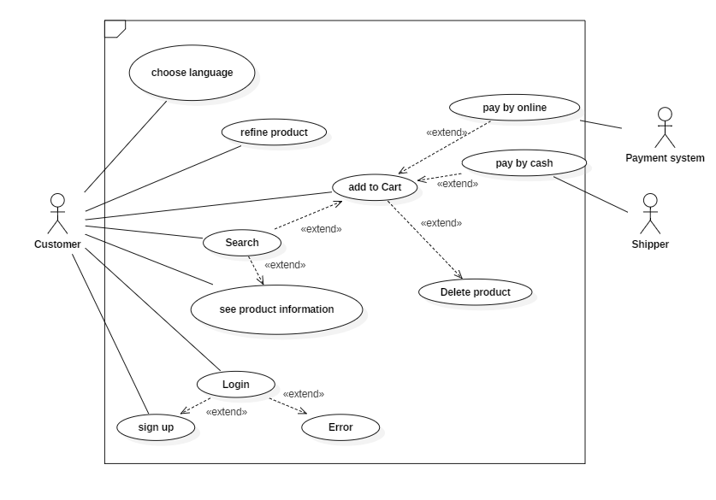

**Figure 2.1:** Use case Diagram for customer

**2.1.2. Admin Use case:**

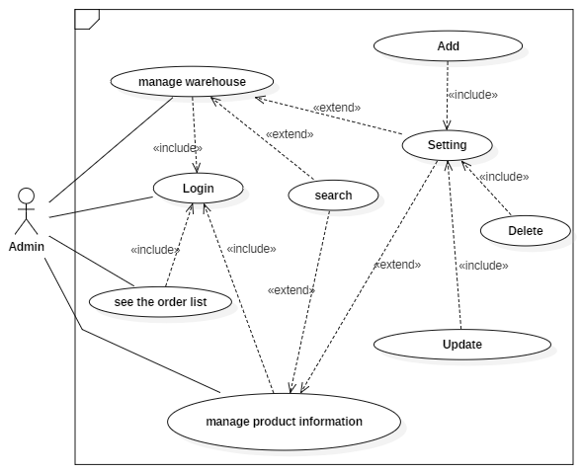

**Figure 2.2:** Use case Diagram for admin

**2.2. Activity Diagram:**

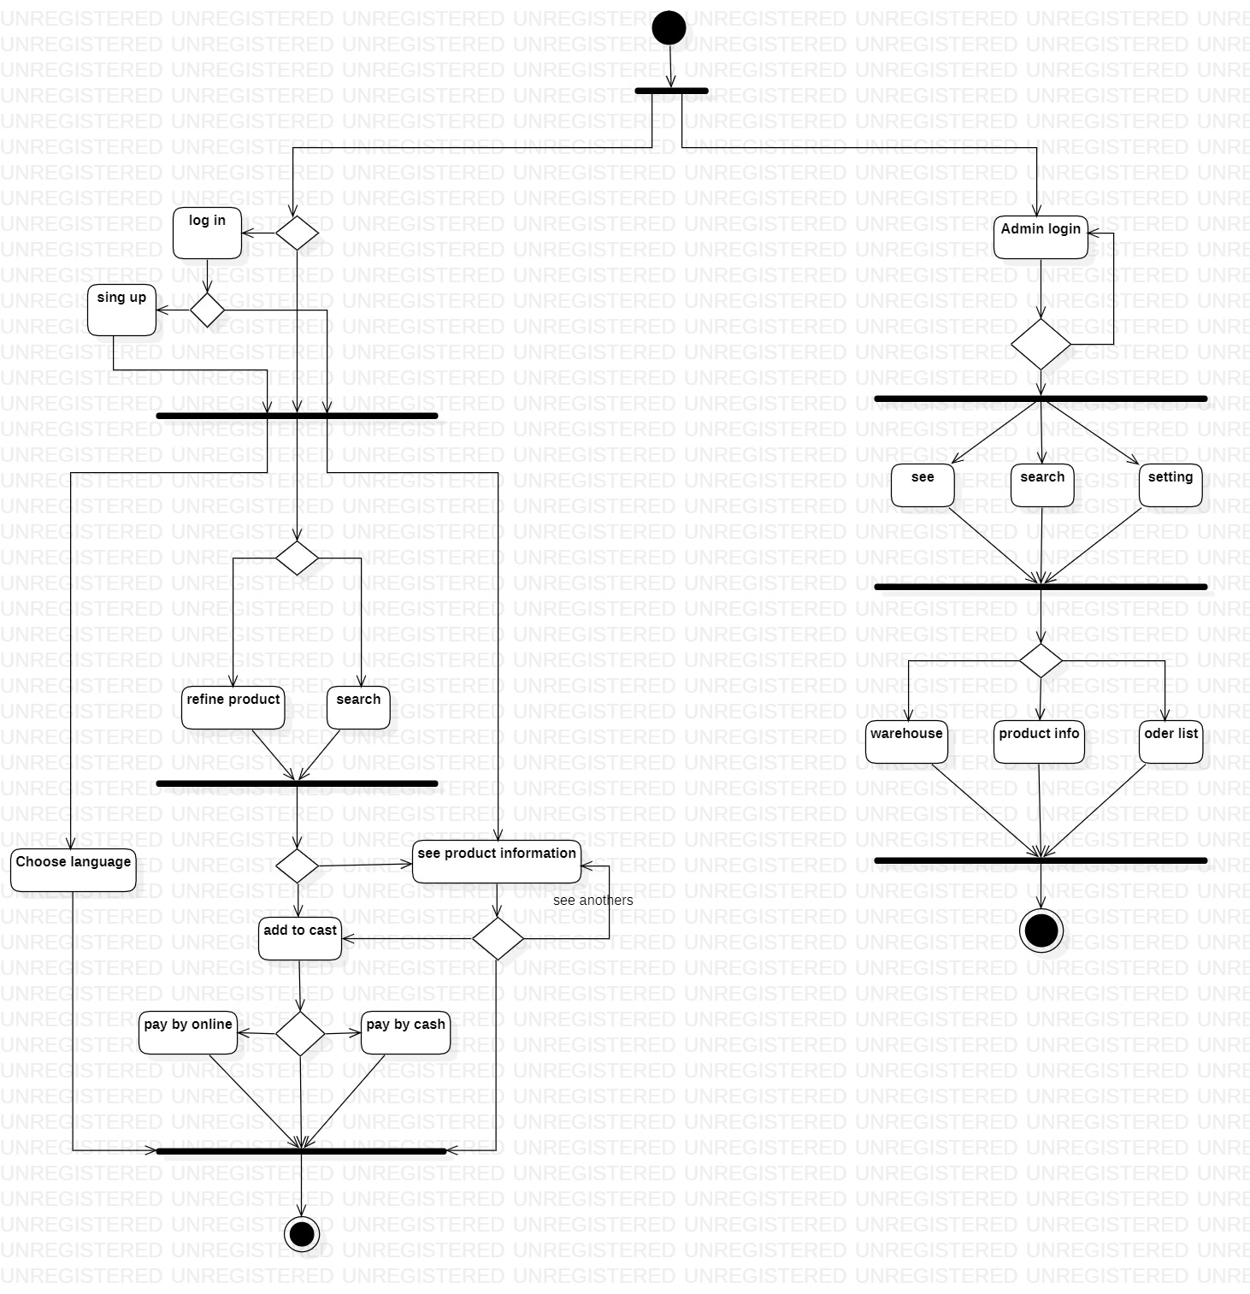

**Figure 2.3:** Activity Diagram for online flower shop

**2.3. Class Diagram:**

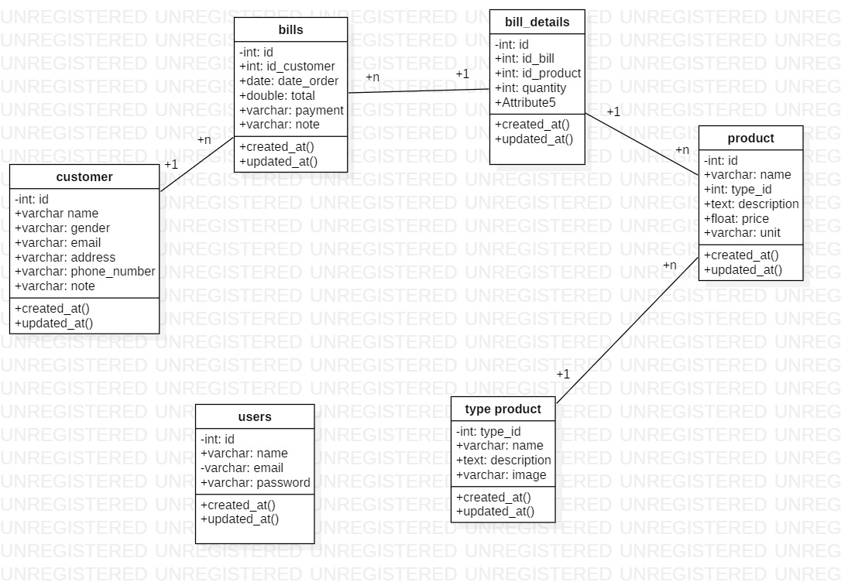

**Figure 2.4:** Class Diagram for online flower shop

**2.4. ERD Diagram:**

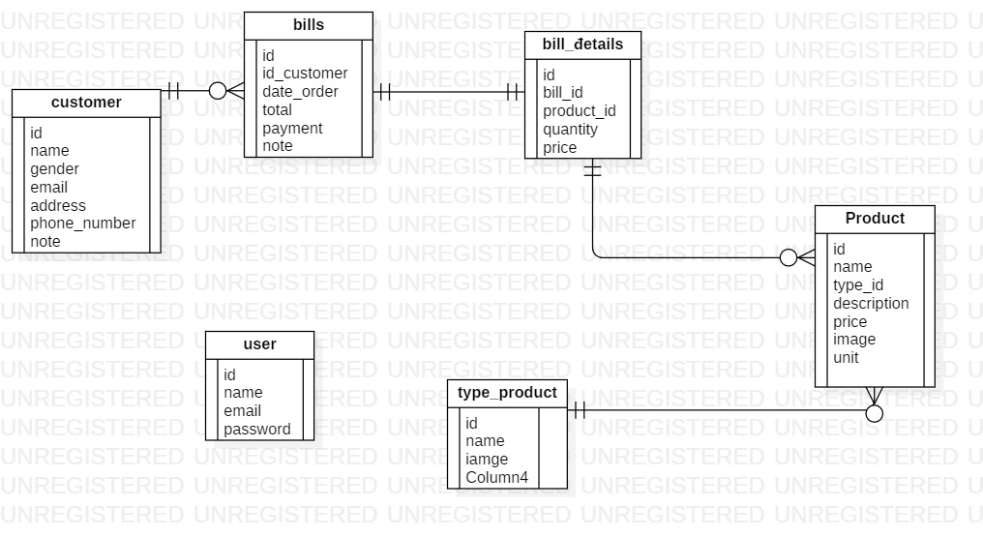

**Figure 2.5:** ERD Diagram for online flower shop

**2.5. Sequence Diagram:**

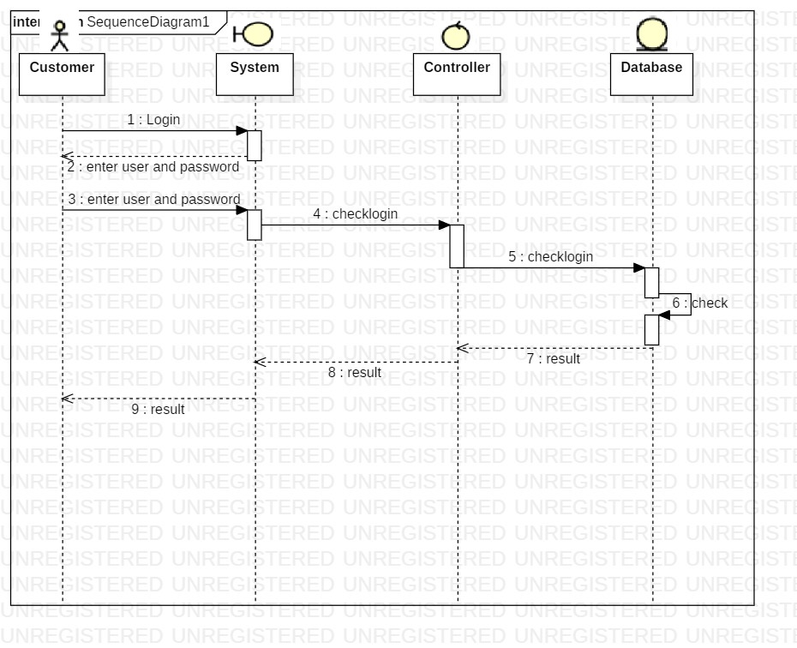

**Figure 2.6:** Sequence Diagram for online flower shop

**CHAPTER 3: USE CASE SPECIFICATION**

## **3.1. Log in(customer):**

|  |  |
| --- | --- |
| **ID:** | **1** |
| **Title:** | Online Flowers shop log in |
| **Description:** | . Customer can be a member by create account and have many other benefits |
| **Primary Actor:** | . Customers  . System |
| **Preconditions:** | . System must save and protect password for users.  . User have account.  . User sign in right username and account. |
| **Postconditions:** | . When account holder log out.  . Users don’t have account.  . Users get wrong password or username. |
| **Main  Success Scenario:** | . As customer, they can get discount in some events and other benefits. |
| **Extensions:** | . If customers don’t have account, they can go to Sign up page  . If users sign in wrong, system will notification for user to know in Error |
| **Priority:** | . User must fill all necessary information |

## **3.2. Sign up:**

|  |  |
| --- | --- |
| **ID:** | **2** |
| **Title:** | Become member in shop |
| **Description:** | . When customer want to become member and get a lot of benefits. They can fill necessary information and create account. |
| **Primary Actor:** | . Customers |
| **Preconditions:** | . Fill all and correct information |
| **Postconditions:** | . Click sign up to create account  . Go back if they don’t want to create account anymore |
| **Main  Success Scenario:** | . All fill in information is correct  . Customer click to submit. |
| **Extensions:** | . Wrong type of username.  . Wrong type of password  . Information unacceptable  . Lost internet before click submit |
| **Frequency of Use:** | . Customer want become member. |

## **3.3. Error:**

|  |  |
| --- | --- |
| **ID:** | **3** |
| **Title:** | Display error |
| **Description:** | . When users fill wrong password or username, system will say for customer that users use wrong account. |
| **Primary Actor:** | . System |
| **Preconditions:** | . Wrong password.  . Wrong username. |
| **Postconditions:** | . User fill right username and password. |

## **3.4. Refine products:**

|  |  |
| --- | --- |
| **ID:** | **4** |
| **Title:** | Shop refine products |
| **Description:** | . Customers can choose what type of flowers, type, color, meaning to find flower they want. |
| **Primary Actor:** | . Customers |
| **Main  Success Scenario:** | . Show all flowers that have categories users choose |
| **Frequency of Use:** | When customers want to find what type of flowers they want |

## **3.5. Add to cart:**

|  |  |
| --- | --- |
| **ID:** | **5** |
| **Title:** | Flowers cart |
| **Description:** | . Customers after search and finding for long time. They finally choose product to buy. But they still want to find the better products and want to save this product as a backup. Buyer will add this product to cart and they can go to find another flowers. |
| **Primary Actor:** | . Customers  . System |
| **Preconditions:** | . Must have flowers that customers want to buy |
| **Postconditions:** | . No stuff that customer wants to buy  . Customers purchase merchandise in cart |
| **Main  Success Scenario:** | . Show all flowers that customers add. |
| **Frequency of Use:** | . Every customer before buy flowers must do. |

## **3.6. See product information:**

|  |  |
| --- | --- |
| **ID:** | **6** |
| **Title:** | View information of flowers |
| **Description:** | . After choose flower, user can see some basic information of that flower. |
| **Primary Actor:** | . Users  . System |
| **Frequency of Use:** | . Every time customer click to the flower picture |

## **3.7. Delete product:**

|  |  |
| --- | --- |
| **ID:** | **7** |
| **Title:** | Delete product in cart |
| **Description:** | After add some product to cart, if user don’t like any products in cart, they can delete it. |
| **Primary Actor:** | . Customers  . System |
| **Preconditions:** | . Have product in cart |
| **Postconditions:** | . No product in cart  . Customer click to buy stuff in cart |
| **Main  Success Scenario:** | . The product which customer click delete will disappear |
| **Frequency of Use:** | . When customer don’t want to buy product which already add in cart |

## **3.8. Choose language:**

|  |  |
| --- | --- |
| **ID:** | **8** |
| **Title:** | Language choosing |
| **Description:** | . User can choose different kind of language display on website. |
| **Primary Actor:** | . Users |

## **3.9. Search:**

|  |  |
| --- | --- |
| **ID:** | **9** |
| **Title:** | Online flower shop search bar |
| **Description:** | . Users write name off flower in search bar and system will show all flowers with that name. |
| **Primary Actor:** | . System  . Users |
| **Preconditions:** | . Right key word |
| **Main  Success Scenario:** | . User will see all flowers have name same as key word they search |
| **Extensions:** | . See product information  . Add to cart |
| **Frequency of Use:** | . When user want to find flowers they want to buy in the fast way |
| **Priority:** | . Flowers that customers search must have at shop |

## **3.10. Pay by online:**

|  |  |
| --- | --- |
| **ID:** | **10** |
| **Title:** | Online purchase |
| **Description:** | . After customers add flowers they want to buy in cart, they can click ‘Buy’ to begin purchase.  . Customers can choose what type of purchase they want to use, like: VISA, online bank, …. |
| **Primary Actor:** | . Customers  . Payment system |
| **Preconditions:** | . Must have merchandise to begin purchase  . Admin must know that someone buy flowers.  . Shop must have internet banking account. |
| **Postconditions:** | . Money send to shop online banking account  . Customers don’t want to buy anymore. |
| **Main  Success Scenario:** | . Money will send to shop and shipper will deliver flowers to customers |
| **Frequency of Use:** | . When customers want to buy flowers at home |

## **3.11. Pay by cast:**

|  |  |
| --- | --- |
| **ID:** | **11** |
| **Title:** | Store purchase |
| **Description:** | . Customers come to store and buy flowers.  . Customers buy flowers at home and pay through the shipper. |
| **Primary Actor:** | . Salesman  . Shipper  . Customers |
| **Preconditions:** | . Customers buy flowers and request to pay through shipper.  . Customers buy flower at store |
| **Postconditions:** | . Customer get flowers.  . Shipper/salesman get money. |
| **Main  Success Scenario:** | . Customer order flowers, then shipper will pic it to the address that customers say.  . When customers at store, they just need give money to salesman and they can get flowers. |
| **Frequency of Use:** | . Customers don’t have internet banking or VISA want to buy flowers.  . Customers want to see real flowers at store. |

## **3.12. Log in (admin):**

|  |  |
| --- | --- |
| **ID:** | **12** |
| **Title:** | Admin log in |
| **Description:** | . This log in for admin to managed shop such as: warehouse management, money, member, employees, order list, product information, setting the product. |
| **Primary Actor:** | . Admin  . System |
| **Preconditions:** | . Manager of shop must have admin account to manage all shop and members. Must have security to protect account. |
| **Postconditions:** | . When admin log out.  . Admin forgets password or username |
| **Main  Success Scenario:** | . As admin, they can manage shop |
| **Frequency of Use:** | . Manager must log in every time any new merchandise come in shop or change information about shop and merchandise |
| **Priority:** | . Admin must have account first and can add, update, delete merchandise.  . Only one account are available for admin. |

## **3.13. Manage warehouse:**

|  |  |
| --- | --- |
| **ID:** | **13** |
| **Title:** | Warehouse management |
| **Description:** | . Every new merchandise come in shop, admin will save this merchandise as type of flowers, quantity, date time go in warehouse |
| **Primary Actor:** | . Admin |
| **Preconditions:** | . Admin must log in to manage the merchandise. |
| **Postconditions:** | . No merchandise go in warehouse. |
| **Main  Success Scenario:** | . All new merchandise will save in warehouse and control by admin. It will save as quantity of each type, day and time this merchandise go in warehouse, money buy flowers, price when sell. |
| **Extensions:** | . Add merchandise  . Delete  . Update merchandise  .Search |
| **Frequency of Use:** | . Every time new merchandise come to warehouse |

## **3.14. See the order list:**

|  |  |
| --- | --- |
| **ID:** | **14** |
| **Title:** | Customers order list |
| **Description:** | . As admin, you can see list of history that customers buy flowers.  . It will show buyer name, address to deliver, what kind of flowers, quantity, price. |
| **Primary Actor:** | . Admin |
| **Preconditions:** | . Admin must log in first |

## **3.15. Manage product information:**

|  |  |
| --- | --- |
| **ID:** | **15** |
| **Title:** | Manage information of flowers |
| **Description:** | . Show information of flower  . Admin can add, delete, update the information of flowers in shop. |
| **Primary Actor:** | . Admin |
| **Preconditions:** | . Admin must log in |
| **Postconditions:** | . Admin save every change information.  . Admin delete flowers. |
| **Extensions:** | . Search  . Add  . Delete  . Update |
| **Frequency of Use:** | . Admin want to change information of flowers.  . New kind of flower sell in shop and admin must add more detail about it. |

## **3.16. Add :**

|  |  |
| --- | --- |
| **ID:** | **16** |
| **Title:** | Save detail |
| **Description:** | . Every time admin have new merchandise, new flowers; admin can add more detail about it.  . Add information to warehouse if new merchandise have import. |
| **Primary Actor:** | . Admin  . System |
| **Preconditions:** | . Admin must log in to online shop.  . Have import new flower. |
| **Postconditions:** | . Don’t have new flowers.  . No new merchandise come in warehouse. |
| **Main  Success Scenario:** | . After import new flowers to shop, admin will fill information to manage warehouse. Then upload new information about these flowers to database. |
| **Frequency of Use:** | . New flower sell in shop. |

## **3.17. Delete:**

|  |  |
| --- | --- |
| **ID:** | **17** |
| **Title:** | Delete |
| **Description:** | . When admin find some flower aren’t in warehouse, so admin can delete it from shop page.  . Some flowers information get wrong, admin will delete that information. |
| **Primary Actor:** | . Admin  . System |
| **Preconditions:** | . Admin must log in to use this. |
| **Postconditions:** | . No wrong information.  . All products in warehouse are in shop. |
| **Main  Success Scenario:** | . Flowers after delete will disappear from shop and warehouse.  . Detail that already delete from some flower won’t show whenever customer choose that flower. |
| **Frequency of Use:** | . Wrong detail about flowers.  . Don’t have flower never appear in warehouse but have it on shop |

## **3.18. Update:**

|  |  |
| --- | --- |
| **ID:** | **18** |
| **Title:** | Update detail |
| **Description:** | . When admin find that in manage warehouse, merchandise have wrong quantity or type, price, ..etc.. He/she will change it to correct information.  . The basic information about flower get wrong, admin will update again these information to correct it. |
| **Primary Actor:** | . Admin  . System |
| **Preconditions:** | . Admin must log in |
| **Postconditions:** | . Admin already change the wrong one. |
| **Main  Success Scenario:** | . Information or detail change for old one to new one. |
| **Frequency of Use:** | . Admin find wrong information and want to change it. |

**CHAPTER 4 – PROJECT APPLICATION**

## **4.1. Technology:**

- PHP is an intuitive, server side scripting language. Like any other scripting language it allows developers to build logic into the creation of web page content and handle data returned from a web browser. PHP also contains a number of extensions that make it easy to interact with databases, extracting data to be displayed on a web page and storing information entered by a web site visitor back into the database.

- PHP consists of a scripting language and an interpreter. Like other scripting languages, PHP enables web developers to define the behavior and logic they need in a web page. These scripts are embedded into the HTML documents that are served by the web server. The interpreter takes the form of a module that integrates into the web server, converting the scripts into commands the computer then executes to achieve the results defined in the script by the web developer.

- PHP MVC is an application design pattern that separates the application data and business logic (model) from the presentation (view). MVC stands for Model, View & Controller. The controller mediates between the models and views.

- Think of the MVC design pattern as a car and the driver. The car has the windscreens (view) which the driver (controller) uses to monitor traffic ahead then speed or brake (model) depending on what he sees ahead.

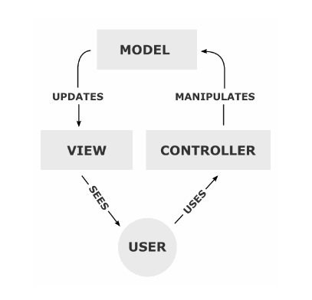

**Figure 4.1:** MVC model

* **Model:** The Model is the name given to the permanent storage of the data used in the overall design. It must allow access for the data to be viewed, or collected and written to, and is the bridge between the View component and the Controller component in the overall pattern.
* **View:** The View is where data, requested from the Model, is viewed and its final output is determined. Traditionally in web apps built using MVC, the View is the part of the system where the HTML is generated and displayed. The View also ignites reactions from the user, who then goes on to interact with the Controller. The basic example of this is a button generated by a View, which a user clicks and triggers an action in the Controller.
* **Controller:** The final component of the triad is the Controller. Its job is to handle data that the user inputs or submits, and update the Model accordingly. The Controller’s life blood is the user; without user interactions, the Controller has no purpose. It is the only part of the pattern the user should be interacting with.

**REFERENCES**