Project Explanation Report with Code – Project 1

Thi Y.N Huynh, Tai Nguyen & Trinh T.T Le
Seneca Polytechnic
BDD200- Structured Database Design
Professor Rani Gnanaolivu
Topic/Store: No Frills
February 6, 2026

Submission Video: https://youtu.be/CYiBc2_mt4w?si=3FzbScVC0fcxXvmD
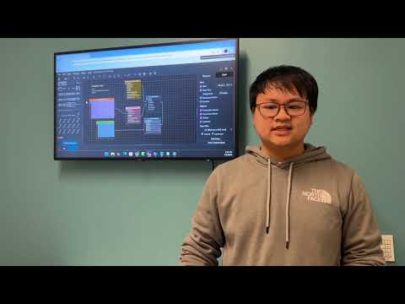

Team Information
Field | Value | Student ID
Group Number | 6
Topic / Store | No Frills
Member 1 | Thi Yen Nhi Huynh | 102549250
Member 2 | Tai Nguyen | 106565252
Member 3 | Trinh Trong Tin Le | 101666253

Responsibility Matrix (Tables Implemented by Each Member)
Table Name | Implemented By | Notes (PK/FK, child/parent)
PROJECT_STORES | Thi Yen Nhi Huynh | Parent table, PK = store_id  Referenced by EMPLOYEES(store_id) and ORDERS(store_id)
PROJECT_CUSTOMERS | Thi Yen Nhi Huynh | Parent table, PK = customer_id; Referenced by ORDERS(customer_id)
PRODUCTS | Tai Nguyen | Parent table. PK = product_id. Referenced by ORDER_ITEMS (product_id) (FK in child table).
EMPLOYEES | Tai Nguyen | Child table. PK = employee_id. FK = store_id →STORES (store_id).
ORDERS | Tin Le | Child table. PK = order_id. FK = customer_id → CUSTOMERS, FK = store_id → STORES. Parent table for ORDER_ITEMS.
ORDER_ITEMS | Tin Le | Child table. PK = order_item_id. FK = order_id → ORDERS, FK = product_id → PRODUCTS.

Part 1 – Entity-Relationship Diagram (ERD)
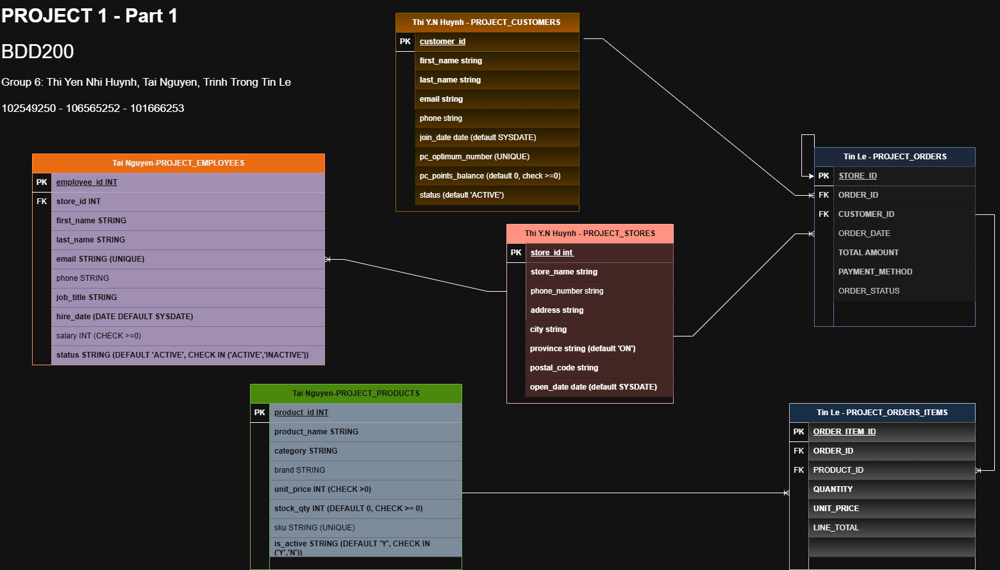

Part 1/2 – Data Dictionary

Data Dictionary – STORES
Created by: Thi Yen Nhi Huynh

Column | Data Type | Constraints | Default | Required? | Description
store_id | NUMBER (5) | PK, NOT NULL |  | YES | Unique identifier for each No Frills location
store_name | VARCHAR2  (60) | NOT NULL |  | YES | Store branch name
phone | VARCHAR2  (20) |  |  | NO | Store contact phone number
address | VARCHAR2  (120) | NOT NULL |  | YES | Street address of the store.
city | VARCHAR2  (40) | NOT NULL | - | YES | City where the store is located
province | CHAR(2) | NOT NULL, check (in list) | ‘ON’ | YES | Province/territory code for the store
postal_code | VARCHAR2  (7) | NOT NULL, check format A1A 1A1) |  | YES | Canadian postal code for the store.
open_date | DATE | NOT NULL | SYSDATE | YES | Date the store opened (or recorded in system)

Data Dictionary – CUSTOMERS
Created by: Thi Yen Nhi Huynh
Column | Data Type | Constraints | Default | Required? | Description
customer_id | NUMBER  (7) | PK,  NOT NULL | - | YES | Unique identifier for each customer.
first_name | VARCHAR2  (40) | NOT NULL | - | YES | Customer first name
last_name | VARCHAR2  (40) | NOT NULL | - | YES | Customer last name
email | VARCHAR2  (80) | NOT NULL,  UNIQUE | - | YES | Customer email address
phone | VARCHAR2  (20) | NULL | - | NO | Customer phone number
join_date | DATE | NOT NULL | SYSDATE | YES | Date the customer record was created / joined.
pc_optimum_number | VARCHAR2  (16) | UNIQUE | - | NO | PC Optimum membership number
pc_points_balance | NUMBER  (9) | NOT NULL, CHECK >= 0 | 0 | YES | Current PC Optimum points balance for the customer.
status | VARCHAR2  (12) | NOT NULL, Check (Active or Inactive) | ‘ACTIVE’ | YES | Customer account status.

Data Dictionary – PRODUCTS
Created by: Tai Nguyen
Column | Data Type | Constraints | Default | Required? | Description
product_id | NUMBER (7) | PK, NOT NULL | - | YES | Unique identifier for each product.
product_name | VARCHAR2 (80) | NOT NULL | - | YES | Product name displayed to customers.
category | VARCHAR2 (40) | NOT NULL | - | YES | Product category (e.g., Dairy, Produce).
brand | VARCHAR2 (40) |  | - | NO | Brand name (e.g., No Name, PC).
unit_price | NUMBER (8,2) | NOT NULL, CHECK (> 0) | - | YES | Unit selling price for the product.
stock_qty | NUMBER (6) | NOT NULL, CHECK (>= 0) | 0 | YES | Quantity in stock (inventory on hand).
sku | VARCHAR2  (20) | UNIQUE | NULL | NO | Stock Keeping Unit code (unique if provided).
is_active | CHAR(1) | NOT NULL, CHECK IN ('Y','N') | ‘Y’ | YES | Active flag: Y = active for sale, N = inactive/discontinued.

Data Dictionary – EMPLOYEES
Created by: Tai Nguyen
Column | Data Type | Constraints | Default | Required? | Description
employee_id | NUMBER (7) | PK, NOT NULL | - | YES | Unique identifier for each employee.
store_id | NUMBER (5) | FK → STORES (store_id), NOT NULL | - | YES | Store where the employee works.
first_name | VARCHAR2  (40) | NOT NULL | - | YES | Employee's first name.
last_name | VARCHAR2  (40) | NOT NULL | - | YES | Employee's last name.
email | VARCHAR2  (80) | NOT NULL, UNIQUE | - | YES | Employee email address (must be unique).
phone | VARCHAR2  (20) | - | - | NO | Employee phone number.
job_title | VARCHAR2  (40) | NOT NULL | - | YES | Employee job title/role.
hire_date | DATE | NOT NULL | SYSDATE | YES | Hire date (defaults to current date).
salary | NUMBER (9,2) | CHECK (>= 0) | NULL | NO | Employee salary amount (non-negative).
status | VARCHAR2  (12) | NOT NULL, CHECK IN ('ACTIVE','INACTIVE') | 'ACTIVE' | YES | Employment status.

Data Dictionary – ORDERS
Created by: Tin Le
Column | Data Type | Constraints | Default | Required? | Description
Order_id | NUMBER(8) | PK,NOT NULL | - | YES | Unique order identifier
Customer_id | NUMBER(7) | FK -> PROJECT_CUSTOMER( customer_id), NOT NULL | - | YSE | Customer who placed order
Store_id | NUMBER(5) | FK -> PROJECT_STORE (store_id), NOT NULL | - | YES | Store where order placed
Order_date | DATE | NOT NULL | SYSDATE | YES | Date order was created
Total_amount | NUMBER(10,2) | CHECK(>=0), NOT NULL | ‘0’ | YES | Total order value
Payment_method | VARCHAR2  (20) | CHECK (Cash, Debit, Credit, Online) | ‘Debit’ | YES | Payment type
Order_status | VARCHAR2  (20) | CHECK (completed, Pending, cancelled) | ‘Completed’ | YES | Order status

Data Dictionary – ORDER_ITEMS
Created by: Tin Le
Column | Data Type | Constraints | Default | Required? | Description
Order_item_id | NUMBER(10) | PK,NOT NULL | - | YES | Unique order item row
Order_id | NUMBER(8) | FK -> PROJECT_CUSTOMER( customer_id), NOT NULL | - | YES | Related order
Product_id | NUMBER(7) | FK -> PROJECT_PRODUCT (project_id), NOT NULL | - | YES | Product purchased
Unit_price | NUMBER(8,2) | CHECK(>=0), NOT NULL | - | YES | Product price at purchase
Line_total | VARCHAR2  (10,2) | CHECK (>=0), NOT NULL | - | YES | Quantity x price
Quality | NUMBER(5) | CHECK (>0), NOT NULL | - | YES | Quantity purchased

Part 2 – Table Creation Scripts (CREATE TABLE)

CREATE TABLE – STORES
Written by: Thi Yen Nhi Huynh
CREATE TABLE code:
CREATE TABLE PROJECT_STORES (
store_id INT PRIMARY KEY,
store_name VARCHAR2(60) NOT NULL,
phone VARCHAR2(20),
address VARCHAR2(120) NOT NULL,
city VARCHAR2(40) NOT NULL,
province CHAR(2) DEFAULT 'ON' NOT NULL,
postal_code VARCHAR2(7) NOT NULL,
open_date DATE DEFAULT SYSDATE NOT NULL,
CHECK (REGEXP_LIKE(postal_code, '^[A-Z][0-9][A-Z][ ][0-9][A-Z][0-9]$')),
CHECK (province IN ('ON','QC','BC','AB','MB','SK','NS','NB','NL','PE','NT','NU','YT'))
);

Screenshots:
- Columns tab:
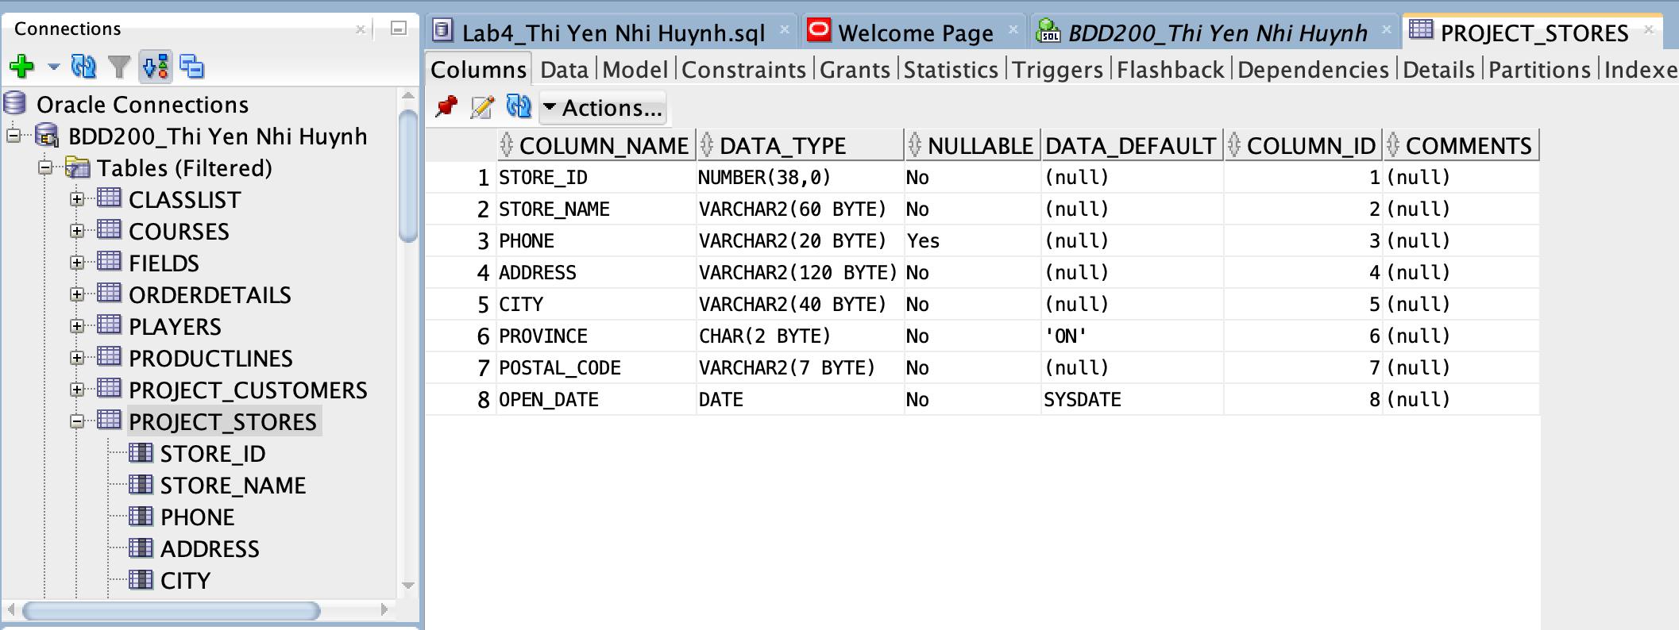
- Constraints tab:
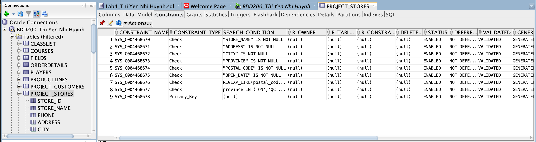

CREATE TABLE – CUSTOMERS
Written by: Thi Yen Nhi Huynh
CREATE TABLE code:
CREATE TABLE PROJECT_CUSTOMERS (
customer_id INT PRIMARY KEY,
first_name VARCHAR2(40) NOT NULL,
last_name VARCHAR2(40) NOT NULL,
email VARCHAR2(80) NOT NULL UNIQUE,
phone VARCHAR2(20),
join_date DATE DEFAULT SYSDATE NOT NULL,
pc_optimum_number VARCHAR2(16) UNIQUE,
pc_points_balance INT DEFAULT 0 NOT NULL,
status VARCHAR2(12) DEFAULT 'ACTIVE' NOT NULL,
CHECK (pc_points_balance >= 0),
CHECK (status IN ('ACTIVE','INACTIVE'))
);

Screenshots:
- Columns tab:
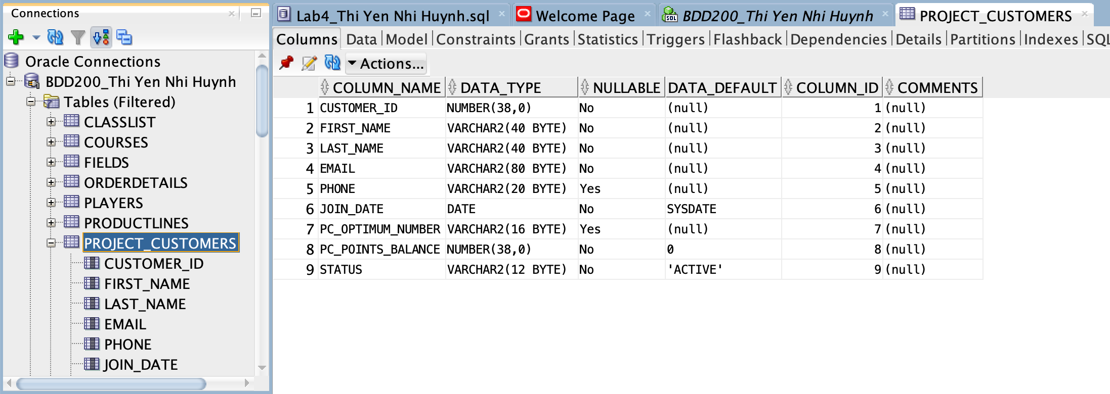
- Constraints tab:
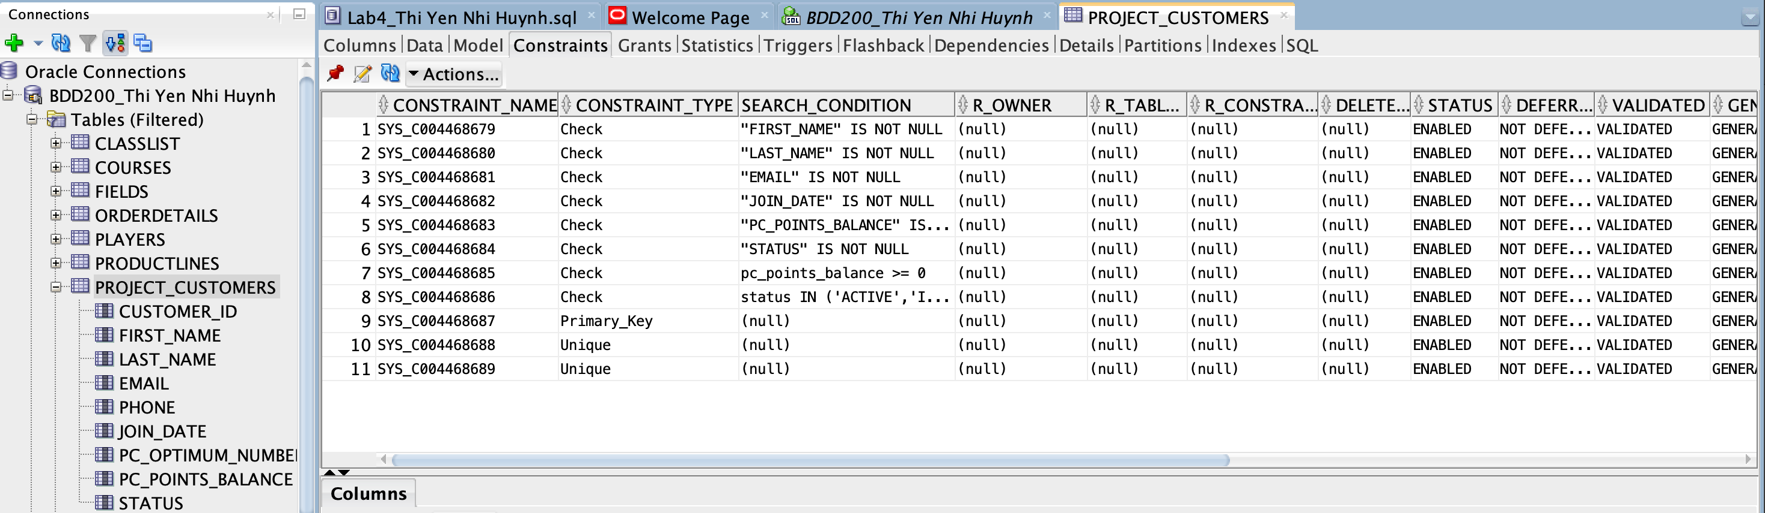

CREATE TABLE – PRODUCTS
Written by: Tai Nguyen
CREATE TABLE code:
CREATE TABLE PROJECT_PRODUCTS (
product_id NUMBER(7) PRIMARY KEY,
product_name VARCHAR2(80) NOT NULL,
category VARCHAR2(40) NOT NULL,
brand VARCHAR2(40),
unit_price NUMBER(8,2) NOT NULL,
stock_qty NUMBER(6) DEFAULT 0 NOT NULL,
sku VARCHAR2(20) UNIQUE,
is_active CHAR(1) DEFAULT 'Y' NOT NULL,
CHECK (unit_price > 0),
CHECK (stock_qty >= 0),
CHECK (is_active IN ('Y','N'))
);

Screenshots:
- Columns tab:
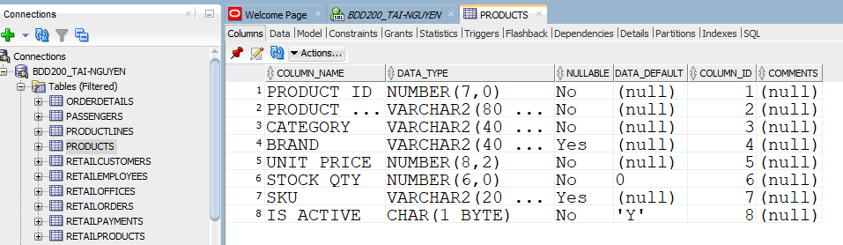
- Constraints tab:
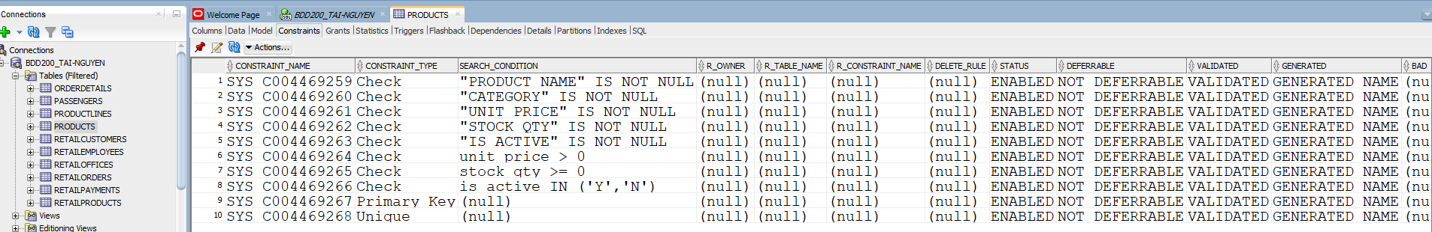

CREATE TABLE – EMPLOYEES
Written by: Tai Nguyen
CREATE TABLE code:
CREATE TABLE PROJECT_EMPLOYEES (
employee_id NUMBER(7) PRIMARY KEY,
store_id NUMBER(5) NOT NULL,
first_name VARCHAR2(40) NOT NULL,
last_name VARCHAR2(40) NOT NULL,
email VARCHAR2(80) NOT NULL UNIQUE,
phone VARCHAR2(20),
job_title VARCHAR2(40) NOT NULL,
hire_date DATE DEFAULT SYSDATE NOT NULL,
salary NUMBER(9,2),
status VARCHAR2(12) DEFAULT 'ACTIVE' NOT NULL,
CHECK (salary IS NULL OR salary >= 0),
CHECK (status IN ('ACTIVE','INACTIVE')),
FOREIGN KEY (store_id) REFERENCES STORES(store_id)
);
- Columns tab:
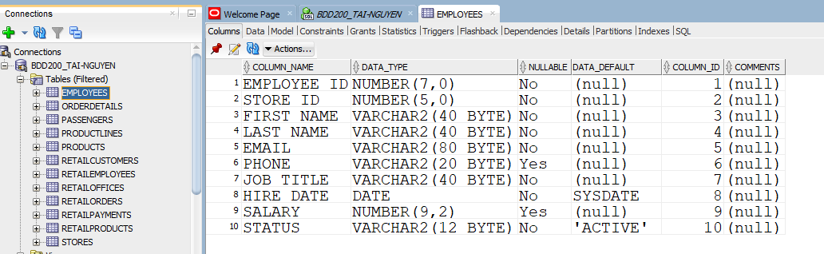
- Constraints tab:
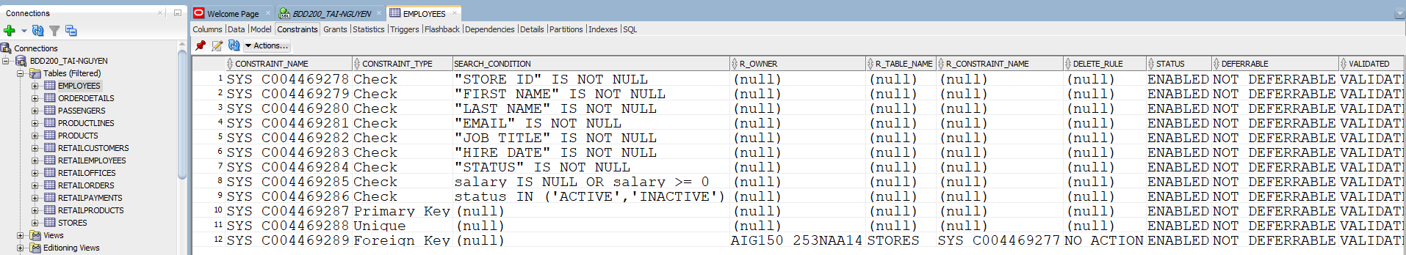

CREATE TABLE – ORDERS
Written by: Trinh Trong Tin Le
CREATE TABLE code:
CREATE TABLE PROJECT_ORDERS (
order_id NUMBER(8) PRIMARY KEY,
customer_id NUMBER(7) NOT NULL,
store_id NUMBER(5) NOT NULL,
order_date DATE DEFAULT SYSDATE NOT NULL,
total_amount NUMBER(10,2) DEFAULT 0 NOT NULL,
payment_method VARCHAR2(20) DEFAULT 'Debit' NOT NULL,
order_status VARCHAR2(20) DEFAULT 'Completed' NOT NULL,

CONSTRAINT chk_orders_total CHECK (total_amount >= 0),
CONSTRAINT chk_orders_payment
CHECK (payment_method IN ('Cash','Debit','Credit','Online')),
CONSTRAINT chk_orders_status
CHECK (order_status IN ('Completed','Pending','Cancelled'))
);
Screenshots:
- Columns tab:
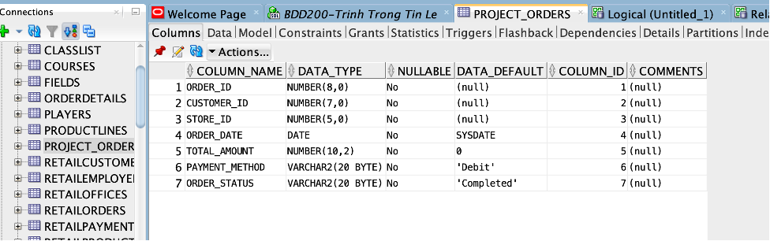
- Constraints tab:
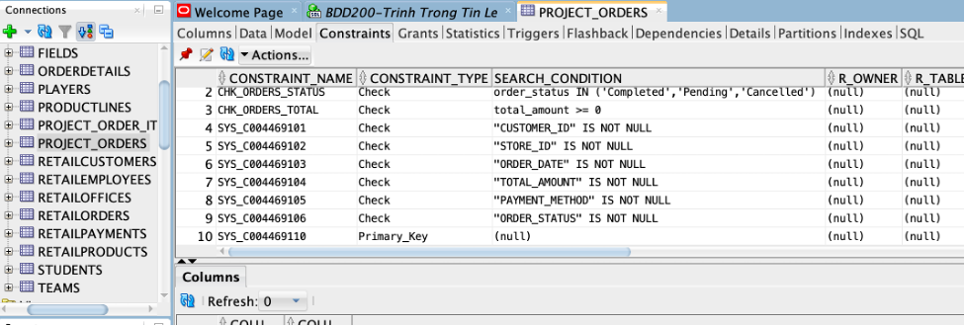

CREATE TABLE – ORDER_ITEMS
Written by: Trinh Trong Tin Le
CREATE TABLE code:
CREATE TABLE PROJECT_ORDER_ITEMS (
order_item_id NUMBER(10) PRIMARY KEY,
order_id NUMBER(8) NOT NULL,
product_id NUMBER(7) NOT NULL,
quantity NUMBER(5) DEFAULT 1 NOT NULL,
unit_price NUMBER(8,2) NOT NULL,
line_total NUMBER(10,2) NOT NULL,

CONSTRAINT chk_orderitems_qty CHECK (quantity > 0),
CONSTRAINT chk_orderitems_price CHECK (unit_price >= 0),
CONSTRAINT chk_orderitems_total CHECK (line_total >= 0)
);
Screenshots:
- Columns tab:
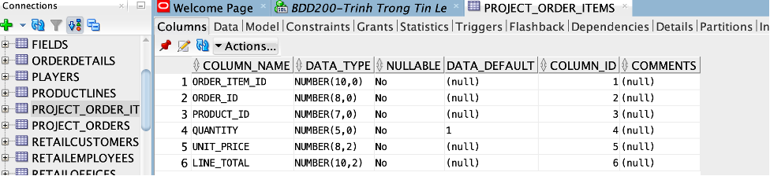
- Constraints tab:
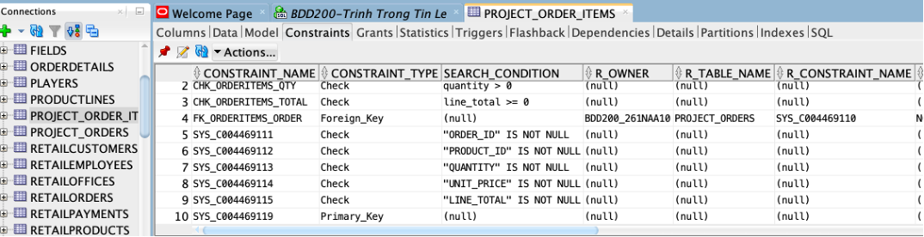

Part 2 – Data Insertion Scripts (INSERT INTO)

INSERT INTO – STORES
Written by: Thi Yen Nhi Huynh
INSERT code:
INSERT ALL
INTO project_stores VALUES (101,'No Frills - Dufferin Mall','416-555-0101','900 Dufferin St','Toronto','ON','M6H 4A9',DATE '2016-05-10')
INTO project_stores VALUES (102,'No Frills - Keele & Wilson','416-555-0102','4000 Keele St','North York','ON','M3J 1N8',DATE '2017-09-20')
INTO project_stores VALUES (103,'No Frills - Scarborough Town','416-555-0103','300 Borough Dr','Scarborough','ON','M1P 4P5',DATE '2018-03-15')
INTO project_stores VALUES (104,'No Frills - Etobicoke South','416-555-0104','250 The Queensway','Etobicoke','ON','M8Y 1J3',DATE '2015-11-01')
INTO project_stores VALUES (105,'No Frills - Mississauga Central','905-555-0105','100 City Centre Dr','Mississauga','ON','L5B 2C9',DATE '2019-07-08')
INTO project_stores VALUES (106,'No Frills - Brampton East','905-555-0106','25 Peel Centre Dr','Brampton','ON','L6T 3R5',DATE '2020-02-18')
INTO project_stores VALUES (107,'No Frills - Markham North','905-555-0107','5000 Hwy 7','Markham','ON','L3R 4M9',DATE '2018-12-05')
INTO project_stores VALUES (108,'No Frills - Richmond Hill','905-555-0108','9350 Yonge St','Richmond Hill','ON','L4C 5G2',DATE '2017-04-22')
INTO project_stores VALUES (109,'No Frills - Vaughan Mills','905-555-0109','1 Bass Pro Mills Dr','Vaughan','ON','L4K 5W4',DATE '2021-06-30')
INTO project_stores VALUES (110,'No Frills - Pickering','905-555-0110','1355 Kingston Rd','Pickering','ON','L1V 1B8',DATE '2016-08-19')
INTO project_stores VALUES (111,'No Frills - Ajax West','905-555-0111','20 Kingston Rd W','Ajax','ON','L1T 4K8',DATE '2019-10-14')
INTO project_stores VALUES (112,'No Frills - Whitby North','905-555-0112','1800 Dundas St E','Whitby','ON','L1N 2K9',DATE '2020-09-09')
INTO project_stores VALUES (113,'No Frills - Oshawa','905-555-0113','2000 Simcoe St N','Oshawa','ON','L1H 7K4',DATE '2015-01-12')
INTO project_stores VALUES (114,'No Frills - Burlington','905-555-0114','777 Guelph Line','Burlington','ON','L7R 3N2',DATE '2018-06-02')
INTO project_stores VALUES (115,'No Frills - Oakville','905-555-0115','2500 Dundas St W','Oakville','ON','L6M 5N4',DATE '2021-01-20')
INTO project_stores VALUES (116,'No Frills - Hamilton East','905-555-0116','75 Centennial Pkwy N','Hamilton','ON','L8E 2P2',DATE '2017-02-11')
INTO project_stores VALUES (117,'No Frills - Waterloo','519-555-0117','200 University Ave W','Waterloo','ON','N2L 3G1',DATE '2019-05-25')
INTO project_stores VALUES (118,'No Frills - Kitchener','519-555-0118','500 Fairway Rd S','Kitchener','ON','N2C 1X3',DATE '2016-03-03')
INTO project_stores VALUES (119,'No Frills - London','519-555-0119','1680 Richmond St','London','ON','N6G 3Y9',DATE '2018-11-18')
INTO project_stores VALUES (120,'No Frills - Ottawa South','613-555-0120','2277 Riverside Dr','Ottawa','ON','K1H 7X6',DATE '2020-12-01')
INTO project_stores VALUES (121,'No Frills - Toronto Midtown','416-555-0121','233 Eglinton Ave W','Toronto','ON','M4R 1A7',DATE '2016-09-13')
INTO project_stores VALUES (122,'No Frills - Toronto East','416-555-0122','1780 Danforth Ave','Toronto','ON','M4C 1J1',DATE '2017-07-06')
INTO project_stores VALUES (123,'No Frills - Toronto West','416-555-0123','1500 Bloor St W','Toronto','ON','M6P 3L2',DATE '2018-10-09')
INTO project_stores VALUES (124,'No Frills - North York Center','416-555-0124','5150 Yonge St','North York','ON','M2N 6L8',DATE '2019-04-17')
INTO project_stores VALUES (125,'No Frills - Don Mills','416-555-0125','890 Don Mills Rd','Toronto','ON','M3C 1W3',DATE '2021-11-05')
SELECT 1 FROM dual;
COMMIT;
Data tab screenshot: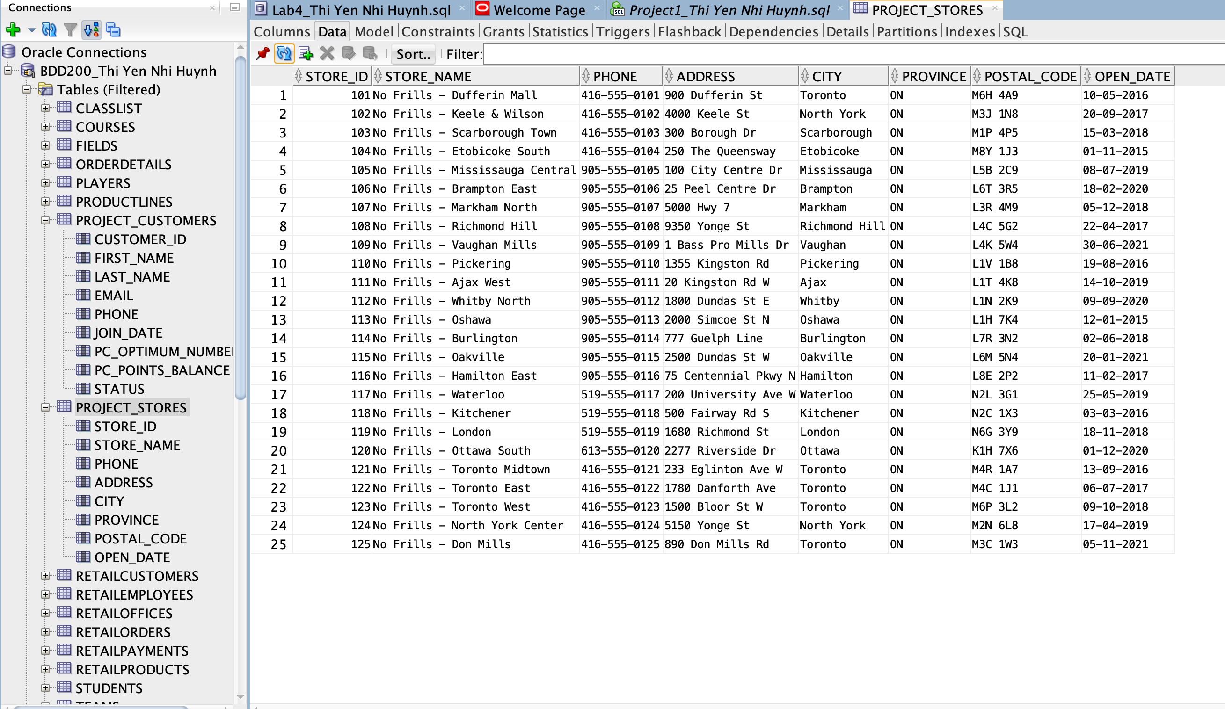

INSERT INTO – CUSTOMERS
Written by: Thi Yen Nhi Huynh
INSERT code:
INSERT ALL
INTO project_customers VALUES (2001001,'Liam','Nguyen','liam.nguyen01@email.com','416-555-2001',DATE '2025-11-10','PC100000000001',1200,'ACTIVE')
INTO project_customers VALUES (2001002,'Emma','Tran','emma.tran02@email.com','416-555-2002',DATE '2025-11-14','PC100000000002',0,'ACTIVE')
INTO project_customers VALUES (2001003,'Noah','Le','noah.le03@email.com','416-555-2003',DATE '2025-11-20',NULL,250,'ACTIVE')
INTO project_customers VALUES (2001004,'Olivia','Pham','olivia.pham04@email.com','416-555-2004',DATE '2025-12-02','PC100000000004',5400,'ACTIVE')
INTO project_customers VALUES (2001005,'Ethan','Vo','ethan.vo05@email.com','416-555-2005',DATE '2025-12-12',NULL,90,'ACTIVE')
INTO project_customers VALUES (2001006,'Ava','Dang','ava.dang06@email.com','416-555-2006',DATE '2025-12-20','PC100000000006',800,'ACTIVE')
INTO project_customers VALUES (2001007,'Mason','Huynh','mason.huynh07@email.com','905-555-2007',DATE '2026-01-05','PC100000000007',15,'ACTIVE')
INTO project_customers VALUES (2001008,'Sophia','Do','sophia.do08@email.com','905-555-2008',DATE '2026-01-08','PC100000000008',2200,'ACTIVE')
INTO project_customers VALUES (2001009,'Lucas','Bui','lucas.bui09@email.com','905-555-2009',DATE '2026-01-10',NULL,0,'ACTIVE')
INTO project_customers VALUES (2001010,'Mia','Ho','mia.ho10@email.com','905-555-2010',DATE '2026-01-12','PC100000000010',3100,'ACTIVE')
INTO project_customers VALUES (2001011,'Henry','Lam','henry.lam11@email.com','905-555-2011',DATE '2026-01-14',NULL,60,'ACTIVE')
INTO project_customers VALUES (2001012,'Isabella','Ly','isabella.ly12@email.com','905-555-2012',DATE '2026-01-16','PC100000000012',9800,'ACTIVE')
INTO project_customers VALUES (2001013,'Jack','Ngo','jack.ngo13@email.com','647-555-2013',DATE '2026-01-18','PC100000000013',400,'ACTIVE')
INTO project_customers VALUES (2001014,'Charlotte','Mai','charlotte.mai14@email.com','647-555-2014',DATE '2026-01-20','PC100000000014',5100,'ACTIVE')
INTO project_customers VALUES (2001015,'James','Khanh','james.khanh15@email.com','647-555-2015',DATE '2026-01-22',NULL,0,'INACTIVE')
INTO project_customers VALUES (2001016,'Amelia','Vu','amelia.vu16@email.com','647-555-2016',DATE '2026-01-24','PC100000000016',120,'ACTIVE')
INTO project_customers VALUES (2001017,'Benjamin','Ngoc','benjamin.ngoc17@email.com','289-555-2017',DATE '2026-01-26','PC100000000017',700,'ACTIVE')
INTO project_customers VALUES (2001018,'Harper','An','harper.an18@email.com','289-555-2018',DATE '2026-01-28',NULL,30,'ACTIVE')
INTO project_customers VALUES (2001019,'William','Minh','william.minh19@email.com','289-555-2019',DATE '2026-01-30','PC100000000019',2600,'ACTIVE')
INTO project_customers VALUES (2001020,'Evelyn','Thao','evelyn.thao20@email.com','289-555-2020',DATE '2026-02-01','PC100000000020',1500,'ACTIVE')
INTO project_customers VALUES (2001021,'Daniel','Ngoc','daniel.ngoc21@email.com','416-555-2021',DATE '2026-02-03',NULL,45,'ACTIVE')
INTO project_customers VALUES (2001022,'Chloe','Phan','chloe.phan22@email.com','416-555-2022',DATE '2026-02-05','PC100000000022',330,'ACTIVE')
INTO project_customers VALUES (2001023,'Michael','Truong','michael.truong23@email.com','905-555-2023',DATE '2026-02-07','PC100000000023',2100,'ACTIVE')
INTO project_customers VALUES (2001024,'Grace','Nguyen','grace.nguyen24@email.com','905-555-2024',DATE '2026-02-10',NULL,0,'ACTIVE')
INTO project_customers VALUES (2001025,'Leo','Tran','leo.tran25@email.com','647-555-2025',DATE '2026-02-12','PC100000000025',600,'ACTIVE')
SELECT 1 FROM dual;
COMMIT;

Data tab screenshot: 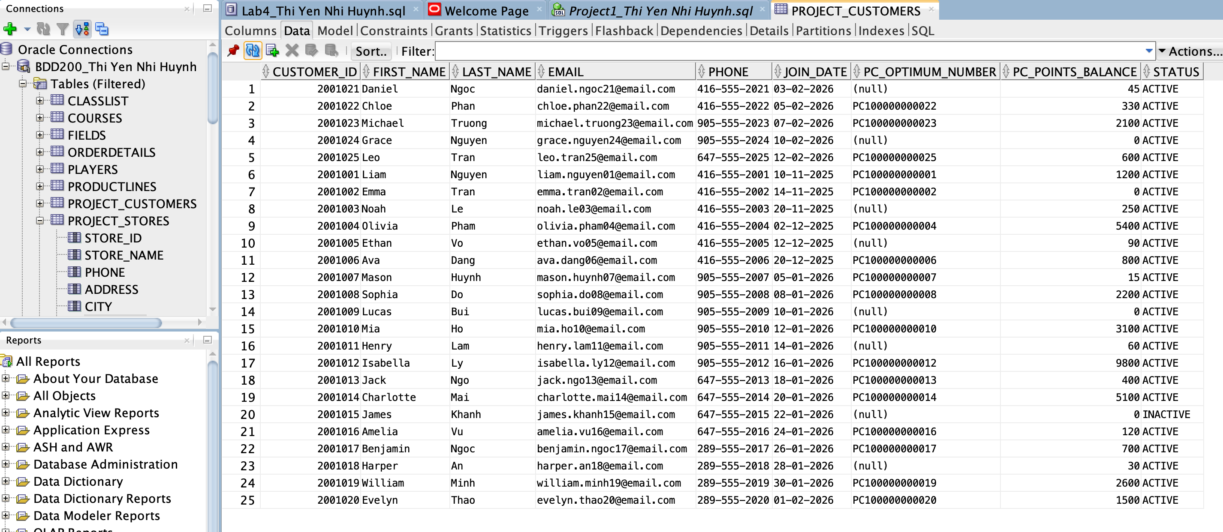

INSERT INTO – PRODUCTS
Written by: Tai Nguyen
INSERT code:
--INSERT INTO –PRODUCTS
SET DEFINE OFF;

INSERT INTO project_products VALUES (3001,'Milk 2L','Dairy','No Name',5.49,120,'SKU3001','Y');
INSERT INTO project_products VALUES (3002,'Eggs Large 12','Dairy','No Name',4.99,90,'SKU3002','Y');
INSERT INTO project_products VALUES (3003,'Butter 454g','Dairy','PC',6.49,60,'SKU3003','Y');
INSERT INTO project_products VALUES (3004,'Greek Yogurt 750g','Dairy','PC',4.79,55,'SKU3004','Y');
INSERT INTO project_products VALUES (3005,'Cheddar Cheese 400g','Dairy','No Name',5.99,40,'SKU3005','Y');

INSERT INTO project_products VALUES (3006,'Bananas 1kg','Produce','No Name',1.99,150,'SKU3006','Y');
INSERT INTO project_products VALUES (3007,'Apples Gala 3lb','Produce','No Name',4.49,70,'SKU3007','Y');
INSERT INTO project_products VALUES (3008,'Tomatoes Roma 1lb','Produce','No Name',2.49,80,'SKU3008','Y');
INSERT INTO project_products VALUES (3009,'Onions Yellow 3lb','Produce','No Name',2.99,65,'SKU3009','Y');
INSERT INTO project_products VALUES (3010,'Potatoes 10lb','Produce','No Name',4.99,50,'SKU3010','Y');

INSERT INTO project_products VALUES (3011,'Chicken Breast 1kg','Meat','No Name',12.99,35,'SKU3011','Y');
INSERT INTO project_products VALUES (3012,'Ground Beef 1lb','Meat','No Name',6.99,45,'SKU3012','Y');
INSERT INTO project_products VALUES (3013,'Salmon Fillet 400g','Meat','PC',10.99,25,'SKU3013','Y');
INSERT INTO project_products VALUES (3014,'Pork Chops 1kg','Meat','No Name',9.99,30,'SKU3014','Y');
INSERT INTO project_products VALUES (3015,'Turkey Slices 175g','Meat','PC',4.99,28,'SKU3015','Y');

INSERT INTO project_products VALUES (3016,'White Bread Loaf','Bakery','No Name',2.49,75,'SKU3016','Y');
INSERT INTO project_products VALUES (3017,'Bagels 6 pack','Bakery','No Name',2.99,60,'SKU3017','Y');
INSERT INTO project_products VALUES (3018,'Croissants 6 pack','Bakery','PC',4.99,35,'SKU3018','Y');
INSERT INTO project_products VALUES (3019,'Muffins 6 pack','Bakery','No Name',3.99,40,'SKU3019','Y');
INSERT INTO project_products VALUES (3020,'Tortillas 10 pack','Bakery','No Name',2.79,50,'SKU3020','Y');

INSERT INTO project_products VALUES (3021,'Rice Jasmine 8kg','Pantry','No Name',14.99,22,'SKU3021','Y');
INSERT INTO project_products VALUES (3022,'Pasta Spaghetti 900g','Pantry','No Name',2.29,85,'SKU3022','Y');
INSERT INTO project_products VALUES (3023,'Canned Tuna 170g','Pantry','No Name',1.49,110,'SKU3023','Y');
INSERT INTO project_products VALUES (3024,'Olive Oil 1L','Pantry','PC',11.99,18,'SKU3024','Y');
INSERT INTO project_products VALUES (3025,'Sugar 2kg','Pantry','No Name',3.29,55,'SKU3025','Y');

COMMIT;

Data tab screenshot:
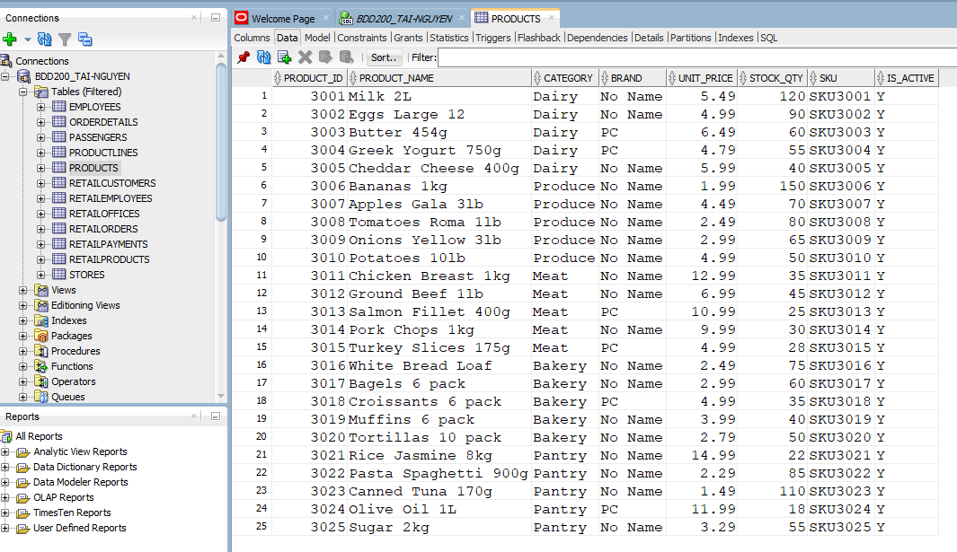

INSERT INTO – EMPLOYEES
Written by: Tai Nguyen
INSERT code:
--INSERT INTO –EMPLOYEES

SET DEFINE OFF;

INSERT INTO project_employees VALUES (4001,101,'Aiden','Nguyen','aiden.nguyen01@nofrills.ca','416-555-4001','Store Manager',DATE '2022-05-10',62000,'ACTIVE');
INSERT INTO project_employees VALUES (4002,101,'Mia','Tran','mia.tran02@nofrills.ca','416-555-4002','Cashier',DATE '2023-02-14',36000,'ACTIVE');
INSERT INTO project_employees VALUES (4003,101,'Leo','Le','leo.le03@nofrills.ca','416-555-4003','Stock Clerk',DATE '2023-06-01',34000,'ACTIVE');
INSERT INTO project_employees VALUES (4004,102,'Sophie','Pham','sophie.pham04@nofrills.ca','416-555-4004','Assistant Manager',DATE '2021-09-20',52000,'ACTIVE');
INSERT INTO project_employees VALUES (4005,102,'Ethan','Vo','ethan.vo05@nofrills.ca','416-555-4005','Cashier',DATE '2023-01-08',35500,'ACTIVE');
INSERT INTO project_employees VALUES (4006,103,'Olivia','Dang','olivia.dang06@nofrills.ca','416-555-4006','Deli Clerk',DATE '2022-11-11',38000,'ACTIVE');
INSERT INTO project_employees VALUES (4007,103,'Noah','Bui','noah.bui07@nofrills.ca','416-555-4007','Stock Clerk',DATE '2023-03-19',33500,'ACTIVE');
INSERT INTO project_employees VALUES (4008,104,'Lucas','Huynh','lucas.huynh08@nofrills.ca','416-555-4008','Cashier',DATE '2024-01-03',35000,'ACTIVE');
INSERT INTO project_employees VALUES (4009,104,'Emma','Do','emma.do09@nofrills.ca','416-555-4009','Customer Service',DATE '2022-07-22',39000,'ACTIVE');
INSERT INTO project_employees VALUES (4010,105,'Henry','Lam','henry.lam10@nofrills.ca','905-555-4010','Store Manager',DATE '2020-04-17',64000,'ACTIVE');
INSERT INTO project_employees VALUES (4011,105,'Ava','Ly','ava.ly11@nofrills.ca','905-555-4011','Cashier',DATE '2023-09-05',35200,'ACTIVE');
INSERT INTO project_employees VALUES (4012,106,'James','Ngo','james.ngo12@nofrills.ca','905-555-4012','Stock Clerk',DATE '2022-12-12',34500,'ACTIVE');
INSERT INTO project_employees VALUES (4013,106,'Isabella','Mai','isabella.mai13@nofrills.ca','905-555-4013','Bakery Clerk',DATE '2023-04-25',37000,'ACTIVE');
INSERT INTO project_employees VALUES (4014,107,'Benjamin','An','benjamin.an14@nofrills.ca','905-555-4014','Assistant Manager',DATE '2021-06-30',51500,'ACTIVE');
INSERT INTO project_employees VALUES (4015,107,'Charlotte','Minh','charlotte.minh15@nofrills.ca','905-555-4015','Cashier',DATE '2024-02-10',34800,'ACTIVE');
INSERT INTO project_employees VALUES (4016,108,'William','Thao','william.thao16@nofrills.ca','905-555-4016','Produce Clerk',DATE '2022-08-08',37200,'ACTIVE');
INSERT INTO project_employees VALUES (4017,108,'Harper','Khanh','harper.khanh17@nofrills.ca','905-555-4017','Cashier',DATE '2023-10-21',35100,'ACTIVE');
INSERT INTO project_employees VALUES (4018,109,'Michael','Truong','michael.truong18@nofrills.ca','905-555-4018','Stock Clerk',DATE '2021-12-01',35000,'ACTIVE');
INSERT INTO project_employees VALUES (4019,109,'Evelyn','Ngoc','evelyn.ngoc19@nofrills.ca','905-555-4019','Customer Service',DATE '2022-03-15',39500,'ACTIVE');
INSERT INTO project_employees VALUES (4020,110,'Daniel','Phan','daniel.phan20@nofrills.ca','905-555-4020','Deli Clerk',DATE '2023-05-09',38200,'ACTIVE');
INSERT INTO project_employees VALUES (4021,110,'Grace','Vu','grace.vu21@nofrills.ca','905-555-4021','Cashier',DATE '2024-04-02',34600,'ACTIVE');
INSERT INTO project_employees VALUES (4022,111,'Chloe','Nguyen','chloe.nguyen22@nofrills.ca','905-555-4022','Bakery Clerk',DATE '2022-02-18',36800,'ACTIVE');
INSERT INTO project_employees VALUES (4023,112,'Logan','Tran','logan.tran23@nofrills.ca','905-555-4023','Stock Clerk',DATE '2021-10-10',35000,'ACTIVE');
INSERT INTO project_employees VALUES (4024,113,'Ella','Le','ella.le24@nofrills.ca','905-555-4024','Cashier',DATE '2023-07-07',34750,'ACTIVE');
INSERT INTO project_employees VALUES (4025,114,'Jack','Pham','jack.pham25@nofrills.ca','905-555-4025','Assistant Manager',DATE '2020-09-09',53000,'ACTIVE');

COMMIT;
Data tab screenshot:
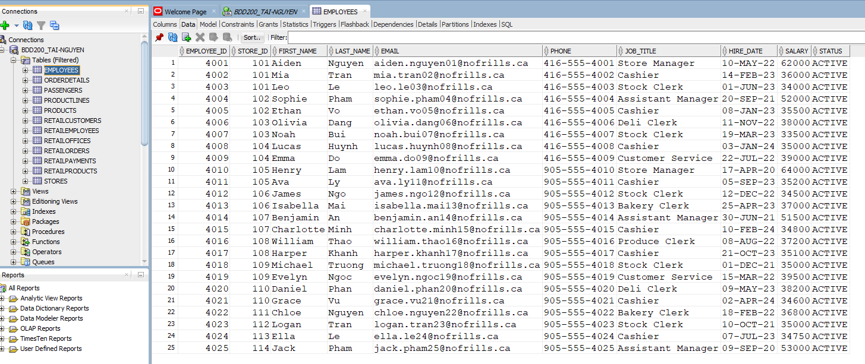

INSERT INTO – ORDERS
Written by: Trinh Trong Tin Le
INSERT code:
INSERT ALL
INTO PROJECT_ORDERS VALUES (300001,2001001,101,DATE '2026-01-05',45.50,'Debit','Completed')
INTO PROJECT_ORDERS VALUES (300002,2001002,102,DATE '2026-01-06',120.25,'Credit','Completed')
INTO PROJECT_ORDERS VALUES (300003,2001003,103,DATE '2026-01-07',15.99,'Cash','Completed')
INTO PROJECT_ORDERS VALUES (300004,2001004,104,DATE '2026-01-08',210.10,'Debit','Completed')
INTO PROJECT_ORDERS VALUES (300005,2001005,105,DATE '2026-01-09',75.00,'Online','Completed')
INTO PROJECT_ORDERS VALUES (300006,2001006,106,DATE '2026-01-10',33.45,'Debit','Completed')
INTO PROJECT_ORDERS VALUES (300007,2001007,107,DATE '2026-01-11',18.70,'Cash','Completed')
INTO PROJECT_ORDERS VALUES (300008,2001008,108,DATE '2026-01-12',95.80,'Credit','Completed')
INTO PROJECT_ORDERS VALUES (300009,2001009,109,DATE '2026-01-13',60.40,'Debit','Completed')
INTO PROJECT_ORDERS VALUES (300010,2001010,110,DATE '2026-01-14',125.30,'Online','Completed')
INTO PROJECT_ORDERS VALUES (300011,2001011,111,DATE '2026-01-15',14.20,'Cash','Completed')
INTO PROJECT_ORDERS VALUES (300012,2001012,112,DATE '2026-01-16',240.00,'Credit','Completed')
INTO PROJECT_ORDERS VALUES (300013,2001013,113,DATE '2026-01-17',88.60,'Debit','Completed')
INTO PROJECT_ORDERS VALUES (300014,2001014,114,DATE '2026-01-18',42.15,'Online','Completed')
INTO PROJECT_ORDERS VALUES (300015,2001015,115,DATE '2026-01-19',67.90,'Debit','Completed')
INTO PROJECT_ORDERS VALUES (300016,2001016,116,DATE '2026-01-20',31.25,'Cash','Completed')
INTO PROJECT_ORDERS VALUES (300017,2001017,117,DATE '2026-01-21',155.60,'Credit','Completed')
INTO PROJECT_ORDERS VALUES (300018,2001018,118,DATE '2026-01-22',22.80,'Debit','Completed')
INTO PROJECT_ORDERS VALUES (300019,2001019,119,DATE '2026-01-23',300.45,'Online','Completed')
INTO PROJECT_ORDERS VALUES (300020,2001020,120,DATE '2026-01-24',59.99,'Debit','Completed')
SELECT 1 FROM dual;

COMMIT;

Data tab screenshot:
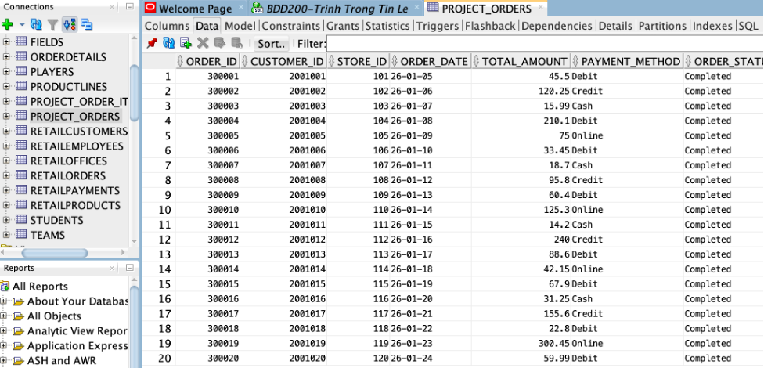

INSERT INTO – ORDER_ITEMS
Written by: Trinh Trong Tin Le
INSERT code:
INSERT ALL
INTO PROJECT_ORDER_ITEMS VALUES (400001,300001,5001,2,5.99,11.98)
INTO PROJECT_ORDER_ITEMS VALUES (400002,300002,5002,1,12.50,12.50)
INTO PROJECT_ORDER_ITEMS VALUES (400003,300003,5003,3,2.99,8.97)
INTO PROJECT_ORDER_ITEMS VALUES (400004,300004,5004,2,10.00,20.00)
INTO PROJECT_ORDER_ITEMS VALUES (400005,300005,5005,1,7.99,7.99)
INTO PROJECT_ORDER_ITEMS VALUES (400006,300006,5006,5,1.50,7.50)
INTO PROJECT_ORDER_ITEMS VALUES (400007,300007,5007,2,4.25,8.50)
INTO PROJECT_ORDER_ITEMS VALUES (400008,300008,5008,4,3.00,12.00)
INTO PROJECT_ORDER_ITEMS VALUES (400009,300009,5009,1,15.00,15.00)
INTO PROJECT_ORDER_ITEMS VALUES (400010,300010,5010,2,9.99,19.98)
INTO PROJECT_ORDER_ITEMS VALUES (400011,300011,5011,3,2.49,7.47)
INTO PROJECT_ORDER_ITEMS VALUES (400012,300012,5012,1,20.00,20.00)
INTO PROJECT_ORDER_ITEMS VALUES (400013,300013,5013,2,6.99,13.98)
INTO PROJECT_ORDER_ITEMS VALUES (400014,300014,5014,3,3.99,11.97)
INTO PROJECT_ORDER_ITEMS VALUES (400015,300015,5015,1,8.75,8.75)
INTO PROJECT_ORDER_ITEMS VALUES (400016,300016,5016,2,4.50,9.00)
INTO PROJECT_ORDER_ITEMS VALUES (400017,300017,5017,5,2.00,10.00)
INTO PROJECT_ORDER_ITEMS VALUES (400018,300018,5018,1,13.99,13.99)
INTO PROJECT_ORDER_ITEMS VALUES (400019,300019,5019,2,18.00,36.00)
INTO PROJECT_ORDER_ITEMS VALUES (400020,300020,5020,3,5.50,16.50)
SELECT 1 FROM dual;
COMMIT;

Data tab screenshot:
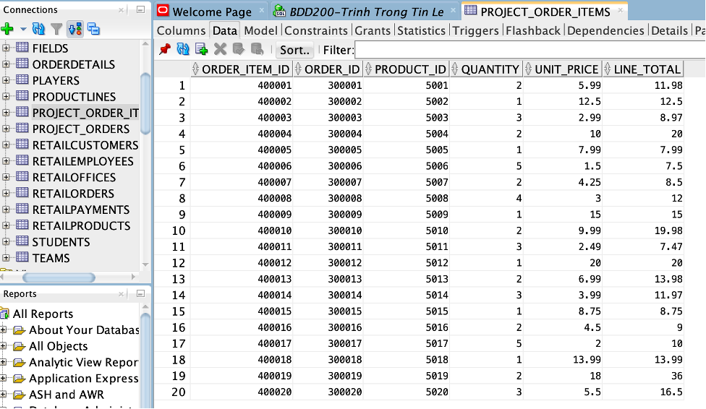

Part 3 – SQL Report (SELECT / JOIN / VIEW)

Member A – Queries
Name: Thi Yen Nhi Huynh

A) SELECT Queries (4 total)

SELECT Query 1: Customers with pc points balance >= 1000 – Done by Thi Yen Nhi Huynh
Query Description: Displaying customers who have a PC Optimum points balance of 1000 or more, showing their customer_id, first_name, last_name, and pc_points_balance, then sorting the results by pc_points_balance in descending order
SQL:
SELECT customer_id, first_name, last_name, pc_points_balance
FROM project_customers
WHERE pc_points_balance >= 1000
ORDER BY pc_points_balance DESC;

Output screenshot:

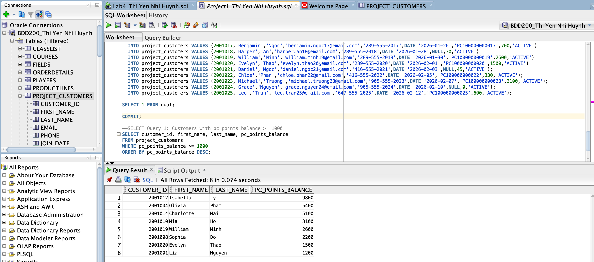

SELECT Query 2: Customers who have PC Optimum membership – Done by Thi Yen Nhi Huynh
Query discreiption: Displays customers who have a PC Optimum membership number by filtering records where pc_optimum_number IS NOT NULL, and sorts the results by customer_id.
SQL:
SELECT customer_id, first_name, last_name, pc_optimum_number
FROM project_customers
WHERE pc_optimum_number IS NOT NULL
ORDER BY customer_id;

Output screenshot:

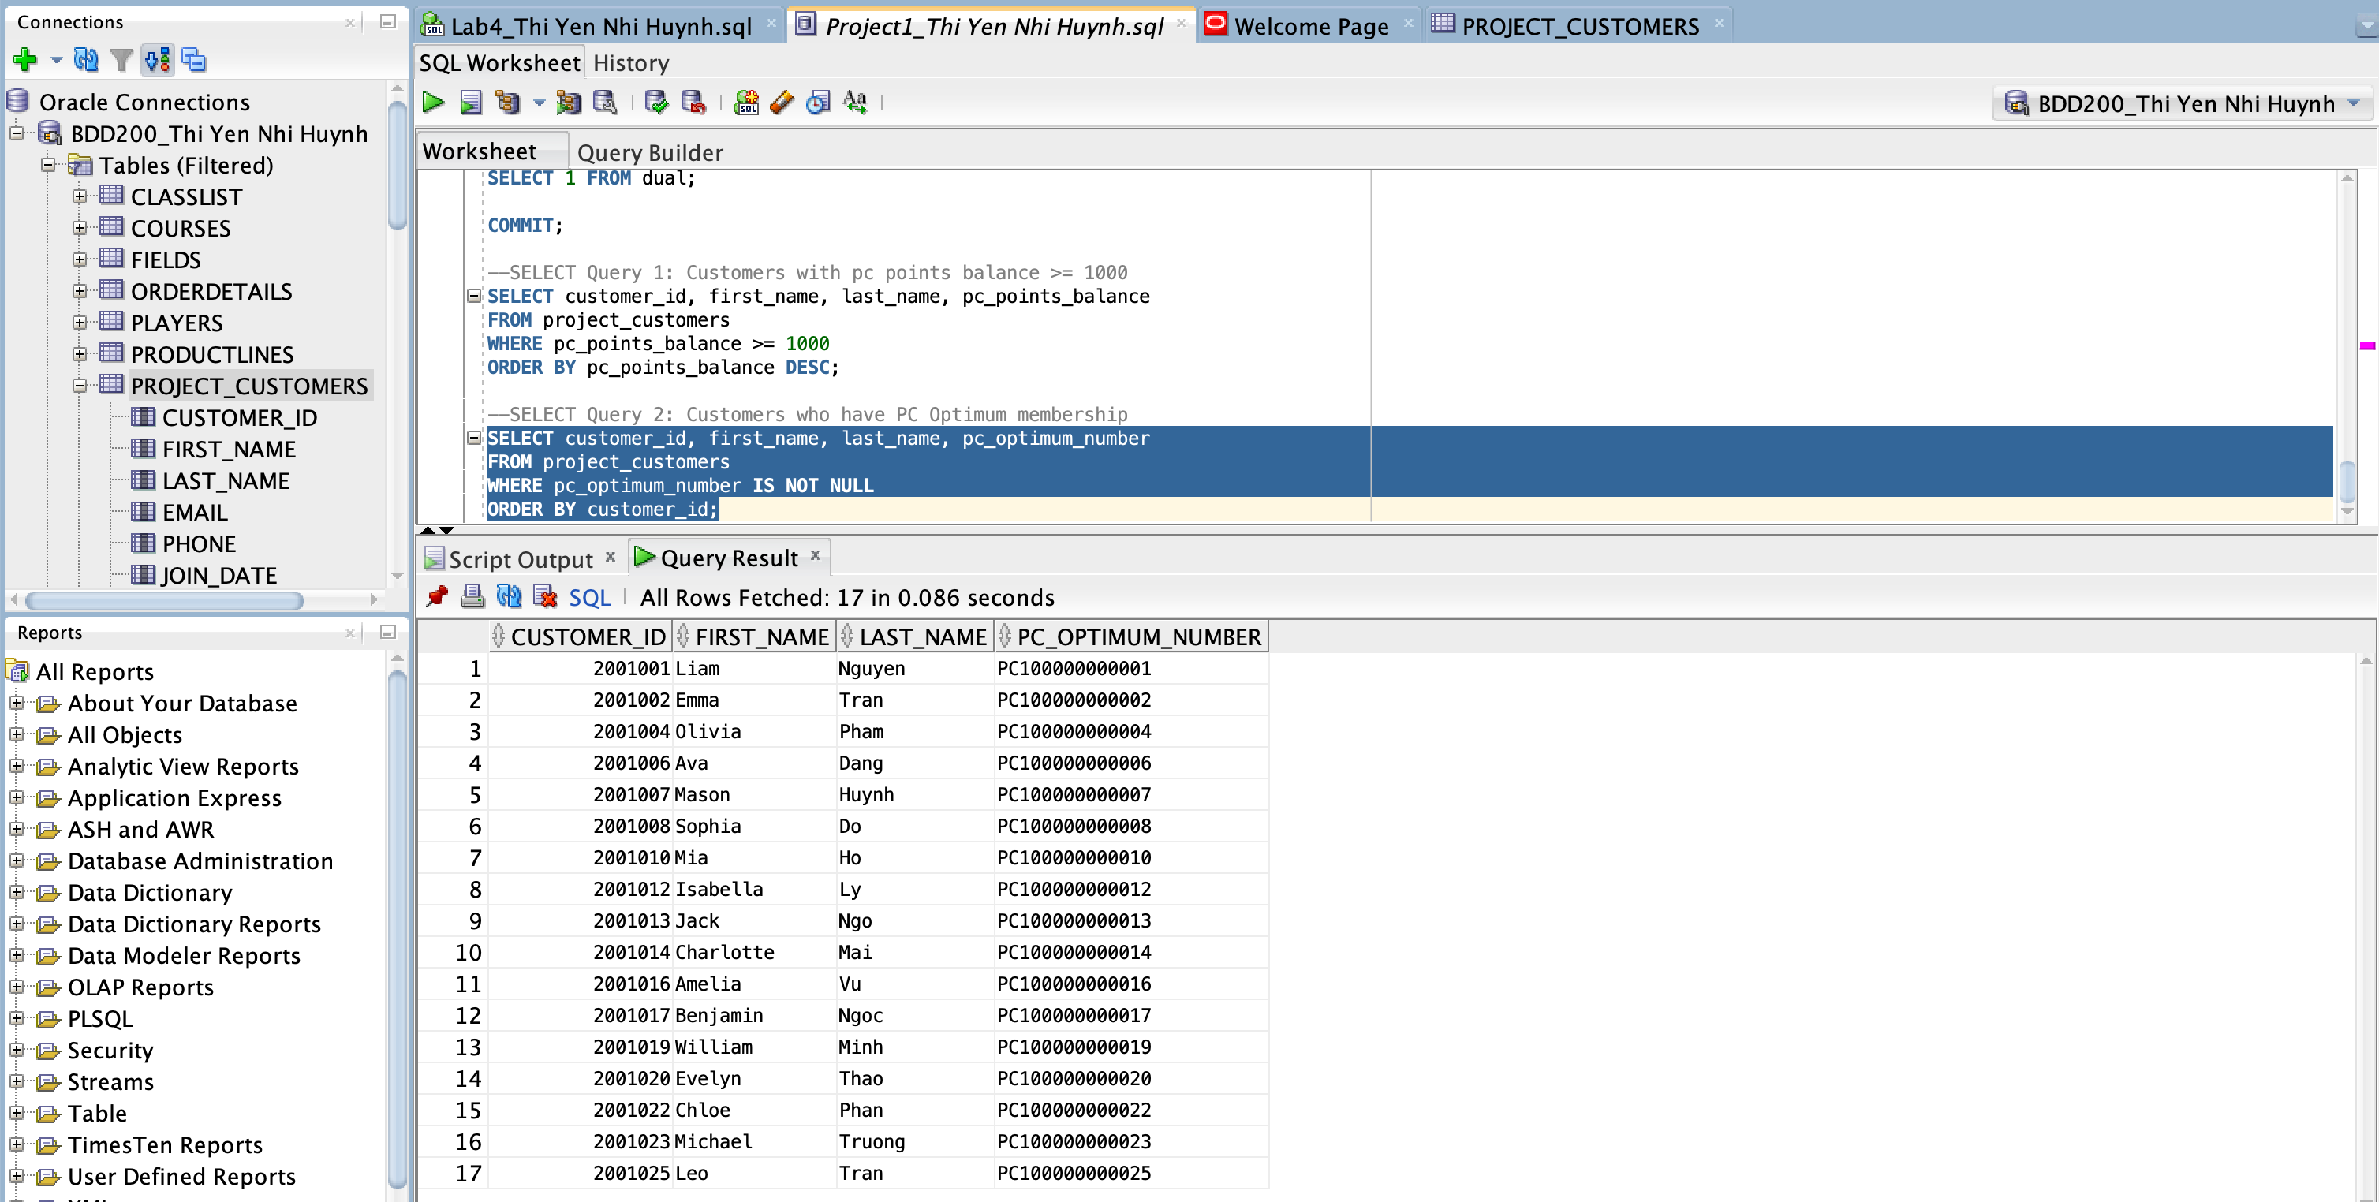

SELECT Query 3: Customers who joined in January 2026 – Done by Thi Yen Nhi Huynh
Query Description: Lists customers whose join_date falls within January 2026 (from 2026-01-01 to 2026-01-31) to identify customers who joined during that month. SQL:
SELECT customer_id, first_name, last_name, join_date
FROM project_customers
WHERE join_date BETWEEN DATE '2026-01-01' AND DATE '2026-01-31'
ORDER BY join_date;

Output screenshot:

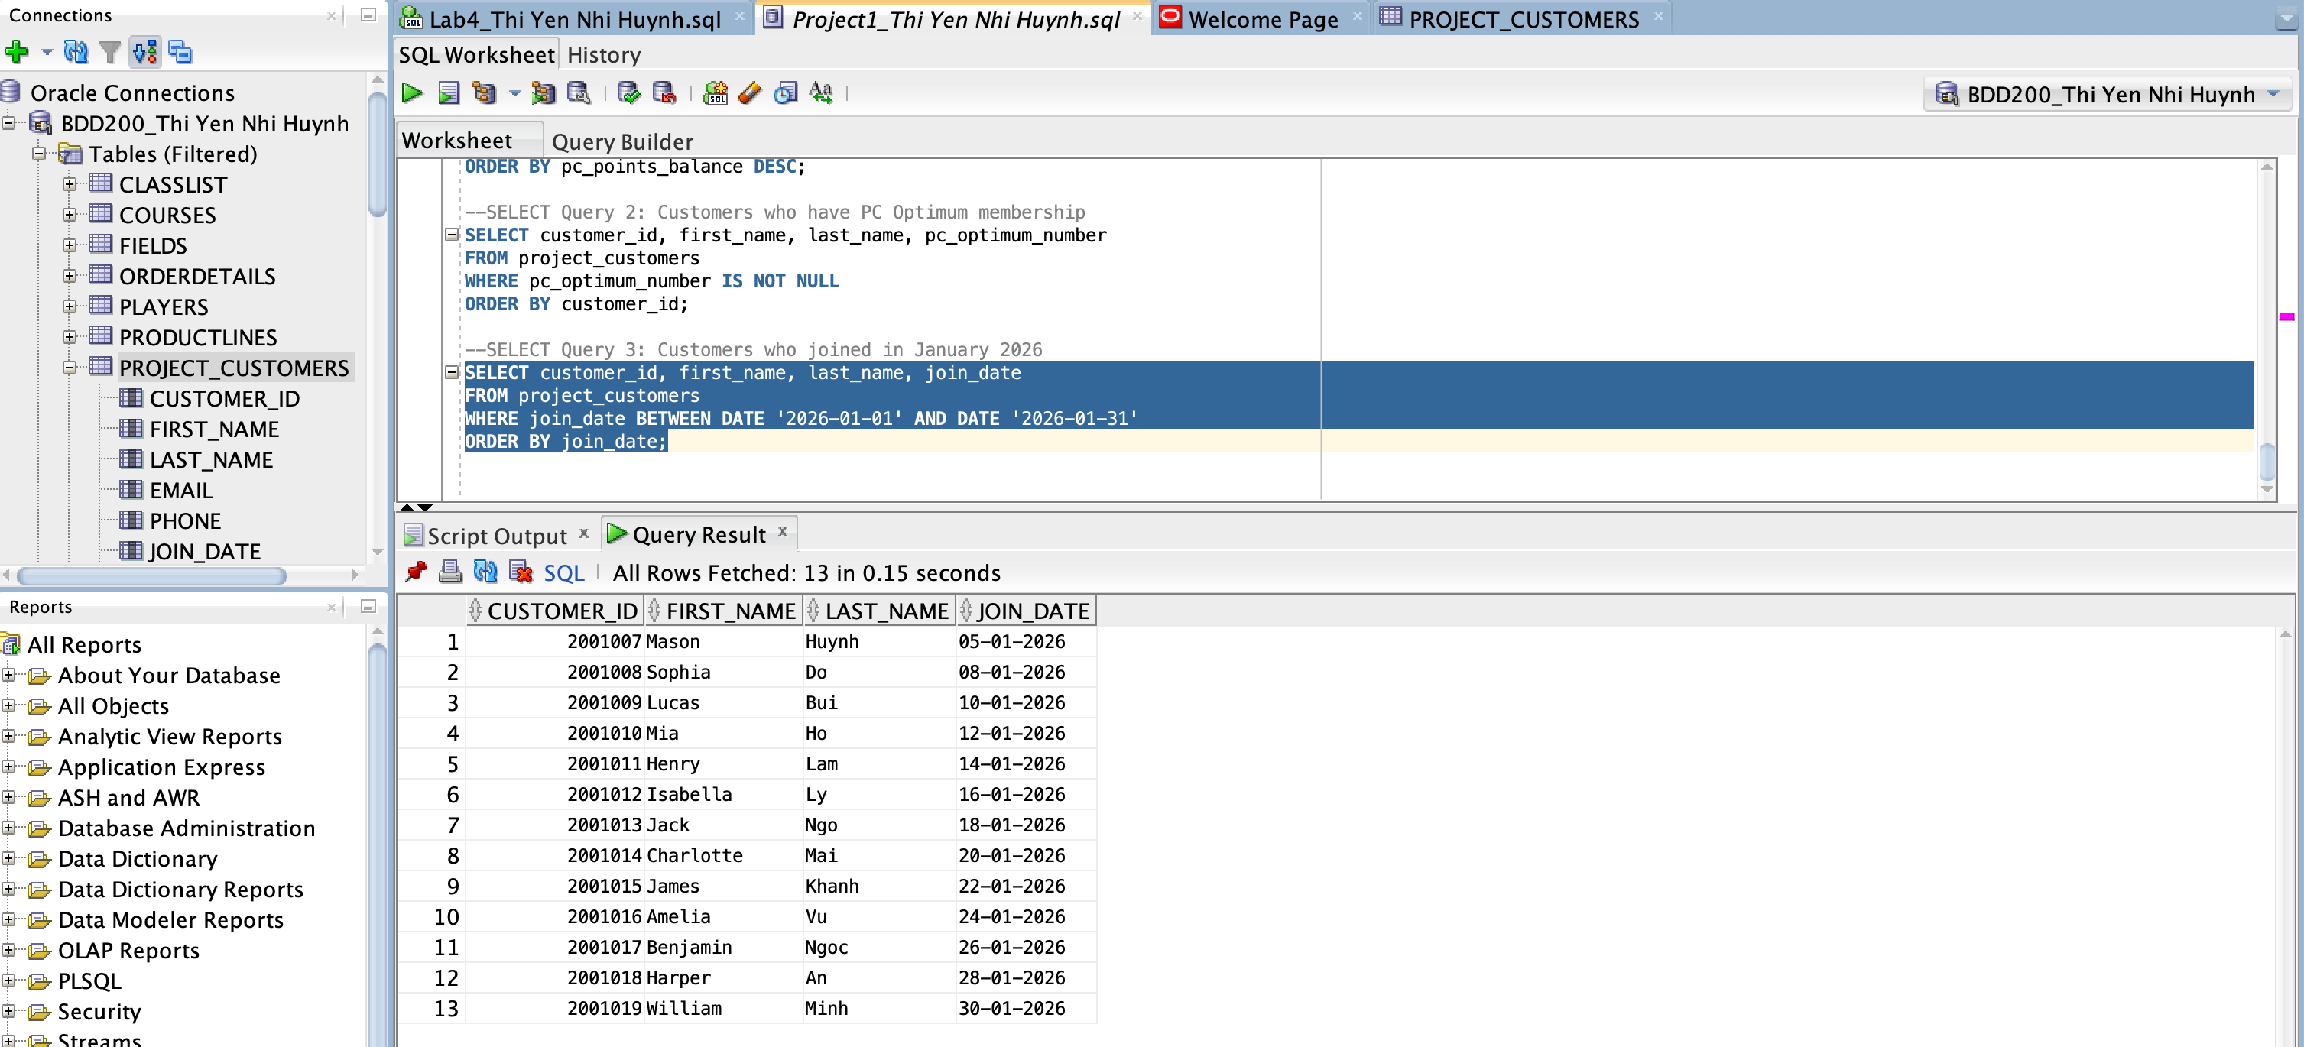

SELECT Query 4: Active customers with low points (<= 100) – Done by Thi Yen Nhi Huynh
Query Description: Shows customers with status = 'ACTIVE' and pc_points_balance <= 100 to identify active customers with low pc points.
SQL:
SELECT customer_id, first_name, last_name, status, pc_points_balance
FROM project_customers
WHERE status = 'ACTIVE'
AND pc_points_balance <= 100
ORDER BY pc_points_balance, customer_id;

Output screenshot: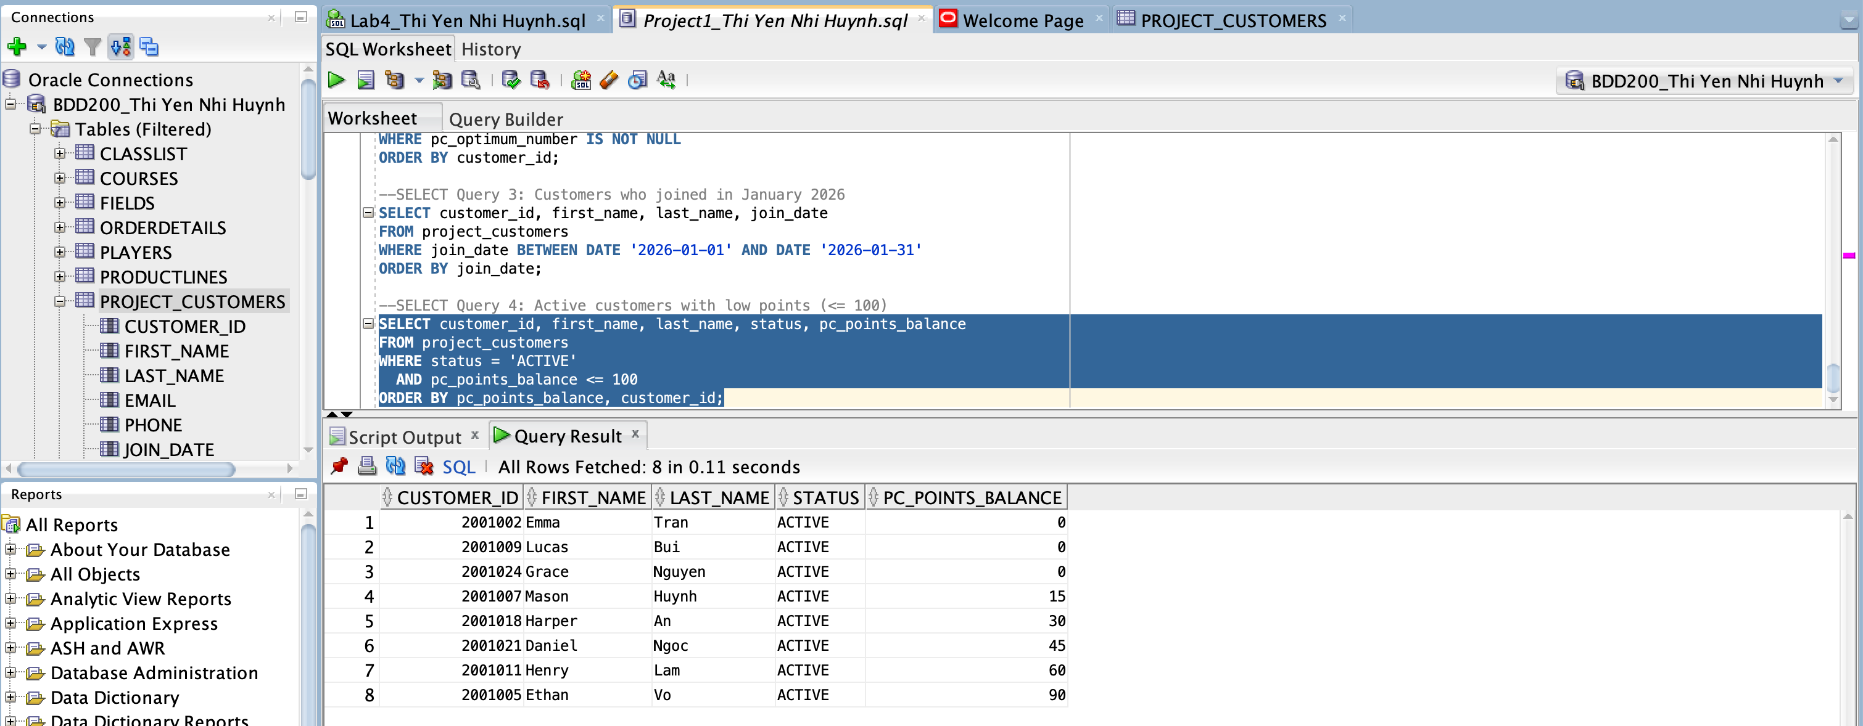

B) JOIN Queries (2 total)

JOIN Query 1: Orders with customer names – Done by Thi Yen Nhi Huynh
Join type: INNER JOIN
Query Description: Uses an INNER JOIN between project_orders and project_customers on customer_id to display orders along with the customer’s full name, then orders the output by order_date.
SQL:
SELECT
o.order_id,
o.order_date,
o.order_status,
c.customer_id,
c.first_name || ' ' || c.last_name AS customer_name
FROM project_orders o
INNER JOIN project_customers c
ON o.customer_id = c.customer_id
ORDER BY o.order_date;

Output screenshot:

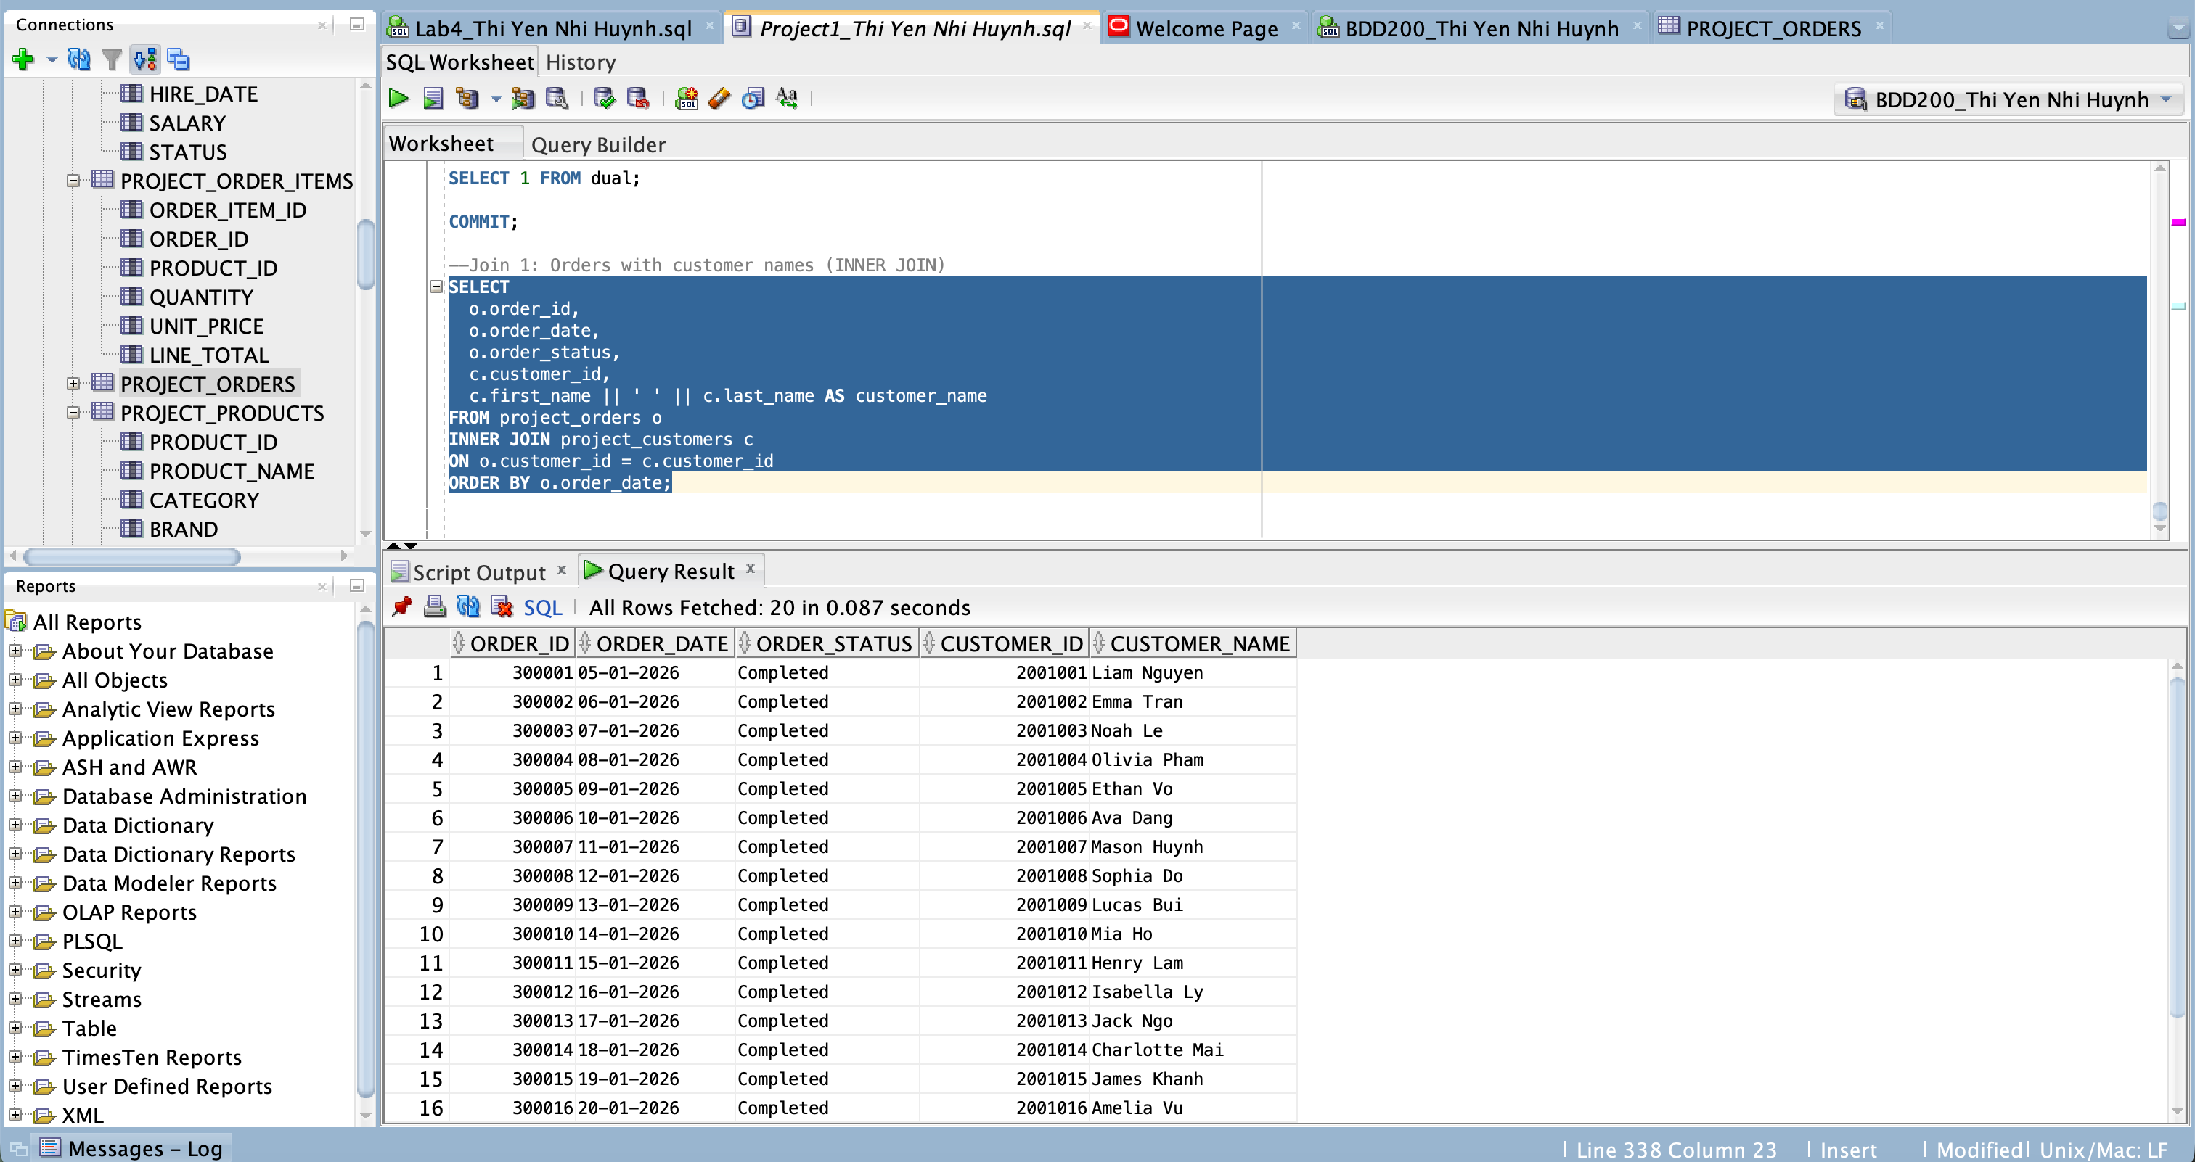

JOIN Query 2: Customers who have never placed an order – Done by Thi Yen Nhi Huynh
Join type: LEFT JOIN
Query Description: Uses a LEFT JOIN to return all customers and match any related orders; then filters WHERE o.order_id IS NULL to find customers who have never placed an order.
SQL:
SELECT
c.customer_id,
c.first_name,
c.last_name,
o.order_id
FROM project_customers c
LEFT JOIN project_orders o
ON o.customer_id = c.customer_id
WHERE o.order_id IS NULL
ORDER BY c.customer_id;

Output screenshot: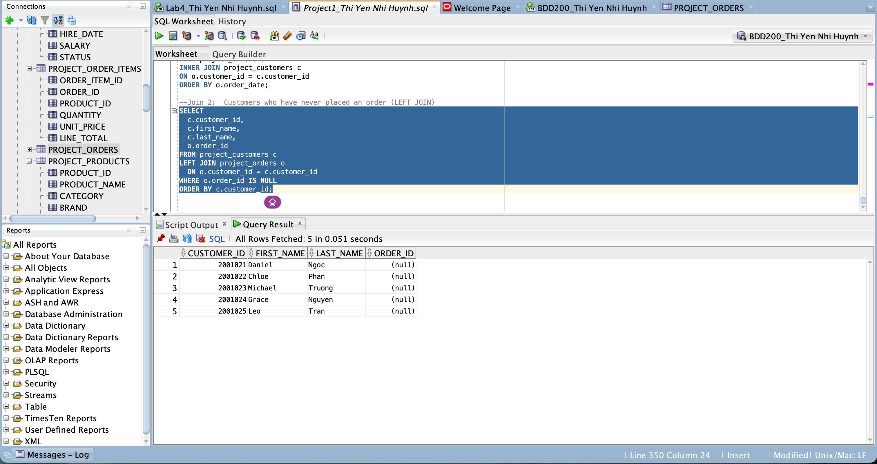

C) VIEW Queries (2 total)

VIEW 1: view_project_pc_members– Done by Thi Yen Nhi Huynh
Query Description: Creates a view that stores customers who have a PC Optimum membership (non-null pc_optimum_number), including customer ID, name, membership number, and points balance for faster reuse in queries.
CREATE OR REPLACE VIEW SQL:
CREATE OR REPLACE VIEW view_project_pc_members AS
SELECT customer_id, first_name, last_name, pc_optimum_number, pc_points_balance
FROM project_customers
WHERE pc_optimum_number IS NOT NULL;

SELECT *
FROM view_project_pc_members
ORDER BY pc_points_balance DESC;

Output screenshot:

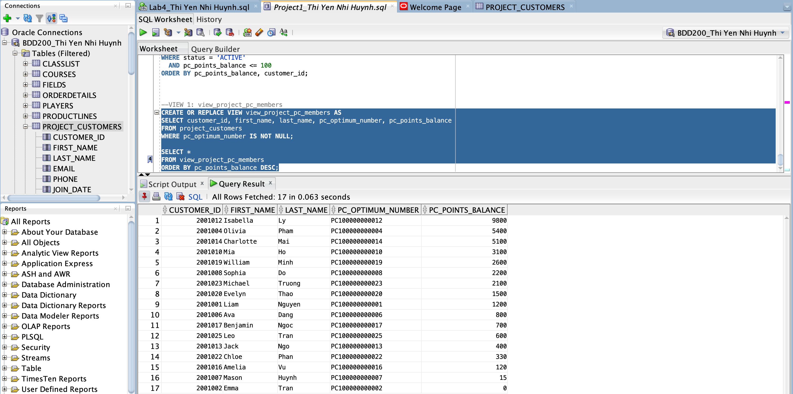

VIEW 2: vw_project_store_locations – Done by Thi Yen Nhi Huynh
Query Description: Creates a view that lists store location details for stores in Ontario (province = 'ON'), including store ID, store name, address, city, province, and postal code.
CREATE OR REPLACE VIEW SQL:
CREATE OR REPLACE VIEW vw_project_on_store_locations AS
SELECT store_id, store_name, address, city, province, postal_code
FROM project_stores
WHERE province = 'ON';

SELECT *
FROM vw_project_on_store_locations
ORDER BY city, store_id;

Output screenshot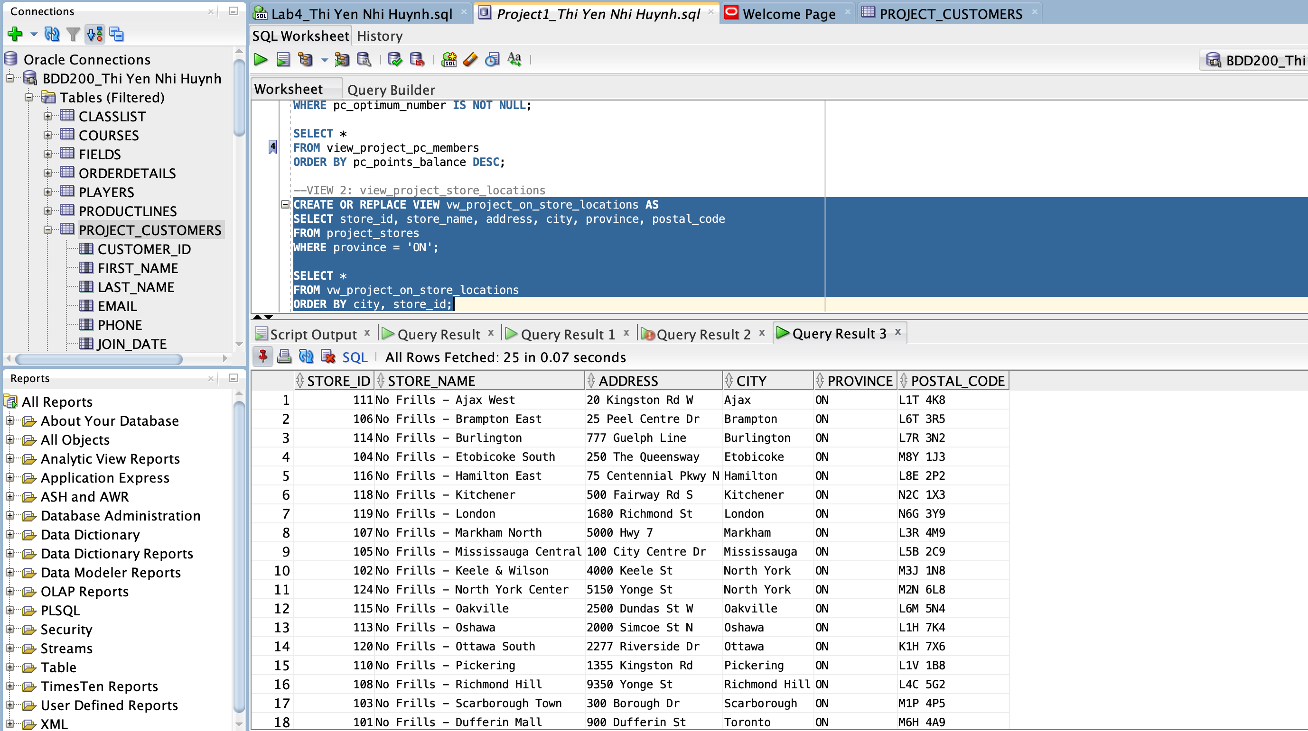

Member B – Queries

Name: Tai Nguyen

A) SELECT Queries (4 total)

SELECT Query 1: Products with unit_price > 10 – Done by Tai Nguyen
SQL:
SELECT product_id, product_name, category, unit_price, stock_qty
FROM products
WHERE unit_price > 10
ORDER BY unit_price DESC;

Output screenshot:
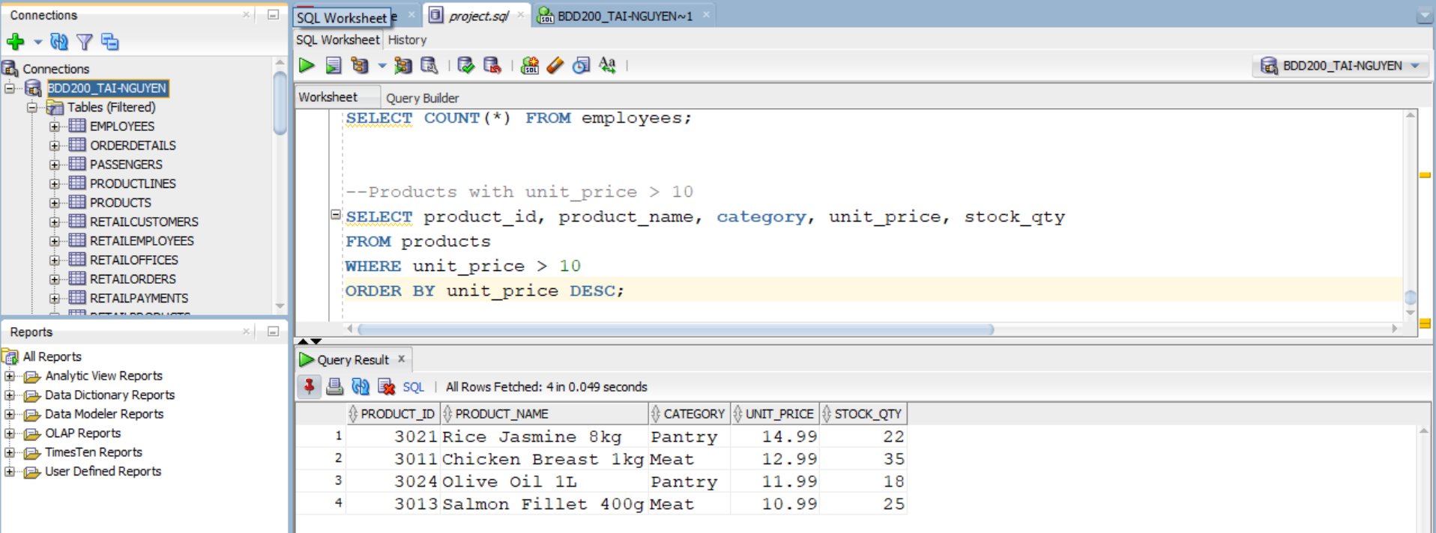

SELECT Query 2: Active Dairy products – Done by Tai Nguyen
SQL:
SELECT product_id, product_name, brand, unit_price
FROM products
WHERE category = 'Dairy'
AND is_active = 'Y'
ORDER BY product_name;

Output screenshot:
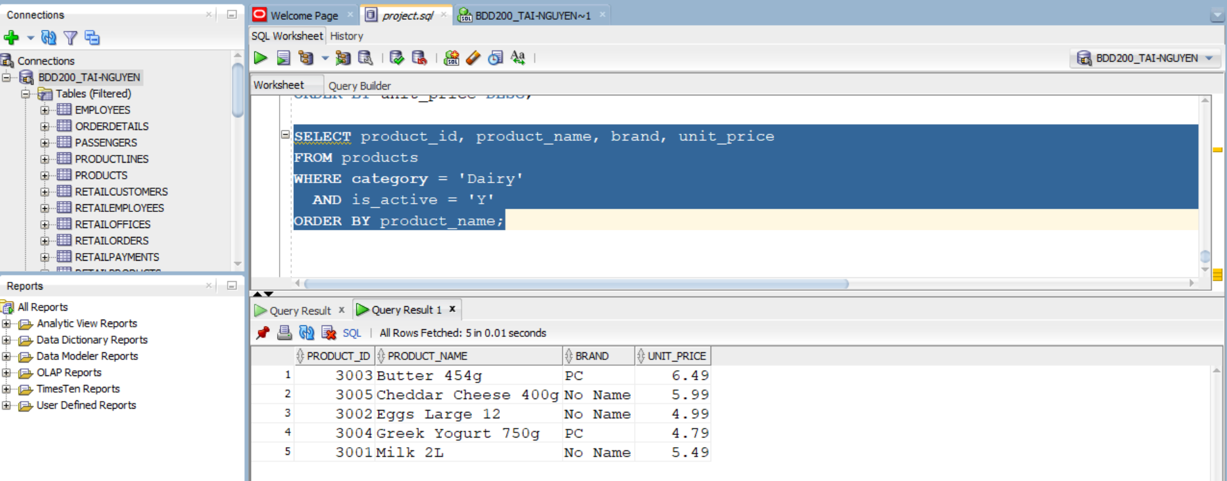

SELECT Query 3: Active employees in Store 101 – Done by Tai Nguyen
SQL:
SELECT employee_id, first_name, last_name, job_title, email
FROM employees
WHERE store_id = 101
AND status = 'ACTIVE'
ORDER BY last_name, first_name;

Output screenshot:
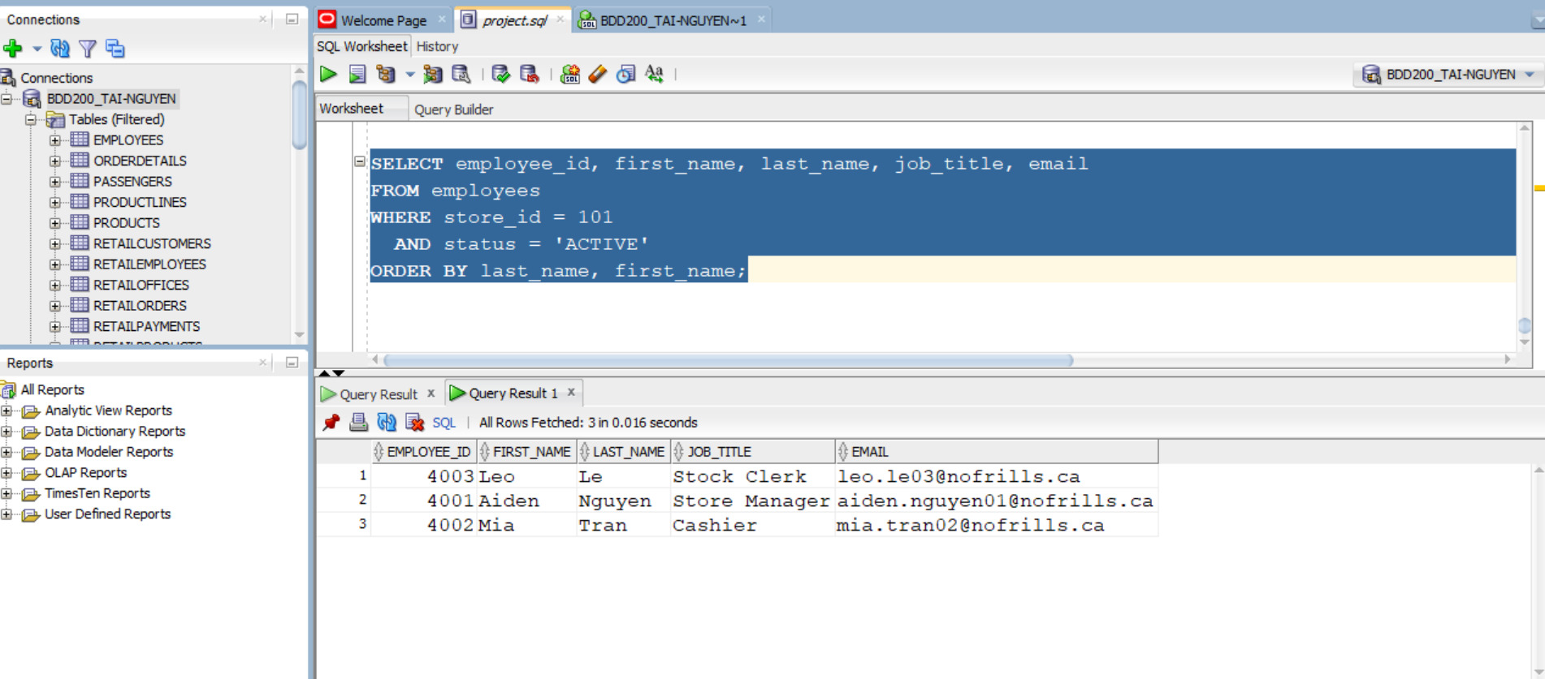

SELECT Query 4: Employees hired after 2023-01-01 – Done by Tai Nguyen
SQL:
SELECT employee_id,first_name,last_name,job_title,hire_date
FROM employees
WHERE hire_date >= DATE '2023-01-01'
ORDER BY hire_date DESC;

Output screenshot:
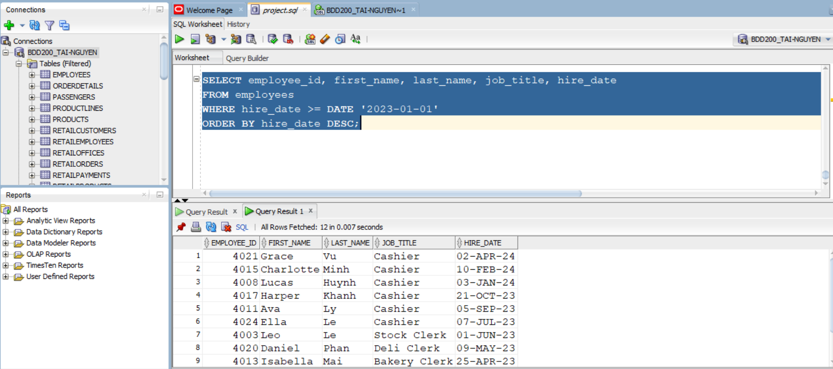

B) JOIN Queries (2 total)

JOIN Query 1: Employees with Store Information – Done by Tai Nguyen
Join type: INNER
SQL:
SELECT
e.employee_id,
e.first_name,
e.last_name,
e.job_title,
e.status,
s.store_id,
s.store_name,
s.city,
s.province
FROM project_employees e
INNER JOIN project_stores s
ON e.store_id = s.store_id
ORDER BY s.store_id, e.employee_id;

Output screenshot:
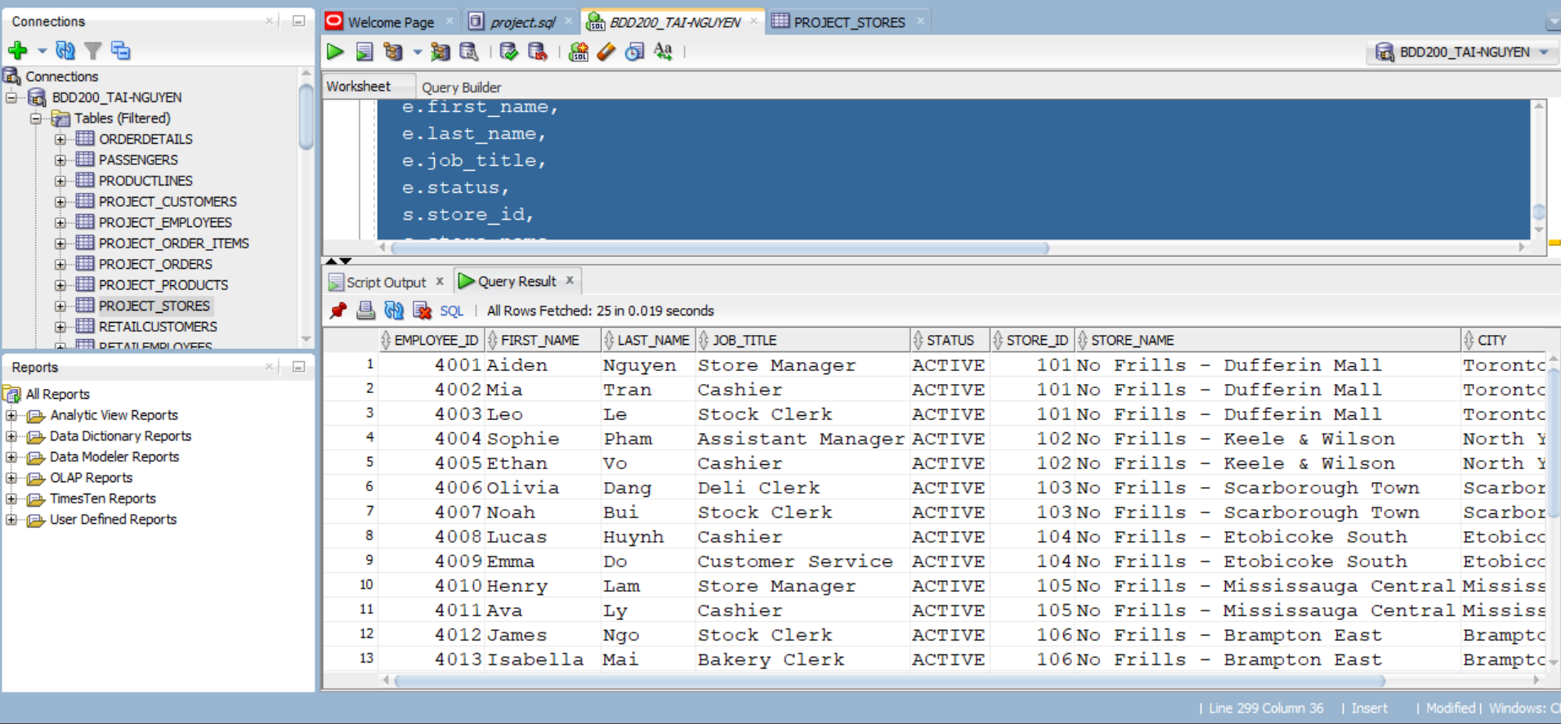

JOIN Query 2: Stores with Employees – Done by Tai Nguyen
Join type: LEFT
SQL:
SELECT
s.store_id,
s.store_name,
s.city,
e.employee_id,
e.first_name,
e.last_name,
e.job_title
FROM project_stores s
LEFT JOIN project_employees e
ON e.store_id = s.store_id
ORDER BY s.store_id, e.employee_id;

Output screenshot:
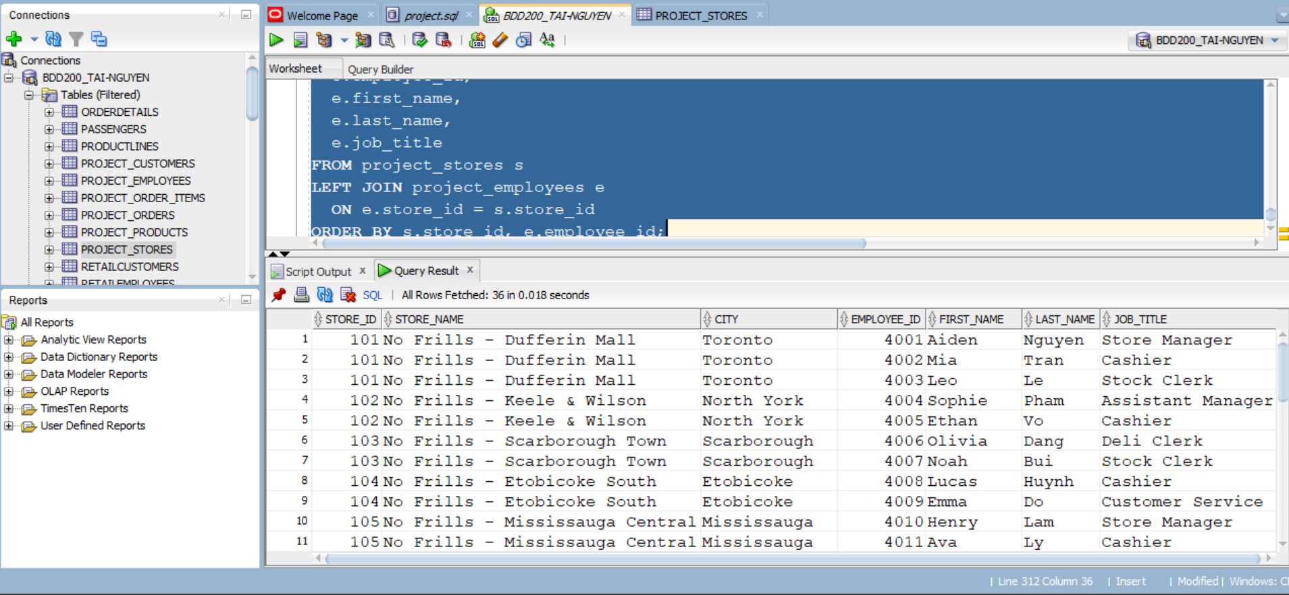

C) VIEW Queries (2 total)

VIEW 1: Active products in stock – Done by Tai Nguyen
CREATE OR REPLACE VIEW SQL:
CREATE OR REPLACE VIEW vw_active_products_in_stock AS
SELECT
product_id,
product_name,
category,
brand,
unit_price,
stock_qty
FROM products
WHERE is_active = 'Y'
AND stock_qty > 0;

SELECT * FROM vw_active_products_in_stock
ORDER BY category, product_name;
Output screenshot:
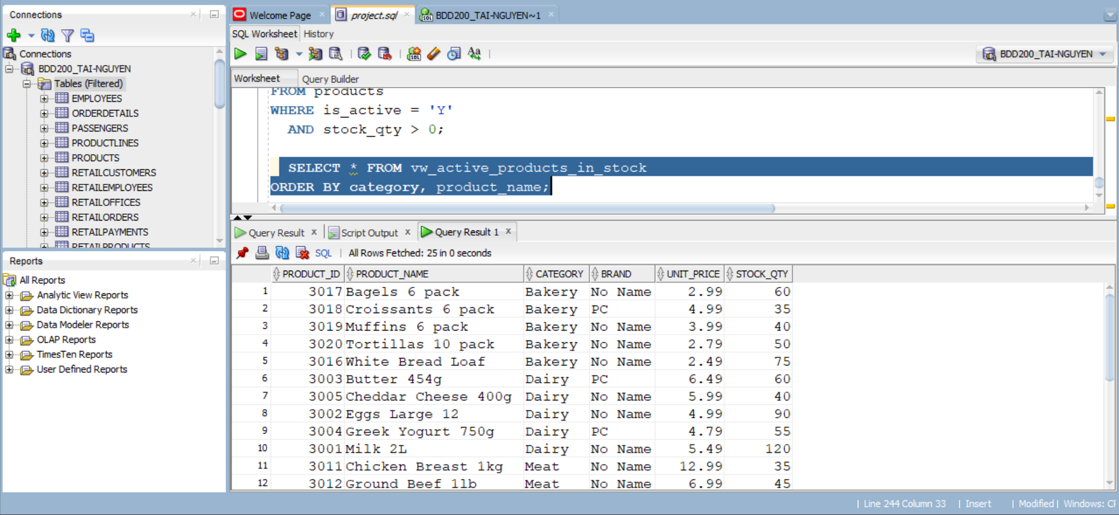

VIEW 2: EMPLOYEES (active employees summary) – Done by Tai Nguyen
CREATE OR REPLACE VIEW SQL:
CREATE OR REPLACE VIEW vw_active_employees AS
SELECT
employee_id,
store_id,
first_name,
last_name,
job_title,
hire_date,
salary
FROM employees
WHERE status = 'ACTIVE';
SELECT * FROM vw_active_employees
ORDER BY store_id, last_name, first_name;
Output screenshot:
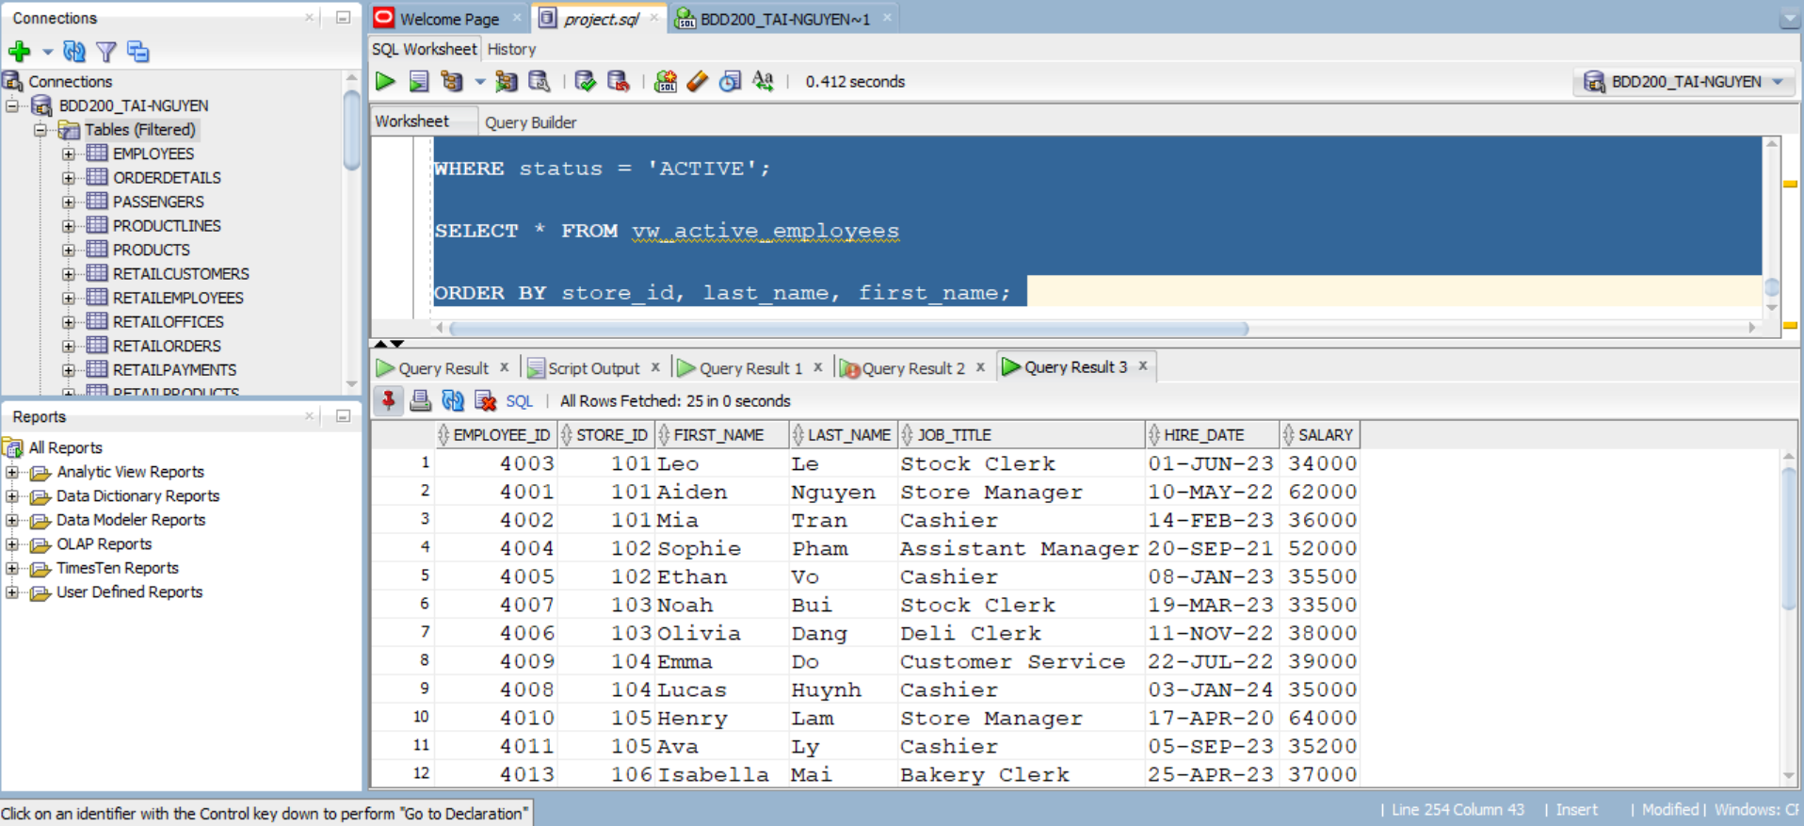

Member C – Queries
Name: Trinh Trong Tin Le

A) SELECT Queries (4 total)

SELECT Query 1: Orders above $100 – Done by Tin Le
SQL:
SELECT order_id, customer_id, total_amount
FROM project_orders
WHERE total_amount > 100;
Output screenshot:

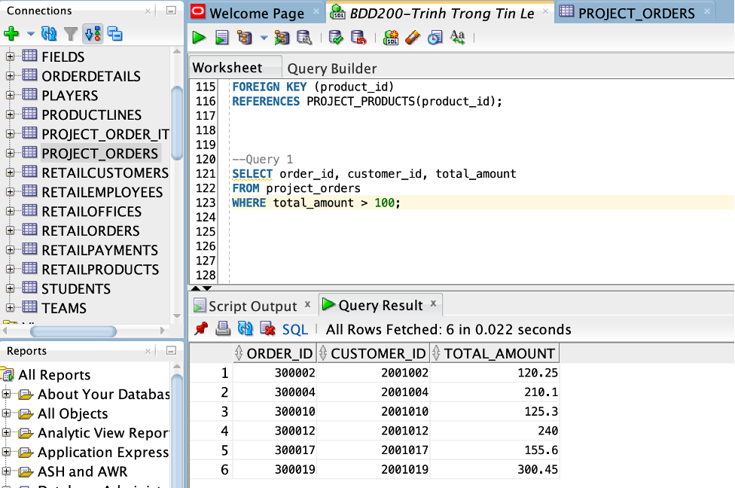

SELECT Query 2: Orders in January 2026 – Done by Trinh Trong Tin Le
SQL:
SELECT order_id, order_date
FROM project_orders
WHERE order_date BETWEEN DATE '2026-01-01' AND DATE '2026-01-31';

Output screenshot:

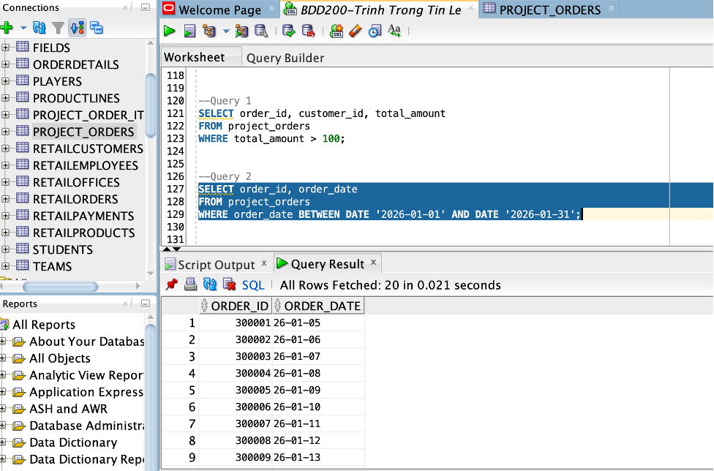

SELECT Query 3: Orders paid by Credit Cards – Done by Trinh Trong Tin Le
SQL:
SELECT order_id, payment_method, total_amount
FROM project_orders
WHERE payment_method = 'Credit';
Output screenshot:

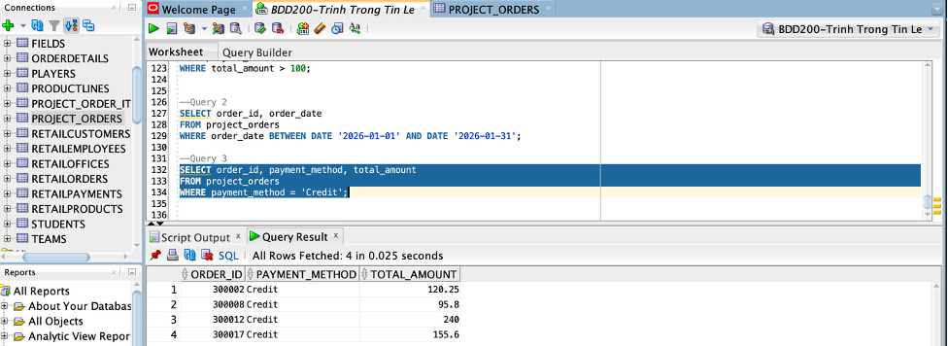

SELECT Query 4: Finding completed orders – Done by Trinh Trong Tin Le
SQL:
SELECT order_id, order_status
FROM project_orders
WHERE order_status IN ('Completed');
Output screenshot:
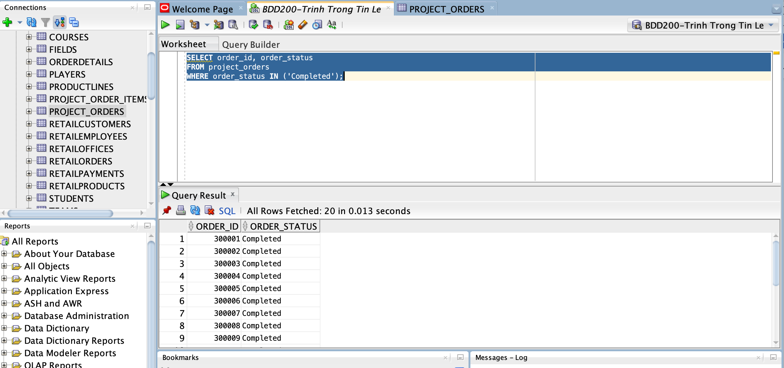

B) JOIN Queries (2 total)

JOIN Query 1: INNER JOIN (Orders + Customers + Stores)
Join type: INNER
SQL:
SELECT
o.order_id,
c.customer_id,
c.first_name || ' ' || c.last_name AS customer_name,
s.store_name,
o.order_date,
o.total_amount,
o.payment_method,
o.order_status
FROM PROJECT_ORDERS o
INNER JOIN PROJECT_CUSTOMERS c
ON o.customer_id = c.customer_id
INNER JOIN PROJECT_STORES s
ON o.store_id = s.store_id
ORDER BY o.order_id;
Output screenshot:

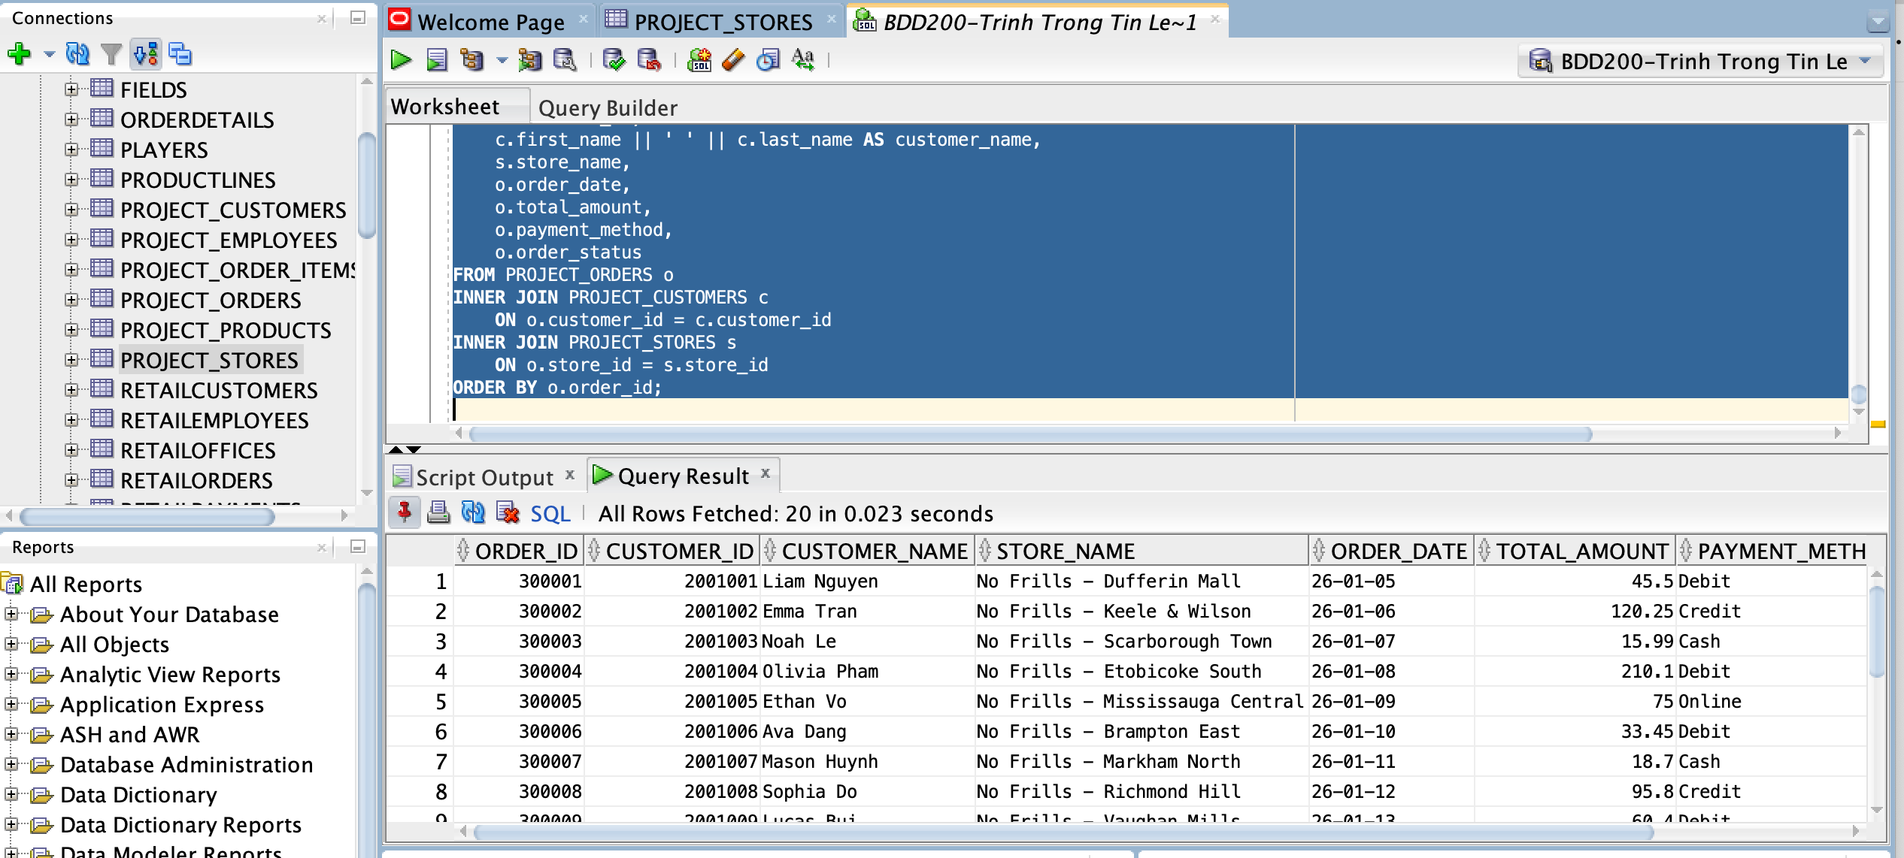

JOIN Query 2: LEFT OUTER JOIN (Orders + Items + Products)

Join type: LEFT
SQL:
-- Purpose: Show order item sales and include product name if exists

SELECT
o.order_id,
oi.product_id,
p.product_name,
oi.quantity,
oi.unit_price,
oi.line_total,
o.order_date
FROM PROJECT_ORDERS o
INNER JOIN PROJECT_ORDER_ITEMS oi
ON o.order_id = oi.order_id
LEFT OUTER JOIN PROJECT_PRODUCTS p
ON oi.product_id = p.product_id
ORDER BY o.order_id;
Output screenshot:
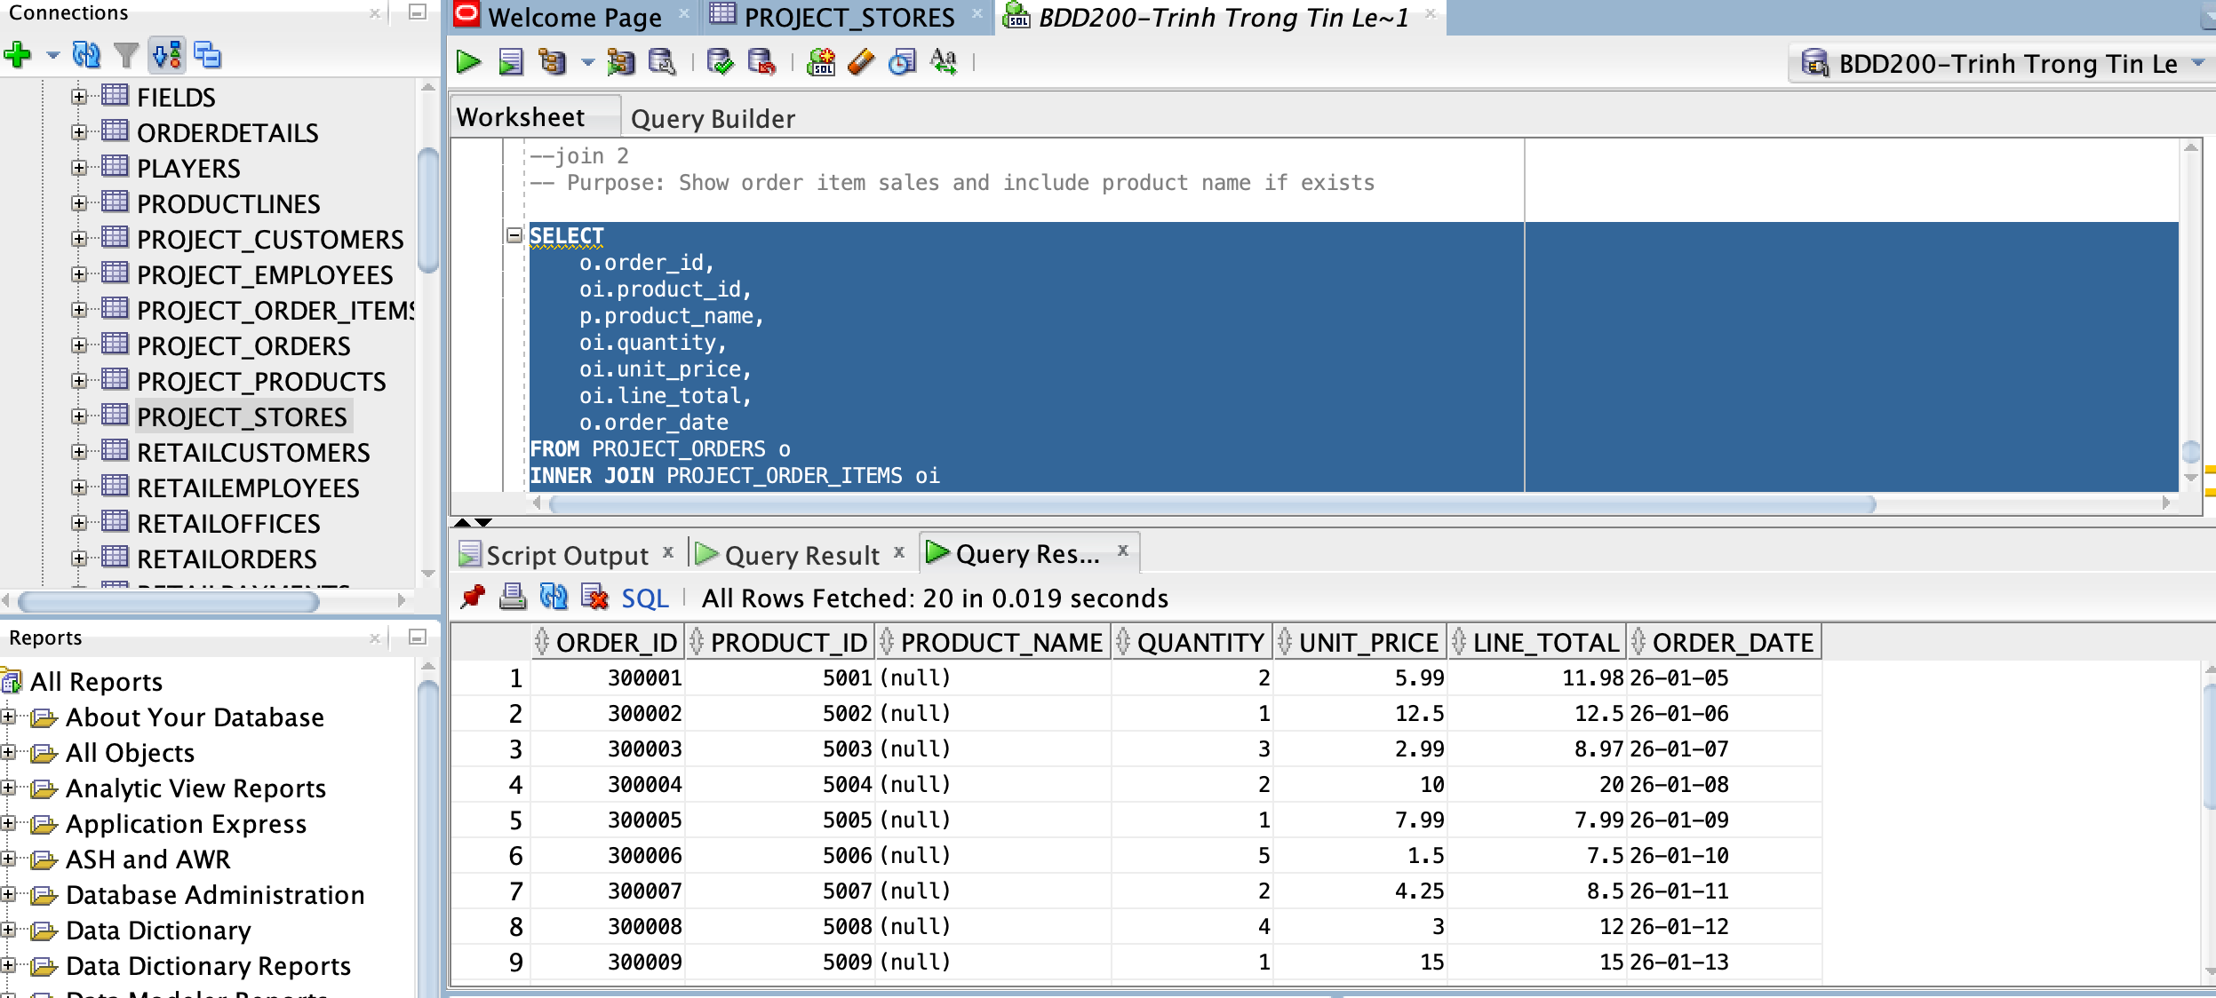

C) VIEW Queries (2 total)

VIEW 1: View Total_calculated – Done by Trinh Trong Tin Le
CREATE OR REPLACE VIEW SQL:
CREATE OR REPLACE VIEW VW_TIN_ORDER_SUMMARY AS
SELECT
o.order_id,
o.order_date,
o.total_amount,
COUNT(oi.order_item_id) AS total_items,
SUM(oi.line_total) AS calculated_total
FROM PROJECT_ORDERS o
JOIN PROJECT_ORDER_ITEMS oi
ON o.order_id = oi.order_id
GROUP BY
o.order_id,
o.order_date,
o.total_amount;
-- 2. Show the contents of the view in the script output
SELECT * FROM VW_TIN_ORDER_SUMMARY;

Output screenshot: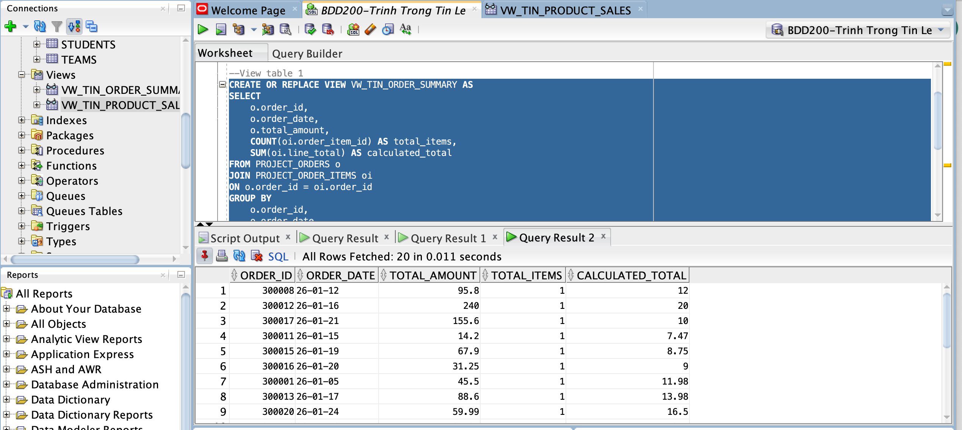

VIEW 2: View quantity_sold and total_sales – Done by Trinh Trong Tin Le
CREATE OR REPLACE VIEW SQL:
CREATE OR REPLACE VIEW VW_TIN_PRODUCT_SALES AS
SELECT
oi.product_id,
SUM(oi.quantity) AS total_quantity_sold,
SUM(oi.line_total) AS total_sales
FROM PROJECT_ORDER_ITEMS oi
GROUP BY oi.product_id;
SELECT * FROM VW_TIN_PRODUCT_SALES;

Output screenshot:
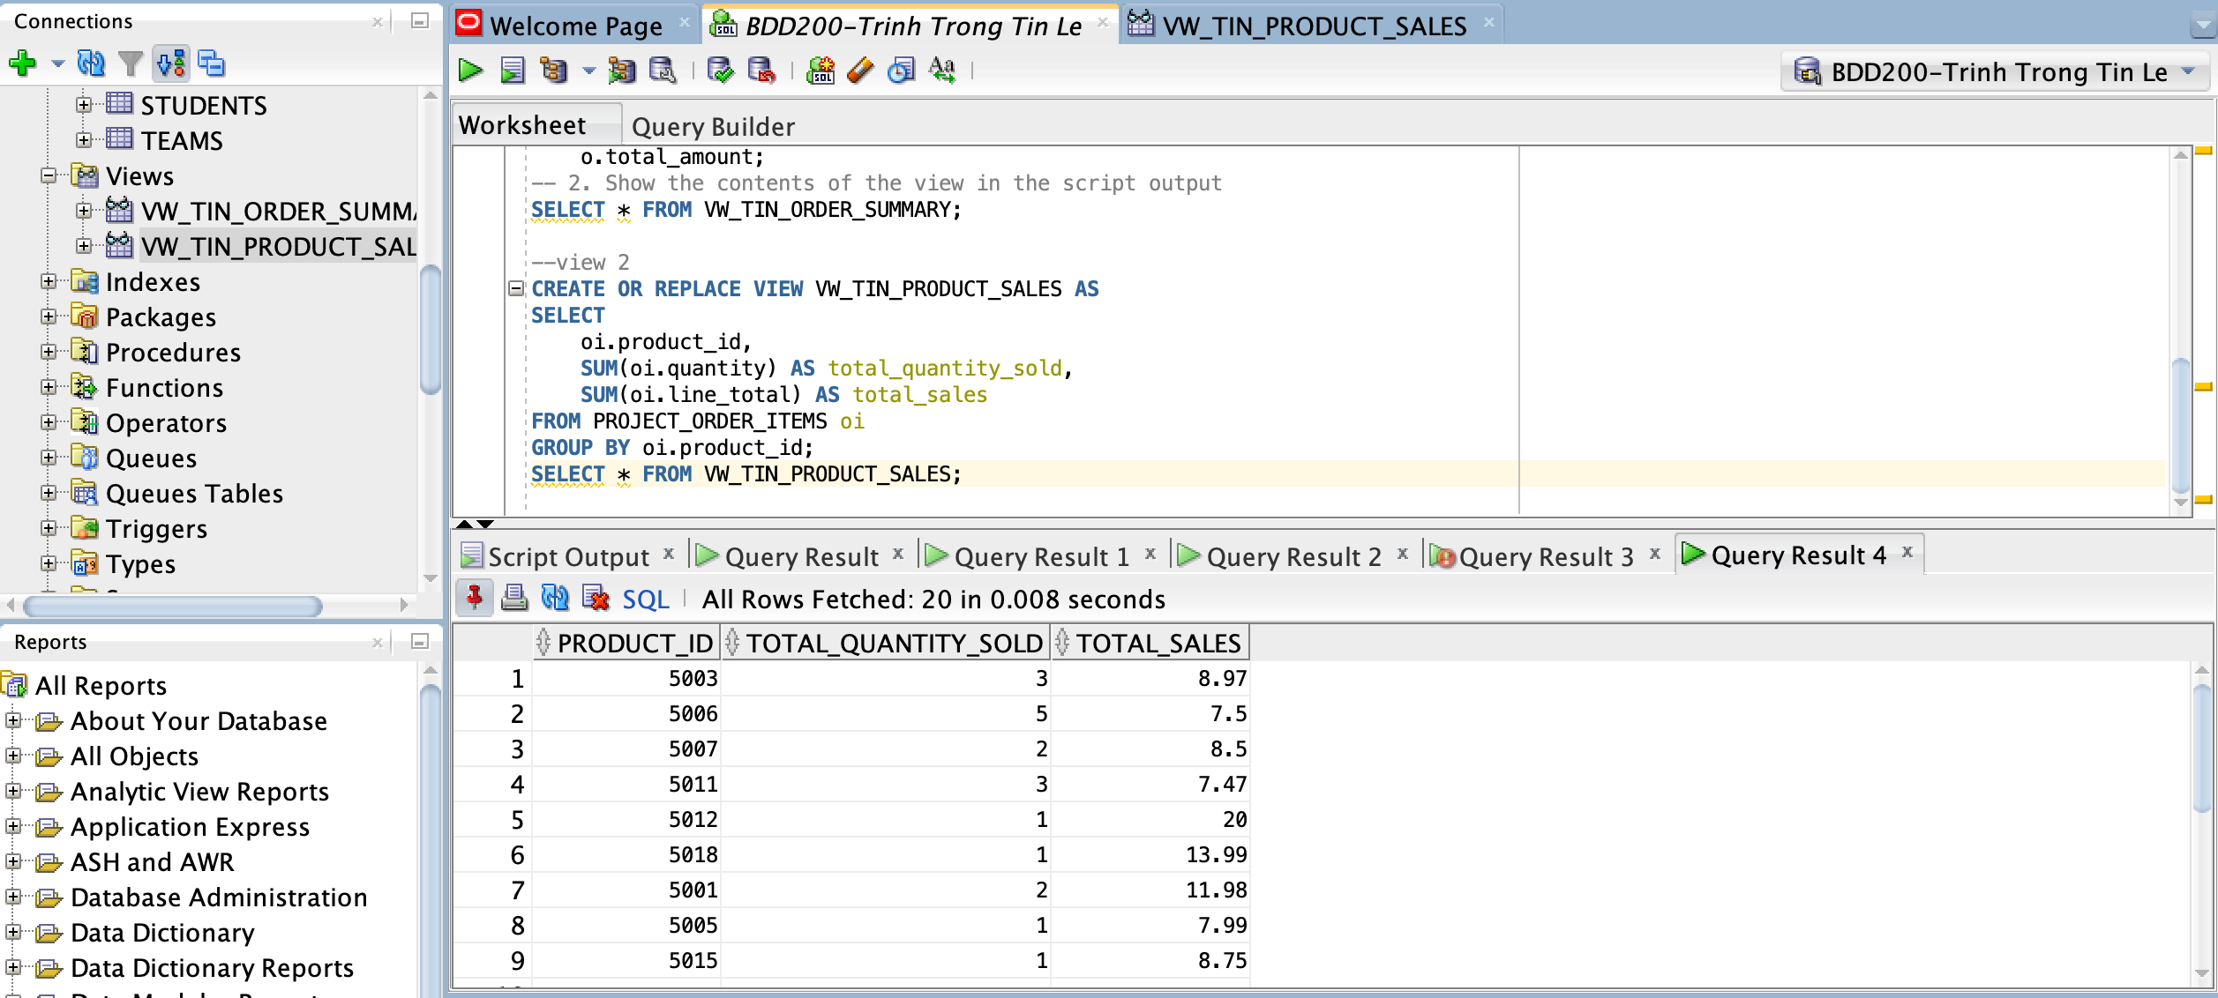

Part 4 – In-person Demonstration (Feb 11)
Checklist for each member:
- Introduce yourself, group number, and teammates.
- Explain the ERD (tables + relationships + cardinalities).
- Show the tables you created and the data you inserted.
- Run ONE SELECT query with a WHERE clause (show code + output).
- Run ONE JOIN query (show code + output).

