Nighttime Lane Detection — System Operating Walkthrough

Reference Manual

1 Prerequisites
Environment
- This project's own scripts, cloned from https://github.com/tantaiauraipun-blip/night-lane-detection.git (Step 0 below) — referred to here as ~/night-lane-detection.
- A conda environment named clrnet_torch113 with PyTorch, OpenCV, NumPy, and CLRNet's own dependencies installed.
- The CLRNet repository checked out separately at ~/CLRNet/CLRNet, with a pretrained checkpoint already available (this manual uses 20260728_134613_lr_6e-04_b_4/ckpt/11.pth as the starting checkpoint throughout).
- The CULane dataset available under a HGLane-style root (default ~/datasets/HGLane), with list/train_gt.txt and list/test.txt present.
Two of the seven scripts — night_lane_only_enhance.py and the visual-compare / worst-grid utilities — need only OpenCV and NumPy, no PyTorch. Everything from data-prep onward needs the full clrnet_torch113 environment.

2 Script Map
Script | Purpose | Needs GPU?
night_lane_only_enhance.py | The 4-step enhancement pipeline: pre-brighten → classical candidate detection → targeted re-enhance → debug overlay. | No
prepare_finetune_and_heldout.py | Builds the enhanced night-only fine-tuning list AND the leak-free held-out test set (raw + enhanced). | No
finetune_night_config.py | CLRNet config for fine-tuning from a pretrained checkpoint on the enhanced night-only list. Run via main.py. | Yes
night_eval_clrnet.py | Proxy metric (Hungarian x-distance F1@20px) evaluation of a checkpoint on the held-out sets. | Yes
official_culane_eval.py | Official CULane metric (IoU@0.5, 30px strips, Hungarian matching) evaluation of a checkpoint. | Yes
bootstrap_significance.py | Paired bootstrap significance test (10,000 resamples) on the per-image JSON dumps from the two eval scripts above. | No
visualize_hard_cases.py | Qualitative output images: single-frame raw-vs-enhanced comparisons, plus two automated scan modes to find the most informative frames. | Yes

3 Step-by-Step Commands
Step 0 — Download the code
cd ~
git clone https://github.com/tantaiauraipun-blip/night-lane-detection.git
cd night-lane-detection
Output: a local ~/night-lane-detection folder with all ten scripts at the top level and a docs/ folder with the report, slides, and manuals. No dataset or checkpoint is included — obtain those separately (see the repo's README). The rest of this manual assumes this path; substitute your own if you cloned elsewhere.
Step 1 — Activate the environment
conda deactivate # repeat if nested in another env
conda activate clrnet_torch113
unset PYTORCH_CUDA_ALLOC_CONF
cd ~/CLRNet/CLRNet
Step 2 — Run the enhancement pipeline
python night_lane_only_enhance.py \
--input_dir ~/culane_night_test \
--output_dir ~/culane_night_lane_only \
--debug_dir ~/culane_night_lane_only_debug \
--mask_width 22
Output: final enhanced images in --output_dir, plus a red/green fitted-lane debug overlay per image in --debug_dir. Console reports how many images had zero detected lane trajectories.
Step 3 — Build the fine-tuning list and the leak-free held-out set
python prepare_finetune_and_heldout.py --hglane_root ~/datasets/HGLane
Output: an enhanced night-only training set and a repointed list/train_gt.txt (original backed up automatically, once); ~/culane_night_heldout_raw and ~/culane_night_heldout_enhanced, each with matching .lines.txt ground truth alongside every image, verified to have zero filename overlap with the training list.
rm -f ~/CLRNet/CLRNet/cache/culane_train.pkl # required before fine-tuning — see note below
If this cache file is not deleted, CLRNet's data loader will silently keep using the old, unfiltered training list, and the fine-tune will not actually train on the enhanced night-only data.
Step 4 — Fine-tune
python main.py ~/night-lane-detection/finetune_night_config.py \
--finetune_from work_dirs/clr/r18_culane/20260728_134613_lr_6e-04_b_4/ckpt/11.pth \
--gpus 1
finetune_night_config.py runs 3 epochs at lr 6e-5 (one tenth of the original 6e-4) by default. The extended run reported in the final report used 8 epochs at roughly one sixth of the original learning rate — edit the epochs / lr fields in finetune_night_config.py and rerun for that variant. Output: a new timestamped checkpoint folder under work_dirs/clr/r18_culane/ — the folder name and exact epoch/checkpoint filename are generated at run time, so check that directory after training completes rather than assuming a fixed name.
Step 5 — Evaluate: proxy metric
python night_eval_clrnet.py \
--config <path to the checkpoint's config.py> \
--ckpt <path to the checkpoint's .pth file> \
--label <short tag, e.g. original / finetuned / finetuned_ext>
Run once per checkpoint you want to compare (original, fine-tuned, fine-tuned_ext), changing only --config/--ckpt/--label each time. Output: a printed summary table (precision, recall, proxy F1@20px, avg drift px) for both the raw and enhanced held-out sets; ~/culane_night_eval_perimage_<label>.json (per-image TP/FP/FN, consumed by bootstrap_significance.py); ~/culane_night_worst_heldout_raw_<label>.txt (worst 20 raw images by false-negative count).
Step 6 — Evaluate: official CULane metric
python official_culane_eval.py \
--config <path to the checkpoint's config.py> \
--ckpt <path to the checkpoint's .pth file> \
--label official_<short tag>
Same pattern as Step 4, but scored with the real official metric (IoU@0.5, 30px-wide rasterized strips, Hungarian matching) instead of the proxy. Use an "official_" prefix on --label so its JSON dumps don't overwrite the proxy-metric dumps from Step 4. This is the metric every number in the final report is drawn from.
Step 7 — Statistical significance testing
python bootstrap_significance.py official_original official_finetuned official_finetuned_ext
Pass whichever --label values from Step 5 you have JSON dumps for. Output: a printed table with, per checkpoint, raw F1, enhanced F1, observed difference, a 95% bootstrap confidence interval (10,000 resamples), an approximate p-value, and a significance call.
Step 8 — Produce qualitative output images
# single frame, side by side, GT (yellow) vs predicted (cyan):
python visualize_hard_cases.py \
--config <config.py> --ckpt <ckpt.pth> \
--fname <image filename> --label <tag> --out <output.jpg>

# scan mode: find total-dropout frames (cheap, coarse):
python visualize_hard_cases.py --scan --config <config.py> --ckpt <ckpt.pth> --label <tag>

# scan_official mode (recommended): rank frames by true positives lost,
# using the real official metric — this is how the report's case-study
# frames were actually selected:
python visualize_hard_cases.py --scan_official \
--config <config.py> --ckpt <ckpt.pth> --label <tag> --top_n 30

4 Where Each Output Is Used
Output | Used in
night_lane_only_enhance.py debug overlay | Method section figure — the enhancement pipeline slide/section.
night_eval_clrnet.py summary table | Proxy-metric results tables — pipeline-iteration and fine-tuning-reversal sections.
official_culane_eval.py summary table | Official-metric results table — the project's headline quantitative finding.
bootstrap_significance.py table | Significance columns in the official-metric results table.
visualize_hard_cases.py (--scan_official + single-frame) | Qualitative case-study figures — the two side-by-side comparison images.

5 Known Gotchas
- Always delete cache/culane_train.pkl after re-running prepare_finetune_and_heldout.py's Job A and before fine-tuning — otherwise the stale cache silently overrides the new, filtered training list.
- The original ~/culane_night_test set is retired — it was found to be 100% contained in the training list. Only ~/culane_night_heldout_raw / _enhanced (built from list/test.txt, verified zero overlap) should be used for any reported number.
- Proxy-metric labels and official-metric labels share the same JSON dump naming pattern (~/culane_night_eval_perimage_<label>.json) — prefix official-metric labels with "official_" so the two don't collide.
- prepare_finetune_and_heldout.py backs up the original train_gt.txt exactly once and will not overwrite that backup on a second run — if you need to restore the original unfiltered training list, copy the backup back manually.

Reference Figures
What the enhancement pipeline's real output actually looks like, for comparison against your own run:
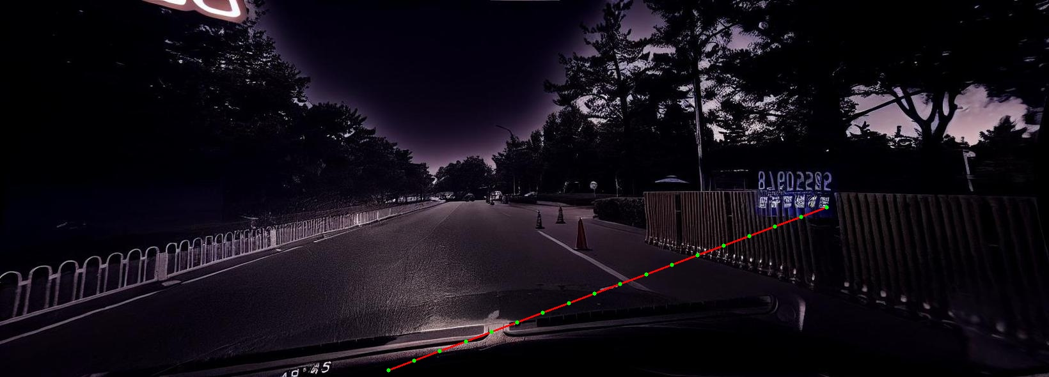
Step-4 debug overlay from night_lane_only_enhance.py: the fitted lane-candidate path (green points / red line) used to place the enhancement band.
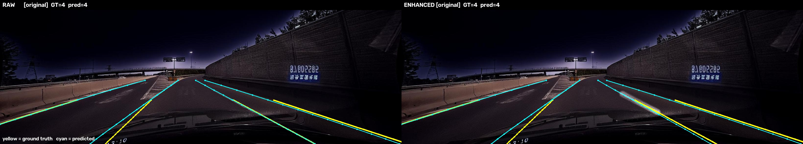
visualize_hard_cases.py single-frame output: ground truth (yellow) vs. predicted lanes (cyan), raw (left) vs. enhanced (right), for one checkpoint.

