

COLLEGE OF ENGINEERING AND DIGITAL TECHNOLOGY
ICCT COLLEGES FOUNDATION INC.

EDIDELIVER: Smart Customer Logistics and Delivery App

A Project
Presented to the
Faculty of College of Engineering and Digital Technology
ICCT Colleges Foundation Inc.
V.V. Soliven Avenue II Cainta Rizal

In Partial Fulfillment
Of the requirements for the Degree of
Bachelor of Science Major in Computer Engineering

By:
MORANCIL, AEDAM RHAJA F.
CADIMAS, JULLIANNA FAITH E.
CASIMERO, NATHANIEL JONES E
CAYABYAB, LORENZ
LUGAY, BRANDON ASHLEY P.

2025-2026

ACKNOWLEDGEMENT

The researchers would like to extend their profound appreciation to the people who made significant involvement in the pursuit of this research. Our heartfelt thanks to our instructor Mr. Rob Gonzales, who spent his time and expertise to guide us during our project development, and Special thanks to our Classmates, for their encouragement and cooperation, which greatly contributed to completing this study. Above all, the Almighty God, for giving the researchers sufficient knowledge, guidance, courage, strength, and joy in pursuing the study. This project was made possible through our teamwork, dedication and the knowledge we gained during our course.
The Researchers

TABLE OF CONTENTS

Page

Title page ................................................................................................................... 1
Acknowledgement ..................................................................................................... 2
Table of Content ........................................................................................................ 3
Project Overview ....................................................................................................... 4
Problem Identification ............................................................................................... 5
Core Idea and Purposes ............................................................................................. 6
Target Audience ........................................................................................................ 8
Object-Oriented Design (with UML ......................................................................... 9
Class Diagram)
Information Architecture ........................................................................................... 10
User Flow (Flowchart) .............................................................................................. 12
User Interface Mockup .............................................................................................. 13
Preparation and Documentation ................................................................................ 18
References ................................................................................................................. 21
Curriculum Vitae ...................................................................................................... 22

PROJECT OVERVIEW

EDIDELIVER is a smartphone-based logistics application designed to simplify delivery booking and tracking through a mobile interface. The system allows customers to request deliveries, monitor their order status, and maintain transaction records conveniently. Built using the Flutter framework in Visual Studio Code, the app showcases the use of Object-Oriented Programming (OOP) principles such as encapsulation, inheritance, and polymorphism in a real-world project.
‎
‎EDIDELIVER uses Firebase as its main database to ensure secure, real-time data storage and synchronization between users. One of its features is the reward points system, where customers earn points for every successful transaction. These points can later be redeemed for discounts or special perks, encouraging customer loyalty.
‎
‎The app also promotes eco-friendly delivery options, allowing customers to choose between bicycle deliveries for lighter packages or motorcycle deliveries for heavier or long-distance orders.
‎
‎Overall, EDIDELIVER serves as a prototype that highlights how OOP concepts can be applied in logistics management while promoting efficiency, sustainability, and accessibility for both customers and small delivery businesses.
‎

PROBLEM IDENTIFICATION

‎In today’s fast-paced digital environment, many small businesses and independent riders still face challenges in managing their delivery operations efficiently. Most available delivery platforms are designed for large companies, making them too complex or costly for small-scale use. As a result, local businesses often rely on manual booking methods—such as phone calls or messaging apps—which can lead to delays, miscommunication, and incomplete transaction records.
‎Customers, on the other hand, often lack a convenient way to book deliveries, track their orders, or earn rewards for their loyalty. These limitations make the overall delivery process inefficient and less transparent.
‎To address these issues, EDIDELIVER: Smart Customer Logistics and Delivery App was developed as a mobile-based logistics solution that simplifies delivery booking, tracking, and management. By using Firebase for secure, real-time data storage, the system ensures that both customers and riders can easily access updated information anytime.
‎The project also tackles the need for sustainable and customer-centered logistics by integrating eco-friendly delivery options (bike or motorcycle) and a reward points system that encourages continued use of the platform. Through these features, EDIDELIVER aims to bridge the gap between technology and small-scale logistics management—promoting efficiency, transparency, and accessibility for all users.

CORE IDEA AND PURPOSE

The core idea of EDIDELIVER: Smart Customer Logistics and Delivery App revolves around creating a smart, practical, and sustainable logistics solution designed for the modern needs of small businesses, local entrepreneurs, and independent riders. In an age where convenience and speed are highly valued, many local businesses still face challenges when it comes to managing deliveries efficiently. EDIDELIVER aims to bridge this gap by providing a mobile-based platform that simplifies how deliveries are booked, monitored, and completed.
‎The app focuses on bringing together three important goals: efficiency, sustainability, and accessibility. It gives customers the ability to book deliveries quickly, view order progress in real-time, and earn rewards for continued use — all within a single mobile interface. At the same time, it supports delivery partners and small-scale logistics providers by offering tools for managing bookings, tracking status updates, and organizing transactions more systematically.
‎Developed using the Flutter framework and integrated with Firebase, EDIDELIVER also serves as a demonstration of how Object-Oriented Programming (OOP) concepts can be applied effectively in real-world applications. Concepts such as encapsulation, inheritance, and polymorphism are implemented throughout the system, showing how programming principles can enhance functionality, reusability, and maintainability in app development.
‎Beyond its technical side, EDIDELIVER also promotes eco-friendly delivery options by allowing users to choose between bicycle and motorcycle deliveries, depending on the package’s weight and distance. This feature encourages sustainability and supports environmentally conscious transport choices within the community.
‎The app also includes a reward points system that allows customers to earn points with every successful transaction. These points can later be redeemed for discounts or perks, motivating customer loyalty and engagement while providing a more interactive user experience.
‎In summary, the purpose of EDIDELIVER is not only to provide a working logistics solution but also to show how technology can simplify everyday processes while promoting innovation, sustainability, and user satisfaction. The project demonstrates that even small-scale or community-based delivery systems can benefit from modern technologies when designed with real-world challenges in mind.

TARGET AUDIENCE

EDIDELIVER focuses on everyday users, small businesses, and independent partner drivers, offering a simple yet functional platform that addresses the unique challenges of community-level delivery services. Customers or sender are the primary users of the system who utilize the application to book and track deliveries for personal or business purposes. Through the mobile interface, they can conveniently input pickup and drop-off details, monitor their parcel status in real time, and view transaction records. The integrated reward points feature encourages loyalty and engagement, while the eco-friendly delivery options promote responsible consumption.
‎Partner drivers refer to freelance or independent riders who are not directly employed by a logistics company but provide delivery services within their community. EDIDELIVER allows them to easily accept and manage booking requests, update delivery statuses, and track their completed transactions. The system supports both bicycle and motorcycle deliveries, ensuring flexibility and accessibility while encouraging sustainable transport choices.
Small businesses and online sellers benefit from EDIDELIVER by gaining access to an organized, efficient, and reliable delivery management system. The platform simplifies record-keeping, reduces human error, and enhances customer satisfaction through transparent delivery tracking and timely updates. It serves as a practical tool for small businesses aiming to modernize their logistics operations without high operational costs. Administrators play a vital role in maintaining the system’s integrity and functionality. They oversee delivery operations, manage user registrations, monitor transactions, and ensure that the database remains accurate and up to date. By providing administrative control and oversight, the app ensures a smooth and coordinated delivery process between customers and drivers. This project also serves as a learning platform for students and developers interested in mobile app development. It demonstrates the real-world application of Object-Oriented Programming (OOP) principles, database integration, and system design using Flutter and Firebase, promoting both technical learning and innovation.

OBJECT-ORIENTED DESIGN (UML CLASS DIAGRAM)

INFORMATION ARCHITECTURE

‎The information architecture of our project serves as the backbone that organizes and structures all the features and content within the system. It ensures that every element—from the Login Page to the Admin Dashboard—is placed logically and can be easily accessed by users. By designing a clear and well-structured flow of information, we aim to make navigation simple, intuitive, and efficient. Through this, users can easily find what they need, perform tasks smoothly, and have an overall seamless experience using the application. The EDIDELIVER app is structured to serve three main user roles: Customers, Drivers, and Admins. When users first open the app, they are greeted by the Welcome Page, which provides options to Log In or Sign Up. During sign-up, users select their role—Customer or Driver—and complete a form with their full name, email, phone number (in E.164 format), and password. After signing up, users are redirected to the Login Page. Customers logging in are directed to a Dashboard which has three Navigation Buttons at the bottom left side, middle, and right side, which are Book, History, and Profile. In Book, they can book a delivery in three simple steps. Step one involves entering the pickup and drop-off addresses, with a map integration to assist in selecting locations. Step two allows them to choose the delivery option based on package size and distance, including Bicycle (eco-friendly for near distances), Motorcycle (for small parcels or documents), Sedan/Car (medium packages), and Van/Truck (large or bulky items). Step three presents payment options, including Cash on Delivery, GCash, PayMaya, or Bank Transfer, alongside a summary of the booking details, including an optional note for the rider. Once confirmed, the booking status displays “Finding a Driver…”. On the other hand, in the middle Navigation Button, customers can view their order history and track the status of current orders. For the right-side Navigation Button, they can access their Profile, which shows their name, phone number, discount eligibility for students or PWDs, and an option to upload supporting documents, as well as a Logout button.
‎Drivers, on the other hand, have the same three Navigation accesses in a Dashboard that displays Home, Earnings, and Profile. In Home Navigation, they can find available deliveries they can accept, while in Earnings Navigation, it includes total earnings, completed deliveries, average earnings, and earnings history. In Profiles Navigation are redirecting to Driver Profiles which require verification before they can accept orders, where drivers submit vehicle details and upload necessary documents depending on the vehicle type—Bicycle requires a bike photo, model, and rider ID, while Motorcycle, Sedan/Car, or Van/Truck require a plate number, driver’s license, and vehicle photo. Submitted verifications remain pending until approved by the Admin. Once verified, drivers can accept deliveries, update delivery statuses, and manage their Profile and account.
‎Admins access a dedicated Admin Dashboard, which includes two main options: an Overview that displays total bookings, registered users, and revenue, and a Discounts section where they can manage customer discounts. Admins also decide on the approval of driver verifications, monitoring of deliveries and statuses, and management of users and transactions. Behind the scenes, Firebase serves as the database, storing user information, booking and delivery records, driver verification documents, reward points, and discount eligibility, ensuring real-time updates and secure data management across all roles. With this structure, EDIDELIVER ensures that every user can navigate the app intuitively, manage deliveries effectively, and access relevant information quickly, creating a streamlined experience for both customers and delivery partners.
‎
‎

USER FLOW (FLOW CHART)

USER INTERFACE MOCKUP

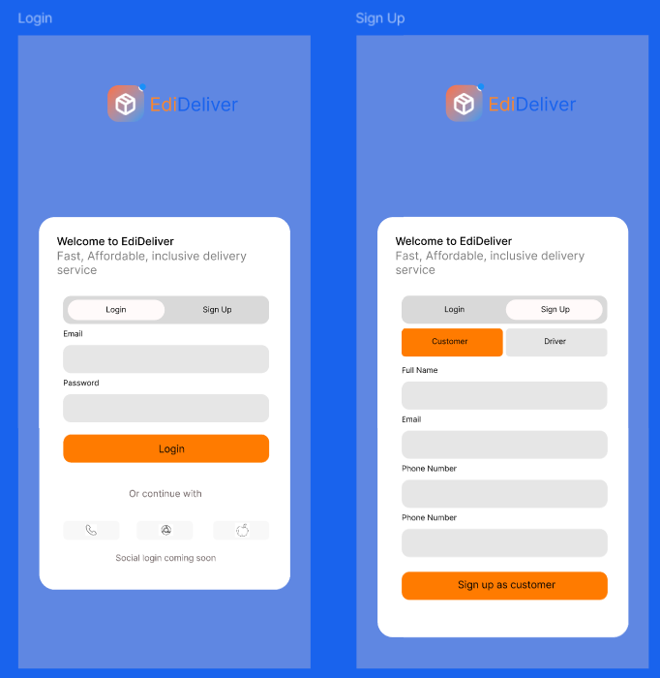
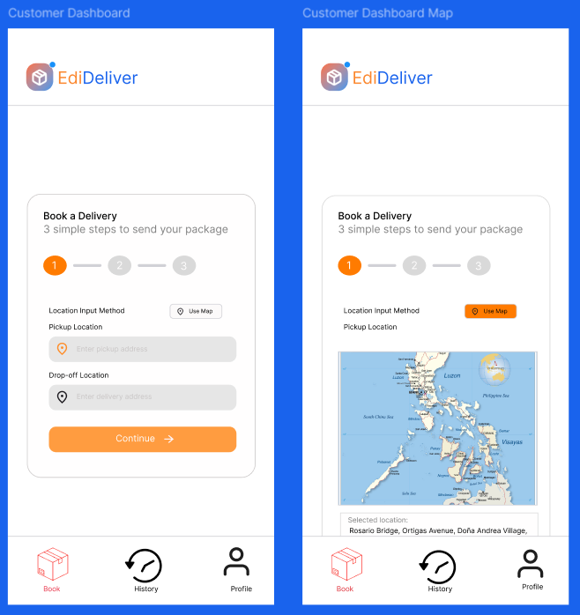

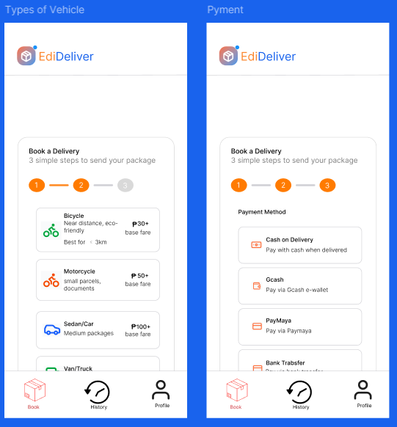

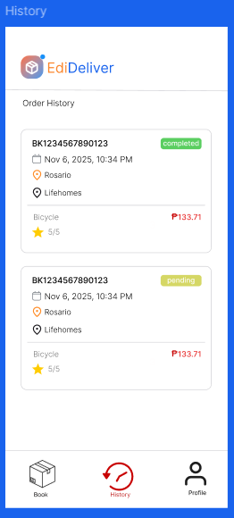
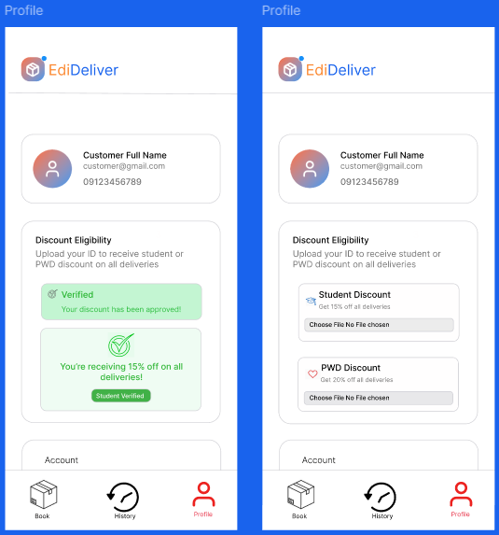

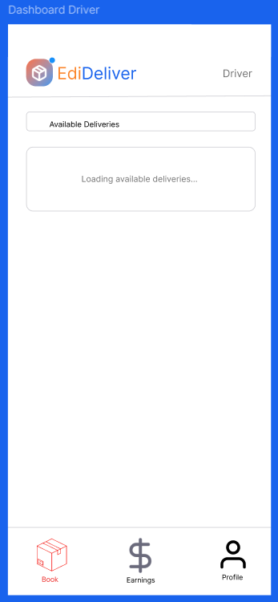
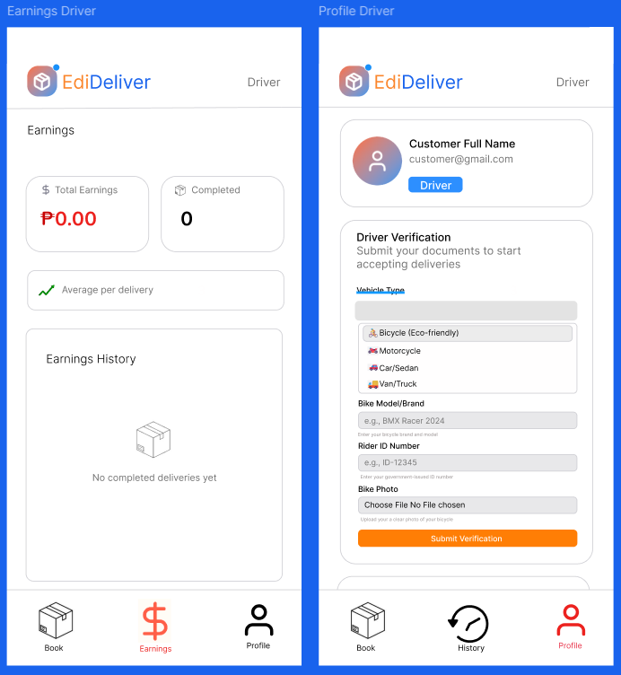

PREPARATION AND DOCUMENTATION

This stage focuses on gathering the necessary information, resources, and design elements to ensure that the app’s development process runs smoothly and effectively. During the preparation, The developers did a brainstorming session about the logistics management system, delivery platforms, and the needs of small businesses and independent riders to identify key features that would make EDIDELIVER both efficient and user-friendly.
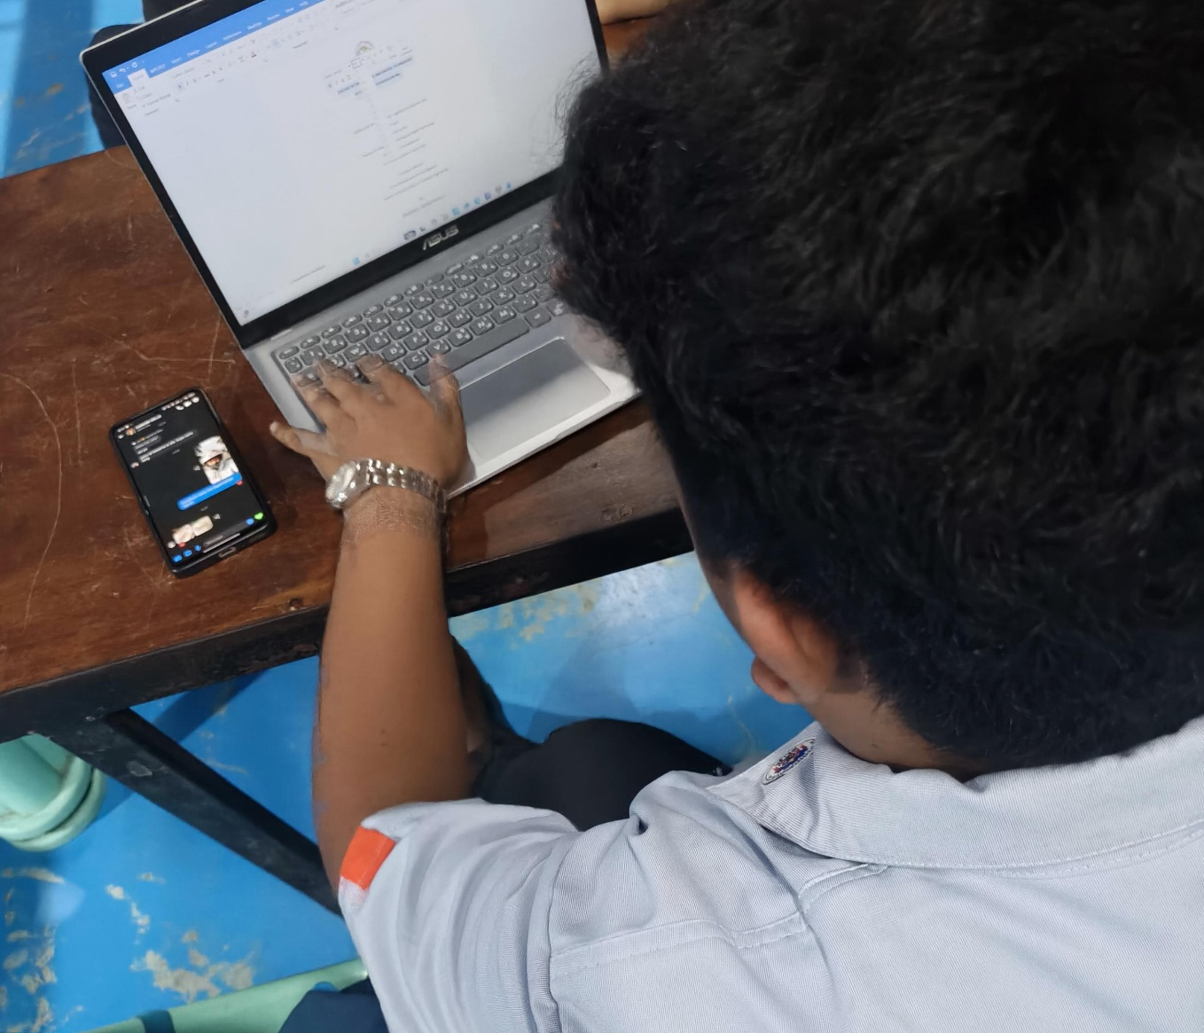

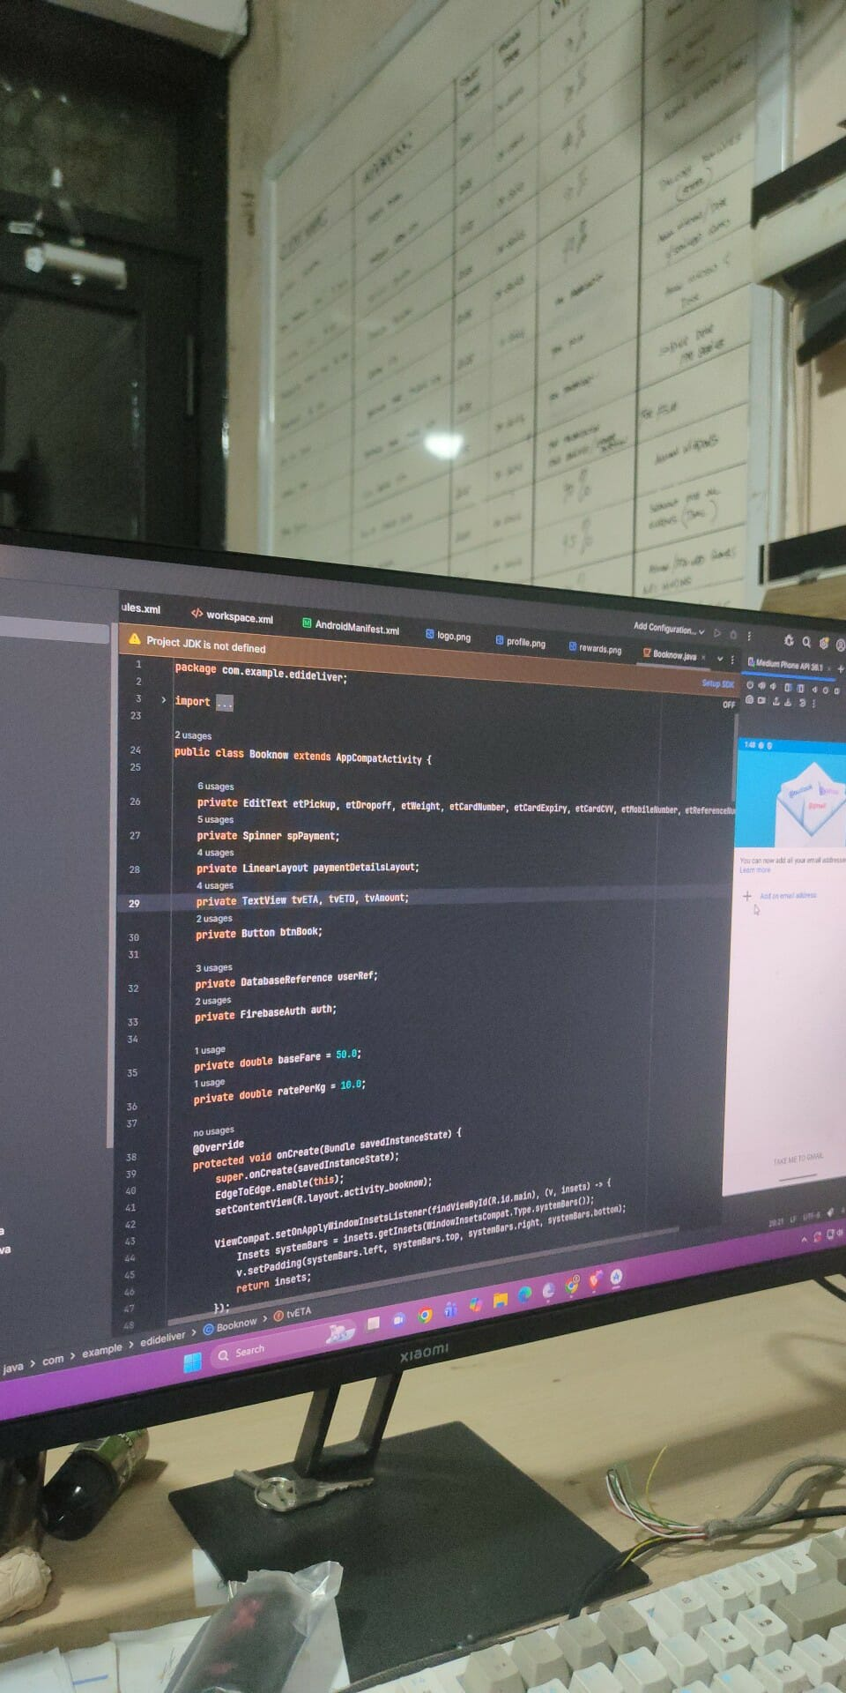
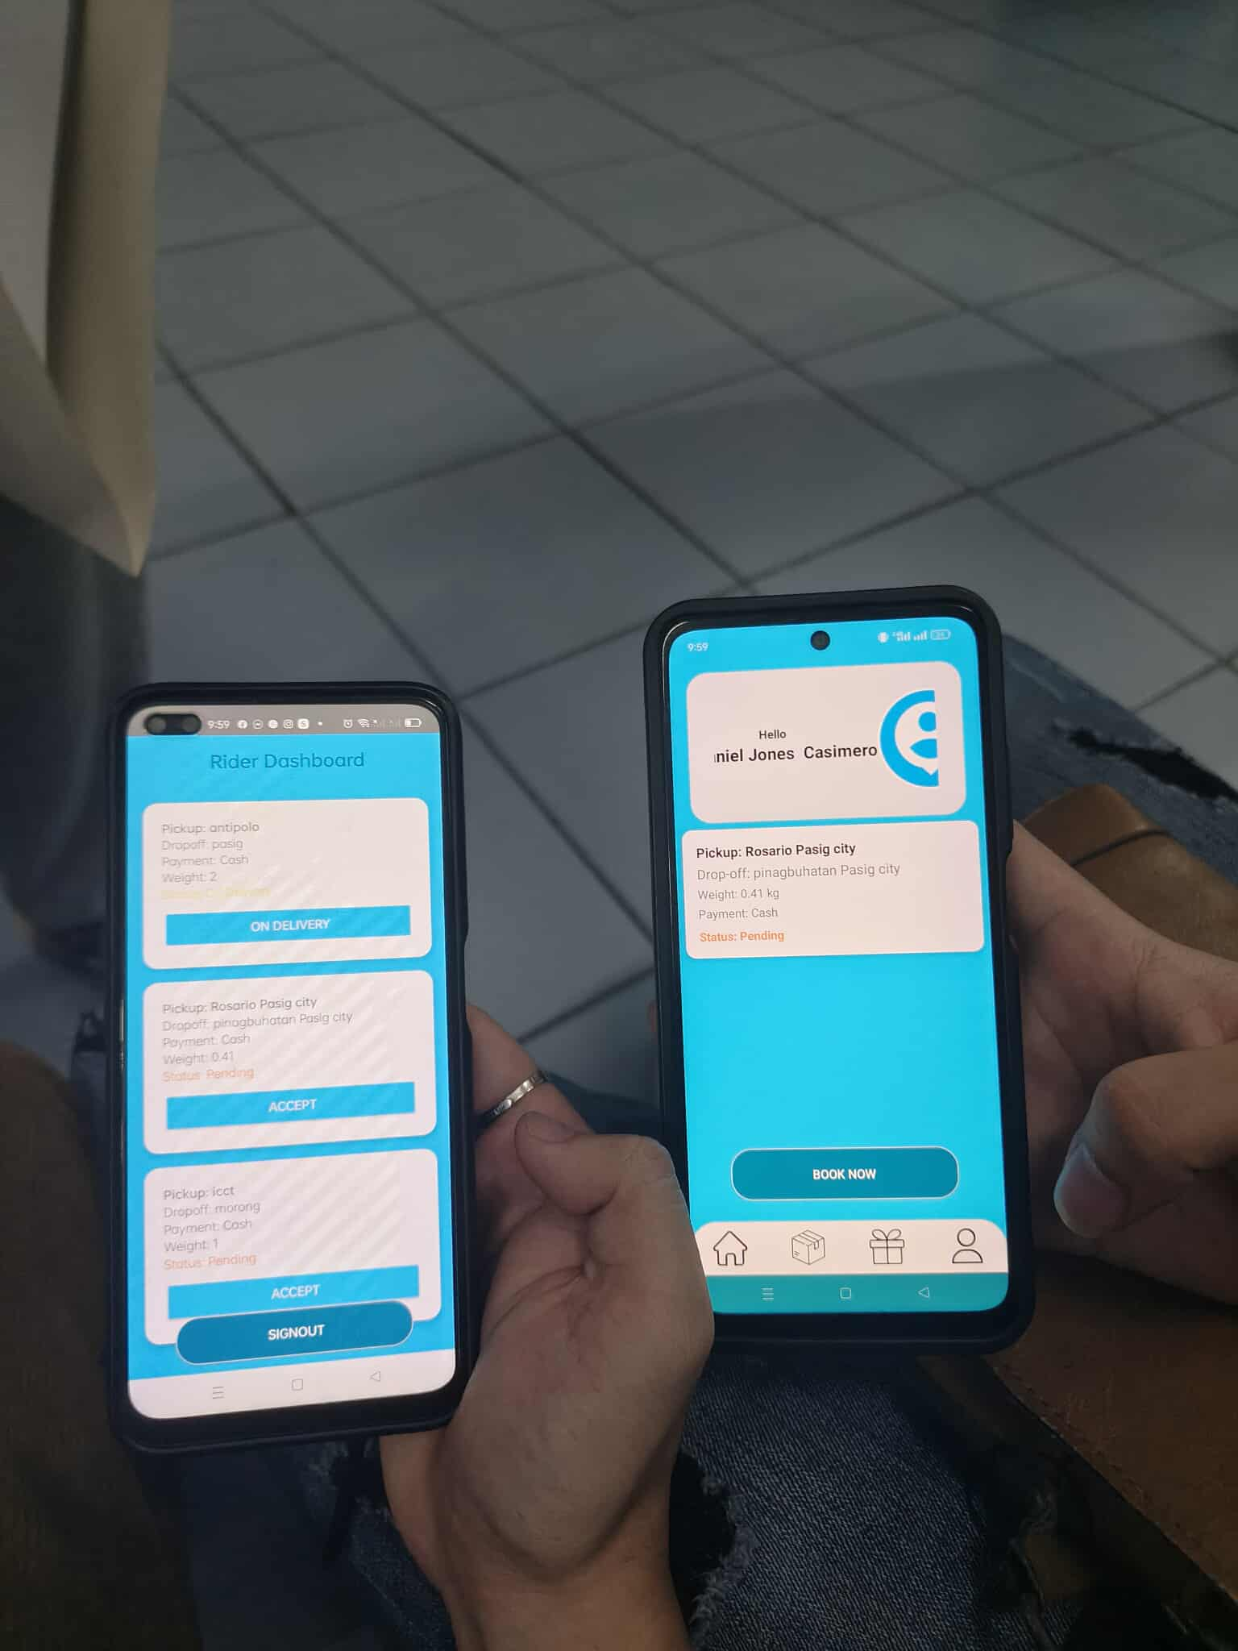

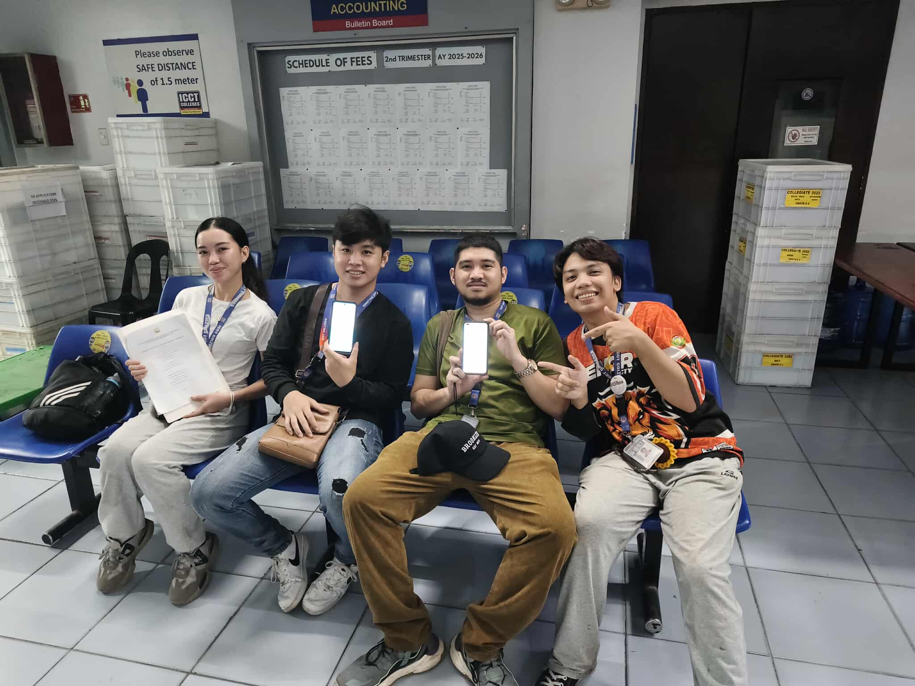
Documentation played a vital role in recording each step of the project, from planning and system design to coding and testing. This ensures that all processes, decisions, and technical details are properly tracked and organized. Through this phase, the group was able to establish clear objectives, define user requirements, and create a detailed plan for implementation. The preparation and documentation process not only guided the development but also strengthened teamwork, problem-solving, and the overall understanding of applying Object-Oriented Programming (OOP) principles in real-world applications.

‎

REFERENCES

Tech Tuts. (2022). Youtube.com. How to Export Figma Project to Andoid Studio 2022. https://youtu.be/lDojjdCBDv0?si=6E1Ty-CmgnnKGoYB
UiLover. (2022). Youtube.com. Food App Android Design – How to make food ordering app? https://youtu.be/9nWcPPHBzMk?si=Bt0glnlo1QAHTF27
Mufaddal. (2020). Youtube.com. Food delivery App, swiggy & Zomato clone, Android studio, Firebase, java. https://youtu.be/tuFYvgSGDLw?si=7X9-qgRxRJrl1CLS
Hagos, T. (2018). Android studio. In Learn Android Studio 3: Efficient Android App Development (pp. 5-17). Berkeley, CA: Apress.
Huang, T. (2024). FEAD: Figma-Enhanced App Design Framework for Improving UI/UX in Educational App Development. arXiv preprint arXiv:2412.06793.

CURRICULUM VITAE
