**C#**

Table of Contents

**1.****LINQ** 2

**2.** **SORT mongodb driver** 2

**3.** **Sort có thể sort 1 hay nhiều fields** 2

**4.** **Gộp nhiều câu filter với BsonDocument** 2

**5.** **Webhook vs. API** 3

1. **LINQ**

 var listOfNames = new List<string>()  
{  
    "John Doe",  
    "Jane Doe",  
    "Jenna Doe",  
    "Joe Doe"  
};

- The Query syntax (giống kiểu SQL)  
var qNames = from name in listOfNames where name.Length <= 8 select name;

- the Method syntax ( sử dụng lamda, giống arrow func và giống C# )

var mNames = listOfNames.Where(name => name.Length <= 8);

1. **SORT mongodb driver**

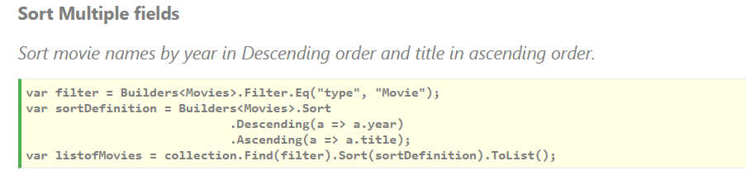

1. **Sort có thể sort 1 hay nhiều fields**

Filter 1 document có chứa 1 field là array

Có thể dùng Filter.ElemMatch

Filter.ElemMatch(param1, param2)

Filter.ElemMatch(_ => _.HandleableDepartments, Builders<MGTFExDepartmentHandlingModel>.Filter.In(h => h.Status, status));

Param1: **_ => _.HandleableDepartments** là field có chứa array

Param2: **Builders<MGTFExDepartmentHandlingModel>.Filter.In(h => h.Status, status)** là 1 filter, filter này sẽ cần 1 field trong array để so sánh

1. **Gộp nhiều câu filter với BsonDocument**

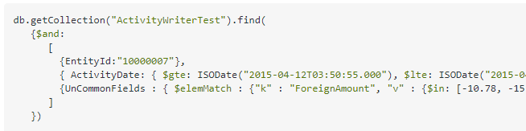

1. **Webhook vs. API**

**Webhooks**

POST to the webhook with some JSON data, and then it'll do something internally.

They are **API requests**, but they **help the server** instead of the client

Webhooks **take in data** and do internal work

**API**

API would be the team whose job it is to respond to inquiries from external parties

Clients make requests to an API from the client

API endpoints **return data** so that the client asking for that data can do something with it.