|  |  |
| --- | --- |
| *school-learn-study-hat-graduate-512.png* | ***Study*** |

**Part A:**

1. Learn how to print without moving to a new line

**Part B:**

Read Chapter 5, section 5.1, 5.3, 5.5, 5.6, 5.7 and 5.10 of “How to Think Like a Computer Scientist: Learning with Python 3”:

<http://www.ict.ru.ac.za/Resources/cspw/thinkcspy3/thinkcspy3.pdf>

And then answer the following questions:

1. What is Boolean? Write down 3 different expression that results a Boolean type (i.e. 5 == 6)

* A value is either True of False
* i.e:
  + x == y
  + x > y
  + x < y

1. What is a flow chart? Draw flow chart for the following code snippet: (you can draw on a paper, take a picture of it)

if name == “Quan":

   print(“Hand some")

elif name == “Tung":

   even\_more\_handsome = True

elif name == “Don":

   say\_hello()

else:

   webbrowser.open(“<https://www.youtube.com/watch?v=04854XqcfCY>”)

* A chart illustrates the order of which statements are executed (the flow of execution).
* 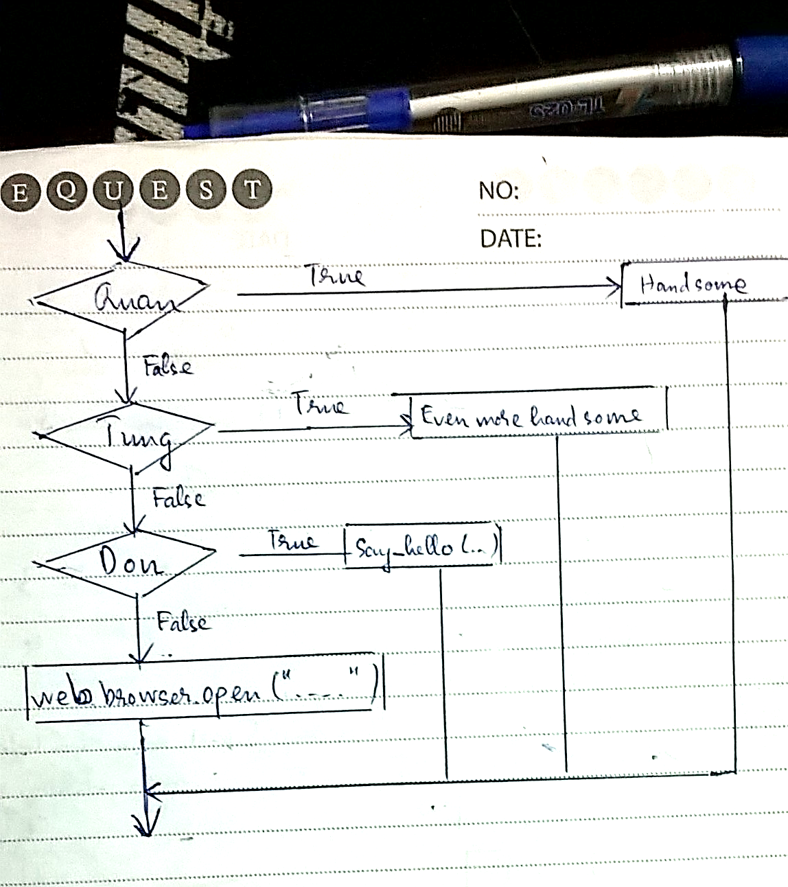

1. What is nested conditionals? Write a piece of code that uses nested conditionals

* Conditionals are nested together in another conditional (conditionals in conditional)

1. wa =int(input("Can nang cua A(kg)?"))
2. wb =int(input("Can nang cua B(kg)?"))
3. if wa > wb:
4. print("A nang hon B")
5. else:
6. if wa < wb:
7. print("A nhe hon B")
8. else:
9. print("A nang bang B")

|  |  |
| --- | --- |
| *http://www.bestappsforkids.com/wp-content/uploads/2012/04/save-turtle.png* | ***Turtle exercises*** |

Using turtle to draw the following shapes:

|  |  |
| --- | --- |
| Screen Shot 2015-12-25 at 04.41.55.png | 2. A dash  https://lh5.googleusercontent.com/IumbisdJpl1EDo5lk2xikbPwF9gZu7qshTfYvEytooAHIbRzvCARbk3pcfC2hRr0eXq8RyesgzCh_LW2CViR51PGooeXQJTzaQbhm28T0SUrIWLPPegOIzbvsxC8MYxjtRXkj847 |
|  |  |

|  |  |
| --- | --- |
| *6iporAnbT.jpg* | ***Serious exercises*** |

1. Write a program that asks user their height (cm) and weight (kg), and then calculate their BMI (Body Mass Index):

**BMI = mass (kg) / (height(m) x height(m) )**

Note: you must do the conversion from cm to m before calculation

Then based on the BMI, tell them that they are:

* Severely underweight if BMI < 16
* Underweight if BMI is between 16 and 18.5
* Normal if BMI is between 18.5 and 25
* Overweight if BMI is between 25 and 30
* Obese if BMI is more than 30

1. Write a program that
   1. Asks users enter a number and then calculates factorial of n: (1 \* 2 \* 3 \*... \* n)
   2. Asks users enter a number and then calculates the harmonic number (1/1 + 1/2 + 1/3 + 1/4 … + 1/n)
2. Print out the following patterns
   * 1. 20 stars

https://lh6.googleusercontent.com/GGreUvzDrGkC8nGSO8kVuSencY8oG4jFGRfY062Okiq4XcUixT2-vNCfkhYi2ZSL6eTvWD4irGFKBXn1yNaM6veNFg2SQk-q9NxuVt_j-BDO0GvIlXe2qM_7Enifovn2wNdF-VhZ

* + 1. n stars, n is from user’s input

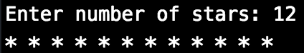

* + 1. 10 stars and 10 x’s, consecutively,:

https://lh6.googleusercontent.com/dosNW5Egg1RMBmUWQDX98zHufgVXhQgTTYWhW7ZuP5TGU0ktshy9WShRGy615V0IDGCma0pSHCm3Zxzt1U-rn9ejgd1SIT7zaGjbm84aK7uklBTI-BNApCtSkvm2cCe-dRyr0fOF

* + 1. n stars and n x’s, consecutively,  n is from user’s input:

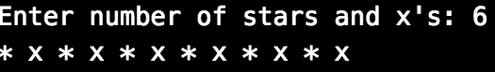

* + 1. [Optional] n stars and x’s **in total**, consecutively,  n is from user’s input:

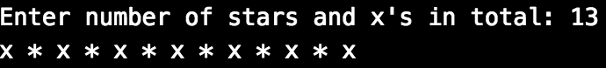

another user case:

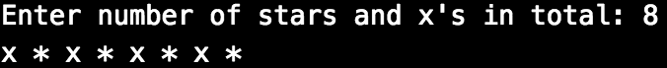

|  |  |
| --- | --- |
| system_config_boot.png | ***Tools preparation*** |

Watch the homework submission tutorial