|  |  |
| --- | --- |
| *school-learn-study-hat-graduate-512.png* | ***Study*** |

Read Chapter 8, section 8.1, 8.2, 8.3, 8.4, 8.5, 8.6, 8.7

[**http://www.ict.ru.ac.za/Resources/cspw/thinkcspy3/thinkcspy3.pdf**](http://www.ict.ru.ac.za/Resources/cspw/thinkcspy3/thinkcspy3.pdf)

Then answer the following question:

* How do we convert  a string to uppercase or lowercase?
* How do we get length of a string?
* How do we print a string, one character per line?
* How do we compare two strings?

|  |  |
| --- | --- |
| *6iporAnbT.jpg* | ***Serious exercises*** |

**Exercise 1**

Write a program to count number occurrences in a list, with OR without using count() function

Example:

https://lh3.googleusercontent.com/wSMhrmYZr8rUTZXhaWqEdOl54QH_IbgDnK6ehDOqkXcvPraBrVH4_GUv3V2gtQ5a1jMAWHSkIRNIAW0TRjxmhNXYV0RWhZccBp3r-ITvAf9npQjULVAWsazmEs5Ab_CinFct1bcH

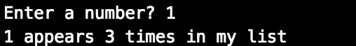

**Exercise 2 [Optional]:**

Implement Guess Your Number Game:

Example:

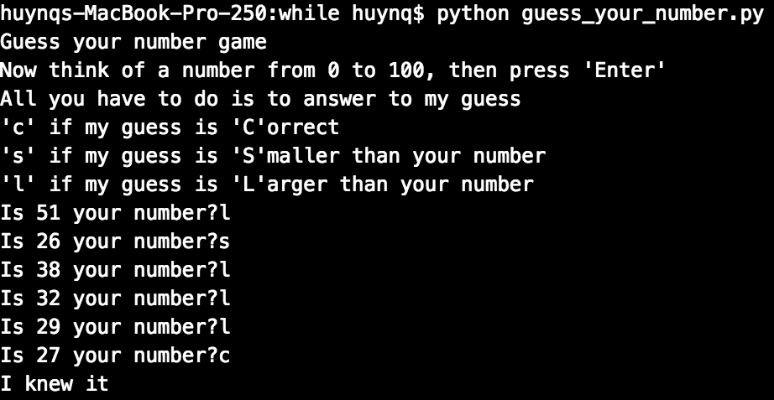

**Exercise 3:**

Implement Word Jumble game

**3. a.** Print a specific word’s characters in random order then ask users to guess the word, then check if they are correct:

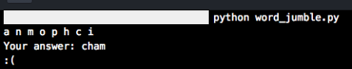

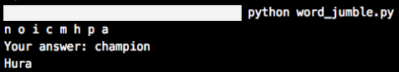

**3.b.** Scale up 3.a by randomly picking the word from a word list

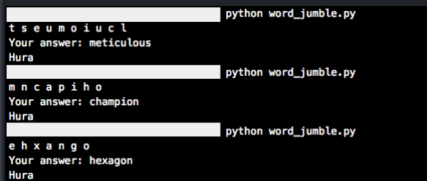

**Exercise 4**

Print out the following patterns:

* + 1. 20 numbers, starting from 0

https://lh6.googleusercontent.com/eSV81ZCHc7It4R6q5BEGZCVn9YHIyIFdpY5GHSxgOwpkZXtjYVzb_AcUdmb32OU0RitBl2OYUSTVZFvBNMTiYpBORnVXEY-0pWOqegTy-iN0j9rOg34MY_CYJrEdbGRXEc31Qxxd

* + 1. Ask users to enter a number, then print n positive numbers from 0 to n-1:

https://lh6.googleusercontent.com/xqqlhIzUYSj_tCcnaLv_qOGgetfTwLmEu2sG-wJ1QWkR2Ggyx-1h_ImJ56P0ompVI9ZLnqG_mcYF-B5yzGtn4XNmk1JYdm7YNN4WkDTUpsRU-ehllPk3eLH9ljMThwtVke7j2oOG

* + 1. 1’s and 0’s, consecutively

https://lh3.googleusercontent.com/_p-mBVDXjb-4cTuyefOz2sQ9JkIaJbnFUKX7LJ5c56JCPmBR-hdFI9Zdw7peTyuqJ3QJk8gUwXF_3y2fVvfNPo7kenNe1pWTSboyJnwvR--0no8RN_xaudc42Pct6I-N2moYGFH9

* + 1. Ask users to enter a number n, then print n 1’s and 0’s in total consecutively:

https://lh5.googleusercontent.com/gQL3Be3vn00o1C6UJRD_9-HvZ-rB1W3_d5Tyl8iAQ1N2UcO0-n_IYb3Ky5wmqGk0UoMdETsAAeIHaN44CaZHOgzv-JKg89kuGIgscMk25lfuG5UZlJEC7rYPPkcBiRX0EOs2zo2N

* + 1. 9 x 9 numbers (multiplication table)

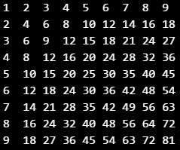

* + 1. Ask user to enter a number n, then print n x n numbers, following multiplication table pattern:

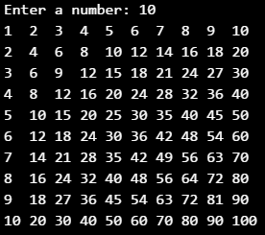

* + 1. 10 x 10 1’s and 0’s, consecutively

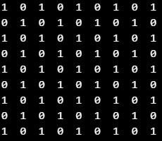

* + 1. Ask users to enter a number n, then print n x n 1’s and 0’s, consecutively

