|  |  |
| --- | --- |
| *6iporAnbT.jpg* | ***Serious exercises*** |

**Exercise 1:**

In Warm Winter Project create a /sign-in route for users to register to our page.

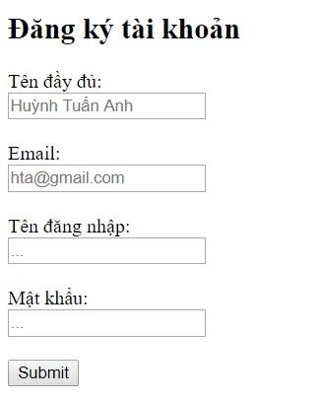

*Hint: You will need a User class for storing all user informations.*

*Each user has a username, password, email (****required****) and a fullname (****required****)*

**Exercise 2:**

In Warm Winter project, when users click on “Chi tiết” link of a service in home page, if they are already logged in, redirect them to Service Detail page, otherwise redirect them to Login Page.

The Login Page must have a “Đăng ký” link in case users do not have an account.

**Requirement:** After users logged in, their ID must be saved into session

**Exercise 3:**



In a service detail page, create a link “Yêu cầu dịch vụ” so that users can order a service for their bussiness.

When users order a service, save their order into database (In Order collection)

**Note:** An Order contains service’s id, user’s id (stored in session), the time they ordered (you can save the current system time) **AND** a Boolean field named is_accepted, representing whether their order is accepted yet.

Then simply response them: “Đã gửi yêu cầu”

**Exercise 4 (Optional):**

In admin page create a link “Xem các yêu cầu dịch vụ”, which leads admin to the Order Page

In this page admin could see all **unaccepted** orders.

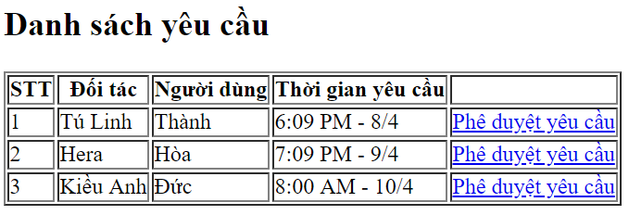

After click on “Phê duyệt yêu cầu”, update the is_accepted field of the respective order, then send an email to that user with a message “Yêu cầu của bạn đã được xử lý, chúng tôi sẽ liên hệ với bạn trong thời gian sớm nhất. Cảm ơn bạn đã sử dụng dịch vụ của ‘Mùa Đông Không Lạnh’”

*Hint: The data type of user’s id and service’s id in Order collection should be ReferenceField*