|  |  |
| --- | --- |
| *school-learn-study-hat-graduate-512.png* | ***Study*** |

Finish 24 exercises about flex-box in this site: <https://flexboxfroggy.com/>

|  |  |
| --- | --- |
| *https://lh5.googleusercontent.com/dlSMj0y7BANdS3sB9I07U7SKJCTaXwtloG7RjuJUKS9bLM6nCQOB08Vc3QHXWszNAf6LMpnnEqd4byHwebDejANzW_Ln8hCD7FQE8ETdXrT5FC1F-yjxQWUxtfJ8yCYV0Vpt96iy* | ***Serious exercises*** |

**Exercise 1:**

Implement css for the following area:



*Hint for creating a round image: border-radius*

**Exercise 2:**

Implement the following page layout:

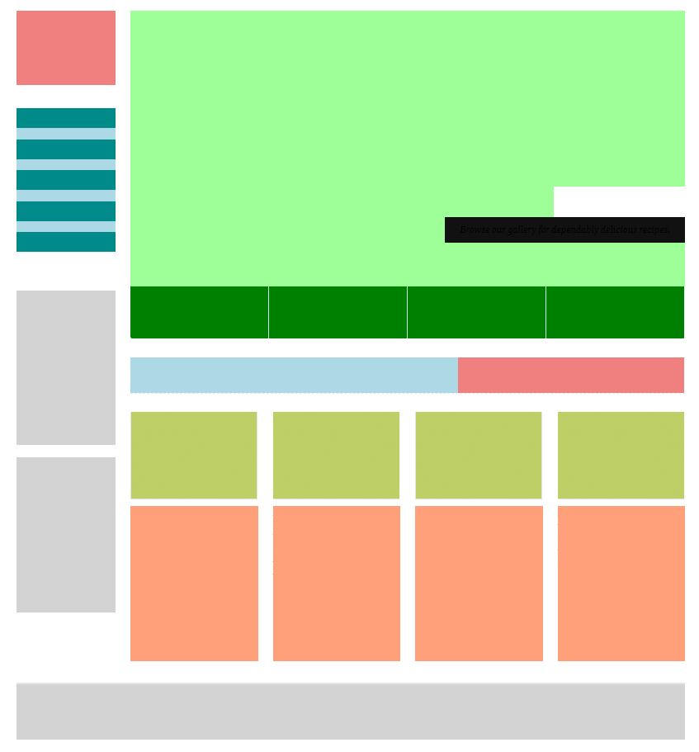

**Exercise 3:**

Download these assets:

<https://drive.google.com/open?id=1RQdX3fsL6nfiqf1xZ5arSmrp1gUBnkos>

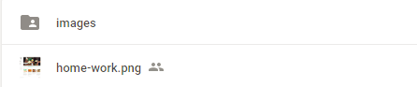

Implement css for the page in home-work.png