Redis VLAN Pub/Sub Project

This project demonstrates a Redis-based Publish/Subscribe (Pub/Sub) system that simulates VLAN ID message publishing and receiving. It includes two main components:  
  
1. publisher_1 – continuously sends VLAN ID messages to the Redis channel.  
2. subscriber_1 – listens to the 'vlan' channel and logs any received VLAN ID messages in real time.  
  
The screenshots below show the live chat initiation, publishing process, and the subscriber receiving messages.

# Publisher Terminal (Chat Start)

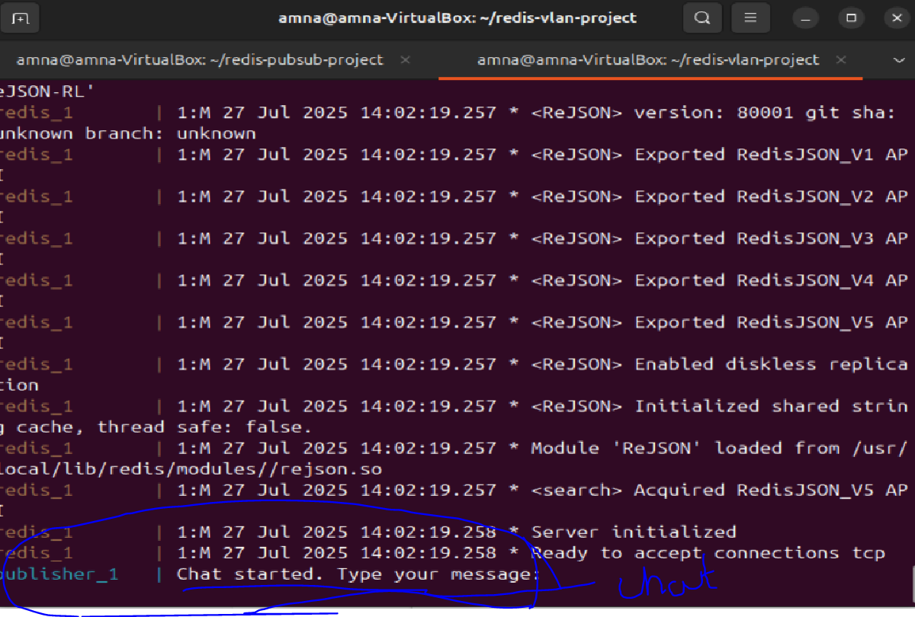

This screenshot shows that the publisher terminal is initialized and ready to send messages. It simulates a chat interface.

# Live VLAN ID Message Publishing and Receiving

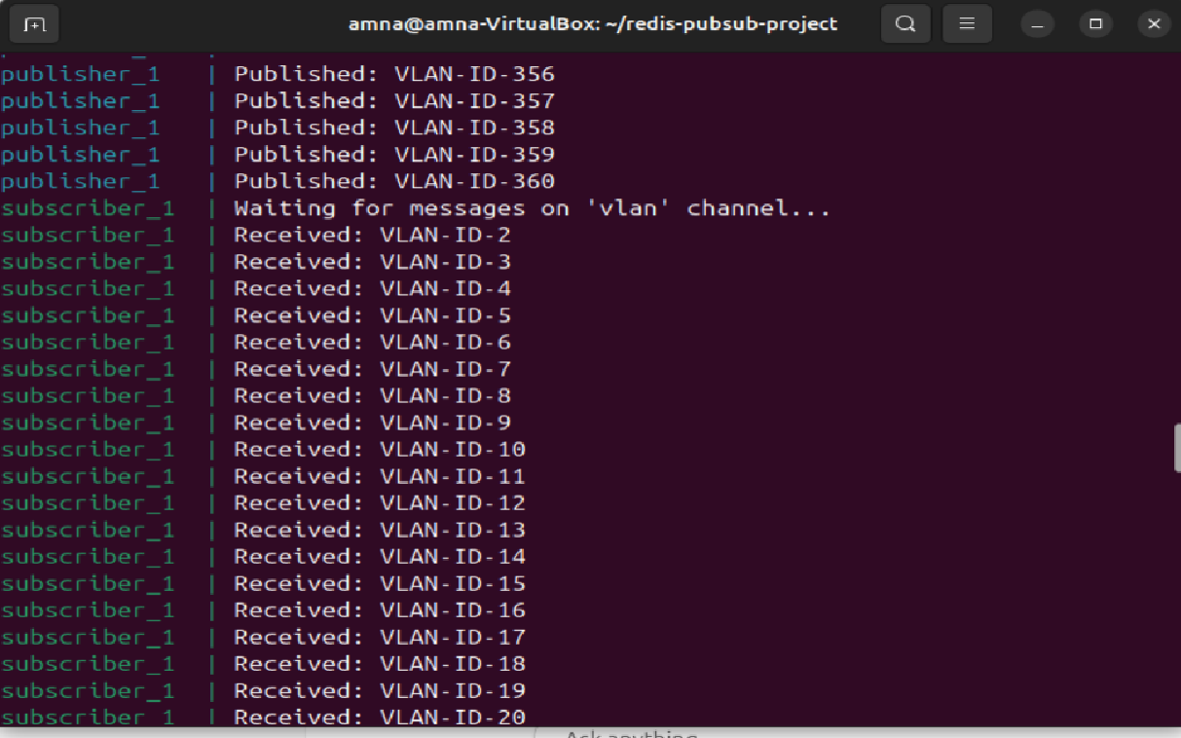

Here, multiple VLAN ID messages are being published and received in real time, demonstrating a working Redis Pub/Sub system.

# Sample Publisher Python Code

import redis  
import time  
  
r = redis.Redis()  
while True:  
 vlan_id = f'VLAN-ID-{random.randint(1, 500)}'  
 r.publish('vlan', vlan_id)  
 print(f'Published: {vlan_id}')  
 time.sleep(1)

# Sample Subscriber Python Code

import redis  
  
r = redis.Redis()  
pubsub = r.pubsub()  
pubsub.subscribe('vlan')  
print('Waiting for messages on vlan channel...')  
  
for message in pubsub.listen():  
 if message['type'] == 'message':  
 print(f"Received: {message['data'].decode()}")