|  |  |
| --- | --- |
| Code | Output |
|  |  |

Hopefully this is easier to read.

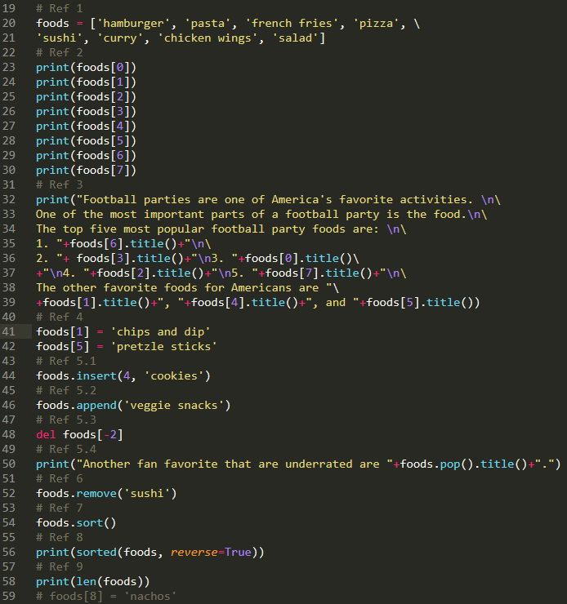

Output:

