Sorry I know it’s impossible to read the code at this size. This was the only way to get it in a table side by side per the instructions.

|  |  |
| --- | --- |
| Code | Output |
|  |  |

Hw3a.py python code

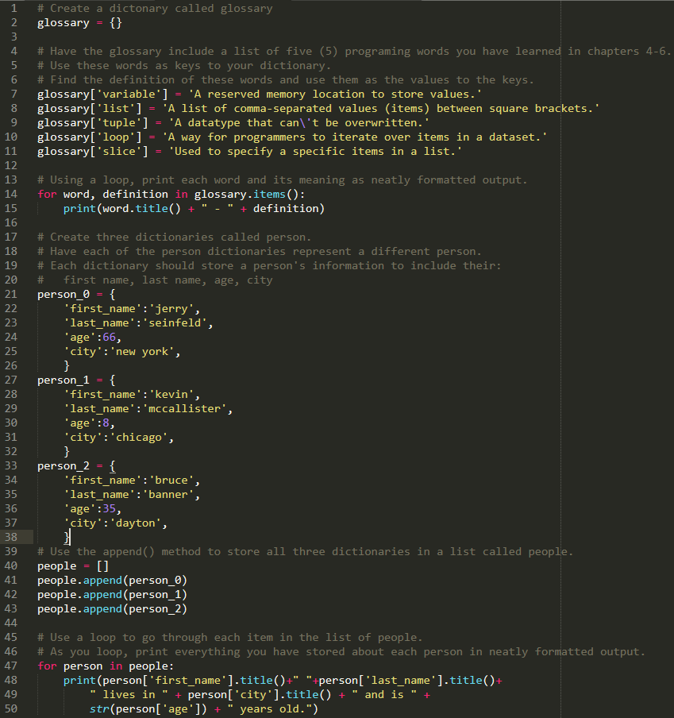

Output of hw3a.py

